Accessibility Plan Guide

May 2023

Available in alternate formats. Please contact Disability Policy Office:
Phone: 709.729.6279
Text: 709.725.4463
Email: disabilitypolicy@gov.nl.ca

Table of Contents

Introduction 4
Accessibility Act NL 4
Provincial Accessibility Standards 5
Public Bodies 5
Getting Started 6
Accessibility Advisory Committee 6
Appoint an Accessibility Lead 7
Learning and Collaboration 8
Develop your Accessibility Plan 9
1. Develop Statement of Commitment 9
2. Identify Accessibility Goals (existing and new) 10
3. Set Focus Areas 11
4. Review Focus Areas 12
5. Make it Public 13
6. Implement and Update Plan 14
Appendix A: Glossary of Terms 16
Appendix B: Suggested Consultation Activities 19
Appendix C: Accessible Communications and Inclusive Engagement Checklists 20
Appendix D: Words with Dignity 22
Appendix E: Accessibility Plan Outline 23
Appendix F: Resources 25
Appendix G: Network of Disability Organizations 27

Introduction
Approximately 1 in 4 people in Newfoundland and Labrador identify as having a disability, higher than the rest of Canada, as noted in the 2017 Canadian Survey on Disability. People with disabilities experience barriers to participating in their communities across the province. Disability related issues are growing and intersect with other groups including, Indigenous, 2SLGBTQAAI+, new Canadians, and seniors. The Government of Newfoundland and Labrador is committed to improve accessibility and inclusion across the province.

Accessibility Act NL
The Accessibility Act became law on December 3, 2021. This enabling legislation allows the Government of Newfoundland and Labrador to outline the principles and goals for an accessible province. The Accessibility Act will improve accessibility by identifying, preventing, and removing barriers that prevent persons with disabilities from full participation in society. In the Accessibility Act:
- A disability includes a physical, mental, intellectual, cognitive, learning, communication or sensory impairment or a functional limitation that is permanent, temporary or episodic in nature that, in interaction with a barrier, prevents a person from fully participating in society.
- A barrier means anything that prevents a person with a disability from fully participating in society, including a physical barrier, an architectural barrier, an information or communications barrier, an attitudinal barrier, a technological barrier, or a barrier established or perpetuated by an Act, regulations, a policy or a practice.
The Minister Responsible for the Status of Persons with Disabilities will oversee the development and implementation of accessibility standards to help prevent, identify and remove barriers that prevent persons with disabilities from fully participating in society. The Minister will also work to ensure:
- Inclusion and equity for all persons in Newfoundland and Labrador by working with stakeholders to ensure equitable access to services and opportunities for people with disabilities.
- Policy and legislative work embraces the principle of Nothing About Us, Without Us.

Note: In June 2019, the Government of Canada adopted the Accessible Canada Act, which applies to organizations under federal jurisdiction. This includes the federally regulated private sector, such as organizations in the transportation sectors, broadcasting and telecommunications services, and the banking and financial sectors. Refer to Employment and Social Development Canada

Provincial Accessibility Standards
The Accessibility Act is enabling legislation that allows for the development of accessibility standards. A key element of this process is the establishment of an Accessibility Standards Advisory Board (Board). Established in June 2022, the Board will advise and make recommendations to the Minister on the development of the accessibility standards and implementation timelines.
Accessibility standards may set out measures, policies, practices, and other requirements for identifying, removing barriers, and preventing barriers. A standard may apply to individuals, organizations, or public bodies that:
- design and deliver programs and services,
- provide information or communication,
- procure goods, services, and facilities,
- offer accommodations,
- provide education,
- provide healthcare,
- employ persons,
- own, operate, maintain, or control an aspect of the built environment other than a private residence with 3 or less residential units, and/or
- conduct an activity or undertaking prescribed in the regulations.

Public Bodies
Public bodies include government departments, agencies, boards and commissions, municipalities, public and private educational institutions. Under the Accessibility Act, public bodies are required to:
- Comply with the standard within the specified time period;
- Prepare and keep records to follow the regulations, and make records available for inspection and examination;
- Develop an accessibility plan within two years of the Accessibility Act becoming law. Accessibility plans must be updated every three years and made public;
- As accessibility standards are implemented, they will be integrated into the plan.
- Consult with persons with disabilities, or representatives from organizations of persons with disabilities, in the development and implementation of accessibility plans; and,
- Set up an Accessibility Advisory Committee, depending on the size of the public body.

Getting Started

Before you create an Accessibility plan, preparation is needed to ensure the Accessibility Plan has the components required to achieve obtainable goals. These components are:
- The Establishment of an Accessibility Advisory Committee
- The identification of an Accessibility Lead
- Learning and Collaboration
Keep in mind that the accessibility plan should outline how barriers to participation identified and removed in the short-term, and into the future. As well, all policies and practices that influence the delivery of programs and services are more significant than any one-time action. It is important for public bodies to examine their policies and operations in a thorough manner and explore opportunities to improve accessibility for systemic and complex issues/practices.

Accessibility Advisory Committee
The role of the Accessibility Advisory Committee is to help a public body to identify, prevent, and eliminate barriers to programs, services, and infrastructures. The mandate and terms of reference of the committee developed by each public body. The committee should play a key role in developing your accessibility plan and helping your public body become accessible.

Questions to Think About
- Will your public body develop its own committee or a joint committee in partnership with other prescribed public sector bodies?
- Not all public bodies need to set up an Accessibility Advisory Committee as it depends on public bodies’ size. It is a good opportunity for your public body to form a joint committee with other public bodies that have a similar mandate or structure. Membership from each public body approved separately.

- Who should be represented on the committee?
- Members may include staff, stakeholders, clients, community members, partners, or others as appropriate.
- It should include persons with disabilities or organizations that represent people with disabilities. Members with a disability include people with a variety of disabilities and expertise to bring diverse perspectives.

Tips:
- Do not assume that you know who does or does not have a disability among your stakeholders.
- Remember that committee members will be your on-the-ground experts on accessibility.

- How will you recruit committee members - with an open call for applicants, a closed appointment process, or some other approach?

- Regardless of the recruitment approach, it is essential that you communicate with various stakeholder groups about opportunities to join the Accessibility Advisory Committee, and the impact the work will have on advancing accessibility within the public body.
- If you hold an open application process, consider advertising in alternate formats, such as large print and accepting applications in diverse formats to encourage diverse candidates. More information is available in Appendix C to make your communications more accessible.

- Will the meetings be open to the public?
- It is up to the public body to decide if the meetings are open to public. Holding public meetings may send a message of openness to your stakeholders, however, some committee members and potential applicants may not be comfortable freely expressing their opinions in public and prefer to discuss their insights in a safe private place.

Appoint an Accessibility Lead
It is recommended that an employee appointed to support the work of the Accessibility Advisory Committee, including the development and implementation of the plan. The lead will:
- Confirm the resources required to establish the Accessibility Advisory Committee, to engage stakeholders, and to develop the accessibility plan.
- Recruit committee members.
- Provide an orientation to the committee on the Accessibility Act, obligations under the Act, and the committee’s mandate.
- Work with the Accessibility Advisory Committee to lead the development of an accessibility plan.
- Work with the committee to identify accessibility needs and provide advice on removing barriers when new policies and programs are introduced.
- Ensure that accessibility awareness is included in employee training and orientation.
- Monitor progress of implementing the accessibility plan and ensure the plans priorities and actions are on target.
- Receive and respond to stakeholder suggestions and issues about the plan.

Learning and Collaboration
Ongoing learning and collaboration is important. Employees, the Accessibility Advisory Committee and senior leadership need a shared understanding of accessibility as a human right, barriers to accessibility, and obligations under the Accessibility Act to remove barriers.
Ongoing learning approaches will depend on local needs, but some suggestions include:

- Guest Speakers:
  - Invite committee members or other stakeholders who have a disability to present to the committee on the barriers they face accessing programs or services from your public body. This will ensure that the voices of people with disabilities are at the table and provide lived experience.
  - Invite guest speakers from local organizations that provide services to people with disabilities.

- Hands-On Learning
  - During consultations with persons with disabilities, there will be opportunities to learn about existing barriers from people with first-hand, lived experience. This knowledge will be critical to inform decision-making to identify, remove and prevent barriers within your public body. Make every effort to consult with people with various types of disabilities to gain a broad perspective of accessibility concerns.

- Online Learning
  - There are many online resources for employees and committee members including webinars, courses, online tools, and more. Examples of resources are included in Appendix F.

Develop your Accessibility Plan

The next step is to develop an accessibility plan, which will be accessible and written in plain language. An Accessibility Plan Outline is included in Appendix E. The steps to create the accessibility plan are:

Develop Statement of Commitment
The Statement of Commitment outlines the commitment to improving accessibility. It summarizes the accessibility message to the stakeholders. Some examples include:
- Ensuring equitable access and participation for all people regardless of their abilities.
- Treating all people in a way that allows dignity and independence.
- Meeting the needs of people who face accessibility barriers by keeping the focus on barriers and not on disabilities.
- Identifying, removing, and preventing barriers by meeting the requirements of the Newfoundland and Labrador Accessibility Act.
It is best practice to post your Statement of Commitment on your website (internal and external) and in common areas of your workplace. Everyone should be familiar with it and work to support the Statement.

Identify Accessibility Goals (existing and new)

- Accessibility Advancements to Date
Provide an overview of your identified accessibility goals, including:
- Advancements in identifying, removing, and preventing barriers in policies, programs, practices, and services.
- Steps to identify, remove, and prevent barriers in policies, programs, practices, and services.
- Learnings and practices to review and evaluate accessibility in your policies, programs, practices, and services.

Some examples of steps your public body may have already taken to improve accessibility could include:
  - Power-operated doors at the entrances to your building and washrooms.
  - Visual fire/emergency alarms throughout your building.
  - Website updated to follow the current international web accessibility standards.
  - Alt text added to images and graphs in public documents.

- Promoting Accessibility Awareness
- An important element of your Accessibility Plan includes promoting awareness throughout your public body about what is accessibility and its importance. Some areas may not be directly relevant to the public body and do not need to be in the plan. The plan can be organized in a way that reflects the mandate and best advances accessibility for stakeholders.

- Glossary of Terms
- The plan should have glossary of terms so that the reader understands the language and ensures that the information is clear and precise/concise. It helps prevent issues with miscommunication.

Set Focus Areas
- The plan should Identify and set focus areas in line with the public body’s goals, including:
- Programs and services to ensure everyone have equitable access
- Built environment to make buildings, shared spaces public transportation and transportation infrastructure accessible
- Information and Communication to ensure everyone can receive, understand, and share the information provided by your public body
- Goods, Services and Facilities to ensure people with disabilities have equitable access to the goods and/or services
- Accommodations to ensure accessible and inclusive accommodations
- Education to provide accessible and inclusive learning for all students
- Health Care to provide accessible and inclusive healthcare for all persons
- Employment to ensure an accessible workplace, and support people with disabilities in finding and maintaining meaningful employment

For each focus area, the plan should consider:
- What is the vision or commitment?
- What is the starting point or current situation?
- What policies are already in place or under development?
- What actions will you take to remove accessibility barriers?
- What policies, if any, promote accessibility for stakeholders and for employees affected by accessibility barriers?
- What partnerships have been formed with people with disabilities or organizations representing people with disabilities?

Tip:
We tend to be more aware of disabilities that are visible, including a wheelchair, white cane, or a service animal. It is important to remember that people with disabilities come in different shapes, sizes and ages. Some people with disabilities have disabilities that are not clearly visible including mental health, intellectual disabilities, and learning disabilities. People may also experience gradual changes in their ability (Example: multiple sclerosis or fibromyalgia) or have an episodic disability.

- Consultations with Stakeholders
Consulting with persons with disabilities or representatives of organizations representing persons with disabilities is necessary for a successful accessibility plan. Involving the community at an early stage allows for the collection of information from people who are directly affected by accessibility barriers within the public body, including information about specific areas of concern and priorities for action. It is important to provide stakeholders with information on why you are doing this work, and what your responsibilities are under the Accessibility Act. Examples include:
- What accessibility barriers exist within our public body? Remember to ask about all areas of accessibility, not just buildings or public spaces.
- What are the top priorities for improving accessibility within our public body?
- What is already working well to make our public body accessible?
- Who is doing work in accessibility in our community? What can you learn from them? Who can you partner with on the work?
Please refer to Appendix G for information on the province’s Network of Disability Organizations, which can be a valuable resource during the development and implementation of the plan.
For tips on hosting a welcoming meeting for people of all abilities, please refer to the Government of Newfoundland and Labrador Public Engagement Policy and the Accessible Communications Policy at Inclusion and Accessibility Policies - Children, Seniors, and Social Development (gov.nl.ca)
Suggestions for consultation activities can be found in Appendix B while a checklist for Accessible Communications and Inclusive Engagements can be found in Appendix C.

Review Focus Areas
Development of the plan should include a review of all focus areas in your public body to identify strengths, gaps and opportunities.
- Identify Accessibility Advancements
The public body may have already taken steps to remove barriers for people with disabilities. Some questions to ask during the development of the plan include:
- What experience does your public body have working with and including people with disabilities?
- What policies, if any, promote accessibility for stakeholders and employees affected by accessibility barriers?
- What partnerships have been formed with people with disabilities or organizations representing people with disabilities?

- Identify Barriers
The development of the plan should include a review of barriers in your public body to identify strengths, gaps and opportunities.
- What barriers have been identified by persons with disabilities to access programs, facilities, and services.
- What policies or operations may create barriers for people with disabilities, including employees and other stakeholders?
- What temporary barriers have been created by renovations, computer software upgrades or pathways that are blocked?

- Identify or establish processes to assess accessibility in your policies and services:
The accessibility plan will be updated every three years as required by per the Accessibility Act. It is a good practice to implement ongoing evaluation processes to assess how your policies and services address accessibility and how well your improvements are working.

Make it Public
- Draft the Plan
- Draft the accessibility plan with information collected from the Accessibility Advisory Committee, consultations, the accessibility review, and an understanding of your budget.
- Develop policies and actions to support outcomes identified by the community.
- Invite stakeholders to give feedback on the draft plan. This can achieved by posting it online or holding an in-person meeting.
- Revise the plan based on feedback.
- Prioritize the actions and identify any gaps in the plan.
- Ensure that the Accessibility Advisory Committee (if applicable) approves the revised plan before it is presented to senior leadership for final approval.
- Seek approval for the plan and make it available to the public.

- Make the plan accessible and in plain language
The plan will need to be accessible and in plain language so that information is understood clearly. More information is available in Appendix D, but some best practices include:
- Use inclusive, person-first language throughout planning, developing and implementing the plan.
- Ensure that policies, initiatives, and plans are consistent with the principles of dignity, independence, integration and equitable opportunity.
- Use plain language in your plan, including:
  - Write short sentences
  - Avoid jargon or acronyms
  - Use the active voice
- Refer to Plain Language Action and Information Network as a helpful tool.

Use a checklist to review each action:
- Is the action practical?
- If it is a multi-step action, does the sequence you have outlined make sense?
- Is the timeline realistic? Is there enough time to complete each step?
- Are resources available now, or is further planning or a proposal to management required?
- Will the completed action result in the barrier being removed or prevented?
- Will the proposed approach to meeting a requirement or removing a barrier create a new barrier to accessibility?

Implement and Update Plan
- Implement the Plan
The organization should implement the plan by:
- Assigning responsibility for the team member(s) who will lead your efforts to meet each commitment.
- Allocating resources to estimate the human, financial and technical resources required
- Providing a timeline for implementation
- Stating how the plan will be monitored and evaluated
- Including mechanisms to respond to questions and complaints

To communicate the plan, the organization should:
- Involve the community. It is important to communicate it through a variety of channels, both to celebrate the plan and to raise awareness about accessibility and your committed actions. Some examples include:
    - Host a town hall meeting.
    - Set up a booth at a community event and ensure the event is held in an accessible location.
    - Post the plan on your social media accounts.
    - Email information about the plan to residents and stakeholders.
    - Issue a media release.
    - Work with the Accessibility Advisory Committee to develop a process for responding to questions, suggestions, or complaints related to the plan.
- Involve employees. They can identify specific budget requirements to implement the plan and ensure priority action items are recommended in the budget. Employees may present other documents to the Accessibility Advisory Committee that relate to implementation of the plan.
Your accessibility plan is a working document. It is important for employees to work closely with the Accessibility Advisory Committee (if applicable) as the plan is implemented and evolves. The committee may provide an annual report card to measure performance in implementing the plan to ensure stakeholder engagement is ongoing.

- Update the Plan
The Accessibility Act requires Plans to be updated every 3 years. Therefore, the organization should review and update the plan regularly. Annual reports, accessibility reviews and/or meetings can be included in the Accessibility Plan.
When standards are developed and made regulations, check compliance for the public body and update the Plan. This updated plan should be publicly available and include an overview of advancements and progress on focus areas previously outlined, as well as measures taken to comply with the Accessibility Act.

Appendix A: Glossary of Terms

Accessibility Act
The provincial law enacted to achieve accessibility by preventing and removing barriers for people with disabilities. The Accessibility Act defines the role and responsibilities of the Disability Policy Office and the Accessibility Standards Advisory Board, and addresses standards, compliance, and enforcement.

Accessibility Plan
A plan developed to address the prevention, identification, and removal of barriers in the policies, programs, practices, and services of a public body.

Accessibility Standards
Accessibility standards establish clear, specific, and achievable goals to identify, prevent and remove barriers. Each standard will be introduced in stages with a timeframe for implementation. The standards and timelines would consider all sectors such as government, business, municipalities, and community organizations.

Accessibility Standards Advisory Board
The Board shall consist of a minimum of seven (7) members and a maximum of nine (9) members appointed by the Lieutenant-Governor in Council on the recommendation of the Minister. The composition of this board states that at least one-half of the members are either persons with disabilities, or representatives from organizations of or for persons with disabilities, and at least one member shall be an Indigenous person.

Accommodation (or disability related support)
Any technical aid or device, personal support or disability-related support or other accommodation a person may require. This can include, but is not limited to: accessible meeting rooms; accessible formats such as Braille and plain language; mobility supports to attend a meeting; and, sign language interpreters, captioning or ensuring space has sensory sensitive features.

Barrier
Something that makes it harder for some people to participate. The Accessibility Act defines a barrier as “anything that prevents a person with a disability from fully participating in society, including a physical barrier, an architectural barrier, an information or communications barrier, an attitudinal barrier, a technological barrier, or a barrier established or perpetuated by an Act, regulations, a policy, or a practice.

Disability
As defined in Accessibility Act: “disability includes a physical, mental, intellectual, cognitive, learning, communication or sensory impairment or a functional limitation that is permanent, temporary or episodic in nature, that, in interaction with a barrier, prevents a person from fully participating in society”.

Disability Policy Office
The Disability Policy Office is a division of government that works with all government departments and agencies to assist in the development of policies and programs that include people with disabilities and that are barrier free. This office also acts as administrative support to the Accessibility Standards Advisory Board.

Enabling Legislation
Enabling legislation allows for further development of associated regulations and policies rather than prescribing specific requirements in legislation. Enabling legislation provides a broad focus on areas of authority that the government can act on in the future. These standards will be developed with the engagement of associated stakeholders including the persons with lived experience, business community, Public Bodies, and government departments.

Equitable/equity
A commitment to fairness. Equitable access is different from equal access. Equality means everybody is treated the same; equity means everybody is treated fairly, based on their needs and abilities.

Plain language
Clear, conversational communication that makes sense to the intended audience. The goal of plain language is to communicate so clearly that the intended audience can easily find what they need, understand what they find, and use the information. There are helpful resources available online, including the Plain Language Action and Information Network

Public Body
As defined in the Accessibility Act, public bodies include all provincial government, agencies, boards, commissions and committees, municipalities, public educational institutions and private educational institutions. Part I (o.) of the Accessibility Act includes the full list.

Standard Development Committee
Where it is determined that an accessibility standard is to be developed, the Accessibility Standards Advisory Board is to establish a Standard Development Committee to assist the Board in developing the content and implementation of the standard. There will be terms of reference for the committee which will identify the criteria for any technical experts and timelines. Committee members will consist of persons with disabilities or organizations representing them; representatives from departments that have responsibilities related to the standard under development and representatives of organizations and public bodies that may be affected by the standard.

Appendix B: Suggested Consultation Activities

When preparing accessibility plans, public sector bodies must seek input from people with disabilities and representatives of organizations representing people with disabilities. All consultation activities to be accessible need to be accessible to ensure that people with a variety of disabilities are able to access the information and are able to give their input. Refer to the Inclusive Public Engagement Policy available from the Government of Newfoundland and Labrador.

Here are some ways to kick-start your consultation:
- Create an Accessibility Advisory Committee working group focused on consultation.
- Gather information from stakeholders, either in person at events/meetings or online.
- Ask for suggestions to improve the accessibility of your public body.
- Ask for help in identifying accessibility priorities and possible examples, such as a hiring practice or a registration process.

Brainstorming
Here are some questions that could spark discussion at a stakeholder meeting:
- What is your current experience of accessibility in [name of public body]? I.e., what is working, what is not?
- How can [name of public body] contribute to an accessible Newfoundland and Labrador?
- What does an accessible [name of public body] mean to you?
- What are some ways to remove accessibility barriers in [name of public body] that are possible now and that would not cost a lot?
- What accessibility improvements would you make to [name of public body] in the long term that would have the biggest impact?
- What local partnerships can you identify that could help implement some of your proposed improvements? Please be as specific as possible.

Ask participants to identify accessibility priorities such as employment, information and communication, and delivery of goods and services and invite them to share their ideas under each category.

Appendix C: Accessible Communications and Inclusive Engagement Checklists

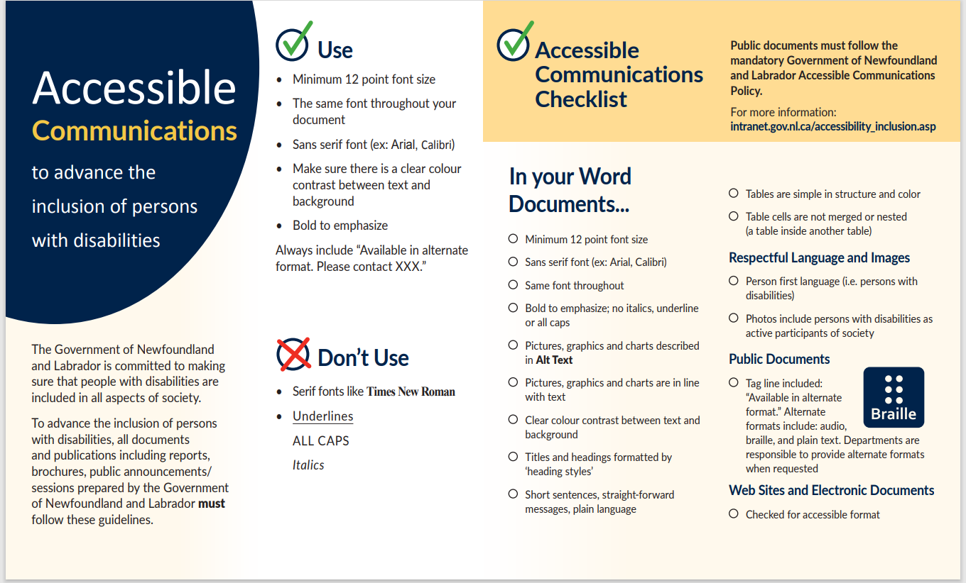

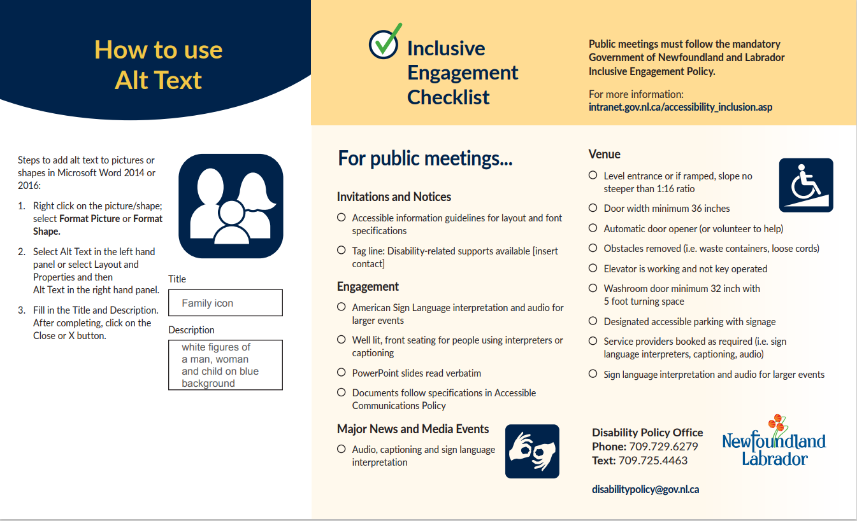

Link: https://www.gov.nl.ca/cssd/disabilities/inclusion-accessibility/

Appendix D: Words with Dignity

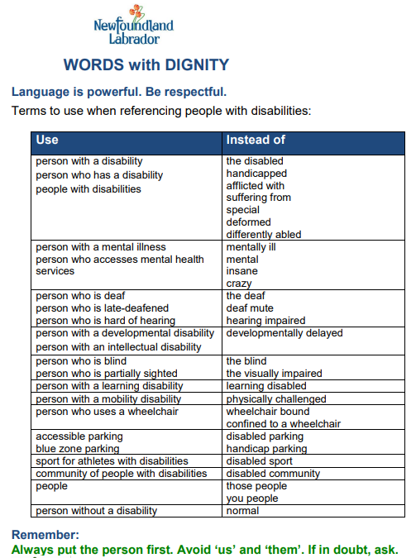

Link: https://www.gov.nl.ca/cssd/files/disabilities-pdf-words-with-dignity.pdf

Appendix E: Accessibility Plan Outline

Welcome Message/Introduction
- Accessibility Advancements to Date
- Accessibility Goals (existing and new)
- Promoting Accessibility Awareness
- Glossary of Terms

Statement of Commitment
Create message on improving accessibility within public body

Focus Areas
Identify and set focus areas within your public body’s goals:
- Programs and Services
- Ensuring the design and delivery of programs and services provide equitable access for all persons
- Built Environment
- Ensuring buildings and public spaces are accessible for all persons
- Information and Communication
- Ensuring all people can receive, understand, and share the information provided by your public body
- Use Inclusive Language
- Procurement of Goods and Services and Facilities
- Ensuring the procurement of goods and services is equitable for all persons
- Accommodations
  - Ensuring accessible and inclusive accommodations
- Education
- Providing accessible and inclusive learning opportunities for all persons
- Health Care
- Providing accessible and inclusive health care for all persons
- Employment
- Making an accessible workplace
- Supporting persons with disabilities to find and maintain meaningful employment

Actions/ Outcomes
Include in your plan how you are implementing and updating:
- Responsibilities – include the responsibilities of your employees and members of your Accessibility Advisory Committee (if applicable).
- Timeline – design a work schedule that aligns with compliance deadlines.
- Monitoring and Evaluating – develop a process to determine the success of your plan.
- Questions and Complaints – develop an effective procedure to respond to and address questions and complaints.
- Public Availability – ensure your plan is available to the public in an accessible format.
- Update the plan every 3 years with ongoing feedback from stakeholders.
- Check compliance when standards or regulations are implemented and update your plan.

Appendix F: Resources

Government of NL:
- Centre of Learning and Development provides internal learning and external learning opportunities for public service employees.
- Public Service Access portal for online courses for the public service employees.

Other tools and information:
Accessible Communications Policy and Inclusive Public Engagement Policy https://www.gov.nl.ca/cssd/disabilities/inclusion-accessibility/
Accessible Documents, Meetings, etc. Tutorials | Accessibility Hub (queensu.ca)

Accessible Virtual Meetings:
- Queen University Accessibility Hub
https://www.queensu.ca/accessibility/how-info/accessible-virtual-meetings
- Accessible Virtual Meeting Tips
https://www.deque.com/blog/virtual-meeting-accessible-zoom/
- How to Make Virtual Meetings Accessible
https://rootedinrights.org/how-to-make-your-virtual-meetings-and-events-accessible-to-the-disability-community/

Free tools:
- Colour contrast checker https://contrastchecker.com/
- Microsoft Word Accessibility checker (built into program) https://support.microsoft.com/en-us/office/improve-accessibility-with-the-accessibility-checker-a16f6de0-2f39-4a2b-8bd8-5ad801426c7f
- PowerPoint Accessibility Checker (built into program) https://support.microsoft.com/en-us/office/make-your-powerpoint-presentations-accessible-to-people-with-disabilities-6f7772b2-2f33-4bd2-8ca7-dae3b2b3ef25#:~:text=To%20manually%20launch%20the%20Accessibility,accessibility%20with%20the%20Accessibility%20Checker.
- PDF Accessibility Checker https://www.adobe.com/accessibility/pdf/pdf-accessibility-overview.html

Inclusion NL https://inclusionnl.ca/
International Website standards https://www.w3.org/WAI/standards-guidelines/
Mental Health First Aid
- https://www.sja.ca/en/first-aid-training/mental-health-first-aid-basic
- https://mhfa.ca/

Plain Language Guidelines https://www.plainlanguage.gov/guidelines/words/use-simple-words-phrases/

Social Media Resources
- Social Media Accessibility - Queens University Accessibility Hub
- CNIB
- Facebook Accessibility - Help Center
- Accessibility - Instagram Help Center
- Accessibility features supported on Instagram
- Twitter Accessibility - picture description
- How to Tweet pictures or GIFs
- You Tube Accessibility

Universal Design
- Principles and guidelines https://universaldesign.ie/what-is-universal-design/the-7-principles/
- Universal Design NL https://universaldesignnl.ca/

Appendix G: Network of Disability Organizations

The Coalition of Persons with Disabilities – Newfoundland and Labrador chair the Network of Disability Organizations. This network is comprised of community and disability organizations that work to provide services and programming for persons with disabilities in NL.

Network of Disability Organizations Members:
- Autism Society of Newfoundland and Labrador
- Canadian Hard of Hearing Association Newfoundland and Labrador
- Canadian Mental Health Association Newfoundland and Labrador
- Cerebral Palsy Association of Newfoundland and Labrador
- CNIB
- Coalition of Persons with Disabilities Newfoundland and Labrador
- Easter Seals Newfoundland and Labrador
- Empower NL
- Epilepsy Newfoundland and Labrador
- Inclusion Canada Newfoundland and Labrador
- Learning Disabilities Association of Newfoundland and Labrador
- Lifewise
- Newfoundland and Labrador Association of the Deaf
- Newfoundland and Labrador Brain Injury Association
- Newfoundland and Labrador Down Syndrome Society
- Newfoundland and Labrador Stuttering Association
- People First of Canada
- Schizophrenia Society of Newfoundland and Labrador
- Spinal Cord Injury Newfoundland and Labrador
- Vision Loss Rehabilitation Canada

