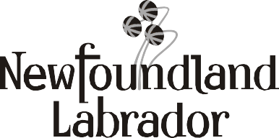
Government of Newfoundland and Labrador
Department of Environment and Climate Change
Water Resources Management Division

Report for Sealing Drilled Groundwater Wells
Subject to Section 18(3) of the Well Drilling Regulations under the Water Resources Act SNL 2002 cW-4.01, the undersigned makes the following report pertaining to the sealing of an unsuccessful or abandoned drilled well.
Original Well Owner Present Well Owner Property Location Well Location on Property

Include a minimum of three measured distances from permanent landmarks or structures on the property
Community
Street/Road Street/Road/Lot # Well Information (NAD 83 & decimal degrees) Lat N
Long W
Depth
Diameter Casing Length ID No. (if available)
Description of Well Sealing Procedure (if necessary, add more pages)

Note: Proof of purchase (receipts) of sealing materials are attached
Company Completing the Well Sealing Work Date Well was Sealed
I certify that the information in this report is true, complete, and accurate.

Date Name (Print)

Signature

RSDGW 06-10-31 Rev. 3

Title

PO Box 8700, St. John’s NL A1B 4J6 Tel: 709.729.2563 Fax: 709.729.0320 https://www.gov.nl.ca/ecc/waterres/

