REGISTRATION PURSUANT TO CHAPTER E-14.2
OF THE ENVIRONMENTAL PROTECTION ACT,
SNL 2002
ENVIRONMENTAL ASSESSMENT
FOR THE DEMOLITION OF THE EXISTING
BRIDGE AND CONSTRUCTION OF A NEW
BRIDGE ON HUMBER RIVER
ROUTE 440
KM 1.4
BALLAM BRIDGE REPLACEMENT
1

TABLE OF CONTENTS
Proponent 3
The Undertaking 4
Construction 7
Owner’s Policy 9
Protection of Vegetation and Wetlands 9
Storage and Handling of Fuels and other Material 10
Contractor Environmental Mitigation Plan 10
Prohibitions 11
Operation 13
Occupations 13
Project-related Documents 14
Approval of the Undertaking 15
Schedule 15
Funding 16
Appendix: General Project Information

BALLAM BRIDGE REPLACEMENT
2

PROPONENT:
- Name of Corporate Body
Department of Transportation and Infrastructure Government of Newfoundland & Labrador
- Address
5th Floor, Confederation Building (West Block)
St. John’s, NF
A1B 4J6
- Chief Executive Officer
Sean Dutton
Deputy Minister
729-3676
- Approval for Environmental Assessment Submission

July 29, 2026
Dan Michielsen Date Assistant Deputy Minister of Roads
729-0648
BALLAM BRIDGE REPLACEMENT
3

v. Principal Contacts for the Purpose of Environmental Assessment
Darryl Bruce Ken Hannaford
Director Senior Environmental Planner
Highway Design and Construction Highway Design and Construction
(709) 466-5688 (709) 729-5540
The Undertaking:
- Name of the Undertaking
Route 440, Humber River bridge demolition and new construction.
- Nature of the Undertaking
The construction of a permanent bridge on Route 440, Humber River, upstream of the existing bridge which will be left opened to traffic during construction
- Purpose / Rationale / Need for the Undertaking
The purpose of this project is to replace the aged and deteriorated bridge on Route 440.
BALLAM BRIDGE REPLACEMENT
4

Description of the Undertaking:
Geographic Location
The project location is on Route 440 at the crossing of Humber River at km 1.4. The coordinates are GPS co-ordinates: 48°57'13.40"N, 57°53'15.06"W.
There are no additional routing alternatives to replacing the bridge. It is an essential link on Route 440 and any alternative would not be feasible.
Physical Features.
The Humber River is designated as a scheduled salmon river flowing into the Bay of Islands. Detailed design work and existing environmental conditions determine the type of structure which will be required and what modifications will be incorporated into the structure to allow for fish habitat. The existing environment at the site consists of a deep steady comprising migration habitat. It is at the mouth of the river and is under tidal influence. There is no spawning habitat at this site and salmon move through it as they seek spawning sites far upstream. The site of the crossing was previously disturbed with the installation of the original bridge.
Environment.
The environment is part of the Western Newfoundland Forest Ecoregion, Corner Brook subregion. Local variation in the geology of the Western Newfoundland Forest ecoregion has affected its geography and biology. This ecoregion experiences warm summers and cold winters and is considered one of the most climatically favorable regions for plant growth on the island. Its mountainous terrain leads to high rainfall amounts, and winds off the Gulf of St. Lawrence drop their moisture when they ascend the slopes. The high humidity contributes to the favorable growing conditions. The Long Range Mountains also provide protection from cold northeasterly winds, which gives this ecoregion the longest frost-free periods on the Island.
5
BALLAM BRIDGE REPLACEMENT

This subregion is characterized by forested, rolling hills, and an underlying limestone geology.
Wildlife in this ecoregion is among the most diverse on the Island. Moose, snowshoe hare, muskrat, otter, mink, black bear, red fox, beaver, otter, and lynx occur throughout this subregion. Other mammals can be seen in the area as well, such as little brown bat, eastern chipmunk, masked shrew, meadow vole and red squirrel.
Fish species within the ecoregion may include Atlantic salmon, brook trout, arctic char, rainbow smelt, mummichog, and banded killifish. three-spined stickleback, three-spined stickleback, black-spotted stickleback and American eel. The banded killifish has been designated as special concern in Newfoundland, meaning it is at risk because of low numbers. The habitat at the project location is of deep water which precludes any habitat requirements of the Banded Killifish.
Birds found within this subregion include a variety of finches (ie: purple finch and pine siskin) and warblers (ie: black-and-white warbler, magnolia warbler,
American redstart, and Tennessee warbler). Yellow-bellied flycatcher, tree
swallow, solitary vireo, and thrushes (Swainson’s thrush and veery, for example) also occur.
The green frog, an introduced species inhabits small quiet ponds and marshes, but it is not widespread, and populations are small. The American toad, wood frog, striped chorus frog, and northern leopard frog (all introduced to the Island) have been recorded in extremely low numbers, and mostly in the Corner Brook area. It is possible introduced Garter snakes may be found in this subregion.
The area needing to be cleared consists of a mix of deciduous and coniferous trees and other herbaceous plants. The reach of the stream is a migration corridor at and adjacent to the existing bridge location. The substrate consists of bedrock. Humber empties into Bay of Islands immediately downstream of the crossing.
The Department of Transportation and Infrastructure (DTI) will consult with the Water Resources Management Division of the Department of Environment, Conservation and Climate Change to ensure that the best available data is utilized to design the bridge. The Water Resources Management Division’s Environmental
6
BALLAM BRIDGE REPLACEMENT

Guidelines for work around watercourses will be used during the design and construction phases.
The bridge will be designed and constructed in consultation with Fisheries and Oceans Canada (DFO). The bridge will be designed and constructed to have increased flow capacity and minimal impact on fish and fish habitat and in accordance with:
• DFO’s Guidelines for Protection of Freshwater Fish Habitat in Newfoundland and Labrador (1998);
- DFO’s Measures to avoid causing harm to fish and fish habitat (http://www.dfo-mpo.gc.ca/pnw-ppe/measures-mesures/measures-mesures-eng.html) and fish passage guidelines and other applicable guidelines and Fact Sheets
Potential receptors are residents of the communities of Route 440 such as Hughes Brook, Irishtown, Summerside, Gillams and others. Receptors include all travelers on Route 440 coming from Trans Canada Highway as well as all the communities in the vicinity of Deer Lake such as Pasadena, Nicholsville, Saint Judes. The interchange with Route 1 is approximately 0.1 km. to the south.
Construction:
The construction of a permanent bridge on Route 440 which will be on a new road alignment approximately 50m upstream from the existing bridge. The new bridge will be a single span 68m long steel girder bridge with a concrete deck and abutments, and on piles completely out of the water.
The existing structure is a 61 m long, three span continuous concrete rectangular-variable depth girder bridge on concrete abutments, wingwalls and shallow foundations. There are two piers in the river. The width of the existing travel way is 7.3m.
The Contractor shall submit a demolition plan for the old bridge to the Resident Engineer/Senior Environmental Planner for review and approval prior to commencing demolition work. Demolition and removal of the existing structure shall be carried out such that no significant debris enters the river. Busting of the
7
BALLAM BRIDGE REPLACEMENT

existing structure while in place shall not be permitted. The Contractor shall ensure that all waste material from the bridge demolition is disposed of in accordance with the Environmental Protection Act, SNL2002 CHAPTER E-14.2 and prior approval by the Department of Environment, Conservation and Climate Change. The Contractor’s Demolition Plan shall clearly demonstrate that there is compliance with all environmental requirements for the project and adhere to the Contractor’s Responsibilities – Regulatory Agencies Section 805.
All work under this item will be in accordance with Section 919.04 of the Departments Specifications Book, MAINTENANCE OF TRAFFIC, except where superseded by the requirements of this or another Supplementary General Conditions.
Fording or moving equipment through the river, or across any other watercourse,
will be strictly prohibited. Temporary culverts or temporary bridging are preferred
at such locations where frequent fording would be required.
Bridge construction will meet S6-25, Geometric Design Guideline for Canadian Roads 2019 standards and the design load is CSA S6-25. The Department of Transportation and Infrastructure will be improving upon the hydrology of this crossing by increasing the opening (end area) of the new permanent structure to allow for 100-year flooding projections. It will be performed by contract forces. The various phases will involve:
(a)field surveys;
(b)new crossing installation;
(c)demolition of old bridge
(d)clean-up and rehabilitation.
The potential sources of pollution during construction would be limited to the possible siltation of the river during subgrade construction. To prevent siltation within the river during construction the Contractor shall use the mitigation in the Specification book, Sections 815 Protection of Watercourses and Water Bodies, 816 Silt Fence, 817 Check Dam Sediment Trap, 818 Floating Silt Curtain/Turbidity Barrier and 845 Equipment Operation and Prevention of Erosion and Siltation (https://www.gov.nl.ca/ti/hdc/highway-specification-book/division-8/ ). In addition, the potential exists for hydrocarbon spillage from temporary fuel storage
8
BALLAM BRIDGE REPLACEMENT

facilities. Contractors will be advised of the environmental requirements for stream crossings and for hydrocarbon spill reporting and the necessity of strict compliance. Flow regime protection and shoreline stabilization will be a priority of DTI.
Owner’s Policy (Division 8, General Specifications Book, 2011):
To ensure protection of the environment, the work at all times shall be subject to inspection by the staff of relevant municipal, provincial and federal agencies. Normally, all inspections other than by the Engineer will be arranged in advance through the Engineer. Any specific matters relating to environmental protection will be dealt with between the Contractor and the Engineer.
Any violations of environmental permits or authorizations or any environmental related incidents which are observed by inspectors representing regulatory agencies are to be reported by them prior to leaving the site to the Engineer. Except in emergency situations, environmental protection measures required by other agencies must be approved by the Engineer prior to implementation by the Contractor.
It is Owner's policy to protect the environment along the route of the project, in areas adjacent the route, and in associated work areas such as pit or quarry sites. DTI is committed to cost-effective environmental protection measures that will prevent serious or irreversible environmental damage through the planning and implementation phases of the project.
Protection of Vegetation and Wetlands:
The Contractor shall be made aware that the work required in and around water crossings shall be performed with due care and caution to prevent undue disturbance to adjacent vegetation and the environment from construction activities and off Right-Of-Way (ROW) travel (Section 850). Immediately following and
9
BALLAM BRIDGE REPLACEMENT

during some construction activities, the Engineer may identify areas requiring seeding/sodding or stabilization by a method to prevent erosion. Damage or disturbance of vegetation and/or wetlands outside the ROW shall be re-vegetated and/or restored to the satisfaction of the Resident Engineer at the Contractor’s expense (Section 855).
Storage and Handling of Fuels and Other Hazardous, Toxic, or Dangerous Material:
Typically, fuel is brought in when needed and storage tanks aren’t used. If used, all storage tank systems must be registered under and in compliance with Newfoundland Regulation 58/03, The Storage and Handling of Gasoline and Associated Products Regulations, 2003 before commencing operation.
Registration does not apply to storage tank systems of a capacity less than 2500 litres that are connected to a heating appliance. Contractors shall supply verification of storage tank registration to the Engineer prior to the commencement of work (Section 820).
Contractor Environmental Mitigation Plan:
A Contractor Environmental Mitigation Plan (CEMP), completed by the
Contractor and approved by DTI before work commences, is required for this
project.
Elements required in a CEMP are:
- Pre-construction planning, including the identification project-environmental interactions (e.g., Valuable Ecosystem Components
including: public and worker safety, wildlife, habitat, plants, resource users, etc.);
- Detailed environmental mitigation measures to avoid negative or irreversible environmental impacts;
- Contingency plans for unplanned events;
10
BALLAM BRIDGE REPLACEMENT

• List of DTI and Contractor contacts and reporting numbers; and
• Decommissioning Plan that includes site rehabilitation measures.
The potential for adverse environmental impacts during construction will be minimized as all construction activities will be undertaken in accordance with the environmental requirements of the Department of Transportation Specification Book for transportation projects.
All heavy machinery will be in good running order with functioning exhaust systems. Dust will be at a minimum with a project of this nature where it is excavation and infilling. We don’t anticipate dust becoming an issue but if it does, a water truck or other means of containing dust will be implemented. TI complies with OHS standards.
Prohibitions:
The following are directives for the Owner and Contractor in carrying out this
project. Reference is also provided to the Section where this prohibition is located
in Division 8.
• Contractors, subcontractors and their personnel shall not harass wildlife or waterfowl or unduly disturb fish (Section 805);
- No pesticides or other products shall be used without prior approval
of the Owner and the Department of Environment and Climate Change
(Section 810);
- The Contractor shall not wash equipment or containers, nor dump herbicides in or near any fresh or saltwater bodies, or at any location where the herbicide may enter a body of water (Section 810);
• No person shall discharge into a body of water any sewage or effluent (Section 815);
- The use of equipment or machinery in a watercourse or water body is not permitted (Section 815);
• The Contractor shall not ford a watercourse without prior approval from the Resident Engineer (Section 815);
11
BALLAM BRIDGE REPLACEMENT

- Silted or muddy water is not permitted to be released into any watercourse or water body or into any ditch or areas that leads directly to a watercourse or waterbody (Section 815.07); • Smoking shall be prohibited within 10 m of a fuel storage area or during refueling operations (Section 820.03);
- Fueling or servicing of mobile equipment shall not be allowed within
100 m of a watercourse, water body, or designated wetlands (Section
820.03);
- The Contractor shall ensure that no servicing or washing of heavy equipment occurs adjacent to watercourses and designated wetlands. Fueling, servicing or washing of equipment shall not be allowed within 100 m of a watercourse (Section 820.04);
• No waste material shall be deposited in any watercourse or wetland (Section 825.01);
- There shall be no open burning of waste material, slash or grubbing
material onsite. Rubber tires, waste oil, or similar material shall not be used
to ignite slash or used to maintain the burning operation (Section 835);
- Unnecessary cutting of trees is to be avoided. Care will be taken during construction to prevent damage to trees and shrubs adjacent to the flagged clearing limits which are to remain after construction (Section 850);
- The Contractor shall not use living trees as survey marks and shall not
cut blazes or otherwise mark live trees except with removable surveyor's
tape and/or tags (Section 850);
- The Contractor shall limit equipment travel to the surveyed right-of-way and existing municipal and provincial roads. Use of equipment of any type is not permitted outside the clearing limits of the right of way without prior approval (Section 850); and
- Should any archaeological remains be encountered, such as stone, bone or iron tools, concentrations of bone, fireplaces, house pits and/or foundations, work in the area of the find shall cease immediately in accordance with the Historic Resources Act (RSNL1990 CHAPTER H-4) (Section 860).
12
BALLAM BRIDGE REPLACEMENT

Operation:
The bridge is a permanent operation with mitigations including inspections and
repair work when needed. Winter maintenance will consist of snow clearing and
the application of sand and salt for ice control.
The current bridge will serve to allow traffic to continue during the construction of the new bridge. It will be removed once the new bridge is open to traffic.
Occupations:
The various types of occupations anticipated for this project include:
- Civil Engineers; 2130
- Structural Engineers; 2231
- Engineering Technicians; 2231
- Road Surveyors; 2154
- Heavy Equipment Operators; 7521
- Drillers and Blasters; 7372
- Carpenters; 7271
- Heavy Equipment Mechanics; 7312
- Labourers; 7621
- Truck Drivers; 7511
- Concrete Finishers; 7282
- Concrete Technicians; 7282
- Material Technicians and Engineers; 2231
- Steel Erectors. 7236
- Senior Environmental Planner 2121
Contract completion is expected to be July 31, 2028. There is an estimate of approximately 20 -45 general construction workers during building. Specialties may include 1-2 welders (2 weeks estimated), 5-10 rebar tiers (1 month estimated), 1-2 crane drivers (2 months estimated). All of the above could change depending on the Contractor and when tender is awarded. Numbers and duration of
13
BALLAM BRIDGE REPLACEMENT

employment of individuals can’t be determined as the winning bidder, the Contractor, has the responsibility of choosing their own employees. This occurs after the project goes to tender which takes place only after the project receives approval from the EA process.
TI projects do not require any project specific hiring. TI will contract the work through a tender as a typical road construction tender. The work does not justify any dedicated project hiring and is a routine project with no extended dedicated project resource:
- TI will manage the contractor using existing internal resources. There is no expected/required hiring.
- The Contractor will manage with their normal and existing organizational resources. There is no expected incremental resourcing to what would be in their normal crews/organization.
As such, there is no expected “recruitment/hiring” by either TI or the Contractor.
Project-related Documents:
- Contractor Environmental Mitigation Plan.
- Department of Transportation and Infrastructure Specifications Manual

BALLAM BRIDGE REPLACEMENT
14

Approval of the Undertaking:
The following is a list of the permits, licenses, or approvals that may be necessary for this project:
MAJOR REGULATORY APPROVALS BY TYPE AND AGENCY
Type of Permit | Agency
Stream crossing approvals | Dept. of Fisheries & Oceans Canada
Stream crossing approval | Water Resources Management Division
Fuel storage & handling | Government Services
Solid waste disposal | Government Services
Commercial Cutting | Forestry, Agriculture, and Lands
Environmental Assessment | Environment, Conservation and Climate Change

Schedule:
The Department of Transportation and Infrastructure would like to complete the requirements under the Environmental Assessment Regulations and the Environmental Protection Act, and seek approval for the project by September 15, 2026. A tender call could take place in late fall of 2026 with construction starting shortly after.
15
BALLAM BRIDGE REPLACEMENT

Funding:
Due to the tendering process and competition between Contractors with the costs involved the Department of Transportation and Infrastructure isn’t in the position to reveal the potential cost of the project.

BALLAM BRIDGE REPLACEMENT
16

Appendix

General Project Details

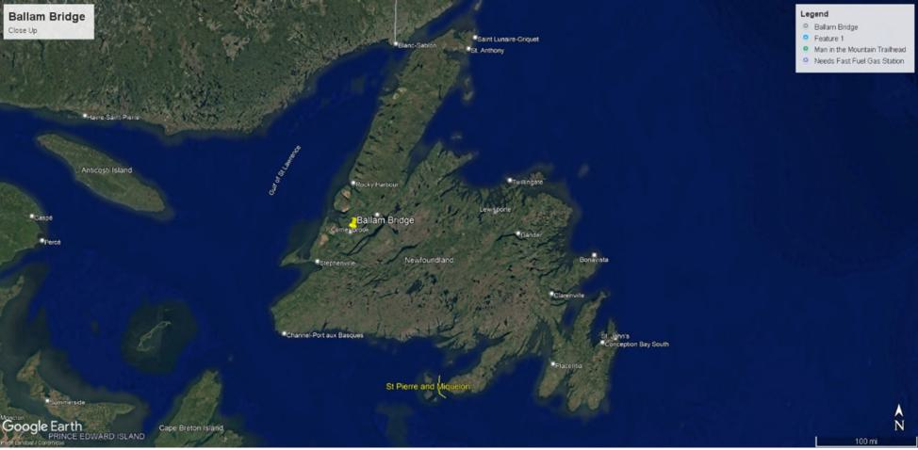
Google Earth Image 1: Location on Island
17
BALLAM BRIDGE REPLACEMENT

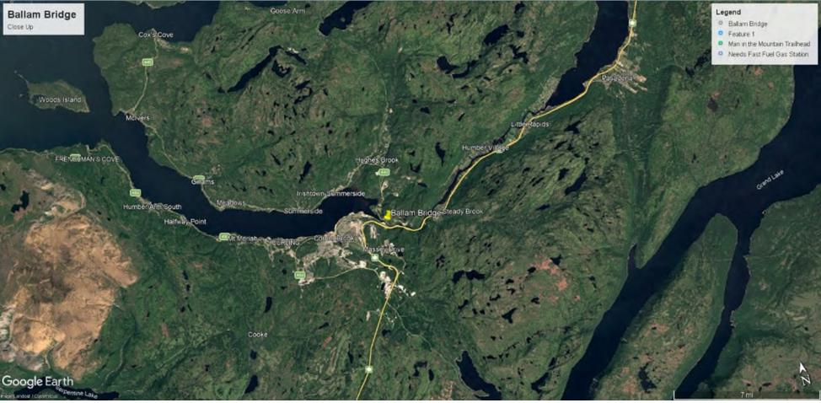
Google Earth Image 2: Broad view of site
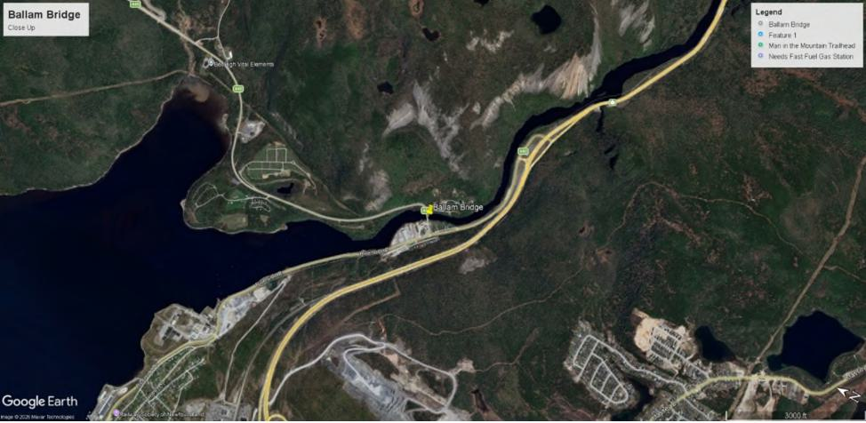
Google Earth Image 3: Location of Bridge on Route 440
18
BALLAM BRIDGE REPLACEMENT

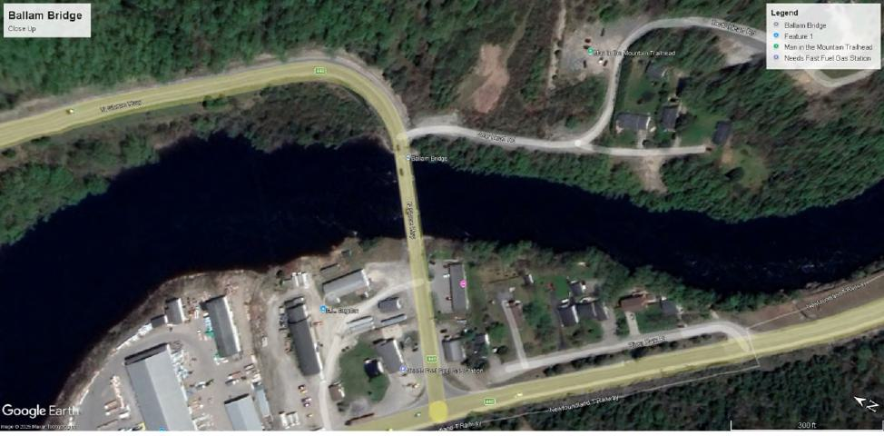
Google Earth Image 4: Close-up of Bridge Site

19

BALLAM BRIDGE REPLACEMENT

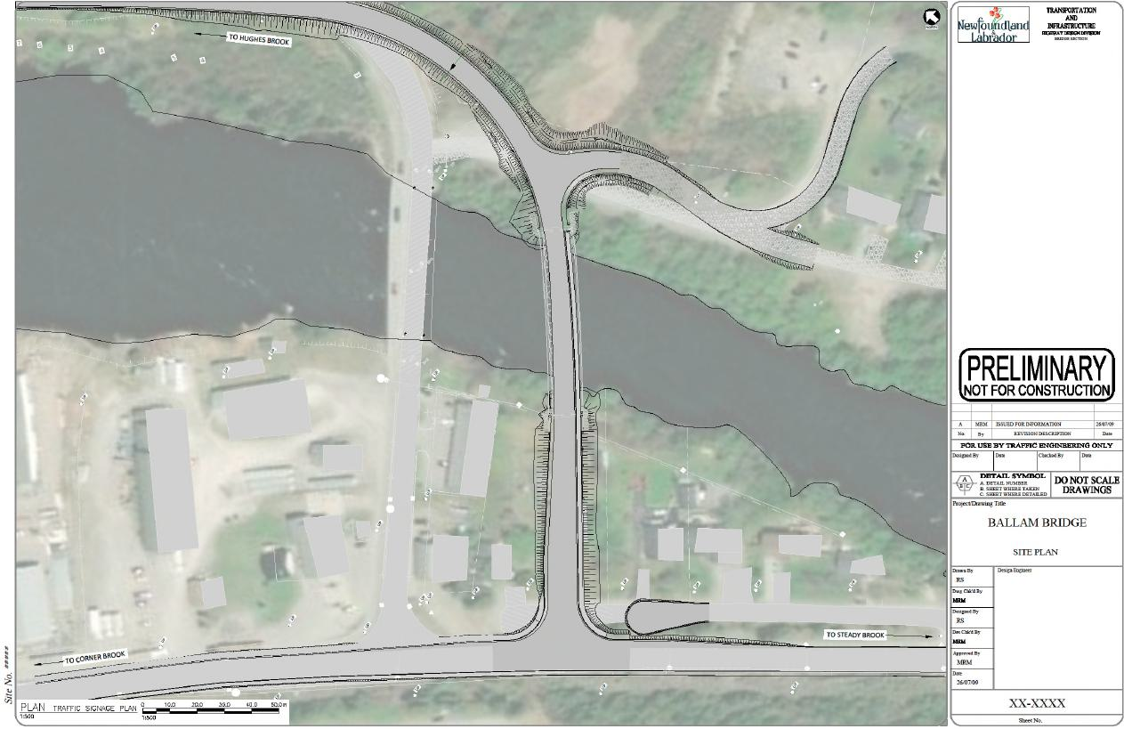
BALLAM BRIDGE REPLACEMENT
20

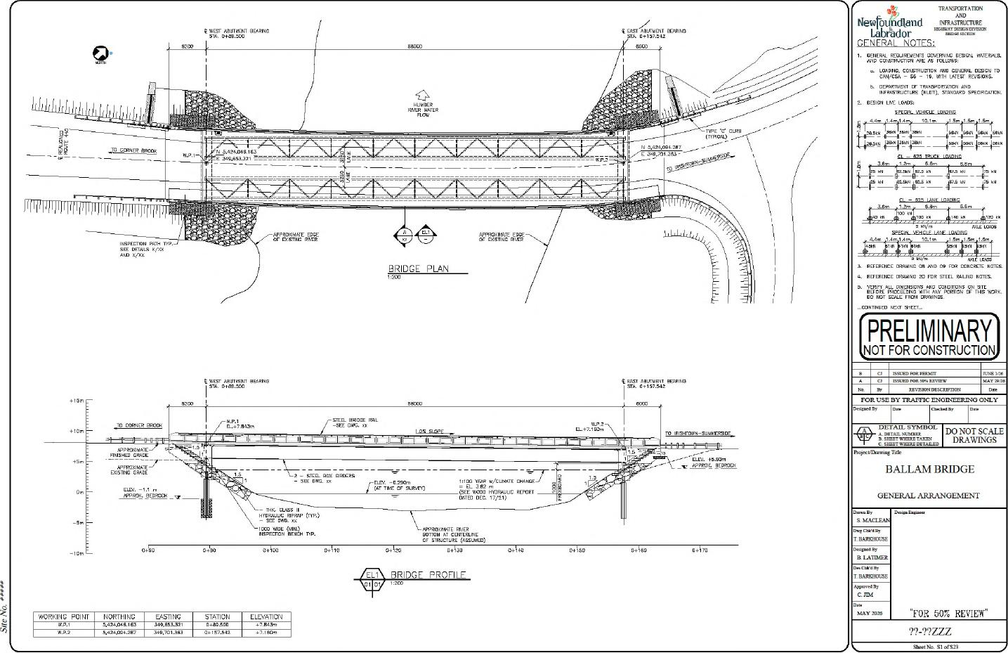
21
BALLAM BRIDGE REPLACEMENT
SIf No.
13.z...day
61.56)(By
DO NOT SCALE DRAWINGS
liewro dland 00
---
Labrador
GENERAL NOTES,
1. GENERAL REQUIREMENTS GOVERNING DESIGN. MATERIALS, AND CONSTRUCCON ARE PS FOLLOWS
LOADING, CONSTRUCCON AND GENERAL DESIGN TO CAN/051 — 56 — IS, WITH LATEST REVISIONS. b. DEPARNENT OF TRANSPORTATION AND INFRASTRUCTURE ((CDC), STANDARD SPECIFICATION
L,E Lopels,
5 TRUCE 10000010
ti;;:m r
⁻6⁷" r=⁻""
CL — 625 H.NE LOADING
3 ,9 139 6 Cm ,4^{AB} 6m
/m¹
,
F.PFC Al VFNO, IPNF 0.5.0
^{rn}ii^{""'"TOR}
3. REFERENCE DRAM CIS MD PI fOR CONCRETE NOTES.
C. REFERENCE DRAWING 20 FOR STEEL RN UNG NOTES.
5 VERIST ALL DIMENSIONS AND CONDITIONS ON SITE
BE ORE DO NOT PROCEEDING OF THIS WORK.
PRELIMINARY)
NOT FOR CONSTRUCTION
ISSUED PORP813101
ISSUED POH50,47HVDSW
MAT 29,76
IVIVSIONDESCILIPTION
FOR USE BYCRAFFIC ENG.:CERA. ONLY
PropefOrnamg Ttle
BALLAM BRIDGE
GENERAL ARRANGEMENT
C.z Clan, Ely EHARIMOUSE
13..day
11 LATIMER
RS cm. By
C Kbel
MAY 2026
"FOR 505 REVIEW"
71-`1?ZZZ
ShENu 5151.523
G WEST ABUTMENT BOPPING
APKROKIATE EDGE OF as⁻n^{LI}. RP.
O^{r}'^{T} r mE „UEGRE
INSPECTION PATH TIP SEE DETAILS X/XX AND X./X%
.⁰⁽⁶ ABITSENE BEARING STA. ⁰+¹⁵⁷ ⁵⁶²
o 0 0
¹53000
ij
4
HULICER RIVER WATER FLOW
TO CORNER BROD
U^{i}l^{i}l^{i}lilUUililiVliNlililiVhlIIUiliV
6
.0.153.50
BRIDGE PLAN
TYPE t⁽ CURB (TYPICAL)
-1 -
C 00001 Ni BGRINS
01⁻
G WEST ABUTMENT BEARING STA 0+013.500
C,0220
APPROXIMATE RIVER BOTTOM PT CENTERLINE CF STRUCTURE (ASSUMED)
_{DO 10}
0+0
0+^{I}90
0H90
0+650
0+190
1 PDC
EL C1 0
NORTHING
FASTING
STATION
O+39.90D
ELEVATION
+7.003m
WORKING POINT
369.701363
0+157.562
TD CORNER BROOK
TO IRISLITOWN-SUAIMEPSIDE
2 - STEEL BOX CINDERS
CLASS III HYDRAGLIG RIPWYP - SEE DWG. 00
1)100 YEAR ./CLIMATE CHANGE]
(SEE WCOD HYDRAULIC REPORT DATED DEC. 17/21)
No' PPM), 31EORGON
APPROX. BEDROCK .₆,
APPROXIMATE FINISHED GRADE
PPROXIMATE^{D'} EXISCLIG GRAPE
BRIDGE PROFILE
+10m -

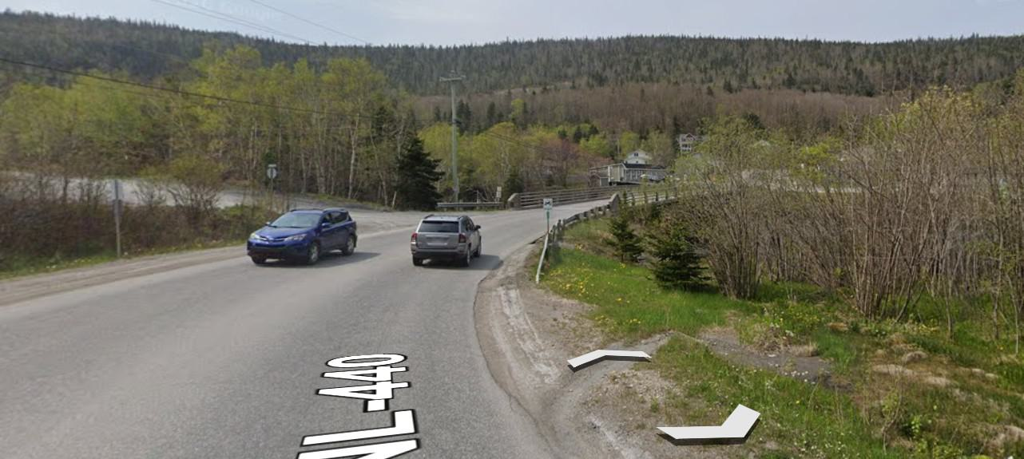

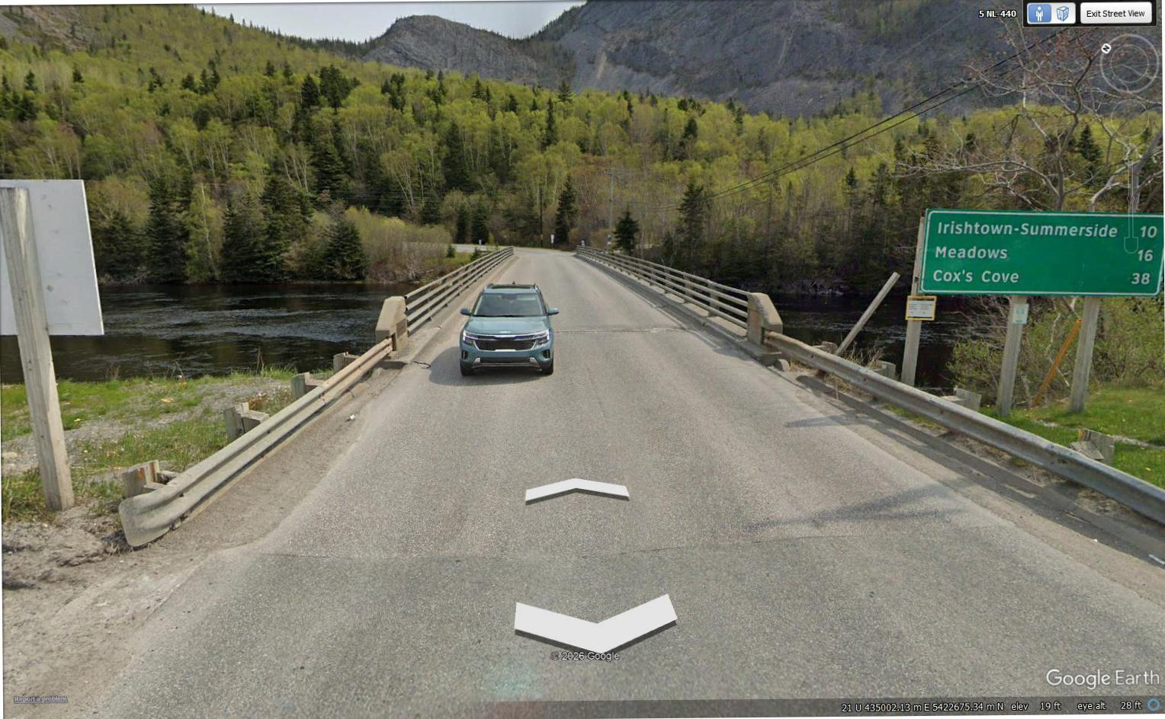
"mnwissrn'wIIIIPrr
Google Earth
e e'a 28'
5 N1-440
Exit Street View

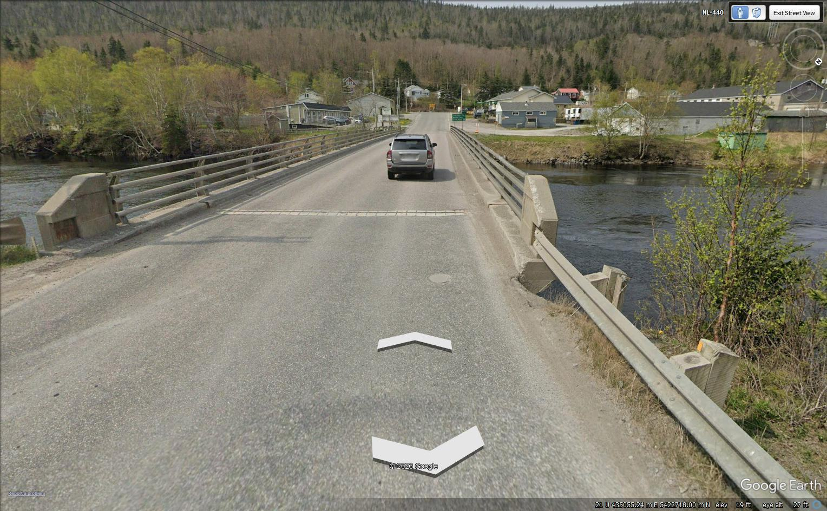
tr..4k4 ⁴¹\ !.v ^{j} ^{4Z}
it 0,
^{k} ^{i} It ejL
⁻kft:•:11
⁴1 ^{r}il`r1.4\¹¹; ⁴¹ ⁴: \r\fi ^{u}t^{k} •
'ft 1 • kg,4 .
T^{.4}
fY
S
A_{i}t-r.N;We
;•." ^{4.}r? - .4
ma^{l}
)cc,te%)* •
j..;
•
N_{tr},
1rr y,
- .
‘ ⁴⁴?I • . ,.. • , ..1_,,,,.,,,..------'....^{Uti}
1⁻ I ^{A} L-ar-aniaalla:r3 34.* _ ' --
i t -, - •
.. I" •:" k ',''
- -
fila^{r'.}
1
04A,,,•—•-• -- ,
W- •
^{41'}44 - • ⁴ 0. 11if
- t ^{r} /¹⁴ gm
:at R.' / ^{°S.} •
⁴r.. T. -', _ ^{r} 2
rI L:7
- :re., • • -•••-sr ,a,,...••• , ^a, ama
fa,..i.acc•7₄.1
- it> .;^{t}1⁻7₄;‘, -••
,1,.. _{if} W • •••
•
I rk
-
) t 4;-;
- Rt,12c-ct
i
j_{i} ,A

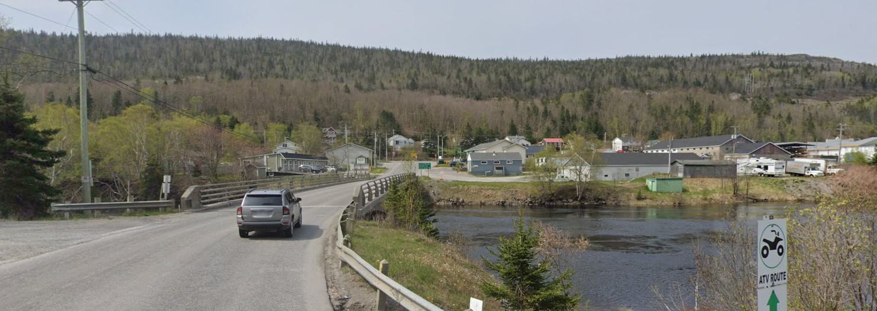
%

Google Earth Link: https://earth.google.com/earth/d/1ruNAbmCkchDtT_4C1zphoE2c2a8ztESo?usp=sharing

New Ballam Bridge:
Coordinates: 48°57'11.99"N, 57°53'13.56"W
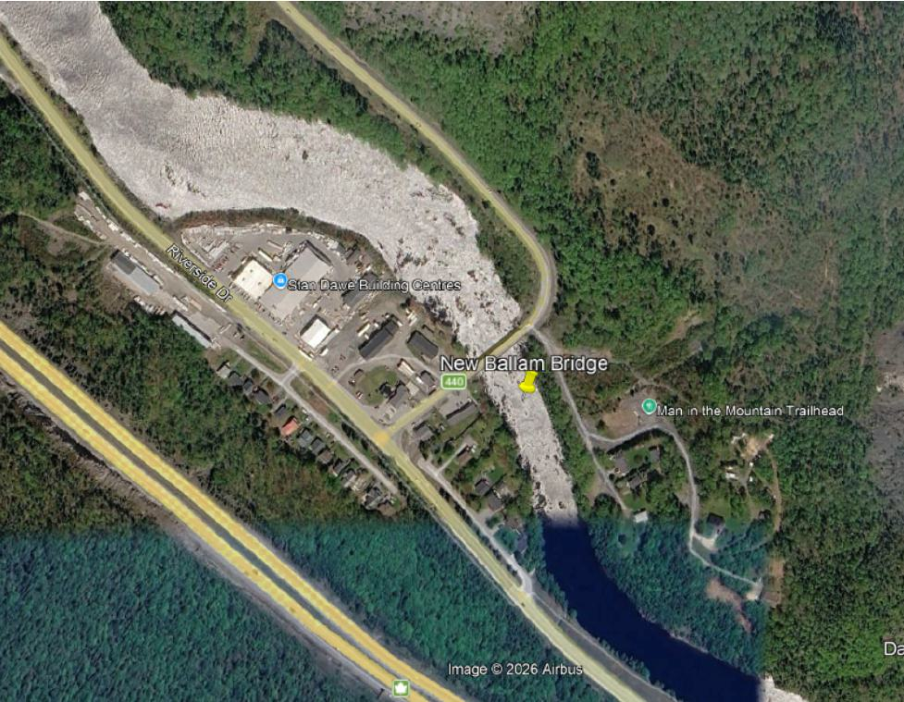
Existing Ballam Bridge:
Coordinates: 48°57'13.40"N, 57°53'15.06"W

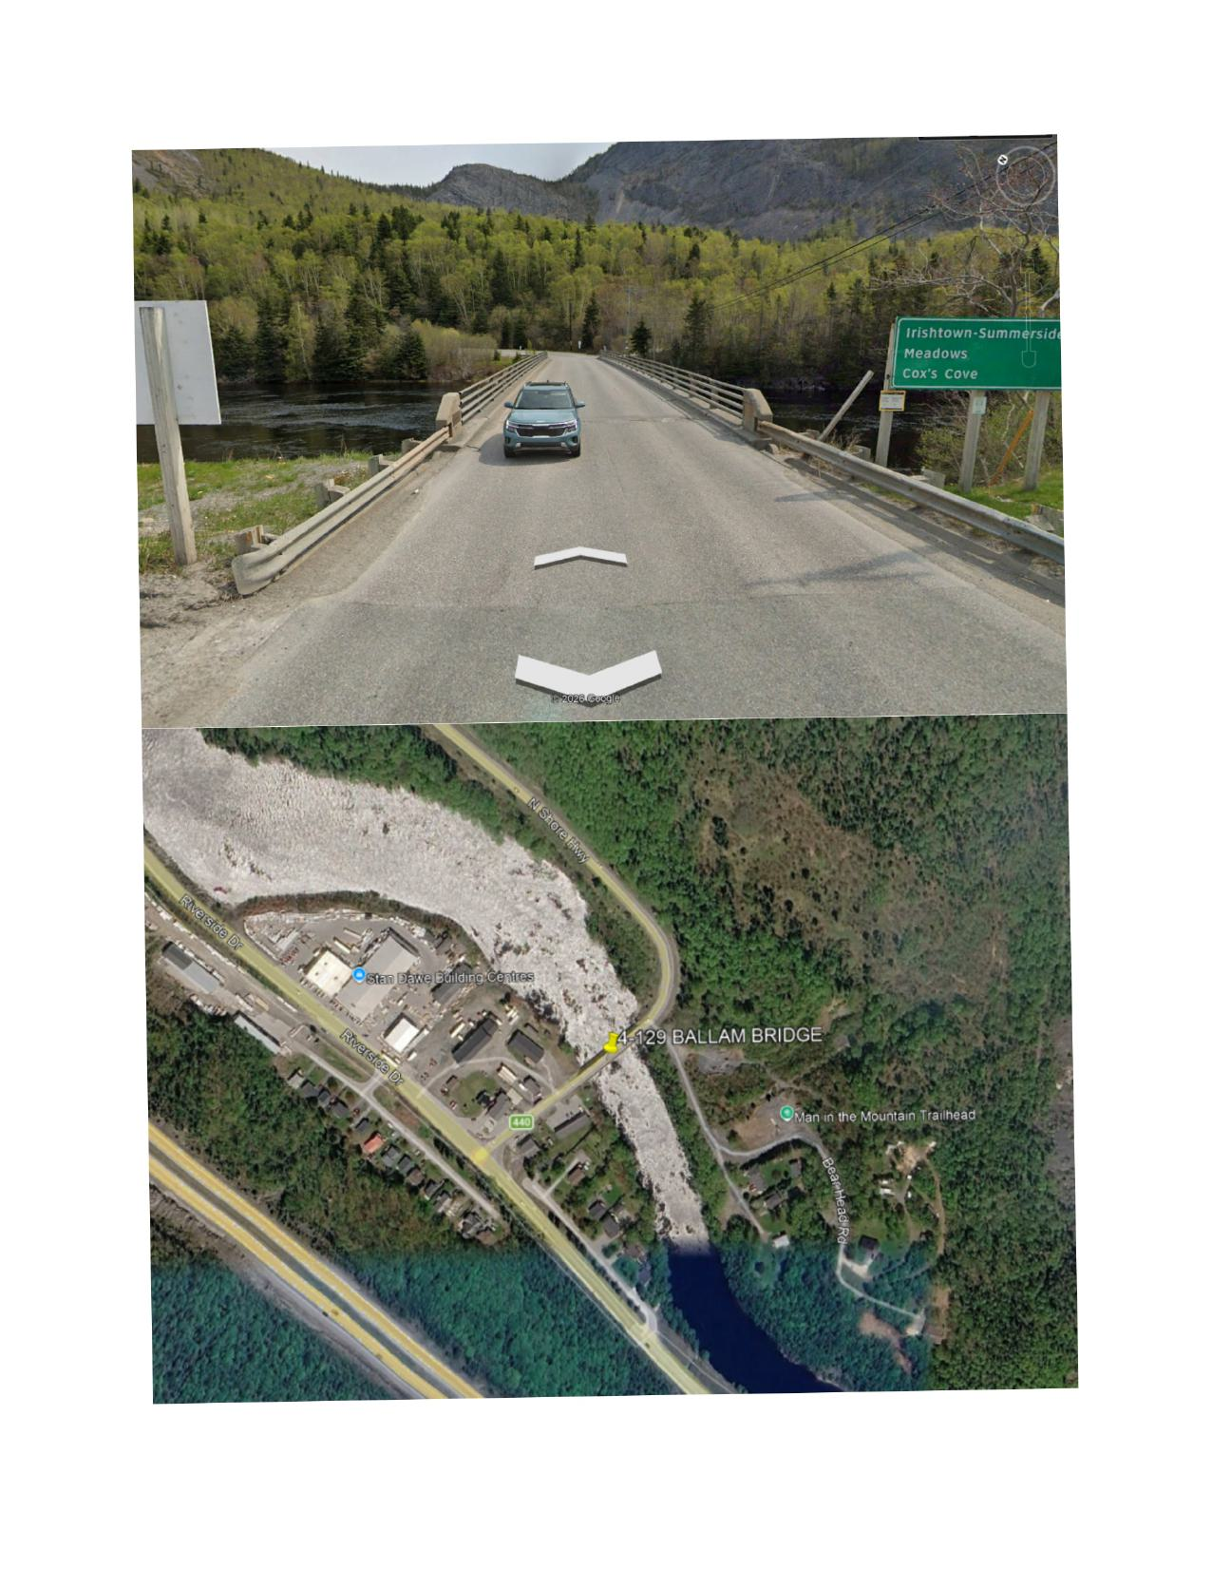

Both locations shown together:
