Adult Basic Education (ABE)
Career Development

Career Development
3213/3313

Electronic Study Guide

Contents
General Information 3
Introduction 3
Resources 3
Study Guide 4
Recommended Evaluation 4
Unit 1: Personal Management 5
Activity 1: Stress Management 8
Unit 2: Financial Literacy 10
Activity 2: Spending Plans 12
Activity 3: Banking Basics 14
Unit 3: Life/Work Exploration and Employability Skills 23
Assignment #1: Case Study – Be Prepared for Change 26
Assignment #2: Create Your Resume 28
Assignment #3: Make a Cover Letter 29
Assignment #4: Job Interview 32
Unit 4: Preparing for Life/Work Transitions 34
Assignment #5 - Research the program you plan to pursue. 36
Appendix A 39
Career Development IE3313 40

General Information

Introduction
Career Development 3213 will assist students with understanding the value and transferability of their learning, knowledge and skills to their personal and career development. Career development is a lifelong, ongoing process through which learners integrate their personal, family, school, and community learning experiences. This course contains units that provide students with information in the following areas:
- Personal Management
- Financial Literacy
- Life/Work Exploration and Employability Skills and
- Preparing for Life/Work Transitions

Career Development 3213 is for students completing ABE.

Career Development 3313 is for students needing to transfer the course back to high school and has the minimum requirement of 30 career development hours prior to the end of the course (see Appendix A). The career development hours must be done outside of classroom time. It is equivalent to the Newfoundland and Labrador high school Career Development 2202 course.

Both courses consist of the same learning outcomes in this study guide.

Resources
Computer with word processor
Internet Access
Printer
This is a web-based course. All answers will be found by searching the Internet or within the links provided. Hyperlinks, as well as the website address, are provided within this document. When searching for an answer or more information, students can use www.google.ca. Students should complete their work either using pen and paper or electronically within this document. If students chose to complete this course electronically, their answers should be typed into this document and submitted to their instructor via email. Students should save their work frequently.

If a provided website link is not working, please email trinagrandy@gov.nl.ca. Instructors should help students find another web resource to continue progress in the course.

Study Guide
This course is an Internet based course. Instead of using a textbook, you use a provided website (in most cases). When answering questions based on information obtained from reading a website, you should not copy and paste directly from a website. That is plagiarism – taking someone else’s words and passing them off as yours without giving credit to the source. You should read the information, and then summarize it in your words. Read what is on the website and process it so that it makes sense to you.
Throughout this study guide, there are focus questions. These questions are intended for you to do some internal reflection and give a personal response. There are no right or wrong answers but you are encouraged to think about each response as it will help you along the career development pathway.
This Study Guide makes it possible for you to work independently in ABE. However, if there is something you do not understand and need assistance with, do not hesitate to ask your instructor. All students doing this course in Newfoundland and Labrador use this Study Guide. Please ensure your instructor is aware of your progress in this Study Guide.

Recommended Evaluation
The evaluation of this course should consider students required work from this study guide, activities and assignments.
Course Work/Notes 45%
Activities 10%
Assignments 45%
Total 100%

The overall pass mark for the course is 50%.
(For students doing IE 3313 the community contribution component has no assessment value but is a requirement for obtaining credit for the course.)

Unit 1: Personal Management
In this unit, you will explore the underlying principles of career development and gain an appreciation for the importance of understanding career education and how it will lead to future success in life. You will start to consider a Personal Career Plan and consider how decision-making, goal-setting, and health and wellness relates to career development.

Do NOT copy and paste from the Internet – this is plagiarism. Copying and pasting from a website is plagiarism since you are stealing and passing off the ideas or words of another as your own without giving credit to the source. In most cases, you should read the website and summarize your response to the question. In all cases, if you want to quote the website, you should credit the source. For example, according to the University of Oxford’s website, “Plagiarism is presenting someone else’s work or ideas as your own, with or without their consent, by incorporating it into your work without full acknowledgement”.

Be careful when summarizing or rewording a website. You do not want to change the context of what is there and remember to give credit to the source when you use their ideas.

To fulfill the intended learning outcomes of this unit, you are required to complete the following outcomes.

  - What is a Personal Career Plan?

Click or tap here to enter text.

  - What are some things to consider when developing a Personal Career Plan?
(https://www.careeraddict.com/building-career-plan)

Click or tap here to enter text.

  - What are SMART goals?
(https://ca.indeed.com/career-advice/career-development/smart-goals)

Click or tap here to enter text.

  - Define Career Development.

Click or tap here to enter text.

Focus Question: What do you plan to do after completing ABE? Explain your next steps and why you are taking them.

Click or tap here to enter text.

Focus Question: Complete the following career map. Next to each bubble list up to three items that personally apply to you. For example, for personality, one might list loyal, conscientious, and courteous.

- Click or tap here to enter text.
- Click or tap here to enter text.
- Click or tap here to enter text.

- Click or tap here to enter text.
- Click or tap here to enter text.
- Click or tap here to enter text.
- Click or tap here to enter text.
- Click or tap here to enter text.
- Click or tap here to enter text.
- Click or tap here to enter text.
- Click or tap here to enter text.
- Click or tap here to enter text.
- Click or tap here to enter text.
- Click or tap here to enter text.
- Click or tap here to enter text.
- Click or tap here to enter text.
- Click or tap here to enter text.
- Click or tap here to enter text.
- Click or tap here to enter text.
- Click or tap here to enter text.
- Click or tap here to enter text.
- Click or tap here to enter text.
- Click or tap here to enter text.
- Click or tap here to enter text.
- Click or tap here to enter text.
- Click or tap here to enter text.
- Click or tap here to enter text.

(The above career map may require that you turn restrictions off to input information. To turn off restrictions, select developer from the top menu, then click restrict editing and lastly select stop protection from the lower right hand screen that appears.
After completing the career map, turn restrictions back on. To turn restrictions on, select developer from the top menu, then click restrict editing and under option 3 from the right hand screen click ‘yes, start enforcing protection’. When the screen appears for selecting a password, just click okay WITHOUT entering a password.
Turning the restrictions back on will prevent you from accidently deleting or changing the outcomes necessary to complete this course. )
Focus Question: A support network provides social relationships and affiliations that can have powerful effects on physical and mental health. Identify some of your existing support network.
Click or tap here to enter text.
1.5 What is life/work balance? Why is it important to have a positive life/work balance? What are some things that affect life/work balance? (https://www.skillsyouneed.com/ps/work-life-balance.html )
Click or tap here to enter text.
Focus Question: Distinction between “living to work” versus “working to live”.
Click or tap here to enter text.
  - What is stress and what impact can it have on our lives?
(https://www.nimh.nih.gov/health/publications/stress ) (https://www.mayoclinic.org/healthy-lifestyle/stress-management/in-depth/stress-symptoms/art-20050987)

Click or tap here to enter text.

In this course, you will do various short activities from the website ABE Skills. You will need to create an account for this website. The instructions and the first activity is below.
- Go to abcskillshub.ca
- Click on
- Create an account by selecting a username, password and using your email address. Record your username and password below so you don’t forget it.
Username: Click or tap here to enter text.
Password: Click or tap here to enter text.
- Once your account is created and you log in, select

Activity 1: Stress Management

In this activity, you will learn what stress is, what it feels like and consider ways to reduce and recover from stress. You will also reflect on sources of stress in your life and make a plan to deal with it.

Scroll down and select 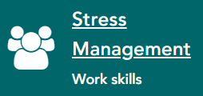
Then click on
The first page of this activity (or any of the activities) is an introduction on how to enter responses to the questions within the activity.
Your responses are recorded on the website. When you are done with each section, at the bottom of the page click . Then select from the pop up window that appears.
The last section of each course will give you an option to . Enter your name and the date. You can print the certificate or take a screen shot of it. To take a screen shot, press the print screen button on the keyboard and then put the cursor in this document where you want the certificate to be. You can then click ‘Ctrl’ and the ‘v’ keyboard buttons at the same time or select paste from a menu from the top of the screen or right clicking on the mouse. You might want to reduce the size of the certificate by clicking on the corner of the image and dragging it in such a way to make the image smaller. Ensure you do not make the image too small that it becomes hard to see.
You can insert the certificate here.

  - What are time management skills? (https://ca.indeed.com/career-advice/career-development/time-management-skills )

Click or tap here to enter text.

  - How can strong time management skills reduce stress? (https://www.zandax.com/blog/how-can-time-management-help-reduce-stress )

Click or tap here to enter text.

Unit 2: Financial Literacy
Financial literacy means having the knowledge, skills, and confidence to make responsible financial decisions throughout one’s life. Learning how to manage finances can help you become independent and provide building blocks to get the most out of life and your career. In this unit, you will learn to distinguish between needs and wants, evaluating personal resources, budgeting, financial planning and earning, spending and saving money.
To fulfill the intended learning outcomes of this unit, you are required to complete the following outcomes.

  - At some point, everyone needs financial guidance. Most people enjoy spending money but are unfamiliar with balancing needs and wants or prioritizing their spending habits. Differentiate between needs and wants.

Click or tap here to enter text.

2.2 Classify the following as wants or needs:

 | Want/Need?
House | Click or tap here to enter text.
Cabin | Click or tap here to enter text.
Jewelry | Click or tap here to enter text.
Clothes | Click or tap here to enter text.
Water | Click or tap here to enter text.
Soda Pop | Click or tap here to enter text.
Chocolate | Click or tap here to enter text.
Medicine | Click or tap here to enter text.
Gas | Click or tap here to enter text.
Television | Click or tap here to enter text.
Child Care | Click or tap here to enter text.

2.3 Using Google or another search engine, find an image that represents Maslow’s hierarchy of needs.

2.4 At what level would the following needs be placed in Maslow’s hierarchy of needs?

Need | Level
Sleep | Physiological
Reputation | Click or tap here to enter text.
Job Security | Click or tap here to enter text.
Best Friend | Click or tap here to enter text.
Food | Click or tap here to enter text.
Siblings | Click or tap here to enter text.
Acceptance | Click or tap here to enter text.
Respect | Click or tap here to enter text.

2.5 John has been saving to purchase a phone for the past 8 months. He found a model that suits both his needs and wants for $740. He could purchase a refurbished one for $600 that comes with a warranty. A third option is a different model but new phone for $675 that does not have all the features that he wanted.

- What are the wants in this scenario?
Click or tap here to enter text.

- What are the needs in this scenario?
Click or tap here to enter text.

- What decision should John make and why?
Click or tap here to enter text.

Activity 2: Spending Plans

In this activity, you will learn what a spending plan is. You will reflect on your money situation, consider income versus expenses, calculate your spending over time and determine your needs and wants.
Go to abcskillshub.ca and login.

View all courses and select the course called . You should have a calculator close by to complete this activity.

Then click on
The first page of this activity (or any of the activities) is an introduction on how to enter responses to the questions within the activity. Your responses are recorded on the website. When you are done with each section, at the bottom of the page click . Then select from the pop up window that appears.

The last section of this course will give you an option to . Enter your name and the date. You can print the certificate or take a screen shot of it. To take a screen shot, press the print screen button on the keyboard and then put the cursor in this document where you want the certificate to be. You can then click ‘Ctrl’ and the ‘v’ buttons at the same time or select paste from a menu from the top of the screen or right clicking on the mouse.
(In section 6: planning your spending - it is not necessary to download and complete the spending plan worksheet unless you want to use it personally). It do not need to be passed in to the Instructor.

You can insert the certificate here.

Focus Question: Write about how the phrase “short-term pain for long-term gain” applies to creating a personal budget and setting financial goals.

Click or tap here to enter text.

2.6 What are the benefits of developing a financial plan? (https://savology.com/6-benefits-of-financial-planning)

Click or tap here to enter text.

2.7 What are the negative consequences of not having a financial plan? (https://bethebudget.com/consequences-of-not-budgeting/)

Click or tap here to enter text.

Focus Question: When developing a financial plan, we often only consider our personal needs and wants. Do you think it is important to consider donations to charities, churches or politicians?

Click or tap here to enter text.
If you want more information on how to create a financial plan, https://www.canada.ca/en/financial-consumer-agency/services/financial-toolkit/financial-planning/financial-planning-2/3.html is a great resource.

Focus Question: What charity would you donate to that aligns with your values?

Click or tap here to enter text.

Activity 3: Banking Basics

In this activity you will learn how to understand your bank account, your rights related to bank accounts and cashing cheques, how to choose the right bank account and how to keep yourself and your money safe in your daily life and online.

Go to abcskillshub.ca and login.

View all courses and select the course called 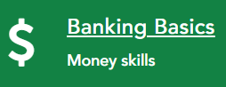

Then click on
The first page of this activity (or any of the activities) is an introduction on how to enter responses to the questions within the activity. Your responses are recorded on the website. When you are done with each section, at the bottom of the page click . Then select from the pop up window that appears.

The last section of this course will give you an option to . Enter your name and the date. You can print the certificate or take a screen shot of it. To take a screen shot, press the print screen button on the keyboard and then put the cursor in this document where you want the certificate to be. You can then click ‘Ctrl’ and the ‘v’ buttons at the same time or select paste from a menu from the top of the screen or right clicking on the mouse.
You can insert the certificate here.

2.8 In the Banking Basics activity, you learned about savings and chequings accounts. It is important to be familiar with these accounts but there are also other important banking terms to know. Explain what each of the following are:

A. Savings account
Click or tap here to enter text.

B. Chequing account
Click or tap here to enter text.

C. Guaranteed investment certificates (GIC)
Click or tap here to enter text.

D. Mutual funds
Click or tap here to enter text.

E. Stocks
Click or tap here to enter text.

F. Registered education savings plan (RESP)
Click or tap here to enter text.

G. Registered retirement savings plan (RRSP)
Click or tap here to enter text.

H. Tax free saving accounts (TFSA)
Click or tap here to enter text.

2.9 Use the following simple saving calculator at https://www.bankrate.com/calculators/savings/simple-savings-calculator.aspx to watch money grow. You can change the numbers on the left-hand side of the screen.
- If you have an initial deposit of $500 and contribute $50 per month over 5 years at 2% interest rate, how much money did you earn in interest? How much do you now have saved?
Click or tap here to enter text.

- If you have an initial deposit of $500 and contribute $50 per month over 5 years at 4% interest rate, how much money did you earn in interest? How much do you now have saved?
Click or tap here to enter text.

Focus Question: What are some strategies you can use to save money?

Click or tap here to enter text.

Focus Question: What are some reasons why it is good to have an emergency savings fund?

Click or tap here to enter text.

2.10 There are two main economic benefits why people work – income and employee benefits.
- What are some different types of income? (https://www.imb.com.au/themoneytree/earning-an-income/types-of-income.html)

Click or tap here to enter text.

- What are some employee benefits?( https://www.aihr.com/blog/types-of-employee-benefits/

Click or tap here to enter text.

2.11 What are some personal benefits of work?

Click or tap here to enter text.

2.12 Employers must provide a pay stub for income that you have earned. Click on this link for information on how to understand your paycheque.
https://www.cpacanada.ca/-/media/site/operational/cc-corporate-citizenship/docs/finlit/just_the_facts_understanding_your_paycheque.pdf?
Answer the following questions.
- What is a pay stub?
Click or tap here to enter text.

- What are the common deductions taken from a paycheque and briefly explain each one.
Click or tap here to enter text.

2.13 Click on this link to answer the following questions. (https://uwaterloo.ca/human-resources/support-employees/payroll/understanding-your-pay-statement)

- What is the Test Worker’s pay period?
Click or tap here to enter text.

- Do you think this worker get paid weekly, biweekly or monthly?
Click or tap here to enter text.

- What is their gross pay for this pay period?
Click or tap here to enter text.

- What is their net pay for this pay period?
Click or tap here to enter text.

- Explain the difference between gross and net pay. Is the net pay always lower than the gross pay?
Click or tap here to enter text.

- What do ‘YTD’ stand for?
Click or tap here to enter text.

- How do this worker receive their money from the pay stub?
Click or tap here to enter text.

2.14 Many services and benefits enjoyed by you are possible through taxes you paid on your paycheque, for example income tax, gas tax, etc. The diagram shows money (revenue) collected by the Government of Newfoundland and Labrador in 2020-2021.

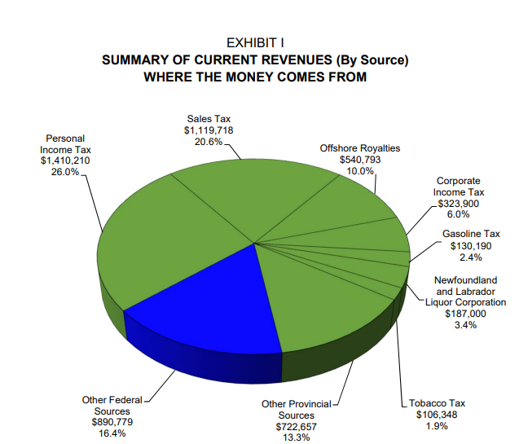

(Diagram taken from the Estimates of the Program Expenditure and Revenue of the Consolidated Revenue Fund 2020-21).

Here is a diagram depicting how the government spends the money.
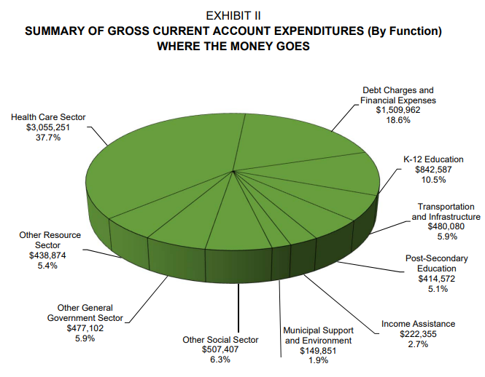
(Diagram taken from the Estimates of the Program Expenditure and Revenue of the Consolidated Revenue Fund 2020-21).

Which of the above sectors did you use in the past week?

Click or tap here to enter text.

2.15 What is income tax? (Include the 2 main kinds of income tax collected.) https://www.taxtips.ca/canadian-federal-personal-income-tax.htm

Click or tap here to enter text.

2.16 How is income tax calculated? https://www.canada.ca/en/financial-consumer-agency/services/financial-toolkit/taxes/taxes-2/2.html
(It is recommended that you complete the entire module to get an overview of income tax.)

Click or tap here to enter text.

2.17 What do you need to file a tax return? (Do not forget to include a list of supporting documents in your answer.) https://students.ubc.ca/enrolment/finances/taxes/filing-taxes-canada

Click or tap here to enter text.

Focus Question: Regarding income tax, why do some people “pay in” while others get “money back”?

Click or tap here to enter text.

2.18 Anyone who uses a smartphone, social media, online education, gaming, etc. is a digital citizen. Being a responsible digital citizen means using technology appropriately and operating online safely and knowledgeably. A good digital citizen will behave respectfully, protect their reputation and privacy, watch their tone and be appropriately skeptical.

Refer to WikiHow (https://www.wikihow.com/Be-a-Responsible-Digital-Citizen).

- Explain how to behave with etiquette while online.

Click or tap here to enter text.

- Explain how to exchange information properly.

Click or tap here to enter text.

- How can you protect yourself online?

Click or tap here to enter text.

2.19 A. What is phishing? (https://www.phishing.org/what-is-phishing)

Click or tap here to enter text.

B. What are some common features of phishing emails?

Click or tap here to enter text.

C. Identify two aspects of the email below that indicate that this is a phishing email.

Image from https://www.consumer.ftc.gov/articles/how-recognize-and-avoid-phishing-scams

Click or tap here to enter text.

As we rely more heavily on technology to complete everyday tasks such as communications and banking, we are more vulnerable to criminals seeking personal information. It is important to be cautious about disclosing personal information. You need to safeguard information such as your birthdate, credit card number, SIN, MCP and address since identify theft is very common and such information makes it easier to happen.

2.20 What is credit? (https://www.debt.org/credit/)

Click or tap here to enter text.

2.21 What is debt? What is a debt agreement? What are some types of debt? (https://corporatefinanceinstitute.com/resources/knowledge/finance/debt/)

Click or tap here to enter text.

2.22 What is debt relief and how does it work? (https://www.forbes.com/advisor/debt-relief/debt-relief-what-it-is/)

Click or tap here to enter text.

2.23 What are some pros of having a credit card? (https://www.creditkarma.com/credit-cards/i/pros-cons-credit-cards)

Click or tap here to enter text.

2.24 What are some cons of having a credit card? (https://www.creditkarma.com/credit-cards/i/pros-cons-credit-cards)

Click or tap here to enter text.

2.25 A. Credit is needed for growth and development of a global economy. What is a credit rating? (https://www.mymoneycoach.ca/credit/check-credit-rating-report-score/what-is-a-credit-rating)

Click or tap here to enter text.

B. What are the two agencies in Canada that create credit reports?

Click or tap here to enter text.

2.26 Refer to the following website to answer the follow (https://www.canada.ca/en/financial-consumer-agency/services/financial-toolkit/insurance/insurance-1/2.html):

- What is insurance?
Click or tap here to enter text.

- What is a premium?
Click or tap here to enter text.

- What is a deductible?
Click or tap here to enter text.

- What is a policy?
Click or tap here to enter text.

- What is an example of an obligatory insurance?
Click or tap here to enter text.

- What is an example of an optional insurance?
Click or tap here to enter text.

Unit 3: Life/Work Exploration and Employability Skills
In this unit, you will have the opportunity to explore the world of work. You will access, examine and use multiple sources of Labour Market Information in the context of exploring a preferred career pathway. You will also explore the skills needed to find, apply for and maintain employment.

To fulfill the intended learning outcomes of this unit, you are required to complete the following outcomes.

3.1 What is Labour Market Information (LMI)? (https://www.gov.nl.ca/labourmarketinformation/what-is-lmi/)
Click or tap here to enter text.
3.2 LMI has information such as demographic information, education, income, labour market indicators and usage of government support programs for regional profiles within our province. Select the region you currently live in and answer the following questions: (https://www.gov.nl.ca/labourmarketinformation/regional-profiles/)
A. Has there been an increase or decrease in the number of individuals who have finished their high school education?
Click or tap here to enter text.
B. What is the employment rate? The unemployment rate?
Click or tap here to enter text.
C. What was the top three industries for employment?
Click or tap here to enter text.
D. What is the average family income?
Click or tap here to enter text.
E. Has the use of employment insurance increased or decreased?
Click or tap here to enter text.
F. Has the use of income support increased or decreased?
Click or tap here to enter text.

3.3 The federal government also has developed LMI for each province. Pick three careers that you are considering (or have considered) and determine if the job prospects in Newfoundland and Labrador are good, fair, limited or undetermined. (https://www.jobbank.gc.ca/outlookreport/location/nl). Then, use the wage report to determine the median wage for each career. (https://www.jobbank.gc.ca/wagereport/location/nl)

Occupation | Job Prospects | Median Wage
Click or tap here to enter text. | Click or tap here to enter text. | Click or tap here to enter text.
Click or tap here to enter text. | Click or tap here to enter text. | Click or tap here to enter text.
Click or tap here to enter text. | Click or tap here to enter text. | Click or tap here to enter text.

3.4 A. What occupation would you like to be doing 5 years from now?
Click or tap here to enter text.
Find the career profile here https://www.gov.nl.ca/labourmarketinformation/career-profiles/ and answer the following questions based on the information found on the career profile page.
B. What is the NOC (National Occupation Classification) code for this career?
Click or tap here to enter text.
C. What are some sample job titles?
Click or tap here to enter text.
D. What do they do?
Click or tap here to enter text.
E. Where do they work?
Click or tap here to enter text.
F. What is the median employment income?
Click or tap here to enter text.
G. What training is required?
Click or tap here to enter text.

3.5 What is NOC? Give a brief explanation. (https://www.gov.nl.ca/labourmarketinformation/career-profiles/)
Click or tap here to enter text.

Focus Question: Do you think it is important to volunteer?
Click or tap here to enter text.

Focus Question: Do you think volunteering could lead to a paid work position?
Click or tap here to enter text.

If you are looking to volunteer, you can check the website for the Community Sector Council. There is a link on the left hand side for Volunteer Opportunities. This is mostly applicable to the Avalon region.

3.6 Many organizations requires that both volunteers and employees have criminal record checks, vulnerable sector checks and codes of conduct completed. In this province, the Royal Newfoundland Constabulary will provide these.
- What is a criminal record screening certificate? (https://www.rnc.gov.nl.ca/services/certificate-of-conduct/)

Click or tap here to enter text.

- What is a vulnerable sector check?
Click or tap here to enter text.

- Why do you think organizations require this?
Click or tap here to enter text.

Assignment #1: Case Study – Be Prepared for Change

Assignments should be prepared separately from this document and submitted to your instructor when completed.
It is important to plan and be prepared for changes in employment status. Changes to employment status can be positive or negative.
- What are some positive changes to employment status?

- What are some negative changes to employment status?

Read the CBC article N.L. Government Will Help Displaced Fish Plant Workers. (https://www.cbc.ca/news/canada/newfoundland-labrador/n-l-government-will-help-displaced-fish-plant-workers-1.1311963)
- Why does the Trinity Bay North Mayor think there is a double standard?

- Who is the Mayor looking to for help?

- At the end of the article, a potential solution was offered to the problem. What was it?

- Can you think of another solution?

- Since this is not the first fish plant to close, what do you think the workers could have done to be better prepared for the fish plant closure? In your response, reflect on the problem and at least two different scenarios of how workers could have prepared.

Job Application Documents
Most jobs require individuals to submit a traditional resume, cover letter and sometimes a formal application. This section will focus on resume writing and writing a cover letter.
3.7 There are many different formats for a resume but the two most common are a chronological resume or a functional resume. Compare and contrast the two types. (https://careerwise.minnstate.edu/jobs/resumecharts.html)
 | Chronological Resume | Functional Resume
Brief overview | Click or tap here to enter text. | Click or tap here to enter text.
Advantage | Click or tap here to enter text. | Click or tap here to enter text.
Disadvantage | Click or tap here to enter text. | Click or tap here to enter text.
Best used | Click or tap here to enter text. | Click or tap here to enter text.
Don’t use if… | Click or tap here to enter text. | Click or tap here to enter text.

Review the examples on the website and decide which format will work best for you to complete the next assignment.

Assignment #2: Create Your Resume

Assignments should be prepared separately from this document and submitted to your instructor when completed.
Remember when creating a resume it is very important that your resume is accurate, neat and clear. First impressions are created with a document such as your resume.
You can look at examples on the Internet and create your own resume or use a free resume builder such as those found in word processing programs such as Microsoft Word. Remember it is good practice to continuously save your work as you go.
Tips:
- Pay attention to the style, appearance and tone of your resume;
- Include proper grammar, spelling and punctuation;
- Ensure your contact information is clear and accurate;
- Use your experience section to highlight your most relevant skills and qualifications to the position you are applying for; and
- Include skills and interests that do not appear anywhere else on your resume.

Assignment #3: Make a Cover Letter

Assignments should be prepared separately from this document and submitted to your instructor when completed.
To write a cover letter, you first need to find a job ad. Go to the Job Opening website for LMI (https://www.gov.nl.ca/labourmarketinformation/jobs-careers/). Find a job of interest to you and print the job ad to submit as part of this assignment.
Once you have found the job you want to apply for, you need to write a cover letter. The purpose of a cover letter is to introduce yourself to an organization, demonstrate an interest in the company or a specific vacancy, draw attention to the resume and give the organization a reason to interview you.
According to www.glassdoor.com, this is a good example of a cover letter format.
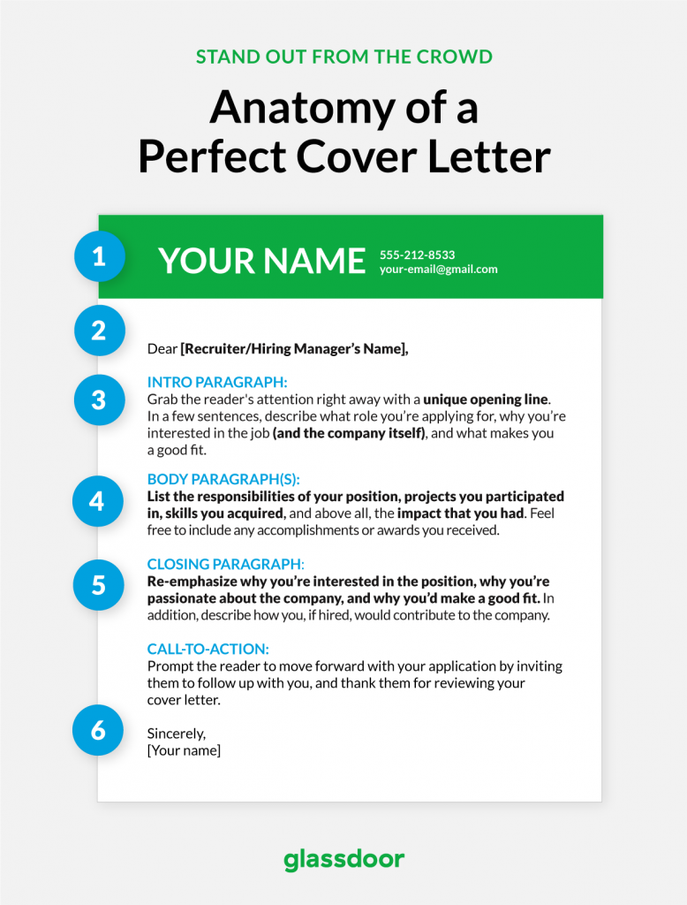
Go to https://www.glassdoor.com/blog/guide/how-to-write-a-cover-letter/ for some important tips on writing cover letters: what to include, what to leave off, and other important tips.
Write a cover letter to apply for the job you found. When you finish your letter, submit it to your instructor for grading.

Tips for writing a good cover letter:
- Write a new cover letter for each job. If you recycle cover letters, that means they are vague and not specific to the job you are applying for.
- Include the person’s name – if you know it. For example, Dear Mr. Smith. Starting with “To Whom it May Concern” is stiff and vague.
- Try to have a great opening line that will catch their attention. Do not start with “My name is Jane Smith”. They will know your name from the closing and your resume.
- Try to elaborate on your resume in the areas that overlap with the job you are currently applying for. This will help to highlight the right experiences from your resume.
- Your cover letter should have a business professional tone. Do not be overly excited.
- Keep it short and sweet.
- Double check for spelling and grammar errors.

3.8 After finding a job to apply for and perfecting your resume and cover letter, you may get a call for the next step in the process – an interview. What should you do to prepare for a job interview? Watch the following video (https://www.youtube.com/watch?v=GmzYrjAsDng) and list out some do’s and don’ts in an interview. You can add items that are not in the video.
Do’s | Don’ts
Click or tap here to enter text. | Click or tap here to enter text.
Click or tap here to enter text. | Click or tap here to enter text.
Click or tap here to enter text. | Click or tap here to enter text.
Click or tap here to enter text. | Click or tap here to enter text.

3.9 A. What are some common questions you should expect to answer at a job interview? (https://www.thebalancecareers.com/top-interview-questions-and-best-answers-2061225)
Click or tap here to enter text.
B. What are some questions that would be inappropriate for an interviewer to ask?
(https://www.businessnewsdaily.com/4037-illegal-interview-questions.html)
Click or tap here to enter text.

Assignment #4: Job Interview

After preparing for an interview by reviewing do’s and don’ts, and speculating on questions you can expect to be asked, you should make some notes on how you would answer the questions. When you are ready, your instructor will give you a mock interview for the job you applied for using your cover letter and resume.

Your instructor will be looking for:
Listening - Did you answer the question that was presented?
Speaking - Did you speak in an articulate manner and integrate professional language?
Integrating - Did you integrate knowledge, content and experiences?
Expressing - Did you express opinions in a tactful and mature manner?
Body Language - Did your body language convey interest and facilitate the responses?
Gestures - Did your gestures seem natural and facilitate the responses?
Eye Contact - Did your eye contact seem natural and facilitate the responses?
Professional Dress - Did you dress in a professional manner?

Tips for a job interview:
- Review your answer to 3.18 (the do’s and don’ts for an interview)
- Prepare for the common interview questions
- Practice your answers to questions before you go
- Anticipate the potential concerns or reservations an interviewer might have and be ready to address it
- Review your selling points (why you are a good candidate for the job) and be confident
- Be aware of your body language

3.10 A. Watch the short video https://youtu.be/ju9aOc2MLyo and use this website (https://www.dictionary.com/browse/digital-citizen ) to explain what digital citizenship is.
Click or tap here to enter text.
B. What is a good digital citizen? (https://beabettercitizen.weebly.com/good-and-bad-digital-citizenship.html )
Click or tap here to enter text.
C. What is a bad digital citizen?
Click or tap here to enter text.
3.11 Many potential employers will search a job candidate’s social media profiles. What are some no-nos when posting to social media? (https://www.careerbuilder.com/advice/social-media-survey-2017)
Click or tap here to enter text.

Unit 4: Preparing for Life/Work Transitions
In this unit, you will have the opportunity to develop plans for the many transitions that will occur throughout your life – from ABE to post-secondary, from school to the world of work, and from one employment opportunity to the next. You will learn about the rights and responsibilities of workers and employers and examine common aspects of many workplaces.

To fulfill the intended learning outcomes of this unit, you are required to complete the following outcomes.

4.1 Once you have obtained your ABE (high school equivalent) diploma, what are the possible paths you can follow next? (https://www.understood.org/articles/en/after-high-school-different-paths-to-success)

Click or tap here to enter text.

4.2 What are credentials? (https://settlement.org/ontario/education/evaluate-my-credentials/credential-evaluation/what-are-credentials/)

Click or tap here to enter text.

Focus Question: Why are credentials important? How do they improve your resume and career outlook?

Click or tap here to enter text.

4.3 Use the following website to answer A – C below. (https://potomac.edu/certificate-vs-diploma-vs-degree/)
A. What is a degree?
Click or tap here to enter text.

B. What is a certificate?
Click or tap here to enter text.

C. What is a diploma?
Click or tap here to enter text.

D. What is a badge? (https://library.educause.edu/topics/teaching-and-learning/badges-and-credentialing)
Click or tap here to enter text.

Focus Question: What post-secondary education are you interested in completing? Is it a university program, college program or something else? (If you do not plan to continue to post-secondary, you can pick one based on interest, curiosity or maybe take the opportunity to learn more about an area that a family member or friend is interested in pursuing.)

Click or tap here to enter text.

Assignment #5 - Research the program you plan to pursue.

Assignments should be prepared separately from this document and submitted to your instructor when completed.

Collect the following information and pass it in to your instructor.

- Describe what the program is and how long it is going to take you to complete it.
- Identify at least 2 schools where you can do this program and indicate which one you prefer and why.
- Go to the school’s website and identify the admission requirements for the program at each of the two schools you picked.
- When is the deadline for applying each year?
- How much is tuition?
- Print off the application to your preferred school and fill it out.

Focus Question: Identify some challenges you foresee after completing ABE. Brainstorm some ideas to help you overcome those challenges.

Challenges | Possible Solutions
Click or tap here to enter text. | Click or tap here to enter text.
Click or tap here to enter text. | Click or tap here to enter text.
Click or tap here to enter text. | Click or tap here to enter text.

4.4 A. What is the Labour Standards Act? (https://www.gov.nl.ca/ecc/labour/nonunion/)

Click or tap here to enter text.

B. Why do you think the Labour Standards Act is important?

Click or tap here to enter text.

4.5 What is WorkplaceNL? (https://workplacenl.ca/workers/)

Click or tap here to enter text.

4.6 What is the Human Rights Act? (https://www.thecanadianencyclopedia.ca/en/article/canadian-human-rights-act)

Click or tap here to enter text.

4.7 What is the Canada Labour Code? (https://www.canada.ca/en/services/jobs/workplace/federally-regulated-industries/canada-labour-code-parts-overview.html)

Click or tap here to enter text.

4.8 A. What is the Occupational Health and Safety Act? (https://www.gov.nl.ca/dgsnl/ohs/legislation-summary/)

Click or tap here to enter text.

B. What are the worker’s duties?

Click or tap here to enter text.

C. What are the employer’s duties?

Click or tap here to enter text.
4.9 Jane works in the kitchen of a restaurant. To clean the pots and pans, she soaks them in a powerful cleaning solution. She uses kitchen gloves to protect her hands and arms.

One evening, Jane was lifting 2 large pans out of the cleaning solution at once. The pans slipped out of her hands and back into the cleaning solution, which splashed on her face and into her left eye. She was unable to see clearly for several weeks but her eyesight did return to normal after a period of time.
- What is the hazard?
Click or tap here to enter text.

- How could Jane have prevented the accident?
Click or tap here to enter text.

4.10 There are many different types of workplaces. What are some tips to make a good impression in any workplace? (https://www.careereducation.columbia.edu/resources/etiquette-workplace)

Click or tap here to enter text.

4.11 Every workplace has workplace etiquette and culture. Compile a list of do’s and don’ts for the workplace. (https://www.northeastern.edu/graduate/blog/workplace-etiquette/)

Do’s | Don’ts
Click or tap here to enter text. | Click or tap here to enter text.
Click or tap here to enter text. | Click or tap here to enter text.
Click or tap here to enter text. | Click or tap here to enter text.
Click or tap here to enter text. | Click or tap here to enter text.
Click or tap here to enter text. | Click or tap here to enter text.
Click or tap here to enter text. | Click or tap here to enter text.
Click or tap here to enter text. | Click or tap here to enter text.

Focus Question: Work and the workplace can change over time; for example, jobs are created or eliminated. How do you feel about technology’s role in the workplace; does it enhance or inhibit progress?

Click or tap here to enter text.

Appendix A

Career Development IE3313
Students wishing to complete IE 3313 to transfer back to high school to receive credit for Career Development 2202 must complete a community contribution component – outside of classroom time. To receive credit for this course, students are required to complete a minimum of 30 hours in volunteerism, community service projects, mentorship, job shadowing and other valuable forms of experiential learning.
Students should check with their instructors before starting the community contribution to ensure the activity will be appropriate to satisfy this requirement.
When completed, student will need to print and fill out the Community Contribution Activity Record (CCAR) located on the next page.
** If you double click the chart, an Acrobat Document will open in Adobe Acrobat Reader (if the software is on your computer). This may provide a better copy to print.

More information about the community contribution component are in the links below:
The rational for the community contribution component as well as a list of eligible activities are at this link. https://www.gov.nl.ca/education/files/k12_curriculum_documents_careered_cd2201_ccguidelines.pdf

A student brochure containing questions and answers regarding the community contribution component is at this link. https://www.gov.nl.ca/education/files/k12_curriculum_documents_careered_cd2201_student.pdf

A volunteer brochure that may be printed or emailed to the organization you hope to do the community contribution with is at this link. https://www.gov.nl.ca/education/files/k12_curriculum_documents_careered_cd2201_volunteer.pdf

