

Department of Forestry, Agriculture and Lands

Request for Proposals

Commercial Timber Allocation
Forest Management District 18
(Rubes Steady)

Project Number: FFA-D18-01-2026
Issued: August 14,2026
Closing: August 27, 2026

Table of Contents
Summary of Key Information 3
1.0 Introduction 4
1.1 Overview of the Request for Proposals 4
1.2 Eligibility to Participate in This RFP 5
1.3 Forest Management Responsibilities of Proponent 5
2.0 RFP Submission Process 5
2.1 RFP Timelines 5
3.0 Submission Instructions 5
3.1 Submission Time and Submission Location 5
3.2 Submission of Proposal 5
3.3 No Fax or Mail Submission 6
3.4 Language of Proposals 6
3.5 Receipt of Complete RFP 6
3.6 Enquiries 6
3.7 Electronic Communication 7
3.8 Addenda 7
3.9 Amendments to Proposals 8
3.10 Material Change After Submission Time 8
4.0 Evaluation 8
4.1 Evaluation Process 8
4.2 Mandatory Evaluation Criteria 9
4.3 Point Rated Evaluation Criteria 9
4.3.1 Development and Employment 10
4.3.2 Timber Harvesting and Transportation 10
4.3.3 Financial Resources 10
4.3.4 Project Management Team 10
4.3.5 Schedule for Project Development and Execution 10
4.4 Evaluation Committee 11
5.0 Selection and Award 11
6.0 Conflict of Interest and Relationship Disclosure 11
6.1 Reservation of Rights to Disqualify 11
6.2 Relationship and Conflict Disclosure 11
6.3 The Province May Make Advance Decisions 12
6.4 Decisions Final and Binding 12
7.0 RFP Terms and Conditions 12
7.1 No Obligation to Proceed 12
7.2 No Contract 12
7.3 Cost of Preparing the Proposal 13
7.4 Access to Information and Protection of Privacy Act, 2015 13
7.5 Confidentiality of Information 13
7.6 Evaluation 14
7.7 General Reservation of Rights 16
7.8 No Collusion 16
7.9 No Lobbying 17
7.10 Ownership of Proposals 17
7.11 Disclosure and Transparency 17
7.12 Limitation of Damages 18
7.13 Interpretation 19
Schedule A – Evaluation Matrix 20
Schedule B – Maps of Proposed Harvest Areas 21
Schedule C – Proponent Forest Management Responsibilities 22

Summary of Key Information

RFP TITLE | Commercial Timber Development Opportunity, Forest Management District 18 (Proponents should use this title on all correspondence).
CONTACT PERSON | Contact for the RFP is: Tim Anderson  Email: tanderson@gov.nl.ca
ENQUIRIES | Please direct all enquiries, by email, to the Contact Person. Enquiries received by any other means may not be answered.  Proponents are encouraged to submit enquiries at an early date to permit consideration by the Province.  The Province may, in its sole and absolute discretion, decide to not respond to any enquiry.
SUBMISSION TIME | Closing Time 4:30pm August 27, 2026 note 10 days after posting.
SUBMISSION LOCATION | Proposals shall be submitted electronically by email directly to the Contact Person.

1.0 Introduction

1.1 Overview of the Request for Proposals
The purpose of this Request for Proposals (RFP) is to provide local individuals, forestry enterprises, and community groups an opportunity to access Crown commercial timber. This request for proposals is for a 2-year softwood timber allocation.

Forest Management District (FMD) 18 is on the Northern Peninsula of the island of Newfoundland. Management of the forest resource is by the Provincial Department of Forestry, Agriculture and Lands (the Department). A short-term commercial wood supply is available in this FMD, and an opportunity exists for the utilization of this resource to support the forest industry. The proposed softwood allocation does not include core hardwood, and only incidental hardwoods will be allocated through this RFP.

This request for proposals is for a total softwood timber allocation of 40,000 m³ (40% estimated sawlogs) and 3,600 m³ of incidental hardwoods to be harvested within a 2 year period and provided through annual cutting permits. To achieve the objectives of the Government of Newfoundland and Labrador for the development of the forest resource of FMD 18 Newfoundland, the Department and the successful proponent will enter a Memorandum of Understanding (MOU) on a way forward to achieve these objectives. If the successful proponent cannot meet criteria outlined in their proposal and subsequent MOU, it may result in the cancellation of the timber allocation.

The allocation period for this RFP starts on the day of signing of the MOU and ends December 31, 2027. There will be no extensions to this allocation period.

To award a successful proponent through this RFP process, the Department will use five criteria to determine the overall value of each RFP in achieving the Department’s goals (Schedule A). Proposals will be ranked on their relative fitness to five criteria:

- Development and Employment
  - Local Benefits
- Timber Harvesting and Transportation Experience
- Financial Resources
- Proponents Project Management Team
- Schedule for Project Development and Execution

All acceptable proposals will be subject to the Government of Newfoundland and Labrador review process that may include assessment by an independent third party.

This softwood timber allocation of 40,000m³ may be subject to change resulting from natural disturbances and required environmental assessment approvals within the current Five-Year Operating Plan for FMD 18. The proposed timber is located approximately 40km east of the community of Plum Point on route 432. Maps of the operating areas can be found in Schedule B. The Department makes no representation, warranty or guarantee to the proponent in respect of the quality or quantity of timber in the proposed harvest areas. Proponents who require further information should correspond with the Contact Person for this RFP.

1.2 Eligibility to Participate in This RFP
This RFP is open to any person, firm, joint venture, partnership, or other legal entity. Proponents must be in good standing with the Department of Forestry, Agriculture and Lands, the Government of Newfoundland and Labrador and must provide proof of good standing with Workplace NL.

1.3 Forest Management Responsibilities of Proponent
Proponents are responsible for management items listed under Schedule C.

2.0 RFP Submission Process

2.1 RFP Timelines
The following represents the anticipated timeline of this RFP:
- Request for Proposals Issue Date:
- Submission Deadline Date:
- Rectification Period: 5 business days from Rectification Notice
- Review of Proposal submissions completed:
- Notification of Selected Respondent:
- Memorandum of Understanding signed:

3.0 Submission Instructions

3.1 Submission Time and Submission Location
Proposals must be submitted electronically to the contact person no later than the submission time.

3.2 Submission of Proposal
To assist with the evaluation process, proposals shall be submitted in accordance with the following basic sections.
- Table of Contents
- Executive Summary
- Development and Employment
- Local Benefits
- Markets for timber produced
- Timber Harvesting and Transportation Experience
- Financial Resources
- Proponents Project Management Team
- Schedule for Project Development and Execution

Proponents are free to add sub-sections within this basic outline to suit the particulars of their proposal. The proposal content, not including any appendices, the table of contents and the executive summary are not to exceed twenty-five (25) pages.

3.3 No Fax or Mail Submission
Proposals submitted by fax, mail or paper will not be accepted.

3.4 Language of Proposals
Proposals shall be submitted in English or French. Any portion of a proposal not in one of the official languages may not be evaluated.

3.5 Receipt of Complete RFP
Proponents are responsible to ensure that they have received the complete RFP, as listed in the table of contents of this RFP, plus any addenda. A submitted proposal will be deemed to have been prepared based on the entire RFP issued prior to the submission time. The province accepts no responsibility for any Proponent lacking any portion of this RFP.

3.6 Enquiries
- All enquiries regarding any aspect of this RFP should be directed to the Contact Person by email.
- Proponents are encouraged to submit enquiries in writing at an early date to permit consideration by the province.
- The province may, in its sole and absolute discretion, decide to not respond to any enquiry. Where responses are issued, the response will be sent within three (3) business days.
- Responses to enquiries will be by email. All enquiries, and all responses to enquiries from the Contact Person, will be recorded by the province.
- If a Proponent considers that an enquiry is commercially confidential, this Proponent may request that a response to such enquiry be kept confidential by clearly marking the enquiry “Commercial in Confidence”. If the Province decides that this enquiry or the province’s response to such enquiry must be distributed to all Proponents, then the province will permit the enquirer to withdraw such enquiry rather than receive a response and if the Proponent does not withdraw the enquiry, then the province may provide its response to all Proponents.
- Notwithstanding the above:
  - if one or more other Proponents submit an enquiry on the same or similar topic to an enquiry previously submitted by another Proponent as “Commercial in Confidence”, the province may provide a response to such enquiry to all Proponents; and
  - if the province determines there is any matter which should be brought to the attention of all Proponents, whether such matter was the subject of an enquiry, including an enquiry marked “Commercial in Confidence”, the province may, in its sole and absolute discretion, distribute the enquiry, response or information with respect to such matter to all Proponents. The province reserves the right of the Contact Person to contact a Proponent (including by telephone) to clarify written communication. Proponents may only rely on written communication from the Contact Person. Information offered from sources other than the Contact Person regarding this RFP is not official, may be inaccurate, and should not be relied on in any way, for any purpose.

3.7 Electronic Communication
- The following provisions will apply to any email communications with the Contact Person, or the delivery of documents to the Contact Person by email where such email communications or deliveries are permitted by the terms of this RFP.
- The province does not assume any risk or responsibility or liability whatsoever to any Proponent:
  - for ensuring that any electronic email system being operated for the province is in good working order, able to receive transmissions, or not engaged in receiving other transmissions such that a Proponent’s transmission cannot be received; or
  - if a permitted email communication or delivery is not received by the province, or received in less than its entirety, within any time limit specified by this RFP.
- All permitted email communications with, or delivery of documents by email to, the Contact Person will be deemed as having been received by the Contact Person on the dates and times indicated on the Contact Person’s electronic equipment.

3.8 Addenda
The province may, in its sole and absolute discretion, amend this RFP at any time by issuing a written addendum. Written addenda are the only means of amending or clarifying this RFP, and no other form of communication whether written or oral, including written responses to enquiries as provided by Section 3.6, will be included in, or in any way amend, this RFP.

3.9 Amendments to Proposals
- A Proponent may amend any aspect of its proposal by delivering written amendments to the Contact Person prior to the Submission Time.
- Amendments shall be signed by a signing officer who signed the RFP or an authorized representative of the Proponent.
- A Proponent may not amend any aspect of its proposal except as set out above.

3.10 Material Change After Submission Time
- A Proponent will give immediate notice to the province of any material change that occurs to a Proponent after the Submission Time, including a change to its membership, ownership structure, Proponent team or a change to the Proponent’s financial capability.
- The province may, in its sole discretion, accept or reject this material change. In the case of a rejection of the material change, the Proponent will be notified in writing that the change has been deemed unacceptable and that their proposal has been disqualified. If a material change is accepted, the province will then evaluate the submitted proposal taking into consideration the new information.

  - Rectification of Proposal
- A Proposal that does not contain the required basic sections as described in Section 3.2 and prepared in accordance with the instructions provided in this RFP will be deemed non-compliant and cannot be evaluated. Such non-compliant Proposals will be subject to a rectification process whereby the province will issue the Respondent a Rectification Notice identifying the deficiencies in its Proposal and outlining the mechanism by which it may be rectified.
- The Rectification Period referenced in Section 2.1 will begin to run from the date and time that the province issues a Rectification Notice. A Respondent that has been issued a Rectification Notice and subsequently fails to submit a revised Proposal with all deficiencies rectified within the Rectification Period will be excluded from further consideration for this RFP.

4.0 Evaluation

4.1 Evaluation Process
- Proposals will be evaluated in accordance with the entire requirement of the RFP criteria. There are several steps in the evaluation process, which are described below:
  - Mandatory Criteria Evaluation: Each proposal will be reviewed to determine whether it meets the mandatory requirements described in this RFP. Proposals that do not comply with each mandatory requirement will be considered non-responsive and be disqualified. The Mandatory evaluation criteria are described in Section 4.2.
  - Point-Rated Criteria Evaluation: Each proposal shall be rated by assigning a score to the rated evaluation criteria, which are identified in Section 4.3.
- Each proposal shall be assessed pursuant to evaluation criteria detailed in this section and ranked based on the total weighted score set out in the Evaluation Matrix outlined in Schedule A. A proposal will not be evaluated if it has been rejected in accordance with this RFP.
- In their proposals, Proponents should clearly demonstrate their understanding of the requirements present in this RFP and explain how they will meet these requirements. Proponents should demonstrate their experience, capability and describe their approach in a thorough, concise, and clear manner.
- The proposal should address clearly and in sufficient depth the points that are subject to the evaluation criteria against which the proposal will be evaluated.
- To facilitate the evaluation of the proposals, Proponents are asked to structure their proposals in the order of the evaluation criteria using the same headings. Proponents may refer to different sections of their proposals by identifying the specific paragraph and page number if the subject topic has previously been addressed.
- An evaluation team composed of representatives of the province will evaluate the proposals. The province may hire any independent consultant, or use any Government resources, to evaluate any proposal.
- The basis of selection for this RFP is the highest score.

4.2 Mandatory Evaluation Criteria
The following mandatory requirements must be met for a proposal to be declared responsive:
- The proposal must be received before the Submission Time.
- Acknowledgement of all addenda.
- Acknowledgement that the proposed RFP requirements are acceptable.

4.3 Point Rated Evaluation Criteria
Proposals will be evaluated and scored in accordance with specific evaluation criteria as detailed below and according to the Evaluation Matrix contained in Schedule A. A Proponent must obtain a minimum mark of 70% to be considered responsive with those scoring less than 70% being unresponsive with the proposal deemed incomplete.

A score of less than 50% in an individual evaluation criterion will result in the proposal being considered unresponsive.

4.3.1 Development and Employment
- Proposals should be committed to the utilization of local businesses, local training, and employment. In cases where expertise is not available, provisions should be made to train residents with the required skills and develop local business capacity. It is understood that in some cases skills and services may have to come from outside the local area on an interim basis.
- The proposal should describe how diversity and equality regarding employment opportunities will be achieved.
- Proposal should describe how any concerns about the scope, scale and execution of the proposal will be addressed; and
- Any partnerships or other developments shall be presented in this section.
- The proposal should describe the proposed markets for timber produced.

4.3.2 Timber Harvesting and Transportation
- The proponent should outline their timber harvesting and transportation of forest products experience,
- Experience with Environmental Management Systems; specifically, the ISO 14001-2015 standard, or any other environmental standards as applicable, and
- Outline if additional equipment and sub-contractors will be required.

4.3.3 Financial Resources
The proponent must be in good standing with the Department of Forestry, Agriculture and Lands. The proponent must be able to provide evidence of adequate funding and resources to finance and complete the development contained in the proposal. This shall include:
- Support letters from product purchasers,
- In good standing with Registry of Companies and Deeds
- Credit check for individual proponent (sole proprietorship),

4.3.4 Project Management Team
- Provide information on the project team, including a brief history of the firm(s), number of years in business and relevant past projects, and
- Describe the proponent’s accomplishments, achievements, experience on “comparable” projects, and provide project specifics such as name and location.

4.3.5 Schedule for Project Development and Execution
Provide a timeline for project startup and execution over the allocation period.

4.4 Evaluation Committee
A Government Evaluation Committee will review and evaluate the proposals submitted in response to this RFP. Based on the results of the evaluation, the Committee will rank proposals in accordance with the criteria outlined in section 1.1 of this RFP and make a recommendation to the Department to enter detailed negotiations with the highest ranked proponent.

5.0 Selection and Award
- Once the Successful Proponent has been selected, the Proponent’s representative will be notified in writing of their selection.
- The province will invite the top-ranked Proponent to enter final discussions to settle all terms and conditions of the proposed Softwood Timber Allocation, based on the top-ranked Proponent’s proposal, including any clarifications that the top-ranked Proponent may have provided during the evaluation of proposals.
- If for any reason the province determines that it is unlikely to reach final agreement with the top ranked Proponent, then the province may terminate the discussions with that Proponent and proceed in any manner that the province may decide, in consideration of its own best interests.
- Any final approvals required by the province will be conditions precedent to the awarding of the Commercial Softwood Timber Allocation.

6.0 Conflict of Interest and Relationship Disclosure

6.1 Reservation of Rights to Disqualify
The Province reserves the right to disqualify any Proponent that in the Province’s opinion has a conflict of interest or an unfair advantage (including access to any confidential information not available to all Proponents), whether real, perceived, existing now or likely to arise in the future, or may permit the Proponent to continue and impose such conditions as the Province may consider to be in the public interest or otherwise required by the Province.

6.2 Relationship and Conflict Disclosure
Each Proponent, including each member of the Proponent team, shall fully disclose all relationships it may have with the Province, or any other person providing advice or Works to the Province with respect to the Work or any other matter that gives rise, or might give rise, to a conflict of interest or an unfair advantage at any time during the RFP Process by written notice addressed to the Contact Person promptly after becoming aware of any such relationship.

At the time of such disclosure, the Proponent will include sufficient information and documentation to demonstrate that appropriate measures have been, or will be, implemented to mitigate, minimize, or eliminate the actual, perceived, or potential conflict of interest or unfair advantage, as applicable. The Proponent will provide such additional information and documentation and implement such additional measures as the province may require in its sole and absolute discretion in connection with the consideration of the disclosed relationship and proposed measures.

6.3 The Province May Make Advance Decisions
The province may make advance decisions, where the province identifies a potential conflict or an unfair advantage. The onus is on the Proponent to clear any potential conflict or unfair advantage, or to establish any conditions for continued participation.

6.4 Decisions Final and Binding
- The decision of the province is final and binding on the persons requesting the ruling and all other parties including Proponents and Proponent team members. The province has discretion to establish the relevant processes from time to time, including any circumstances in which a decision may be amended or supplemented.
- The province may provide any decision by the province regarding conflicts of interest to all Proponents if the province, in its sole and absolute discretion, determines that the decision is of general application.

7.0 RFP Terms and Conditions

7.1 No Obligation to Proceed
This RFP does not commit the province to select a Successful Proponent, to enter into an MOU or issue a cutting permit. The province reserves the complete right to at any time reject any or all proposals, and to terminate this RFP and the RFP process and proceed with the project in some other manner. If the Successful Proponent does not sign the MOU by the date indicated in Section 2.1 of this RFP, the province reserves the right to terminate this RFP and proceed with the project in another manner.

7.2 No Contract
This RFP is not a contract between the Province and any Proponent, nor is this RFP an offer or an agreement to purchase work, goods, or works. No contract of any kind for work, goods or works or commitment of crown timber whatsoever is formed under, or arises from this RFP, or as a result of, or in connection with, the submission of a Proposal.

7.3 Cost of Preparing the Proposal
Each Proponent is solely responsible for all costs it incurs in the preparation of its proposal, including all costs of providing information requested by the province, attending meetings, and conducting due diligence.

7.4 Access to Information and Protection of Privacy Act, 2015
- The province is subject to the Newfoundland and Labrador Access to Information and Protection of Privacy Act, 2015 (“ATIPPA”), which gives people a right of access to records in the custody or control of the province, with certain exceptions.
- Once a Proposal is submitted to the province, it is subject to ATIPPA.
- The ATIPPA can be accessed as follows: http://www.atipp.gov.nl.ca/.
- By submitting a proposal, the Proponent represents and warrants to the Province that the Proponent has complied with applicable laws, including by obtaining from each person any required consents and authorizations to the collection of information relating to such individual and to the submission of such information to the Province and the use, distribution and disclosure of such information as part of the Proposal for the purposes of, or in connection with, this RFP.

7.5 Confidentiality of Information
- All information pertaining to the RFP received by any Proponent or Proponent team member through participation in this RFP is confidential and may not be disclosed without written authorization from the Contact Person, and in no event will a Proponent discuss the information with any member of the public or the media without the prior written approval of the province.
- Except as expressly stated in this RFP, and subject to ATTIPA or other applicable legislation, all documents and other records submitted in response to this RFP will be considered confidential.
- The Department nor any of its representatives will not, and a Proponent may not, require the Department nor any of its representatives to sign a confidentiality agreement in respect of any step taken or information provided as part of this RFP process.
- The Proponent, by submitting a proposal, agrees that the Department may disclose to other Proponents and the public:
  - name and address of the Proponent.
  - name and address of the successful Proponent.
- In this regard, by responding to this RFP each proponent agrees that each proposal submitted is the property of the Department.
- The Department may provide a Proponent’s proposal to any person involved in the review and evaluation of Proponent’s proposals on behalf of the Department and may for such a purpose:
  - Make, and distribute copies of the Proposal; and
  - Retain the Proposal.
- The Department, as required by law, may disclose any information with respect to the Proponents, the Proposals, and the RFP Process to any person.
- Each prospective Proponent receiving any of the following, and each Proponent by submitting a Proposal acknowledges and agrees that all material, data, information (whether oral or written), or any item in any form, whether it is in electronic or hard copy format, supplied by or obtained from the Department other than this RFP document or an addenda to this RFP document during the RFP process:
  - shall remain the sole property of the Department and that any prospective Proponent and/or Proponent receiving the same shall treat the same as confidential.
  - shall not use the same for any other purpose other than submitting a Proposal(s) in response to this RFP.
  - shall not disclose the same to any person who is not involved in the Proponent’s preparation of its Proposal(s) without prior written authorization from the Department; and
  - shall on request by the Department, return the same to the Department no later than ten (10) calendar days after such a request by the Department to return the RFP Information.

7.6 Evaluation
- The Province may, in its sole and absolute discretion, take any one or more of the following steps, at any time and from time to time, in connection with the review and evaluation, including ranking, of any aspect of a proposal, including if the Province considers that any proposal, or any part of a proposal, requires clarification or more complete information, contains defects, ambiguities, alterations, qualifications, omissions, inaccuracies or misstatements, or does not for any reason whatsoever satisfy the Province that the proposal meets any requirements of this RFP at any time, or for any other reason the Province in its sole and absolute discretion deems appropriate and in the interests of the Province and this RFP, or either of them:
  - Waive any such defect, ambiguity, alteration, qualification, omission, inaccuracy, misstatement, or failure to satisfy, and any resulting ineligibility on the part of the Proponent, or any member of the Proponent team.
  - Independently consider, investigate, research, analyze, request, or verify any information or documentation whether contained in any proposal.
  - Request interviews or presentations with any, all or none of the Proponents to clarify any questions or considerations based on the information included in proposals during the evaluation process, with such interviews or presentations conducted in the sole and absolute discretion of the province, including the time, location, length and agenda for such interviews or presentations.
  - Conduct reference checks relevant to the RFP with any or all of the references cited in a proposal and any other persons (including persons other than those listed by Proponents in any part of their proposals) to verify any and all information regarding a Proponent, inclusive of its directors/officers and key individuals, and to conduct any background investigations that it considers necessary in the course of the RFP Process, and rely on and consider any relevant information from such cited references in the evaluation of proposals.
  - Not proceed to review and evaluate or discontinue the evaluation of any proposals and disqualify the Proponent from this RFP.
  - Seek clarification or invite more complete, supplementary, replacement or additional information or documentation from any Proponent or in connection with any proposal or any part of their component packages.

- Without limiting the foregoing, the Province may, in its sole and absolute discretion (and without further consultation with the Proponent), reject any proposal which in the opinion of the Province: (i) is materially incomplete or irregular, (ii) contains omissions, exceptions or variations (including any modifications), (iii) contains any false or misleading statement, claims or information, or (iv) contains any false statements, criminal affiliations or activities by a Proponent or Proponent team member.
- To enable the province to take any one or more of the above-listed steps, the province may enter separate and confidential communications of any kind whatsoever, with any person, including any Proponent. The province has no obligation whatsoever to take the same steps, or to enter the same or any communications in respect of all Proponents and proposals, or in respect of any Proponent, including the Proponent whose proposal is the subject of the review or evaluation.
- The review and evaluation, including the ranking, of any proposal may rely on, consider, and include any information and documentation, including any clarification, more complete, supplementary, and additional or replacement information or documentation, including information and documentation obtained through any of the above-listed investigations, research, analyses, checks, and verifications.
- Proponents may not submit any clarifications, information, or documentation after the Submission Time without the prior written approval of the province or without an invitation or request by the province to do so.
- If any information, including information as to experience or capacity, contained in a proposal is not verified to the province’s satisfaction, the province may, in its discretion, not consider such cited experience, capacity or other information.
- The province is not bound by industry custom or practice in taking any of the steps listed above, in exercising any of its discretions, in formulating its opinions and considerations, exercising its discretions in making any decisions and determinations, or in discharging its functions under or in connection with this RFP, or in connection with any Proponent, proposal, or any part of any proposal.

7.7 General Reservation of Rights
The province reserves the right, in its sole and absolute discretion, to:
- Amend the scope of the RFP and/or modify, cancel, or suspend the RFP at any time for any reason.
- Accept or reject any proposal based on the province’s evaluation of the proposals in accordance with the Evaluation guidelines in Section 4 and the Evaluation Matrix in Schedule A and in particular the province is not obliged to select any proposal.
- Reject a proposal that fails to meet the Mandatory Requirements.
- Waive a defect, irregularity, non-conformity, or non-compliance in or with respect to a proposal or failure to comply with the requirements of this RFP except for Mandatory Requirements, and accept that proposal even if such a defect, irregularity, non-conformity or non-compliance or failure to comply with the requirements of this RFP would otherwise render the proposal null and void.
- Reject, disqualify, or not accept any or all proposals without any obligation, compensation, or reimbursement to any Proponent or any of its team members.
- Re-advertise for new proposals to this or a modified RFP, call for quotes, proposals, or tenders, or enter negotiations for this Work or for work of a similar nature.
- Make any changes to the terms of the business opportunity described in this RFP.
- Amend, from time to time, any date, time, or deadline provided in this RFP, upon written notice to all Proponents.

7.8 No Collusion
- Proponents and Proponent team members, their employees and representatives involved with their proposal will not discuss or communicate, directly or indirectly, with any other Proponent or any director, officer, employee, consultant, advisor, agent, or representative of any other Proponent (including any Proponent team member of such other Proponent) regarding the preparation, content or representation of their proposals. For sub-consultants that are partnering or considering partnering with more than one Proponent, such sub-consultants shall keep all pricing, strategy or other commercially confidential information discussed with one Proponent confidential in their discussion with another Proponent.
- By submitting a proposal, a Proponent, on its own behalf and as an authorized agent of each firm, corporation or individual member of the Proponent and Proponent team, represents and confirms to the province, with the knowledge and intention that the province may rely on such representation and confirmation, that its proposal has been prepared without collusion or fraud, and in fair competition with proposals from other Proponents.
- In the event of any collusion in contravention of this Section, the Province in its sole and absolute discretion may at any time, but will not be required to, reject all proposals submitted by that Proponent without further consideration or compensation.

7.9 No Lobbying
- Proponents, Proponent team members, and their respective directors, officers, employees, consultants, agents, advisors, and representatives will not engage in any form of political or other lobbying whatsoever in relation to this RFP, including for the purpose of influencing the outcome of the RFP process. Further, no such person (other than as expressly contemplated by this RFP) will attempt to communicate in relation to this RFP, directly or indirectly, with any representative of the Government of Newfoundland and Labrador (GNL) (including any Minister or Deputy Minister, or any Members of the House Assembly, or any employee of the GNL), or any director, officer, employee, agent, advisor, consultant or representative of any of the foregoing, as applicable, for any purpose whatsoever.
- In the event of any lobbying or communication in contravention of this Section, the Province in its sole and absolute discretion may at any time reject all proposals submitted by that Proponent without further consideration or compensation.

7.10 Ownership of Proposals
All proposals submitted to the province become the property of the province and will be received and held in confidence by the province, subject to the provisions of ATIPPA and this RFP.

7.11 Disclosure and Transparency
- The province is committed to an open and transparent procurement process. To assist the province in meeting its commitment, Proponents will cooperate and extend all reasonable accommodation to this endeavor.
- The province may publicly disclose the following information during the RFP process:
  - The RFP.
  - The number of Proponents; and
  - The name of Proponents along with details of the Proponent team members.
- Following awarding the softwood timber allocation, the province may publicly disclose:
  - A report including an overview of the RFP process and a summary of the final evaluation and assessment.
- Each Proponent agrees that:
  - To ensure that all public information generated about the RFP is fair and accurate and will not inadvertently or otherwise influence the RFP process, the disclosure of any public information generated in relation to the RFP, including communications with the media and the public, must be coordinated with, and is subject to prior written approval of, the province.
  - It will notify the province of all requests for information or interviews received from the media; and
- It will ensure that all the Proponent team members and others associated with the Proponent comply with the requirements of this RFP. In the event of any contravention of this Section 7.11, the province in its sole and absolute discretion may at any time, but will not be required to, reject any proposal submitted by that Proponent without further consideration or compensation.

7.12 Limitation of Damages
Each Proponent on its own behalf and on behalf of the Proponent team and any member of a Proponent team:
- Agrees not to bring any claim against the province or any of its respective employees, advisors, or representatives for damages in excess of the amount equivalent to the reasonable costs incurred by the Proponent in preparing its proposal for any matter in respect of this RFP, including:
  - if the province accepts a non-compliant proposal or otherwise breaches, or fundamentally breaches, the terms of this RFP; or
  - if the RFP process is modified, suspended, or cancelled for any reason (including modification of the scope of the RFP or modification of this RFP or both) or the province exercises any rights under this RFP; and
- Waives all claims against the province, or any of their respective employees, advisors, or representatives for loss of anticipated profits or loss of opportunity if no agreement is made between the Province and the Proponent for any reason, including:
  - if the province accepts a non-compliant proposal or otherwise breaches or fundamentally breaches the terms of this RFP or the RFP Process; or
  - if the RFP Process is modified, suspended, or cancelled for any reason (including modification of the scope of the RFP or modification of this RFP or both) the province exercises any rights under this RFP.

7.13 Interpretation
In this RFP:
- Any action, decision, determination, consent, approval, or any other thing to be performed, made, or exercised by or on behalf of the province, including the exercise of “discretion” or words of like effect, unless the context requires it, is at the sole, absolute and unfettered discretion of the province.
- The use of headings is for convenience only and headings are not to be used in the interpretation of this RFP.
- A reference to a Section or Schedule, unless otherwise indicated, is a reference to a Section of, or Schedule to, this RFP.
- Words imputing any gender include all genders, as the context requires, and words in the singular include the plural and vice versa.
- The word “including” when used in this RFP is illustrative only and is not to be read as limiting or exhaustive.
- A reference to a “person” includes a reference to an individual, legal personal representative, corporation, body corporate, firm, partnership, trust, trustee, syndicate, joint venture, limited liability company, association, unincorporated organization, union, or government Province; and
- Each Schedule attached to this RFP is an integral part of this RFP as if set out at length in the body of this RFP.

Schedule A – Evaluation Matrix

The following describes the weighting of the various evaluation components.

Evaluation Matrix – Rated Criteria marked on a scale 0-10, then calculated to the percentage of overall score |  | Score | Weight
1 | Development and Employment: | 10 | 3.0
2 | Timber Harvesting and Transportation Experience: | 10 | 3.0
3 | Financial Resources: | 10 | 1.0
4 | Project Management Team: | 10 | 1.5
5 | Schedule for Project Development and Execution: | 10 | 1.5
 | Total Score

Criteria Scoring Guide
0 | Deficient – the Response fails to meet the requirements of the applicable RFP references and associated scoring criteria in a suitable and documented manner.
1-3 | Poor – The Response fails to meet the requirement of the RFP references and associated scoring criteria in a suitable and documented manner. The response has some merit, but there are significant weaknesses.
4-6 | Fair – the Response barely meets the requirements of the applicable RFP references and associated scoring criteria in a suitable and documented manner. The response has substance but there are weaknesses.
7-8 | Good - the Response reasonably demonstrates that the requirements of the applicable RFP references and associated scoring criteria are met in a documented and suitable manner. The response is comprehensive but there are minor weaknesses.
9-10 | Excellent - the Response fully demonstrates that the requirements of the applicable RFP references and associated scoring criteria are met in a documented and suitable manner. There are no apparent weaknesses.

Schedule B – Maps of Proposed Harvest Areas

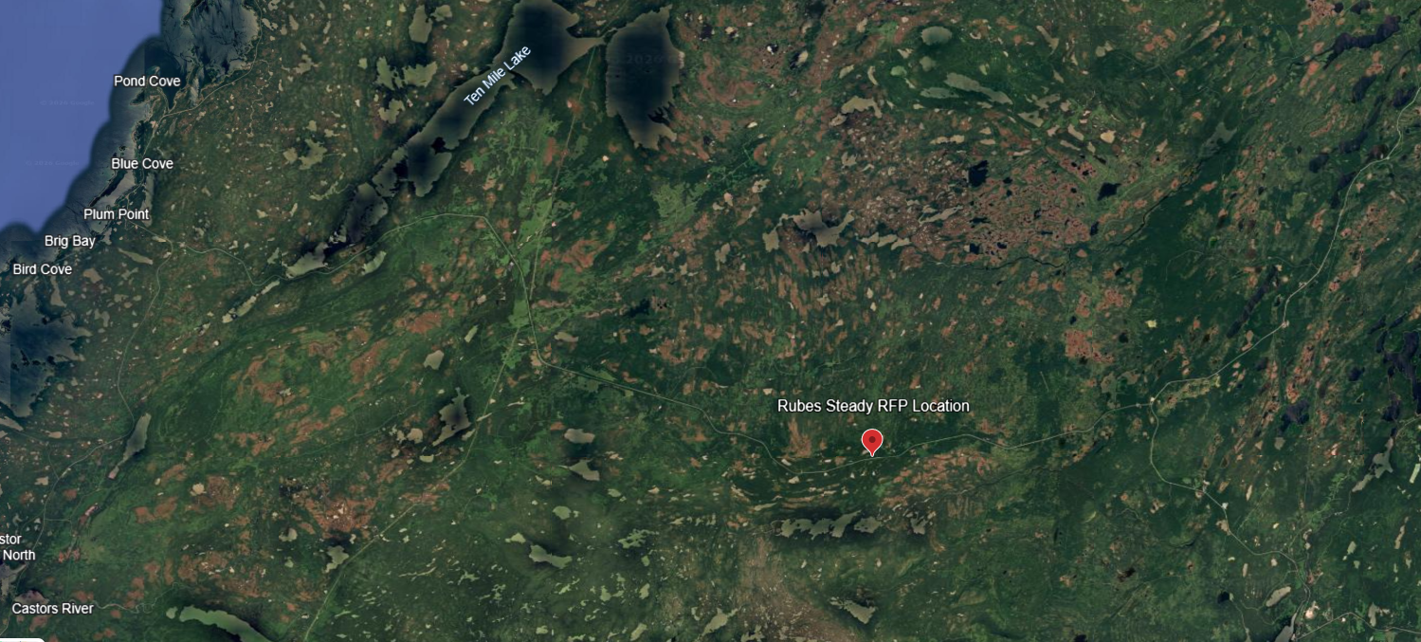
Figure 1: Rubes Steady proposed harvest area Location
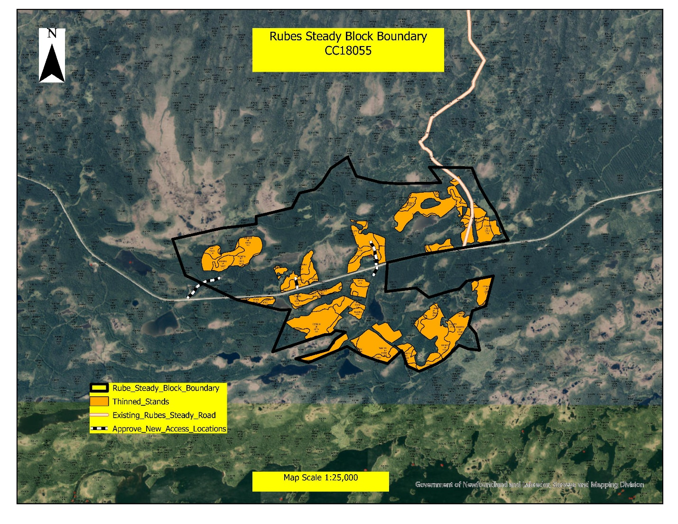
Figure 2: Rubes Steady Harvest Area

Schedule C – Proponent Forest Management Responsibilities

Forest Management Responsibilities
This Commercial Softwood Timber Allocation is subject to:
- The Forestry Act and associated regulations.
Harvesting and road building associated with this Commercial Softwood Timber Allocation is subject to the Department’s Environmental Management System (ISO 14001 - 2015) and the Environmental Protection Guidelines set out in the FMD 17 Sustainable Forest Management Plan.

Forest Access Road Development and Maintenance
The successful bidder will be responsible for all new and re-construction of forest access roads identified in the harvest blocks. These roads are for general public use and resource development. Forest access roads are used extensively by the general public and other industrial users for a wide range of purposes such as hunting, fishing, outfitting, berry picking, mineral exploration etc.
When constructing forest access roads or forwarding trails, the successful proponent must abide by construction standards for forest access roads in NL. These standards were developed by the Forest Engineering and Industry Services Division. Forest access roads shall be constructed to an approved standard; the approved road standards can be requested from the Resource Roads supervisor, Dan Myles (dmyles@gov.nl.ca).

