Effects of short to medium-term dairy manure and biochar applications on the growth, forage production and quality, soil quality and health in a continuous silage corn monocropping system in boreal climate

Facts Sheet

Submitted to

Canadian Agriculture Partnership Program
Agriculture Growth and Innovation Program Application
Department of Fisheries and Land Resources
Agriculture Business Development Division
Corner Brook, NL

Submitted by

Dr. Mumtaz Cheema (PI)

Grenfell Campus
Memorial University of Newfoundland
Corner Brook, NL

March 5, 2022

1.0 Background
Through the Way Forward Policy, the Newfoundland and Labrador (NL) government is engaged in an ambitious drive to double food production by 2022. Dairy industry is presently the most valuable agricultural commodity, contributing approximately $125 million to the provincial economy. However, local forage production is approximately 55-60% and is not sufficient enough to cater the needs of dairy industry. Local production has been mainly limited by short growing seasons and inherently poor-quality soils. Biochar (BC) is a carbon rich product of pyrolysis of biomass under limited oxygen. Adding BC to the soil increases soil organic carbon (SOC), reduces soil bulk density, increases soil porosity and adsorption capacity, and improves the soil hydraulic properties. In silage corn systems where, liquid dairy manure (DM) is applied, BC application can greatly improve the adsorptive capacity of the soil, improving nutrient retention and overall soil health due to the additional SOC. The soil health benefits of DM and BC application have not been fully quantified in NL. We submit that in order to expand DM and BC use on existing or new farms, there is a need to quantify benefits. Most farmers are reluctant to adopt new practices due to lack of evidence of benefits. However, to address the need to increase local production of forage to eliminate reliance on imports, and to sustain growth in the dairy industry, producers need incentives and confidence for adopting practices that are more environmentally sustainable. We hypothesized that DM and BC will enhance silage corn yield and soil health parameters in the boreal climate of NL.

2.0. Study Objectives:
- To quantify the effects of short to medium-term application of DM and BC on forage yield and nutritional quality of silage corn.
- To evaluate the short to medium term effects of DM and BC application on soil microbial communities in a continuous silage corn cropping system.
- To monitor some soil physiochemical properties following DM and BC application to silage corn in a boreal climate.
3.0. Research Plan
3.1. Experimental site, Design and Plot Establishment
This field experiment was set up at Pynn’s Brook Research Station, Pasadena (49° 04′ 21.9″ N, 57° 33′ 37.4″ W), Canada in 2016. Experimental treatments were: 1) dairy manure with high N conc. (DM1, 0.23% N); 2) dairy manure with low N conc. (DM2, 0.079% N); 3) inorganic N fertilizer (IN); 4) DM1 + BC; 5) DM2 + BC; 6) IN + BC; 7) control (N0). The experiment was laid out in a randomized complete block design with four replications. Each plot was 4.8 m × 1.5 m. DM was applied before seeding @ 30,000 L ha⁻¹ during 2016, 2017, 2018, 2020 and 2021. Silage corn (Pride A4414RR) was seeded with the SAMCO 2200 system (SAMCO Agricultural Manufacturing Ltd) using 90,900 seeds ha⁻¹.

3.2 Soil Sampling and Analysis

Soil samples from each plot were collected from 0-20 cm depth to determine soil chemical and biological properties. For physical properties (bulk density, water holding capacity and field capacity), samples were taken at 2 different depths (0-10cm, 10-20cm) and sieved (<2 mm) prior to subsampling or storage. Soil for total C (TC), total N (TN), particulate organic matter (POM), and PMN was immediately air-dried for 7 d prior to further processing. Subsamples for DNA profiling were stored at -80ºC immediately after sieving.
3.3 Chlorophyll measurement
Chlorophyll contents of third fully expanded leaves from top was measured at tasseling stage from six plants from each experimental plot, using SPAD 502 Plus chlorophyll meter (Spectrum Technologies, IL, USA).
3.4 Forage Yield and Nutritional Quality Determination
Plants from one square meter of each experimental unit were harvested and fresh weight was recorded. A sub sample was taken and oven-dried at 60ºC for 3 – 7 days to determine moisture content. Forage yield of silage corn was calculated based at 35% dry matter content of the sample and converted to Mg ha⁻¹. The dry samples were ground using a Wiley mill and homogenized, a 50 g subsample was sent to Activation Laboratories Ltd (Actlabs), Ontario for nutritional quality (protein, fibre, carbohydrates, digestibility, and milk production potential) analyses.

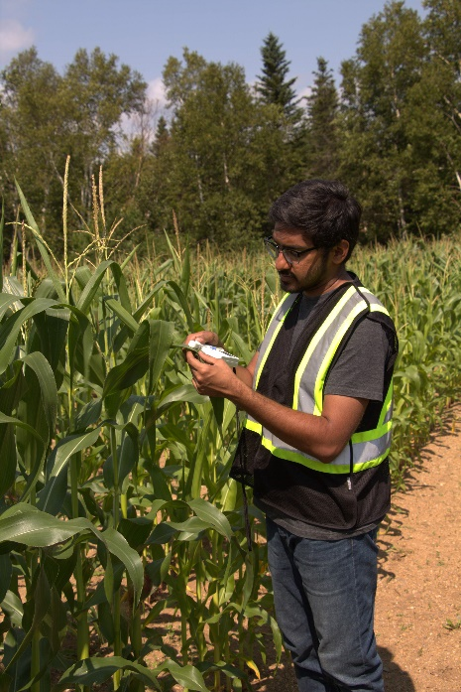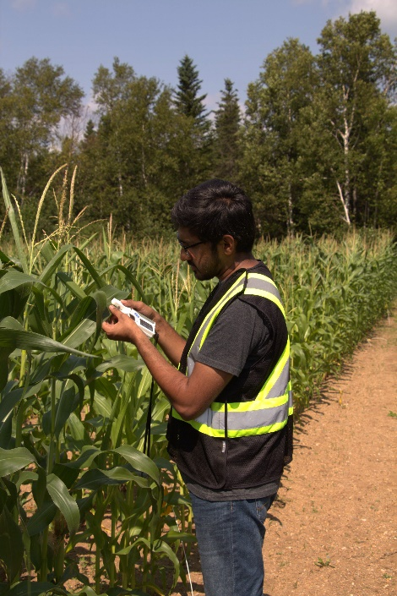
Data measurement for chlorophyll

4.0. Results
4.1. Chlorophyll content
DM, IN and BC amendments had non-significant (P = 0.07) effects on chlorophyll content in silage corn. However, DM1 application exhibited slightly higher chlorophyll content (46.04) and lowest were recorded in control (38.32).
4.2. Forage yield
Experimental treatments had significant (P = 0.01) effects on forage yield of silage corn. DM1+BC treatment produced higher forage yield (12.87 Mg ha⁻¹) whereas the lowest (6.37 Mg ha⁻¹) was observed in control. BC addition to DM1 and DM2 treatments produced 14% and 16% higher forage yield, respectively. Enhanced forage yield with BC amendment could be attributed to the porous structure, large surface area and functional groups of BC that adsorbed/retained more nutrients from DM application and made available to silage corn. The results of present study substantiate the findings of Ashiq et al., (2020) who observed 6% and 10.5% increase in forage yield in DM plots amended with BC. BC amendments improve soil moisture contents and other physicochemical properties results in increased crop yield (Baronti et al., 2014; Duarte et al., 2019; Hass et al., 2012).
4.3. Forage quality
Experimental treatments had non-significant effects (P = 0.32; P = 0.30) on crude protein and available protein and significant (P = 0.04 and P = 0.01) effects on acid detergent fiber (ADF) and non-fibrous carbohydrates, however non-significant (P = 0.055) effect was observed on neutral detergent fiber (NDF). BC amendment with DM1 and DM2 increased 17% and 19% ADF, 13% and 14% NDF respectively, however reduced 4% and 6% ADF and NDF in IN fertilizer amended BC treatment. Additionally, BC amendment in DM1 and DM2 treatments decreased 12% and 16% NFC but increased 5% NFC in IN+BC treatment. DM1 and DM2 treatment exhibited 17.25% and 16.83% higher total digestible nutrient (TDN) compared to control. However, BC amendment in DM treatments reduced TDN by 12% but increased 1.63% in IN+BC treatment. DM, IN and BC application had significant (P = 0.02; P = 0.03 and P = 0.03) effects on net energy for lactation (NEL), net energy for maintenance (NEM) and net energy for gain (NEG) in silage corn. DM application produced higher NEL, NEM and NEG whereas, BC amendment in DM1 and DM2 reduced 17% and 18% NEL, 19% and 21 NEM and NEG by 30% and 32% respectively and increased 3%, 3% and 4% NEL, NEM and NEG in IN + BC treatment. Higher milk production was observed in DM amended plots compared to control though statistically at par with IN and IN+BC treatments. BC amendment in DM plots reduced milk production potential whereas, increased in IN+BC amended plots.

REFERENCES
Ali W., Nadeem M., Ashiq W., Zaeem M., Thomas R., Kavanagh V., Cheema M. (2019) Forage Yield and Quality Indices of Silage-Corn Following Organic and Inorganic Phosphorus Amendments in Podzol Soil under Boreal Climate. Agronomy 9:489.

Ashiq, W., Nadeem, M., Ali, W., Zaeem, M., Wu, J., Galagedara, L., ... & Cheema, M. (2020). Biochar amendment mitigates greenhouse gases emission and global warming potential in dairy manure based silage corn in boreal climate. Environmental Pollution, 265, 114869.

Baronti, S., Vaccari, F.P., Miglietta, F., Calzolari, C., Lugato, E., Orlandini, S., Pini, R., Zulian, C., Genesio, L., 2014. Impact of biochar application on plant water relations in Vitis vinifera (L.). Eur. J. Agron. 53, 38–44.
Duarte, S. de J., Glaser, B., Cerri, C.E.P., 2019. Effect of biochar particle size on physical, hydrological and chemical properties of loamy and sandy tropical soils. Agronomy 9.
Hass, A., Gonzalez, J.M., Lima, I.M., Godwin, H.W., Halvorson, J.J., Boyer, D.G., 2012. Chicken manure biochar as liming and nutrient source for acid Appalachian soil. J. Environ. Qual. 41, 1096–1106.
Zhang Y., Wang J., Feng Y. (2021) The effects of biochar addition on soil physicochemical properties: A review. CATENA 202:105284. DOI: https://doi.org/10.1016/j.catena.2021.105284.

