Before completing your MTAP In-Province Flight Pass application, please read this User Guide in full. Ensure that all information provided is accurate and complete. Incomplete or incorrect information may delay the processing of your application.

Introduction

This guide shows you how to complete the fillable PDF for the MTAP In-Province Flight Pass Application. This information is needed to request a prepaid flight pass. You will be asked to provide contact details, appointment details, and other important information.

Only people who currently live in the Labrador-Grenfell Health Zone can use the flight pass program.

Tip: Have your appointment information ready before you begin.

What You Need
- Your MCP number
- Proof of your scheduled appointment
- Escort information and medical note, if required (see Section 2)

Section 1: Patient Information

This section (Picture 1) asks for basic personal information, including your name, contact information, MCP number, address, and email address (if you have one). Make sure the information matches the identification you will use during travel.

Your MCP must be valid and not expired. The expiry date can be found on your card. If you recently renewed your MCP but have not yet received a new card, you can attach a copy of the renewal confirmation document with your application.

If your Mailing Address (e.g., PO Box) is different than your Residential Address (street name and number), enter the mailing address as well.

Picture 1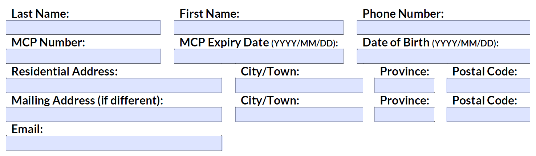
If you have private health insurance, select Yes (Picture 2). Please provide the name of your insurance company in the space provided.

If you are eligible to receive travel support through your employer, another department, government, or organization such as Hope Air, select Yes (Picture 2).

If you select Yes (Picture 2) to receiving income support, or home support or financial benefits through the Community Support Program, you are not eligible for MTAP. You need to contact the Medical Transportation Supports Program (MeTS) for help with travel at 1-833-729-6106 or email MeTS@gov.nl.ca.

Picture 2
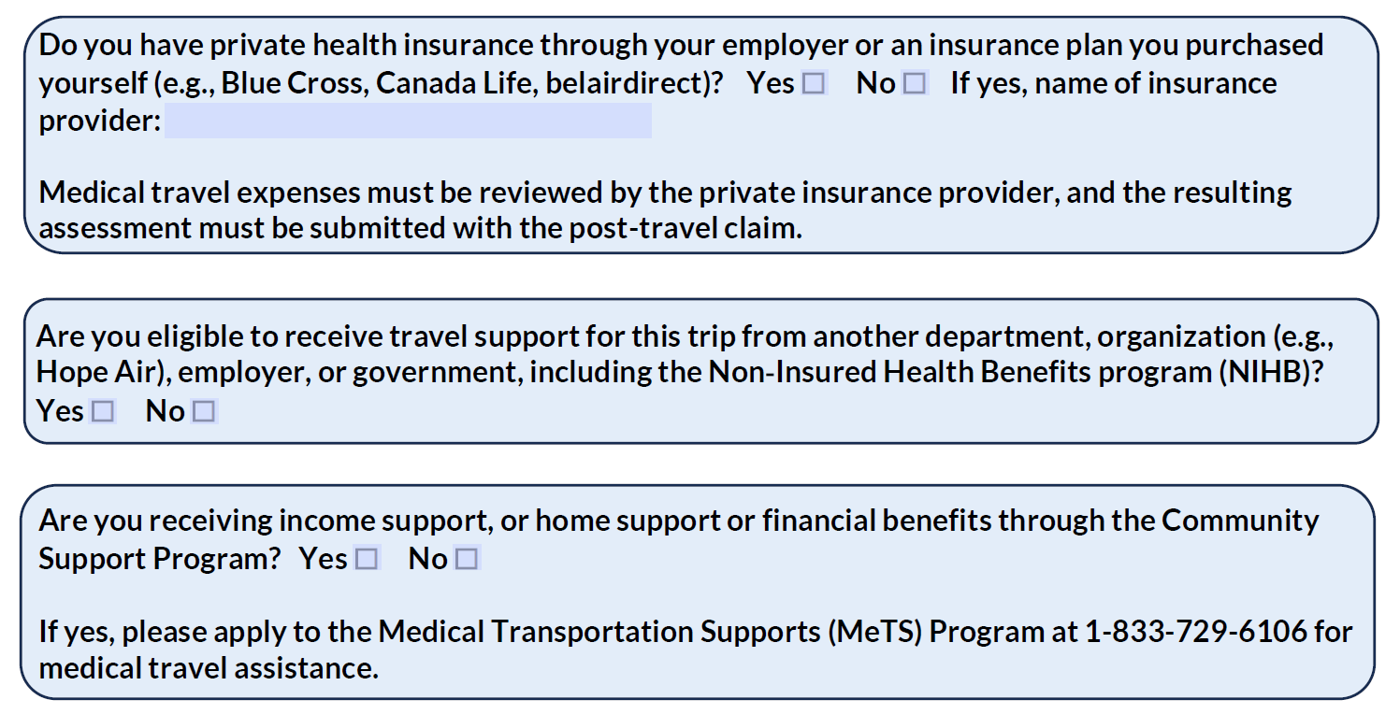

Section 2: Escort Information

This section (Picture 3) asks if someone will be travelling with you to provide support. This person is called an escort and must be required for medical reasons and supported by medical documentation from a physician or nurse practitioner. Escorts must be 18 years of age or older. Healthcare professionals travelling in their professional capacity to provide care or transportation services are not eligible to be an escort.

The information you provide must match the ID they will be using during travel.

Picture 3
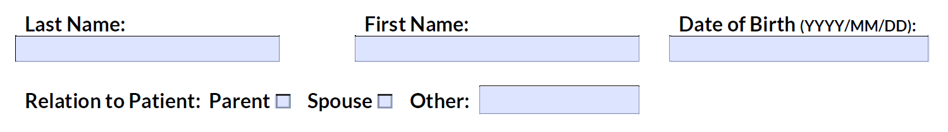

Section 3: Details of Medical Travel

This section (Picture 4) collects appointment details and flight information. The Appointment Location may include the name of the facility (e.g., Health Sciences Centre) or the street address (e.g., 123 Avenue) where your appointment is taking place.

Choose the Primary Reason for Travel from the dropdown list. If you have multiple appointments, select the reason that applies to the earliest appointment and enter the date of that appointment.

If you know the Physician Specialty (e.g., surgeon, Ophthalmologist, Cardiology), include it here. You can also say if you are travelling for a test (e.g., MRI, CT scan), illness or treatment (e.g., cancer, dialysis) or indicate Unknown.

Choose where you are Departing from (closest airport to where you live), where you will be Arriving (closest airport to your appointment), and if a round-trip is needed. Do the same for your escort, if applicable. If your escort is not travelling from the same airport, or if you are returning to a different airport, you may need to provide extra documents.

Picture 4
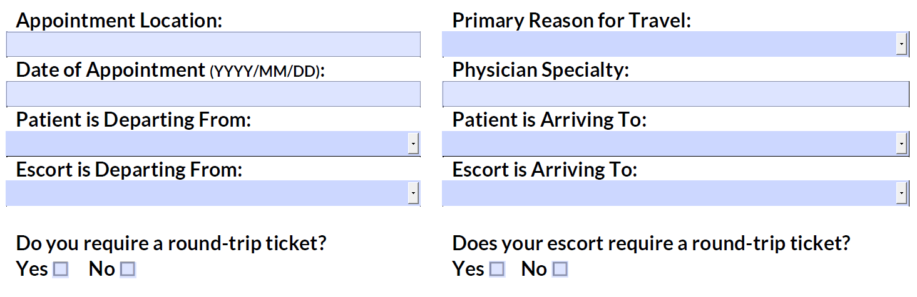

Section 4: Supporting Documentation

The supporting documentation checklist (Picture 5) reminds you of what is needed to complete your request.

Picture 5
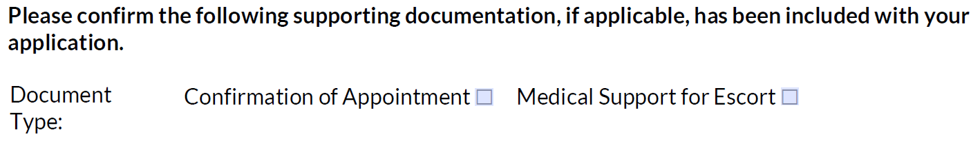

Supporting documentation should be submitted by email along with your application.

Section 5: Declaration and Submission

This section (Picture 6) contains the privacy rules and terms you need to follow for MTAP In-Province Flight Pass program. Read them carefully; by signing, you agree to the privacy statement and terms presented.

Picture 6
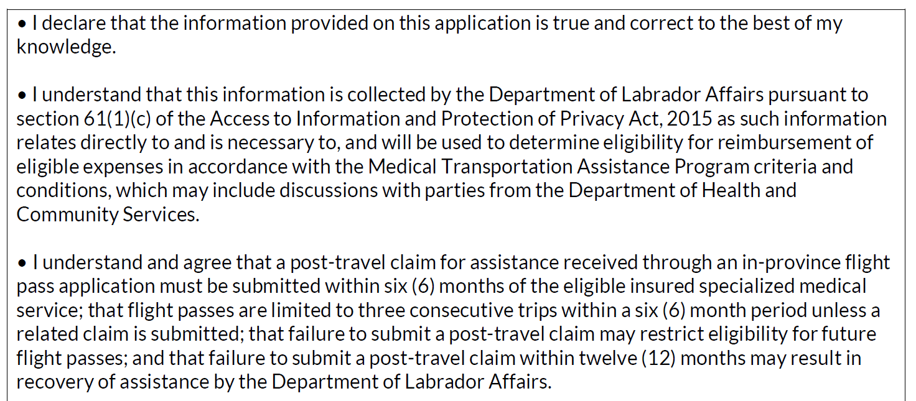

Completed applications can be submitted to FlightPassMTAP@gov.nl.ca. Incomplete applications may result in a delay.

Emails from MTAP will come from FlightPassMTAP@gov.nl.ca. If you are waiting for an email, please check your junk or spam folder.

Support & Troubleshooting

If you need help filling out the application, email us at FlightPassMTAP@gov.nl.ca.

