Before completing your MTAP Out-of-Province Medical Transportation Claim - Flights and Other Travel Costs, please read this User Guide in full. Ensure that all information provided is accurate and complete. Incomplete or incorrect information may delay the processing of your claim.

Introduction

This guide shows you how to complete the fillable PDF MTAP Out-of-Province Medical Transportation Claim - Flights and Other Travel Costs. This process should be used when you are claiming eligible airfare, accommodation, and other travel expenses for one out-of-province trip.

If you are claiming for in-province travel, please use the "MTAP In-Province Medical Transportation Claim - Flights and Other Travel Costs”.

You will be asked to provide contact details, patient and escort details, appointment details, and other important information.

Tip: Have the appointment information, receipts, specialist referral, and private insurance provider’s explanation of benefits, if applicable, ready before you begin.

What You Need
- Your personal information (MCP number and expiry date, address, and contact information)
- The patient’s MCP number and expiry date
- Escort information and medical note, if required (see Section 3)
- NL Physician Specialist Referral Letter (see Section 4)
- Travel itinerary documentation (e.g., flight itineraries)
- Confirmation of attendance for each appointment
- Private insurance provider's explanation of benefits (payout details) for travel, if applicable
- Expense receipts, including proof of payment

Section 1: Claimant Information

The claimant is the person submitting the claim and receiving any reimbursement related to it. The claimant may be the patient or another member of the same household who incurred the eligible expenses and is acting on the patient's behalf, such as an approved escort.

This section (Picture 1) asks for basic personal information, including your name, contact information, MCP number, address, and email address (if you have one).

Refer to Section 2 of this guide for information about the patient(s).

Your MCP must be valid and not expired. The expiry date can be found on your card. If you recently renewed your MCP but have not yet received a new card, you can attach the renewal confirmation as a document with your claim.

If your Mailing Address (e.g., PO Box) is different than your Residential Address (street name and number), enter the mailing address as well.

Picture 1
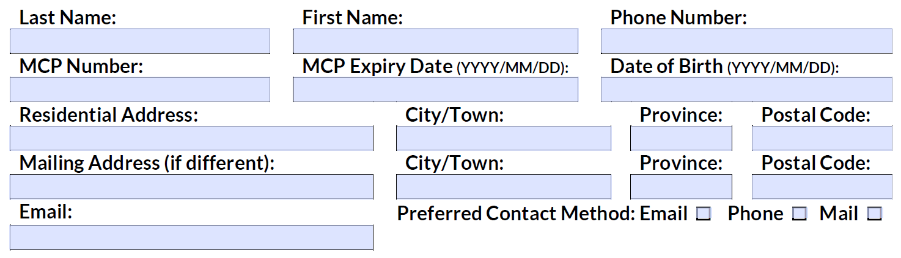

Section 2: Patient Information

This section (Picture 2) asks for information about the patient or patients associated with the claim.

If you are also the patient who received the medical services and incurred the travel expenses, select Yes. You do not need to enter the same information again under Patient Details. If you are using compatible PDF software, selecting Yes will automatically copy the claimant's information into the first line of the Patient Information section.

If you are claiming expenses for multiple patients for the same trip, enter the patient's name, MCP number, MCP expiry date, and relationship to you under Patient Details.

Remember: Only one trip may be included per claim. If you need to claim expenses for a different trip, you must submit a separate claim.
Patients included in the claim must reside in the same household as you.

Picture 2
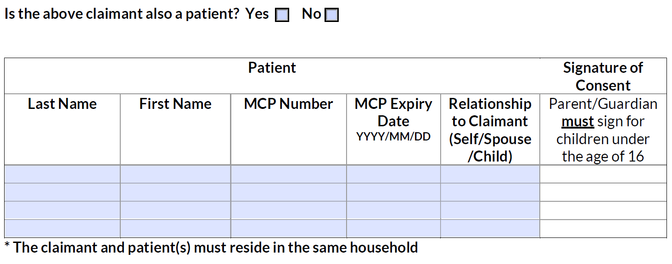

If either patient has private health insurance, select Yes (Picture 3). Add the name of the insurance company in the field provided.

If either patient received or is eligible to receive travel support through an employer, another department, government, or organization such as Hope Air, select Yes (Picture 3). Please enter information about the source and amount in the fields provided.

If either patient answers Yes (Picture 3) to receiving income support, or home support or financial benefits through the Community Support Program, they are not eligible for MTAP and must be removed from the claim, along with any expenses related to them. They will need to contact the Medical Transportation Supports Program (MeTS) for help with travel at 1-833-729-6106 or email MeTS@gov.nl.ca.

Picture 3
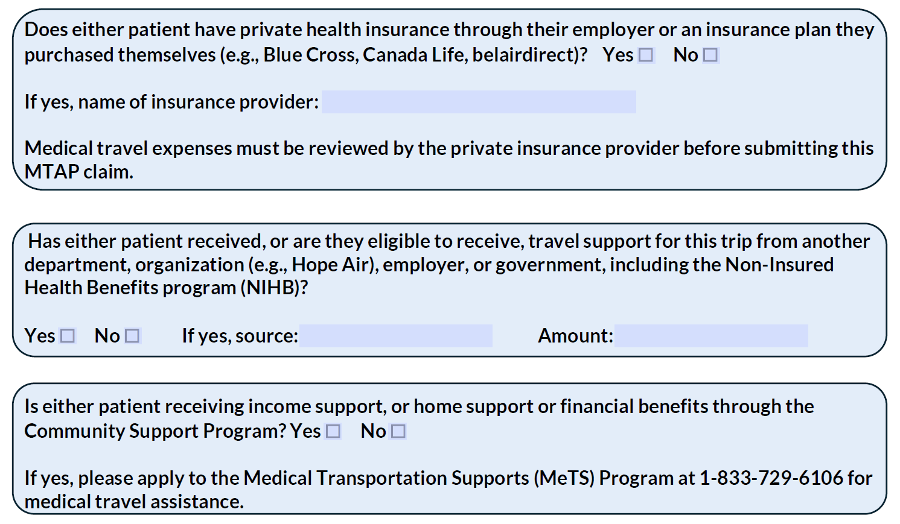

Section 3: Escort Information

This section (Picture 4) asks if someone travelled with the patient(s) to provide support. This person is called an escort and must be required for medical reasons and supported by documentation from a physician or nurse practitioner. Escorts must be 18 years of age or older. Healthcare professionals travelling in their professional capacity to provide care or transportation services are not eligible to be claimed as escorts.

Picture 4
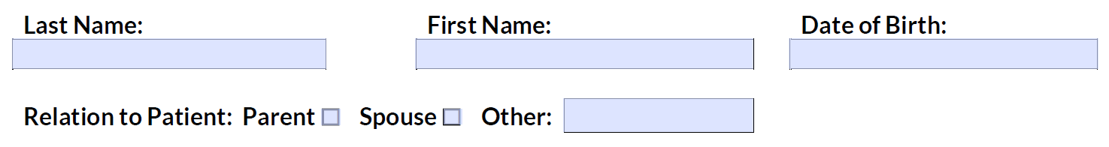

Section 4: Referring Specialist Physician

All out-of-province travel must be supported by a referral from a Newfoundland and Labrador physician specialist.

This section (Picture 5) asks for information about the NL Referring Physician Specialist who referred the patient for out-of-province care. A copy of the referral letter and/or other supporting documentation should be attached with your claim. Refer to Section 6 of this guide for additional information.

Picture 5
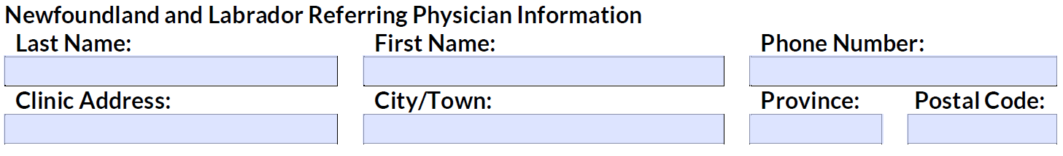

If known, enter the address of the physician specialist's office or the location where the patient was seen under the clinic address.

Under Name of Physician/Hospital to Whom This Patient Was Referred (Picture 6), enter the name of the physician, specialist, or healthcare facility that provided the out-of-province service.

Under Physician/Hospital of Where Patient Was Referred, enter the address of the physician's office or healthcare facility, if known. If there were multiple appointments, enter the primary physician or facility associated with the trip.

Picture 6
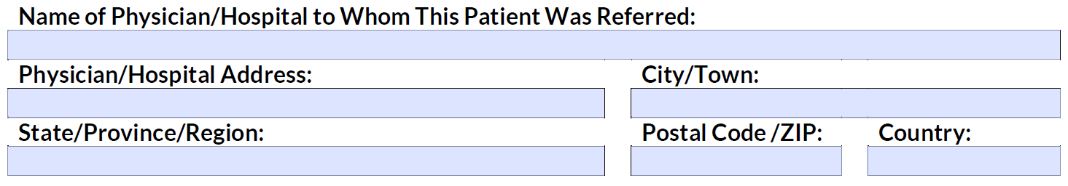

Section 5: Details of Medical Travel

This section collects travel, appointment, and expense details. The Date of Departure and Return (Picture 7) should reflect the first date of travel and the date the patient returned home.

Choose the Primary Reason for Travel from the dropdown list. If you have multiple appointments, select the reason that applies to the earliest appointment and enter the date of that appointment.

If you know the Physician Specialty (e.g., surgeon, Ophthalmologist, Cardiology), include it here. You can also say if the patient travelled for a specific test (e.g., MRI, CT scan), illness or treatment (e.g., cancer, dialysis) or indicate Unknown.

Picture 7
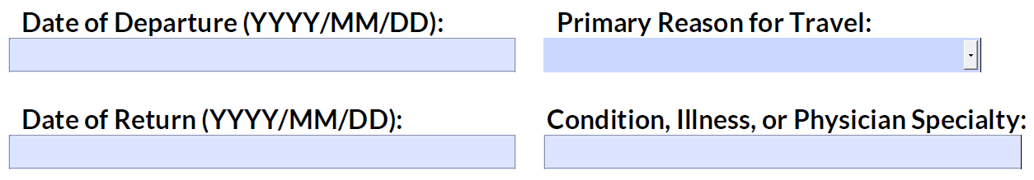

Under the Appointment Details (Picture 8), the Appointment Location may include the name of the facility (e.g., Princess Margaret Cancer Centre) or the street address (e.g., 123 Avenue) where the appointment took place.

The Date of Appointment and Name of Specialist (e.g., Dr. Smith) should be indicated for each appointment.

Picture 8
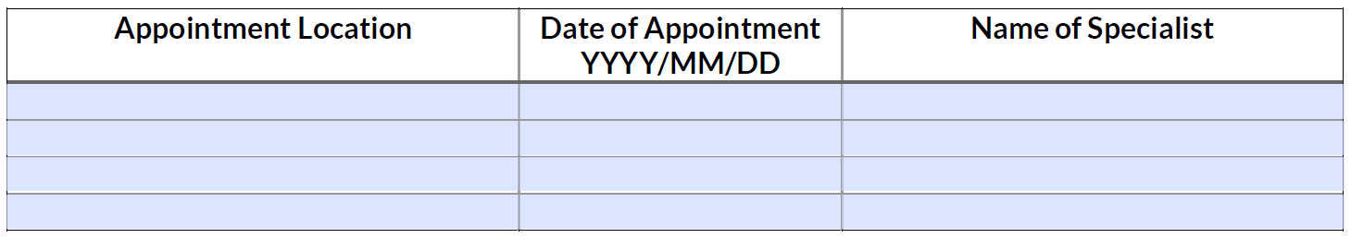
If any appointments included an in-patient stay (Picture 9), where either patient was required to stay overnight in a medical facility, select Yes. Add the Date of Admission and Date of Discharge in the fields provided.

Picture 9
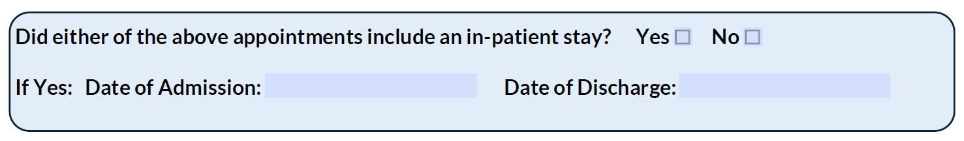

For each Expense Type (Picture 10), enter the date or date range for the expense and the total amount claimed. Repeat this process for each expense type being claimed.

Meal per diems do not need to be entered as an expense type. Eligible meal per diems are automatically calculated based on the information provided in the claim.

Example: If a taxi was used each day from June 15 to 19 and each trip cost $20.00, you can enter a single Taxis and Car Rentals expense with a date range of June 15–19 and a total claimed amount of $100.00. Receipts supporting the expense must be attached with the claim. Refer to the Supporting Documentation and Submission Section of this guide for additional information.

Please note: Receipts are required for most expenses. However, receipts are not required for private accommodations, meal per diems, or private vehicle mileage.

The total claimed amount is automatically calculated from the amounts entered for each expense type.

Picture 10
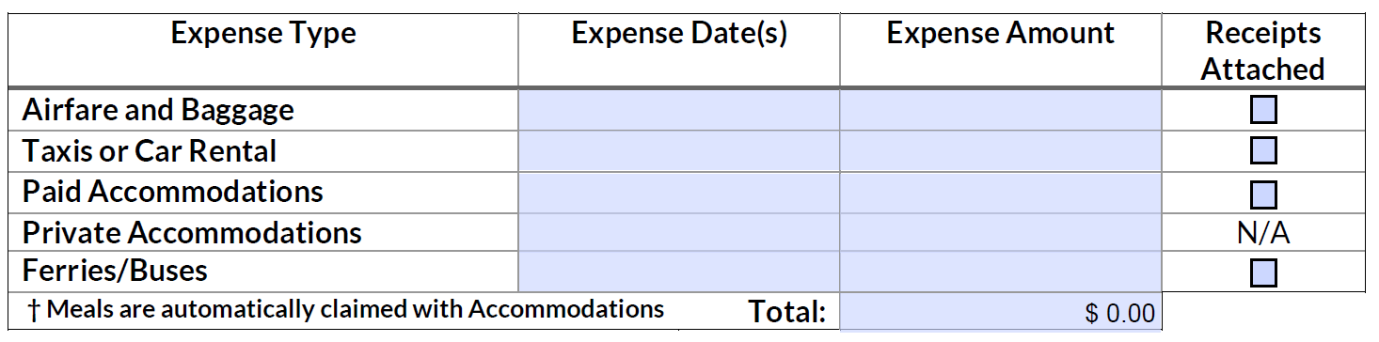

If you are also claiming private vehicle mileage (Picture 11) for this trip, you must complete the Private Vehicle Mileage section.

To help calculate the distance travelled, enter the Starting Location, which is typically the patient's community of residence (e.g., Grand Falls-Windsor), and the Ending Location where the appointment took place. The ending location may be the name of the facility (e.g., IWK Health Centre) or the city or town where the appointment is located (e.g., Halifax). Do not include stops along the route unless they relate to another medical appointment.

Note: Distance calculations are based on community-to-community distances, not specific street addresses. For assistance calculating distances out-of-province, refer to Google Maps.

Under Date(s) of Travel, enter the date or dates travelled. For a round trip, this is generally the departure date and return date.

Under Total Distance, enter the total kilometres travelled. If Round Trip is selected, include both the trip to the appointment and the return trip in the total distance.

As an example, if the patient travelled from Grand Falls-Windsor to Halifax on May 5 and returned on May 10, you would enter: “Grand Falls-Windsor” as the starting location, “Halifax” as the ending location, “May 5 / May 10” for dates of travel, “” for round trip and “2,310” as the kilometres driven.

Picture 11
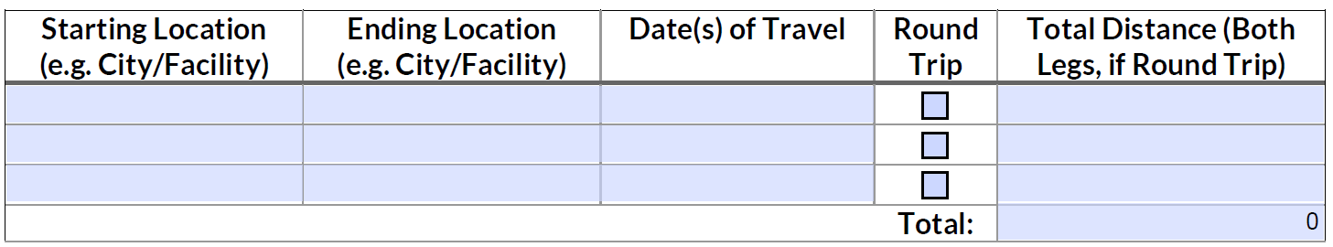

Section 6: Supporting Documentation

The supporting documentation checklist (Picture 12) reminds you of what is needed to complete your request.

Picture 12
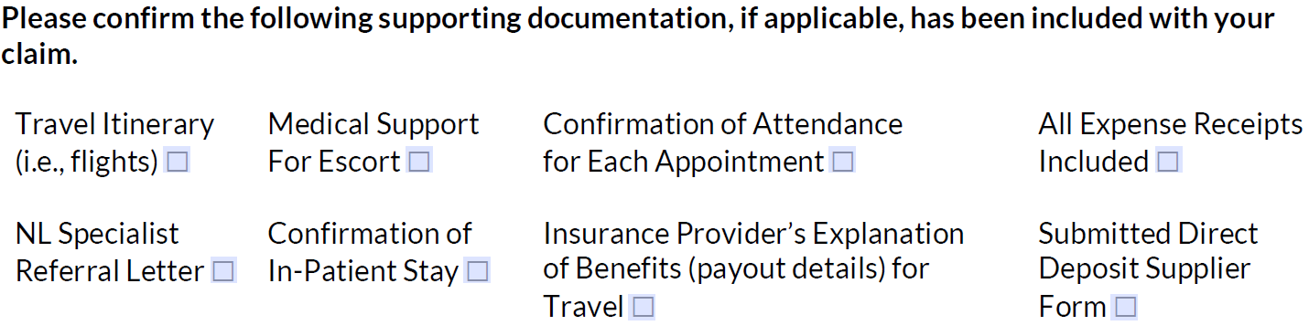

Supporting documentation should be submitted by email along with your claim.

Section 7: Declaration and Submission

This section (Picture 13) contains the privacy rules and terms you need to follow for the MTAP Out-of-Province Medical Transportation Claim - Flights and Other Travel Costs. Read them carefully; by signing, you agree to the privacy statement and terms presented.

Picture 13
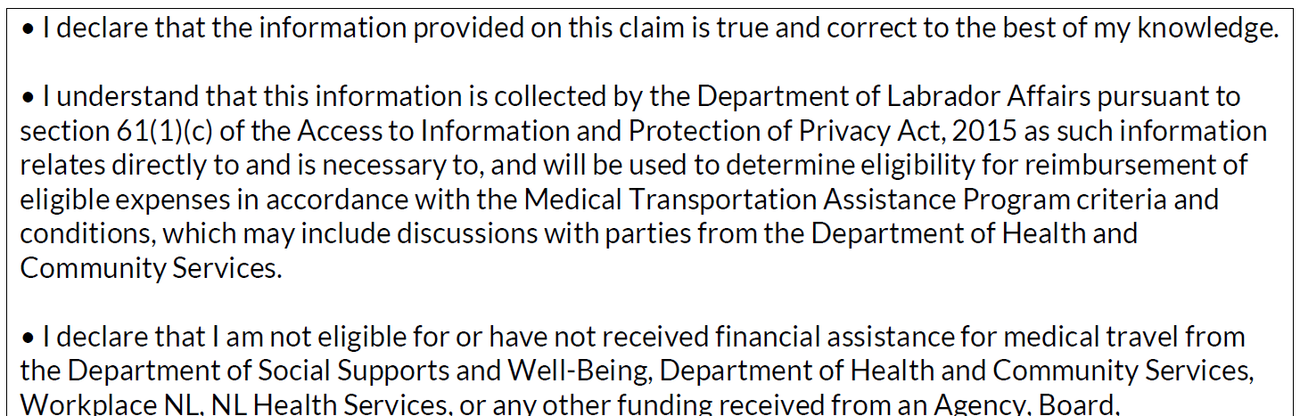

Completed claims can be submitted to MTAP@gov.nl.ca. Incomplete claims may result in a delay.

Emails from MTAP will come from MTAP@gov.nl.ca. If you are waiting for an email, please check your junk or spam folder.

Support & Troubleshooting

If you need help filling out the claim, email us at MTAP@gov.nl.ca or call 1-877-475-2412.

