OWN-FORCE LABOUR REQUEST
HPRM Ref # -

Project Details
MI Project Number |  |  | Request Date
Project Title
Ultimate Recipient (UR)
Approved Project Value (incl HST)
Request Type | ☐ Work by UR forces, project managed by a consultant.  ☐ Work by contactors, Project Management by UR.  ☐ Work by UR forces, Project Management by UR.
To be eligible for reimbursement of associated costs under the project, which will be at the original funding agreement cost share, own-force labour costs will only be incurred after approval of this request in writing by the Director of Municipal Infrastructure.

Rationale for Request (provide anything you want considered, add lines as needed)
1
2
3
4
5

Why is it NOT Feasible to Tender a Contract? (select at least one)
☐ There is a lack of private sector capacity to undertake the work (must be demonstrate with research, attach applicable documents)
☐ Work involves proprietary/specialized infrastructure/equipment that requires specific knowledge.
☐ Collective agreement requires the recipient to use their own unionized employees for certain work.
☐ Other unique circumstance identified below:

Past History of Project Management (provide anything you want considered, add lines as needed)
Provide 2 examples of projects where the UR utilized the same approach as this request for similarly scoped projects.
1 | Title |  | Project Cost
1 | Procurement Method |  | Completion Date
1 | Questions | Was it completed on time? ☐ Yes ☐ No  Completed on budget? ☐ Yes ☐ No  Any safety incidents? ☐ Yes ☐ No
1 | Other Information
2 | Title |  |  | Project Cost
2 | Procurement Method |  |  | Completion Date
2 | Questions | Was it completed on time? ☐ Yes ☐ No  Completed on budget? ☐ Yes ☐ No  Any safety incidents? ☐ Yes ☐ No
2 | Other Information

Project Eligibility (select all that apply)
The work involves:
☐ Building envelope replacement or rehabilitation (windows, doors, siding, roof)
☐ Minor interior renovation of a building (not related to life safety)
☐ Small scale water, sewer, storm water, that does not require paving and less than 100m
☐ Small access trails to municipal infrastructure
☐ Walking trails, parks, playground, dog parks, gardens
Note:
- Projects that have the following conditions are not eligible for Work by Own-Force:
  - Life Safety
  - Water/Wastewater (lift station, treatment, outfalls, linear length greater than 100m)
  - Water source development, dams
  - Buildings with regular occupancy or those requiring LEED
  - Any project that includes blasting
- Projects over $20,000 + HST in value are not eligible. A case maybe made for consideration otherwise.
If the project does not fall within the above listed categories, please identify why the project should be eligible.

Risk Analysis
Risk (A) | Likelihood (B) | Impact (C) | Risk Rating (D) | Mitigative Actions (E)
A - Brief description of the risk
B - Identify the likelihood, how likely the risk is to occur (vertical axis of chart below)
C – Identify the impact, if the risk takes place, how seriously will it impact your project (horizontal axisof chart below)
D - On the chat below to identify the risk rating (colored cells in the chart below corresponding to B and C)
E - Identify how the UR proposes to mitigate the risk
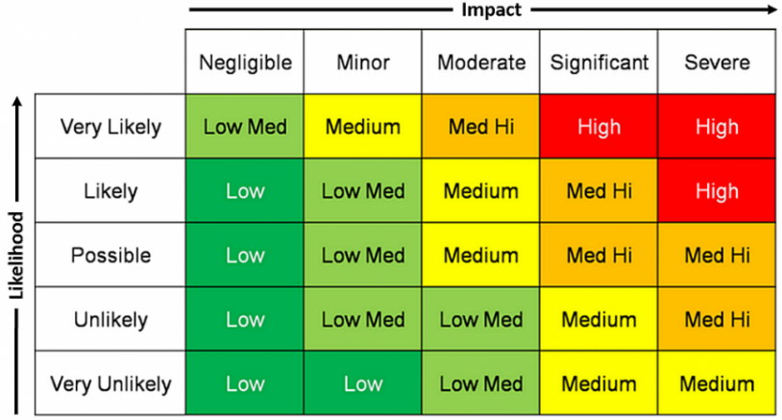

Procurement Plan (list all procurement packages and when they will be advertised)
Procurement Package Description | Method  (Limited Call, Public Open Call) | Estimate  (incl HST) | Schedule
Notes:
- All contractors utilized must be COR certified.
- All work must use MI specifications, and front end documents.
- All contracts must have bonding in place.
- All contractors and consultants must have appropriate insurances in place.

Cost Management Plan (list methods to control costs)

Scope Management Plan (list methods to control scope)

Quality Management Plan (list methods to control scope, and ensure quality of work)

Financial Analysis
Incremental Costs (add lines as needed)
Employee Position /  Equipment | Description of Work |  |  | Incremental Cost
NOTE:
- Costs are associated with backfilling the position of an employee who is assigned to the project or hiring a new employee to work on the project. New internal employee would be a temporary and terminated at end of project.
- UR cannot charge for equipment owned by the UR usage or the operator, however, the gas can be.
- UR may rent equipment for the project specifically and terminate the rental immediately after.
Cost Benefit Analysis
Provide a business case to indicate that this option will save the UR, and the project, funding.
Modify the items to be project specific
Item  (Edit as necessary) |  | Option One  Estimate ($)  Incl HST  Without Own-Force | Option Two  Estimate ($)  Incl HST  With Own-Force
Project Management
Design
Site/Resident Inspection
Rental Equipment
Construction Materials
Construction labour
Training
Testing
Permits
Engineering
UR Costs
Total (incl HST)
Savings to project (incl HST)

Ultimate Recipient Attestation (select all that apply)
MI will determine if any that are not selected pose an issue to the application for the specifics of the project.
The Ultimate Recipient attests that the organization and/or staff working on this project:
☐ Has an Occupational Health and Safety Policy that addresses work in scope (provide copy).
☐ Is in good standing with WorkPlaceNL (letter may be requested).
☐ Has qualified technical project management staff (engineer/technologist) (resumes may be requested).
☐ Has properly trained journeyperson trades people for the work required (tickets may be requested).
☐ Has knowledge of policies, regulations, codes, and standards as relevant to the project.
☐ Has knowledge of Municipal Water, Sewer and Roads Master Construction Specifications, TI Highway Design Specifications Book, and NL Master Specification Guide for Public Funded Buildings as relevant to the project.
☐ Has knowledge of the Public Procurement Act, Regulations, and policies, and will follow all the requirements.
☐ Will engage competent, licensed consultants and contractors with COR certification, appropriate bonding, and insurances.
☐ Will ensure that all permits required are received prior to the start of construction.
☐ The individual signing this document has support of the governing body to request and proceed if approved with the project in this manner.

UR Representative |  | Position
Signature |  | Date

Decision (internal use only)

Project Details
MI Project Number |  |  |  |  |  |  | Request Date
Ultimate Recipient (UR)
Request Type |  |  |  | ☐ Work by UR forces, project managed by a consultant.  ​​☐ Work by contactors, Project Management by UR.  ​​☐ Work by UR forces, Project Management by UR.
Municipal Infrastructure Project Representative Review
Comments:
Project Representative |  |  |  |  |  | Recommendation |  |  | ☐ Approve  ☐ Reject
Signature |  |  |  |  |  | Date
Regional Engineer Review
Comments:
Regional Engineer |  |  |  |  |  | Recommendation |  |  | ☐ Approve  ☐ Reject
Signature |  |  |  |  |  | Date
Headquarters Review
Yes | No
 |  | The Own-Force Labour request is in respect of a project that is approved
 |  | The Own-Force Labour costs requested are not otherwise ineligible under the program
 |  | Employee and/or leased equipment is engaged in work that would otherwise be contracted out
 |  | The requested costs are Incremental and will be reimbursed at the prescribed shares
 |  | Due to unique circumstances, it is not economically feasible to tender a contract
Director |  |  |  |  |  | Decision |  |  | ☐ Approve  ☐ Reject
Signature |  |  |  |  |  |  |  |  | Date
HPRM Reference Number -

