

Municipal Infrastructure Division
Departmen t of Transportation and Infrastructure

ASSET MANAGEMENT TOOLKIT:
GUIDANCE DOCUMENTS



Guidance Document 1:
Toolkit Overview

Introduction
Infrastructure in Canada represents generations of investment by federal, provincial and municipal governments. Older infrastructure in the Province is coming to the end of its service life. We have a unique opportunity to begin full life cycle planning for upgrades and replacements. This is getting away from the “fix it when it breaks” approach, which leads to a shortage of funding to replace infrastructure. Proper planning considers initial construction costs of capital projects, the cost to operate and maintain that infrastructure, and the cost to eventually replace the infrastructure.

Toolkit Overview
Asset Management gives decision makers the tools and policies required to inform council and the public of their communities needs and strategies. This toolkit provides templates, guidance documents and software tools to assist communities in reaching their goals for service delivery. Asset management tools and policies help decision makers identify service gaps and make strategies to reduce them.

HINT: Whenever you see a word formatted like this, that means a definition is available in, Section 7 Glossary.
The following are 7 key asset management questions you can answer with this Program;
- What do I own?
- What is it worth?
- When will it need to be replaced?
- How do I budget to replace it?
- What does the public expect?
- What is the acceptable level of risk?
- How do I ensure long-term affordability?
The Toolkit comprises four Tools, this Guidance Document and a Condition Assessment Guide. The Tools are accessible Excel spreadsheets for users to manage their Inventory, create plans, and create reports. The Guidance Documents teach the users standard practices and how to easily apply them to the Tool and their work.
This Toolkit provides a step-by-step guide and Tools for municipalities to collect and maintain asset inventories, develop asset management plans and implement enforceable corporate policies. Table 1-1: Key Challenges, highlights some of the main challenges municipalities face and how they were considered in the development of the Toolkit:
Table 1-1: Key Challenges
Challenge | Mitigation Strategy
Limited Staff Resources | The Toolkit provides progressive training and free tools to municipalities and to raise awareness of the benefits of asset management and gain support within their organization.  A focus on internal capacity building helps long-term success of a municipality’s asset management program. The Toolkit allows the user to input different levels of detail and continue to refine information as their asset management program grows.
Limited Funding Resources | Many communities across Canada face funding challenges. The Toolkit developed is open source with no purchase or subscription cost. Excel 2007 or newer is required and is assumed to be required for a municipality’s current operations. Meaningful progress can be made prior to any field collection of asset data, the most expensive step your Asset Management Program.  Working with neighbouring municipalities and resource sharing is also strongly encouraged.
Integrating with Existing Work | For municipalities that may already have an Asset Management Program, the Toolkit is based in excel, a platform used across many industries. The Tool is fully integrated with software that can import/export CSV files, including GIS and database systems.

Tool Overview
There are 3 Tools, they are macro-enabled Excel spreadsheets compatible on Windows for excel 2010 or newer;
- The Inventory and Reporting Tool
- The Climate Change Adaptation Tool
- The Facility and Fleet Tool
The Climate Change Integration Tool helps you assess how climate change could impact your infrastructure. The Facility and Fleet Tool, stores all information for your fleet and facilities which is imported into The Inventory and Reporting Tool. The Inventory and Reporting Tool, stores all data related to; transportation, potable water, sanitary sewer, storm sewer and the information from the Facility and Fleet Tool. This allows the user to make and compare plans and generate reports with a click of a button. The following key features are currently in place in the Tools:
- Asset inventory management
- Condition assessment guidelines and reporting
- Risk analysis processes, guides and reporting
- Financial calculations for replacement cost, amortization, salvage costs, depreciation and inflation
- Lifecycle analysis incorporating maintenance, degradation and inflation
- Climate change impacts and guides to assess potential impacts

Guidance Documents Overview
The Guidance Documents present the fundamentals of Asset Management and how the Tools incorporate them. One of the Program’s goals is to support capacity building within municipalities, so they can confidently run their asset management programs without needing to hire consultants. The following documents are included within the Toolkit.
- Toolkit Guidance Document
- Inventory Guidance Document
- Asset Valuation and Service Life Guidance Document
- Condition Self-Assessment Guidance Document
- Risk Management Guidance Document
- Financial Planning Guidance Document
- Climate Change Integration
- Glossary
- Appendix A: Quick Start Guide (if you want to skip right to using the tools!)
The Toolkit is designed to be user-friendly, approachable to all skill levels, and most of all, of instant use to municipalities who want to manage their infrastructure with an Asset Management Program. Figure 1-1: Program Flow Chart, shows the general Program workflow and related Tool & Guidance Documents.
Public Consultation:
- Council Reporting
Refined Planning:
- RSOIR
- Risk Management
- 5-year Plan
Preliminary Planning:
- PSOIR
- 20-year outlook
Implement:
- Policy
- Capital Planning
Data:
- Collection
- Management
- Updating
Assess:
- Compare current state and past projection
Learning:
- All Guidance Documents
- External Resources
- Collaboration

Figure 1-1: Program Flow Chart

Feedback
This Toolkit was created by specialists in Asset Management and reviewed by individuals of diverse backgrounds and skillsets within Atlantic Canada. The Tools are built on free, open-source platforms by several contributors shown on the “Contributors” page of the spreadsheets.
AIM Network, an asset management community of practice in Atlantic Canada is one contributor and intends on continuing to adapt the tools to meet the needs of Atlantic Canadian municipalities. Users are encouraged to reach out and provide feedback to increase the value these tools provide to municipalities. AIM Network can be reached at info@aimnetwork.ca.

Guidance Document 2:
Inventory & Data Management

Using Your Data
Sound planning starts with good data. Data collection can also be the costliest piece of planning. Determining the appropriate level of detail prevents overinvesting in data that is not useful to your asset management and capital planning.
HINT: The 80/20 rule (a.k.a Pareto Principle) is a simple idea to keep with you throughout the process. 20% of the effort yields 80% of value, the remaining 80% of effort only yields 20% of value. This guide shows how to keep effort focused on the high value 20% of effort.
This Guidance Document provides readers with a background understanding of data collection and inventory management in asset management, and how it is used in the toolkit. The Inventory and Reporting Tool (the Tool) is very flexible and allows you to import data in many ways.

Data Requirements
The Tool allows data entry by several methods. You can enter line by line or import datasets from GIS, Excel, or a CSV file. The more infrastructure your municipality manages, the more likely it is that detailed inventory will give more useful reports. There are a minimum of five fields required that must be included in your data:
- Municipal ID
  - Found in the Inventory and Reporting Tool’s “Background” sheet in the Municipality ID table. This value will be the same for all your assets.
- Feature Code
  - A unique code used to represent a type of asset and must be in the “Feature Code” table in the “Background” Sheet, e.g., MHSA, is a maintenance hole for your sanitary sewer main.
- Condition
  - Numerical value on a 1 to 5 scale, with 1 being “like new” and 5 being “extremely poor”.
- Quantity
  - The length or number of assets.
- Status
  - Either “Active” or “Inactive”. Inactive assets will not be included in reports or projections.
HINT: Staff, particularly those in the field, have a wealth of knowledge to offer. This knowledge will not be permanently available as people retire or move to other jobs so now is the time to convert this from human memory to digital memory.
HINT: The “Quantity” field notes the number of assets and allows flexibility in data entry. If you have ten hydrants in your Municipality, you may have one-line item with feature Code HY and Quantity 10, or you may break this out into ten-line items, each with quantity 1. Linear infrastructure, such as roads or pipes work the same way. You may enter one item for 1000 metres of road or have one line item for each intersection to intersection.

Level of Detail
The Asset Readiness Scale developed by the Federation of Canadian Municipalities is an excellent guide to help you asses the state of your Municipality’s Asset Management. The Tools accommodate all levels within the Data and Information section. It is recommended that you work your way up the scale and do not jump too far ahead. To reach level one in the Data and Information section, no field work is required!
HINT: When choosing the level of detail of your data collection, focus on refining the detail by putting an emphasis on assets of high cost, high risk and high corporate priority.

Data Hierarchy
Data follows a general hierarchy in the Toolkit, Figure 2-1: Asset Hierarchy, shows the organization for assets in the Toolkit.
Figure 2-1: Asset Hierarchy
Asset Class
(ex. Potable Water)
Asset Sub-Type
(Ex. Pipe)
Feature Code
(ex. Distribution Main)
Cost Factor
(ex. Corrosion Protected)

Data Collection
The Tool allows data entry in a variety of ways. You may type in your information line by line, import survey data from a CSV file, or import excel compatible files from other software such as GIS.
HINT: If you enable edit mode (see 2.4.6) you can simple start typing in your data line by line for a simplified Asset Management Program.
Data is imported through a spreadsheet, a DBF file from a GIS system, a CSV export from GIS or CSV file using the “Import” button on the “Inventory” sheet (see 2.4.3). The source of your import can be survey, user entry, or from a software like GIS. The Tool is simply performing a copy and paste with a few error checking processes.

Data Management
It is important to keep all data secure, so it is not corrupted or altered without you realizing it. It is recommended to keep a master copy data set in a protected location where limited users have access. The master copy should not be worked on or edited, only copies of it should be used day-to-day. Several backups on alternate storage locations are also recommended in case of accidental corruption or data loss.

General
Figure 2-3: Tool Overview, provides a general overview of where the features discussed are in the Tool. The relevant sections in the Guidance Documents are stated in the Dashboard. A short form version of the Guidance Documents has been included within the Tool on the sheet “User Guide” and can be accessed through the links on the Inventory Tool Dashboard, shown in Figure 2-3.
HINT: If you are importing a feature code that is not in the background or lookup table, the calculation operation will return an error. This is fixed by following Section 2.4.8 Error Checking.

Figure 2-3: Inventory and Reporting Tool Dashboard Overview

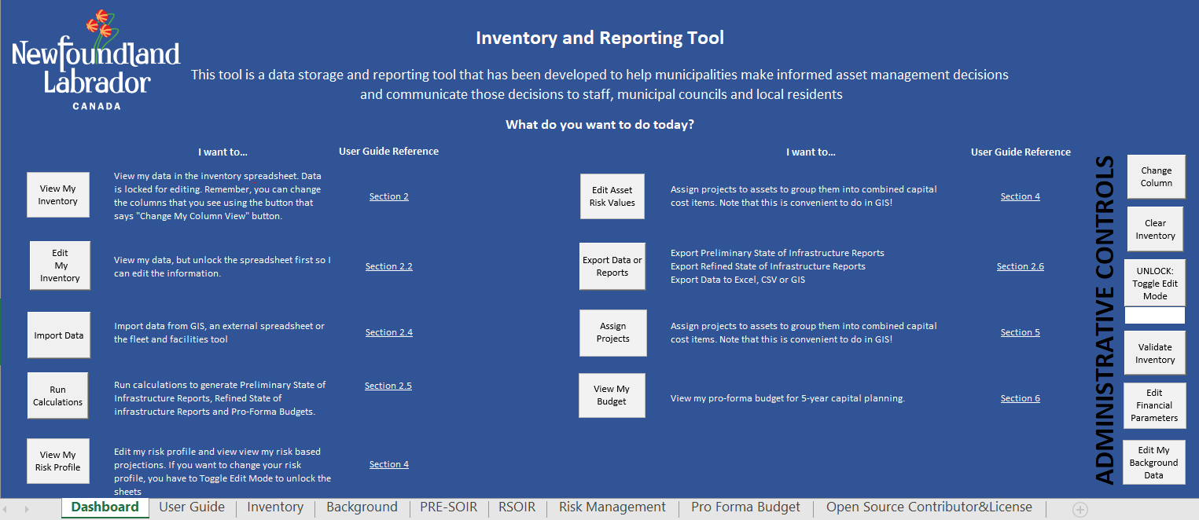
These are your sheets

Column Filters
The column filters are in place to help you navigate through your inventory. The 79 headers used in the tool can be filtered from view, so you only see what you need. You can filter columns by clicking the button on the “Inventory” sheet shown in Figure 2-4: Filter Columns Form.
Add selected Columns
Add all Columns
Click here to display form
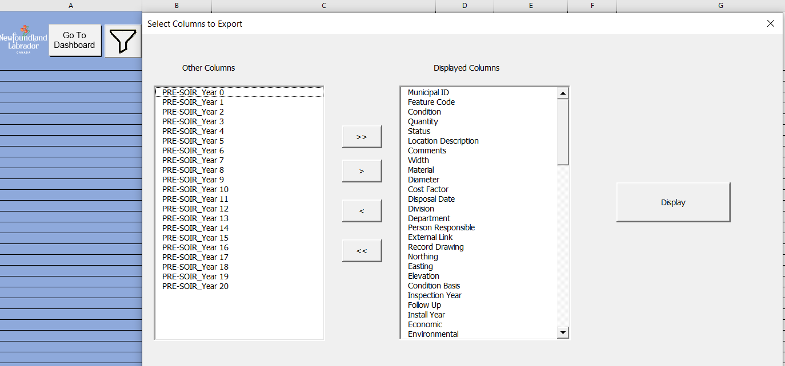
Click here when finished to display selected columns

Remove selected Columns
Remove all Columns

Figure 2-4: Filter Columns Form

Import
The spreadsheet allows multiple methods of data entry. The simplest method is to type in your data directly into the spreadsheet while in edit mode (see 2.4.6). However, this is not always practical for larger sets of data.
If you have existing data, you may use the “Import” button to bring in data from an external source. When you click the button, you may choose between importing Spreadsheet data such as a survey file, other software export, or pre-existing inventory. You will also use this tool to import Facility and Fleet Tool information.
The Import tool will ask that you map your headers. This matches the header in your import source data, with where you want the information to appear in the Inventory and Reporting Tool.
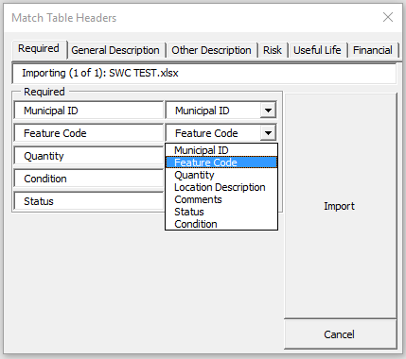
Drop-down selection
Import Header
Tool Header
Section Filters
Import file name
Figure 2-5: Import Header Mapping
HINT: The import mapping automatically selects headers in your source that match the Tool. If you want to import data quicker, copy the headers in the Inventory and Reporting to your source data as a template. This is more feasible if you are just beginning your Asset Management Program. The main benefit of the mapping function is for compatibility data sources that already exist.

Calculate/Refresh
HINT: Whenever you import new data or change information in the spreadsheet, you must click the “Calculate/Refresh” button. This button will fill in any missing calculation(s) in the “Inventory” page. It will also refresh the reports in the “PSOIR” and “RSOIR” sheets.
HINT: Try to only make one change at a time when viewing the reports so you know the effect of the change. If you change multiple pieces of information, during the same session, you will not know how much each change affected the reports.

Export
The Tool allows you to export a ‘.CSV’, or a ‘.xlxs’ file by selecting it. This allows you to:
- Link the information the Tool calculated back to another software.
- Share your inventory with others easier.
- Analyze your inventory separately from the Tool.
- Create backups of your inventory.
The “Export” button is also where you export the reports. The PSOIR allows you to select which asset classes are included in the report. The RSOIR is not customizable.
HINT: Exporting as a ‘.xlxs’ creates a backup copy of your inventory using less space than copying the entire Tool. You can restore your data by importing the backup file into a blank copy of the Inventory and Reporting Tool (See 2.4.3). It is recommended to perform this backup prior to making changes to your data.

Edit and Sort Data
The spreadsheet is password protected to prevent accidental editing of the data. When editing is enabled, the button will change on the “Dashboard” sheet, Figure 2-5: Edit Mode Button. This will allow you to freely edit your information in the “Inventory” and “Background” sheets.
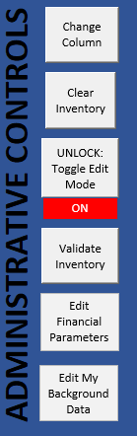
Figure 2-6: Edit Mode Button
HINT: Excel does not allow you to sort or filter locked cells. If you want to sort columns, “Edit Mode” must be enabled.

Error Checking
The Inventory and Reporting Tool has built in error checking processes. When a calculated cell cannot be determined, it will change to red.
HINT: IF you see “VLOOKUP” and there is an error, your input is not in the “Background” sheet. Adjust your input to an item in the “Background”. You may type in new information to the “Background” while in Edit Mode.
HINT: IF you see math symbols (+, -, *, /, ^), this means you have text rather than a number in one of the cells.

Facility and Fleet Tool Walkthrough
The Facility and Fleet Tool was created to easily organize the complexity of fleet and facility assets. The Tool provides simple input of data which can then be export to the Inventory and Reporting Tool for planning.
Each Facility and Fleet is stored on a separate sheet. Click the “Add Facility” button or the “Add Fleet” button on the “Main” sheet and you will be prompted to input a name. A sheet will be created with all standard components. Simply adjust the grey cells where applicable.
HINT: Most small communities will only require 1 Fleet sheet. Having multiple sheets is beneficial when you wish to organize for department or service area.

Guidance Document 3:
Asset Valuation

Asset Valuation and Useful Life
Having an idea of when you will have to replace your assets, what it will cost, and how long the replacement will last are important questions when developing an asset management program. This Guidance Document is intended to provide the reader with the background understanding of asset valuation and useful life in asset management.
Unit cost and an expected useful life is given to each asset using a combination of; feature code, material, size, and cost factor inputs. A default life and cost has been included in the Inventory and Reporting tool based on 2022 data. These costs should be edited by the user to reflect their municipality and can be periodically updated as new cost information is received. The cost data set is under the “Background” tab.
HINT: The Tool allows you to have a very broad or specific cost and life for each asset. You may simply say that all wastewater mains cost $350/m and last seventy-five years. Alternatively, you can go as far as to say the 300mm PVC Sanitary Sewer under a road is $400/m and last eighty years while the 300mm PVC Sanitary Sewer through a field is $250/m. The level of detail you include is up to you.
HINT: The Material and Diameter of your assets generally are the two largest factors when determining the cost or the lifespan. Therefore, they are specified as their own fields. However, there are many factors that can have a large influence on cost and life. The cost factor field allows you to enter any other piece of information that you know will impact the cost and life.

Unit Costing
The unit costs in the Tools are intended to be high level as cost can vary greatly from project to project. Unit costs can first be edited through discussion with experienced staff and information from past projects. The unit cost in the Tools should be conservative, but not extreme. Your unit cost should be an average that you expect across your municipality.
HINT: Setting up a simple tracking document for all your future work will help you keep these costs up to date and accurate.
HINT: Discussing with nearby municipalities will help to gather even more information and gain confidence in your information.
All costs are edited by going to the “Background” sheet and editing the “Base Cost”. This value is then adjusted by the factors in the ‘Asset Valuation’ table, which can also be edited by the user. The final replacement cost is calculated by Equation 3-1: Replacement Cost Formula.
$$=Quantity*Base Cost*(1+\%Supplemental Costs)$$
Equation 3-1: Replacement Cost Formula
The Inventory and Reporting Tool is equipped with supplemental costs which can be applied to any asset. You may add a percent increase to your unit costs for: engineering, inspection, removals, and contingency. You may set these to 0% if you prefer. You may also add multiple options that can be applied to different assets. The Inventory and Reporting Tool contains default recommended values. The following is a list of typical ranges for supplemental costs;
- Engineering considers the cost of design and project management; most capital projects require engineering. Dependent on the complexity and scale of the project. Typical Range; 3% - 10%, recommended 5%.
- Inspection considers the cost of the presence of site inspection during and following the completion of a projects. Dependant on the complexity of the project, capacity of municipal staff to perform inspection, and your risk tolerance. Typical range; 0% - 15%, recommended 10%
- Removals considers the cost of demolition and safe removal of the asset being replaced. Dependant on the type of asset. Typical Range; 0% - 10%, recommended 10%.
- Contingency considers additional costs for unanticipated construction costs or delays not identified in the budget or scope. Dependant on the complexity and unknowns of a project. Typical range 5%- 50% recommended 30%. The relatively high contingency costs are included to accommodate unknown project elements that are typically not identified at this stage of planning.
HINT: Costs for individual assets in your inventory can be input if desired by entering a value in the “Asset Renewal Cost” field column in the “Inventory” sheet. This will override the calculation and is helpful for projects that you currently have estimates for. These costs will not be affected by the supplemental costs.

Service Life
Having an accurate service life of your assets is important for your planning so you can project when you will have to spend money. The longer an asset can stay in service the more value you get from it. There are currently useful lives built into the “Lookup” sheet for each asset, which are based on engineering opinions, as opposed to PSAB standards. These values are meant to be general and cannot capture the impacts of use, environment, product quality and maintenance.
The useful life does not represent the age that you would replace an asset. It represents when an asset will no longer be able to provide the service expected by users. This can vary by expected levels of service. Expect for emergency cases, assets would generally be replaced before they reach this stage.
HINT: The Risk management Guidance Document outlines when you should consider replacing your assets. Service life is only a piece of this decision, ultimately the question you should ask is what the asset’s risk is to not meet my level of service (also see section 5.1) and how long can I tolerate that risk.
Updating your assets’ useful lives is similar to updating unit costs. Discuss with experienced public works staff to determine what useful life they are confident in using for planning. The install year field is an important field to capture during your data collection if it is available. Comparing the condition of your assets to their age and tracking the age of assets that fail will help you refine the useful lives and your Asset Management Program matures.
HINT: When updating your assets’ useful lives and unit costs it may seem overwhelming to update everything. Focus on the assets that take up the most of your budget. This will provide you the most value for your effort at the early stages of planning.

Degradation
Degradation curves define how an asset wears down over time. Items such as machinery may appear to be in good condition, then quickly begin to break down and become poor. The Tool is equipped to allow the user to input degradation curves for their assets. Typical degradation curves for assets are shown in Figure 3-1: Degradation Curves. The condition value of 0 is not used in the tool, but represents a brand new, and unused condition. Condition 6 represents that the infrastructure has failed (is no longer providing the intended service) and will trigger replacement within the next five years.
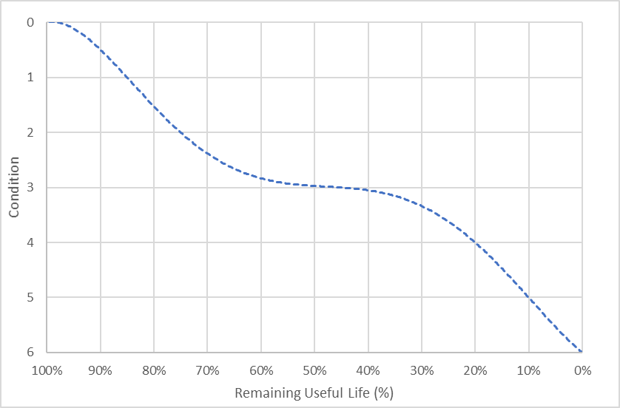
Figure 3-1: Degradation Curves

Guidance Document 4:
Risk Management

Risk Management
Much of the attention and focus of public complaints is focused on the condition of infrastructure. With limited funds available it should not be the primary focus of a municipality. The focus should be on reducing risk of your asset’s failure.
This Guidance Document is intended to provide the reader with the background understanding of risk management in asset management, and how it is implemented into the Toolkit. Risk should be assessed by municipal staff with a variety of scenarios. Their impact on finances should be presented to elected officials for final decisions. The risk tools are intended to allow staff to easily analyze the effects of risk and clearly communicate the risk definitions and their impacts to elected officials and the public.

Defining Probability and Consequence of Failure
Asset priority is set by risk. By definition in this Toolkit, an extreme risk is a combination of probability and consequence that is unacceptable, e.g., an almost certain catastrophic consequence. By definition, a high risk is a combination of probability and consequence that can be tolerated no longer than five years. These assets will be scheduled to be replaced within the first five years. Subsequent assets are scheduled to be replaced within the five-year period that they are projected to reach high risk, or if they have a very low consequence of failure, they will be projected to be replaced at their end of expected useful life.
Risk is based on two factors; Probability of Failure (PoF) and Consequence of Failure (CoF). As a default, the PoF is simply the condition of your asset on a 1 to 5 scale. The CoF is also on a 1 to 5 scale. CoF should be defined by municipal staff and approved by elected officials. Figure 4-1: PoF and CoF Rating Definitions presents general definitions of the PoF and CoF on the 1 to 5 scale.
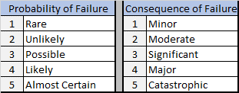
Figure 4-1: PoF and CoF Rating Definitions
The Inventory and Reporting Tool defines a default PoF and CoF. The default PoF (‘dPoF’ field) is the condition of the asset. The default CoF (‘dCoF’ field) is defined in the ‘background’ sheet and can be edited with the same process as editing you costs.
You may override these default values with the Refined Probability, ‘rPoF’, and Refined Consequence, ‘rCoF, fields on an asset-by-asset basis. This is a low effort, high value process to help you prioritize assets, if all roads have the same default CoF and as condition defining a CoF for each road helps you identify what is most important to your community.
A typical template for defining rCoF is contained in the Tool and is presented in Figure 4-2: Refined Consequence of Failure Definition.

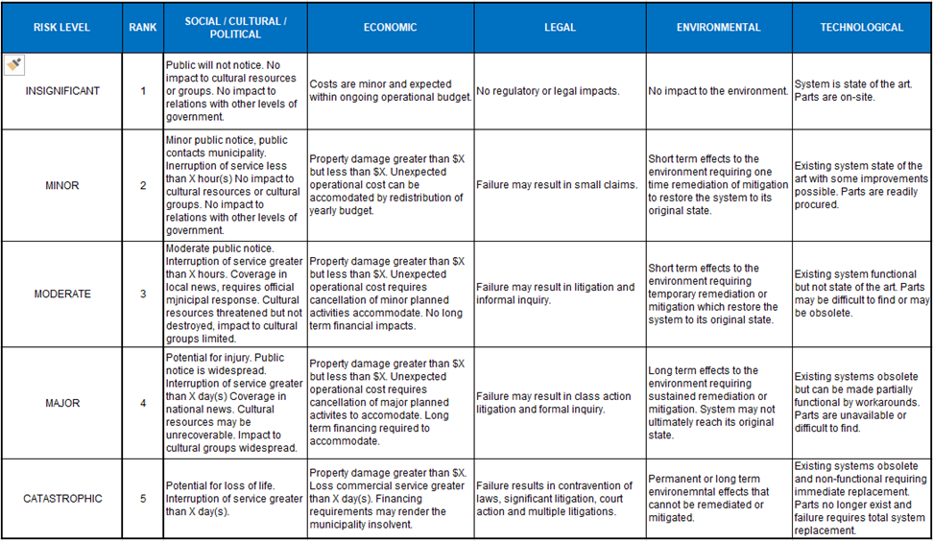
Figure 4-2: Refined Consequence of Failure Definition

Defining Risk
The combination of an assets PoF and CoF will create an overall risk score. This is simply done using a matrix which is stored in the Inventory and Reporting Tool. The matrix can be customized to suit your municipality’s needs. All final decisions are recommended to be approved by elected officials. The default risk matrix is presented in Figure 4-3: Default Risk Matrix.
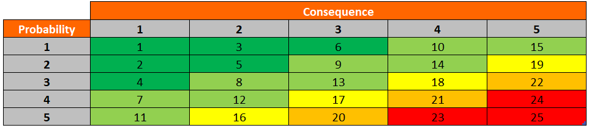
Figure 4-3: Default Risk Matrix
The overall risk score is then ranked by your municipality’s tolerance which is represented in the matrix by colour and define in the Inventory and Reporting Tool. The default risk tolerances are presented in Figure 4-4: Default Risk Tolerance.
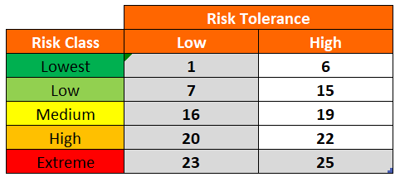
Figure 4-4: Default Risk Tolerance

Refining Risk and Prioritizing Works
Risk score is the basis of the Refined State of Infrastructure Reporting created in the Tool. The Refined 20 year Capital Plan, presented in Figure 4-6: Sample Refined 20 Year Capital Plan, prioritizes works based on the information present in Figure 4-5: Priority Definition.
When assessing the impacts of risk on your cost projections, it is recommended you adjust the ranges in your risk tolerance, not the matrix. Make sure you understand what this tolerance means. Defining “High Risk” as 16-20 means that you can be comfortable not replacing an asset in Very Poor condition (PoF of 5) for 6-10 years, provided the consequence of the asset failing is insignificant (CoF of 1), making the risk score 15, medium risk. This would also mean that if the consequence of the asset failing is major (CoF of 4), and the condition is poor (CoF of 4), the risk score is now 21 and defined as extreme. This would mean you should plan to replace it immediately. Balancing the risk with your budget is one of your main challenges and tools when it comes to communicating the state of your infrastructure and what it means, to council and the public.
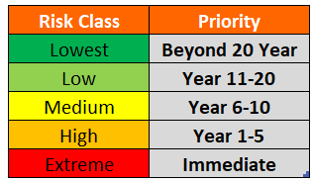

Figure 4-5: Priority Definition

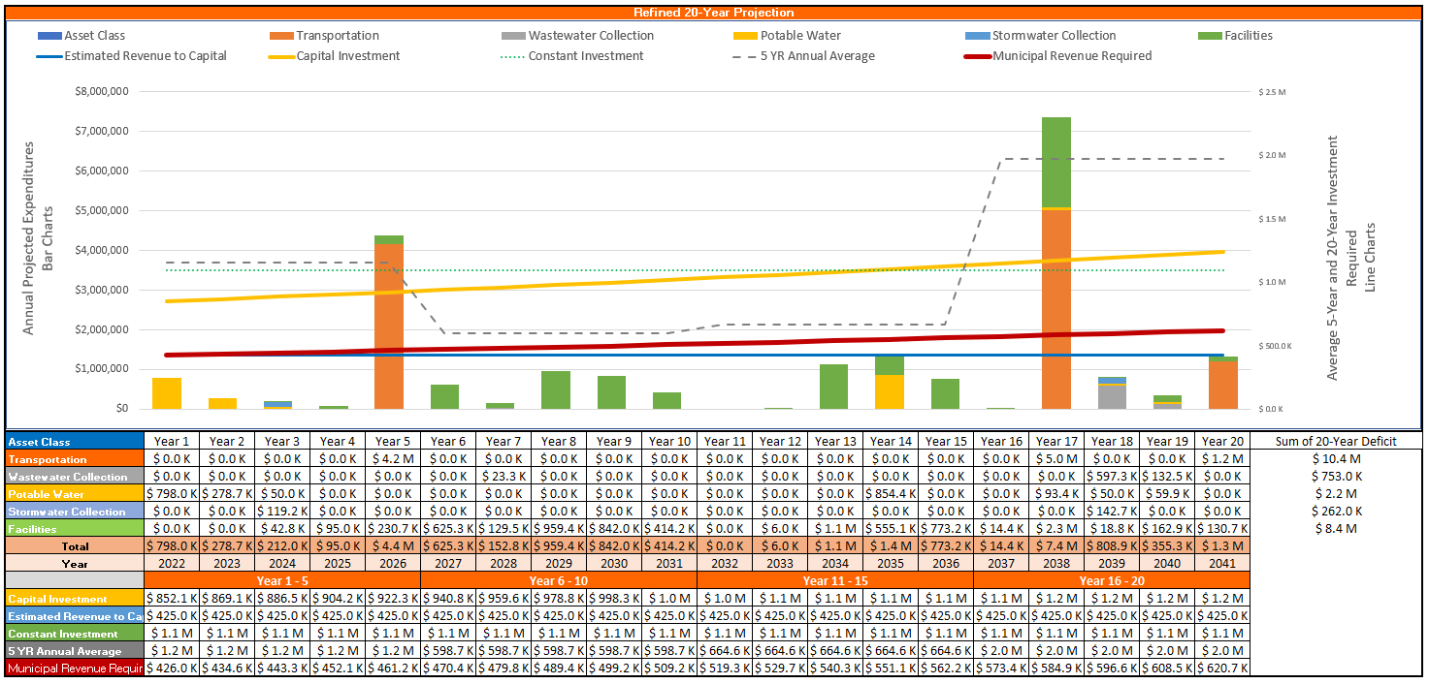

Figure 4-6: Sample Refined 20 Year Capital Projection

Adjusting Risk for Level of Service and Climate Change
PoF and CoF can be manually adjusted in the spreadsheet based on considerations related to level of service demands (Refer to Section 5.1 of this Guide) and Climate Change considerations (Refer to Section 4.6 of this Guide). These adjustments will change the risk and priority profile:
- Current gaps and future reduction or increase to Level of Service requirements may change the Probability of Failure; e.g.:
Changing population to an older demographic may decrease use at an arena which increases the chance that the facility will no longer meet community expectations;
Reduction in sewage flow from reduced population may decrease the chance of failure at an overloaded sewage lift station.
In this case, manually adjust the probability of failure in the Inventory and Reporting Tool.
- Current gaps and future reductions, or increases to Level of Service requirements may change the Consequence of Failure; e.g.:
Change of use by decommissioning a school may reduce the consequence of failure of a water main providing service to the building;
Change of road classification or zoning can increase the consequence of failure of a road with flooding issues.
In this case, manually adjust the consequence of failure in the Tool.

Risk Mitigation
The primary focus of a municipality should be to reduce its risk. This can be performed by either reducing the PoF, CoF, or adjusting risk tolerance. The decision on which option to explore can be difficult and vary on an asset-to-asset basis. The Tool enables you to analyze options by looking at the costs to reduce each factor and its overall benefit.
An example of success in Risk Mitigation is a municipality that has multiple wastewater pumping stations. A long-term replacement program was being proposed to be fast tracked due to an increasing number of failures and public complaints. Instead, the municipality hired a local pumper truck operator. The operator would be on site by an agreed upon time and on-call at all hours to pump sewage past the pumping station while repairs took place. This allowed the municipality to keep their replacement project on track and keep the public happy. For risk management, this would lower the CoF of the pumping station, reducing the overall risk score.
An example of reducing the PoF, without replacing the asset, is slip lining a corroded culvert without excavating and replacing it (provided it still has enough capacity!). This is a lower cost option to renew the infrastructure.
An example of reducing the CoF is to develop alternate routes for emergency services to detour roads that are subject to flooding. This allows services to continue without interruption during extreme weather.
Another example is an aging rail bridge that has been converted for public use. The trail is popular for snowmobiles and occasionally locals take their trucks across the bridge. The bridge had a high-risk score and was assessed by an engineer. The inspection showed that the bridge was not safe for motorized vehicles but safe for pedestrians. The inspection stated there is no immediate failure for pedestrian use. The municipality put a weight restriction on the bridge only allowing pedestrians and installed a lock gate to prevent motorized vehicles from crossing. This reduced the PoF and overall risk score.

Climate Change Adaptation
Climate change adaptation projections require adjusting the risk elements, probability and consequence of failure:
- Projected climate change impacts may increase the Probability of Failure; e.g.:
Increasing precipitation and rising sea levels may decrease the expected lifespan of a stormwater system, shoreline erosion protection or increase the probability that a ditch system will fail and cause flooding;
Climate change impacts do not tend to reduce the probability of failure of an asset.
In this case, manually adjust the probability of failure in the Tool.
- Projected climate change impacts may increase the Consequence of Failure; e.g.:
Projected increase in wind velocity can increase the forecasted magnitude of damage to structures;
Climate change impacts do not tend to reduce the consequence of failure of an asset.
In this case, manually adjust the consequence of failure in the Tool.
The climate change adaptation tool can be used to work through these forecasts of PoF and CoF changes in a consistent and standardized process. This adaptation tool is based on guidance from Federation of Canadian Municipalities, and the process can be found in the document: Federation of Canadian Municipalities: A Guide for Integrating Climate Change into Asset Management through Levels of Service and Risk Management (2020): https://fcm.ca/sites/default/files/documents/programs/mamp/guide-for-integrating-climate-change-considerations-into-municipal-am.pdf
This version of the tool contains an added analysis in the Loss Avoidance section. If you enter potential costs related to emergency response, damage or lost economic performance in the “Do Nothing Costs” section of the spreadsheet, shown in Figure 4-7: Do Nothing Costs, the tool will calculate a risk weighted “loss avoidance”, the potential loss avoided, pro-rated based on your risk assessment, that indicates an adaptation value of the project. The loss avoidance percentage, the ratio of potential loss avoided to the project cost, can be used to prioritize projects, where higher percentages are more valuable projects.
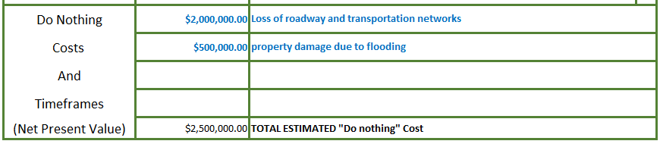

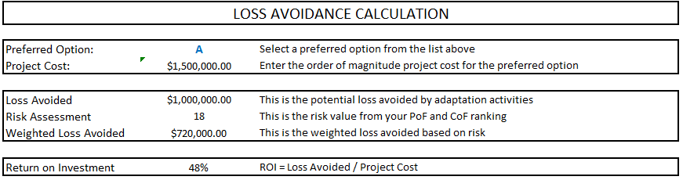
Figure 4-7: Do Nothing Costs

Figure 4-8: Loss Avoidance Calculation

Guidance Document 5:
Capital Planning

Capital Planning
Asset Management gives municipal staff the tools to make informed decisions. Capital Planning is where decision making happens. All aspects of a communities Asset Management Program should be utilized to select projects for capital planning with transparency.
This Guidance Document is intended to provide the reader with the background understanding capital planning in asset management, and how it is implemented into the Toolkit. Capital Planning should be performed by municipal staff by reviewing a variety of scenarios incorporating all aspects of their Asset Management Program. Their decision making should be presented to elected officials for final decisions.

Level of Service
Levels of Service describe the extent and quality of services that the municipality provides to users. Levels of Service link an asset's performance to target performance goals and can be broken down into the following categories:
  - Legal Requirements: Statutory, Regulatory and contractual requirements are the minimum levels of service that must be provided. For example, drinking water must meet legislative requirements.
  - Community (Customer) Levels of Service (CLOS) define how a service is perceived by the user, with non-technical measures for service goals. The CLOS refers to the entire system that provides the service being evaluated. Considerations for evaluating CLOS include capacity, safety, reliability, quality, and sustainability. For example, customers expect the system to be reliable without excessive service disruption.
  - Technical Levels of Service (TLOS) are specific and quantifiable measures for service targets. Continuing the example above, the CLOS may be related to technical performance in that the system has no more than 10 breaks per year with service disruptions no greater than eight hours.
  - Operation levels of service (OLOS) are the asset level requirements to ensure the technical levels of service. For example, to achieve the TLOS, there should be no more than 30% of pipes with condition 5 (Very Poor), the municipality must retain spare pipe, valves, fittings for adequate response time, and equipment such as loaders, dump trucks and backhoes are needed to perform the work.
Projects should be considered that close any gaps in your current level of service, or to ensure that the current level of service can be sustained.
HINT: Choosing to lower a level of service to reduce costs can be a smart Asset Management decision.

Setting Investment Targets
The Refined State of Infrastructure Report shown in

Assigning Projects
Selecting which projects to include in your budget for replacement requires all aspects of your Asset Management Program. Projects can include any number of assets, for example, a street reconstruction project may include; the street, sewer, sidewalks, signage etc. You will select projects to be included in a five-year proforma budget within the Tool which would typically be included in your formal capital plan. Selected projects for the upcoming year are typically done to a further level of detail outside the Tool with more detailed cost-estimates. While everyone will have a different approach to selecting projects, there are general steps you can follow to get started.

HINT: GIS systems are very help when projects. You can quickly see when multiple assets of high risk are located and select them all to create a project.

First you can refine your list by asking the following questions;

- Is the Asset at High or Extreme risk?
- Is the Asset meeting my Level of Service?
- Has the Asset Failed?

If the answer is yes to any of these questions you already have a shortlist of assets to consider in your capital plan. To refine further, a good first step is location. Typically works are completed by street from intersection to intersection and this is a good way to approach the high-level five-year plan. Ask yourself these questions;

- Is there a street in very poor condition that also has underground utilities in very poor or poor condition?
- How will replacing these assets impact my other assets? Are any of those assets that would be impacted still low risk?

Small difficult decisions arise at this stage. If you have two projects to consider, first being a sewer in very poor condition under a road in good condition, second being a sewer in poor condition under a road in poor condition, it may be more cost-effective to replace the second. You will also likely want to replace assets that were not shortlisted but are impacted by the project, like signage on a street reconstruction.
HINT: When weighing two choices one may be slightly better than the other. Selecting the “less right” project doesn’t make it a wrong decision. These are complex problems with many variables that change constantly. We are making informed decisions, not perfect decisions. You’re doing great and learning everyday.
The final step is the determining cost. The Tool will assign a total value of the project by adding all the renewal costs together. A simple check is to multiple your yearly budget by 5 and see if your total project costs are over or under budget. If you are fortunate enough to be under budget you can explore adding additional projects to the budget or putting away money in reserves to ensure you are ready for the next five-year cycle. Section 6 discussed dealing with difficult financial decisions.

HINT: Make sure you are aware of your 20-year, and generational cost projections. There could be a spike of costs in the future that you need to plan for now and set up reserves.
HINT: Many projects get funding from grants outside your revenue. Most communities can expect 50-66% of the cost of there projects to be funded. Consider this when looking at your final project costs.
Assigning projects in the Tool after your decisions are made is straightforward. Each project needs a unique name at all assets in the project will share. Enter the name in the “Project Name” field for the corresponding assets. You may also assign a year that you plan for the project to be completed. The Tool is indent to only plan projects over a five-year period. The final thing, that is easy to miss, is the “Department Field”. For the tables on the “Pro Forma Budget” sheet to display the cost by department, each asset in the project needs to be assigned its corresponding department i.e., Transportation, Potable Water Supply etc.
An unfortunate truth for many municipalities across Canada is that there or more projects that need to be completed than there is budget to complete them. You will likely find yourself comparing multiple options, in addition to comparing multiple projects and their cost or risk you can look at alternative solutions.
This can be done by following the steps to adjust risk tolerance in Section 4.3 Refining Risk and Prioritizing Works or by increasing expected useful life, and accepting a higher risk of service disruption, by following Section 3 Asset Valuation and Useful Life
HINT: If you want to see the impact of changes to your risk, useful life, cost, etc., make your edits with the “Edit Mode” enabled (2.4.6 Edit and Sort Data). Click the “Calculate/Refresh” button and go to the “PSOIR” or “RSOIR” sheet.
If a project includes the creation of a new asset that you do not currently own you can include it in your budget still. Create a new asset as you typically would by filling in the required fields; Municipal ID, Feature Code, Quantity, Status (active). You may also want to add additional fields like material or diameter, treat it like any other asset. You must enter the Condition of the asset as ‘6’. This will allow the new asset to be incorporated in the twenty-year projection.

Guidance Document 6:
Financial Planning

Financial Planning
The inventory tool provides a dataset of all your asset inventory and projected infrastructure capital demands. This is not a capital plan but can be used to assist in capital planning priorities, rate setting and reserve funding. This Guidance Document shows the recommended use of the Tools to:
- Interpret reports for financial planning
- Assess short- and long-term budget requirements for capital planning
- Adjust priorities to match capital demands with available budget
- Assess asset renewal options (maintain, rehabilitate or replace)
- Assess the impact of new infrastructure financial projections
- Plan capital reserve financing for future growth
- Plan contingency reserve financing for reducing risk

Inputs
To allow financial planning in the spreadsheet, inputs can be adjusted in the “Background” sheet and can be quickly found by clicking the “Financial” button in the Table Filters. The following inputs are required:
Inflation Rate: this is the anticipated average annual inflation rate for the term of the projection. It is based on historical averages. A default value of 2% is provided in the Tool.
Revenue: this is the current municipal annual revenue based on tax rates, anticipated funding from Provincial and Federal levels of government, utility rate payments and any other revenue sources.
Revenue Change: this is your anticipated annual percentage change in revenue. This is entered as a negative percentage if revenue is expected to drop (e.g., from a reduction in population) and is positive if revenue is expected to increase (e.g. from increased tax rates, increased funding opportunities, increasing population, or changes to land use taxation). Adjust this value in the “Background” sheet.
Municipal Contribution: Most capital projects rely on funding for sources outside of municipal revenue, such as gas tax funding. This entry is the percentage of cost, on average, that you expect your municipality to contribute after other funding sources.

Financial Planning
The Refined State of Infrastructure Report (RSOIR) is intended to guide capital planning and is not the capital plan itself. Figure 1 shows the 20-year projection yearly costs and three potential funding scenarios (shown as dashed lines). The funding scenarios are generated based on the Inflation Rate (R_{i}) entered in the database.
NOTE: Yearly operations and maintenance (O&M) are included in the capital infrastructure deficit report. While capital expenses and operations / maintenance are sometimes managed under separate budgets, they are both important for funding projections. This arrangement also allows correct assessment of renewal options (e.g., increased capital expense which reduces O&M cost).
HINT: The spreadsheet calculations assume that municipal returns on investment (e.g., for reserve funding) will be equal to the Inflation Rate. If municipal reserve funding has a return on investment greater than the Inflation Rate, excess funding will be available. If municipal reserve funding has a return on investment less than the Inflation Rate, asset renewal and maintenance will be underfunded.
Reporting from the asset management tool will show infrastructure projections over twenty-years.
The bar charts show the projections for each asset class in each year. Totals are shown in the tables below the chart.
The yellow line shows the annual investment required to construct all the forecasted capital projects, starting in current dollars and increasing with expected inflation. This is the investment target based on your projections, which will include municipal contributions and outside funding.
The red line is municipal investment target (not including outside funding) required to delivery the yearly capital demands over twenty years.
The dashed grey line shows the average of each five-year planning period.
The blue line shows your projected revenue over the period. This is based on your current revenue and how much you expect your revenue to change in the future.
If the blue revenue line is above the red line, there will be enough funding to meet infrastructure demands. If this line is below the red line, there will not be enough funding to meet the twenty-year infrastructure demands.
In the second case, to meet infrastructure funding demands, the municipality can adjust demands and revenue using the methods in Section 6.4.
HINT: Changes to prioritization of infrastructure should only be adjusted by making risk and prioritization decisions, that is, making decisions that change the probability and consequence of failure.
HINT: The funding requirements shown come from all sources including municipal revenue, service fees and funding from other levels of government.

Figure 6-1: 20 Year Capital Projections

Short Term Capital Budget Planning
Municipalities can use the reporting from the RSOIR to assess whether the forecasted revenue from all sources will be enough to fund their projected capital works in the near and long term. Capital demands are based on Asset Risk and Prioritisation.
But what if My Town’s funding sources are not enough to meet capital and operational demands?

What if there is not enough money?
To match the 20-Year projection with available funding, you must make decisions on what assets to defer for replacement. This may even require deciding to abandon or decommission assets if they are not an essential service. To adjust the 20-Year projection, a municipality has the following options:
- Adopt a higher level of risk by adjusting the risk matrix developed using the Asset Risk and Prioritisation section. This decision can be made by reviewing the potential liabilities identified in the risk assessment process and accepting a higher probability of occurrence.
- Decrease the probability of failure of an asset. This is done by adding cost to the rehabilitation field.
Following rehabilitation, the asset’s condition can be upgraded and / or the expected service life may be increased.
An example of this would be slip lining a deep culvert under a roadway to avoid trenching and road rehabilitation or scheduling early crack sealing and overlaying to extend the life of a roadway.
- Reduce the consequence of failure with a lower cost activity. By adding a lower cost process, procedure or asset, consequence of failure ratings can be lowered.
Examples of this would be installing “no winter maintenance” signs to reduce operations costs for snow clearing on active transportation corridors or having spare parts on hand to reduce down- time for equipment failure.
- Decommission the asset
By deciding to decommission or abandon an asset, it can be removed from the inventory database as it no longer needs to be maintained or replaced. Don’t forget to include decommissioning costs.
An example of this would be eliminating replacement of a boardwalk by shutting it down to public use.
- Increase Revenue
Revenue can be increased by seeking out new funding streams, increasing tax rates or adding user pay systems. To adjust this in the spreadsheet tool, change the “Revenue Change” percentage based on the strategy that is adopted. This will change the yearly revenue and amortized revenue available.

Assessing Options
It will not always be clear whether it makes the most sense to include budget for maintenance, rehabilitation, or replacement. Using Life Cycle Costing, the total present value of different options will be developed to compare different options and their effect on costs over the life of the asset.

Planning for Change
Municipalities change over time. New developments or land use can change the amount of revenue coming from different sources. Decreasing populations can reduce revenue available over time, as well as the level of service required. This can result in additional or reduced infrastructure to meet level of service expectations.
The first step in assessing the impacts of infrastructure growth is to use Life Cycle Costing to estimate the initial capital expense, yearly operation cost, periodic maintenance cost and decommissioning or replacement costs. You may then project ongoing costs and replacement costs over several years. Use the Following steps in the Inventory and Reporting Tool to perform Life Cycle Costing.
- Export RSOIR twenty-year projection as Existing Condition
- Adjust useful life, replacement cost, maintenance cost, etc. in background sheet.
- Re-Export twenty-year projection as new Scenario
- Repeat for all funding scenarios you wish to compare
HINT: If you want to see what change has the greatest impact on the budget. Only adjust one thing at a time. You can then see what impacts your budget the most. Then begin to adjust several things at a time to create a budget scenario which can be presented to council as an option.

Contingency Reserves for Risk Mitigation
The spreadsheet tool will calculate contingency reserves required to meet future infrastructure needs and will change based on the information entered and updated using the procedures in other modules of the Toolkit and procedures in this Guidance Document.

Valuation of Assets
Inflation is in the existing Tool as a single value, located in Column X in the “Lookup Sheet” to allow future value calculations of assets. All assets under this mandate are tangible capital assets, so the asset Toolkit also calculates depreciation, amortization payments and salvage or disposal value which can all be edited within the Toolkit. Current value is assigned by a linear depreciation over the useful life, by defining the location of the asset on standard degradation curves using the condition rating, or by generating a modified useful life scale based on condition ratings.

Guidance Document 7:
Glossary

Glossary
Term | Definition
Amortization | Paying off the cost of an asset over multiple payments. Similar to a Mortgage.
Asset | Any resource owned by the municipality.
Asset Management | The organization of assets to determine when they need to be replaced and how much it will cost to replace them.
Asset Management program | A combination of guidance documents, spreadsheets, and procedures used to help manage assets.
Asset Valuation | Estimating how much an asset is worth.
Capital Planning | The process of determining how much money will be required for future work and putting aside a certain amount to ensure that future repairs and replacements are possible, as well as current requirements
Consequence of Failure (CoF) | A numerical value on a scale from 1 to 5 that represents the resulting impact of an asset failing
Condition Assessment Guide | Instructions on how to complete condition assessments using visual inspection or operational data
CSV | CSV stands for comma separated values. It is a file format used to store data where information is separated by commas. Files in this format will end in ".csv". Often surveys are formatted this way.
Cycle Costing | Process of adding all the costs an asset will have over its lifetime (such as installation costs, repair costs, etc.) to determine its total cost.
Data | Information about an asset including, location, material, size, unit cost, etc.
Data collection | The process of gathering data to be input into the asset management database.
Database | A collection of data, typically kept on a computer. Often refers to more advanced programs designed to store vast amounts of data.
Degradation | When the condition of an asset becomes worse over time. Deterioration of an asset. The process of the condition of an asset becoming progressively worse.
Degradation Curves | A graph whose line represents the deterioration of an assets condition over a specified period of time
Depreciation | The decrease in the value of an asset over time because of age and usage.
End of life | When an asset is no longer able to serve its purpose. This would be represented by a probability of failure of 5.
GIS | Stands for Geographic Information System. A system that is used to make maps.
Guidance Document | A document used to help the reader understand a certain process or procedure.
Inflation | The decrease in the value of money making the cost of goods and services increase.
Inflation Rate | A percentage representing the expected increase in the price of an asset based on how much prices have increased in the past. A default value of 2% is provided in the Tool.
Inventory | A list of all assets that a municipality owns.
Inventory Management | The organization of materials to determine when more materials need to be ordered.
Level of Service | The quality and specific services that the Municipality supply’s and are expected by the Public.
Life cycle | The expected length of time that an asset will be useable. This is the time it takes to go from a Condition 1 to a Condition 5. Can be impacted by maintenance and materials.
Life cycle analysis | The process of determining the life cycle of an asset.
Life cycle cost | How much an asset will cost over its life cycle. Including upfront cost, maintenance, and decommissioning.
Macro | A type of computer programming used in Excel the minimizes the effort required to complete certain tasks.
Maintenance | Repairs and support required throughout the life of an asset that is meant to prevent failure of the asset.
Map | In the context of the guidance document. Mapping refers to lining up the columns in your source data to the tool.
Open source | Software that is free and does not require a license to use.
Probability of Failure (PoF) | The likelihood that an asset will fail. This is based on the age of the asset, its material, and how much it has been used.
Program | The combination of guidance documents, spreadsheets, and procedures used for this asset management process.
PSAB | Stands for Public Sector Accounting Board. This identifies accounting standards for the public to use.
Renewal | The process of fixing or replacing an asset.
Revenue | The amount of money a municipality has made after subtracting costs for maintenance, replacements, etc.
Revenue Change | The amount a municipality's revenue is expected to change between one year and another.
Risk analysis | The process of determining what the likelihood of failure and the result of failure are for an asset and then deciding on a timeline you are willing to wait before replacing it.
Salvage Cost | How much an asset's parts can be sold for after it has reached its End of life.
Service Delivery | A Municipality providing services such as potable water to the Public.
Service Gaps | Services that a Municipality cannot afford to provide to the Public.
Straight line degradation | When the condition of an asset becomes worse at a constant rate.
Tangible Capital Assets | Assets that have physical form and a specified monetary value
Toolkit | The Toolkit is the combinations of Tools and Guidance documents commission by the Province.
Tools | Three Excel spreadsheet; Inventory & Reporting, Fleet & Facility, and the Climate Change Integration Tools.
Unit cost | The cost assigned for a specific measurement of an asset
Useful life | When an asset is no longer able to serve its purpose. When an asset reaches this point, the salvage cost can be calculated, and its useful parts can be sold or repurposed.

Appendix A:
Quick Start Guide

Overview
This Guidance Document will show you the fastest way to begin your Asset Management Program. The Inventory and Reporting Tool and the Fleet and Facility Tool will be used to generate capital reports. Additional features are shown in section 2.

Computer Requirements
To run the Tools on your computer you will need the following:
- Windows Operating System
- Microsoft Excel 2010 or newer
This Document is using Windows 10 and Excel 2016.

Inventory and Reporting Tool
The Inventory and Reporting Tool holds all your data. To begin inputting data you need to hit the “Toggle Edit Mode” button. When the square next to the button turns red, you may start typing in data.
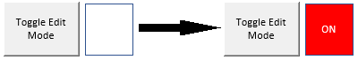
Figure A-1: Edit Mode
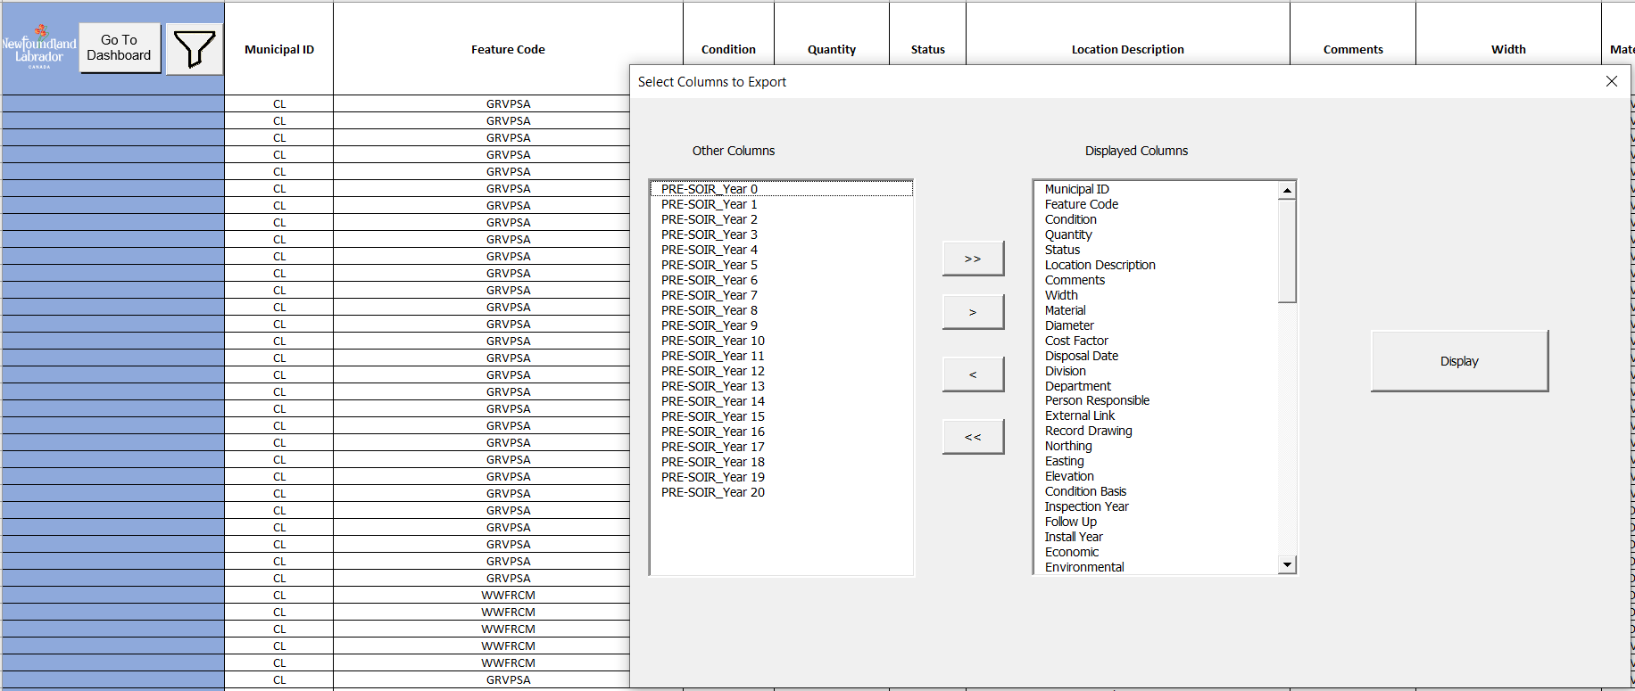
You may now begin typing in your data. There are a lot of columns. If you put the mouse over the title for a few seconds a description of the column will pop up. You can also change the column set you see with the filter button at the top right of the inventory.

Figure A-2: Column Description
To begin creating reports, you need to have several columns populated:
- Municipal ID
  - Found in the Inventory and Reporting Tool’s “Background” sheet in the Municipality ID table. This value will be the same for all your assets.
- Feature Code
  - A unique code used to represent a type of asset and must be in the “Feature Code” table in the “Background” Sheet, e.g., MHSA, is a maintenance hole for your sanitary sewer main.
- Condition
  - Numerical value on a 1 to 5 scale, with 1 being “like new” and 5 being “extremely poor”.
- Quantity
  - The length or number of assets.
- Status
  - Either “Active” or “Inactive”. Inactive assets will not be included in reports or projections.
Once you have entered some data, press the “Run Calculations” button on the dashboard and you will already be on your way to asset management planning!
To begin entering your data you should first focus on assets that cost the most money. Let’s say my community has 10km of paved roads in fair shape, 5 km of paved roads in poor shape, 8 corrugated steel culverts in good shape, and a 3 km trail in very good shape.
First, I need to enter data in the required fields (green). The Municipal ID (column B) is the unique code for my municipality in the “Background” sheet. I am using an example so my Municipal ID will be “EX” for all my assets.
Next, I need to enter a Feature Code (column E) for each asset. This can also be found in the “Background” sheet. I have a paved road (RR), culvert (CLVT) and trail (RRTR).
The next green field is the quantity (column G) of the asset. This represents how much of each asset I have. This is important for costing. In the “Asset Valuation” table in the “Background” sheet you will see the “Unit” field (column AM). My culverts are in ‘m’ (meters). If you are not sure what the lengths of the culverts are, the easiest thing to do is assume each culvert’s length. Let’s say each culvert is 15m. So, 8 culverts at 15 m each is 120 m total.
My roads and trail are ‘sqm’ (square meters). I will need to convert my lengths of my roads and my trial from ‘km’ to ‘m’ and then fill in an additional field. This is the ‘Width’ (column K) of the asset. My roads all have 2 lanes, and I will assume this means a total width of 7 m. My trail is about 2 m wide. I will have to put those values into the ‘Width’ field.
The “Status” field (column O) is next. Enter ‘Active’ for each asset. If you have any assets that you want to keep track of but do not manage, you may input ‘Inactive’.
The final field is condition (column Z). Condition is on a 1 to 5 scale, where 1 is very good and 5 is very poor.
Figure A-5: Condition
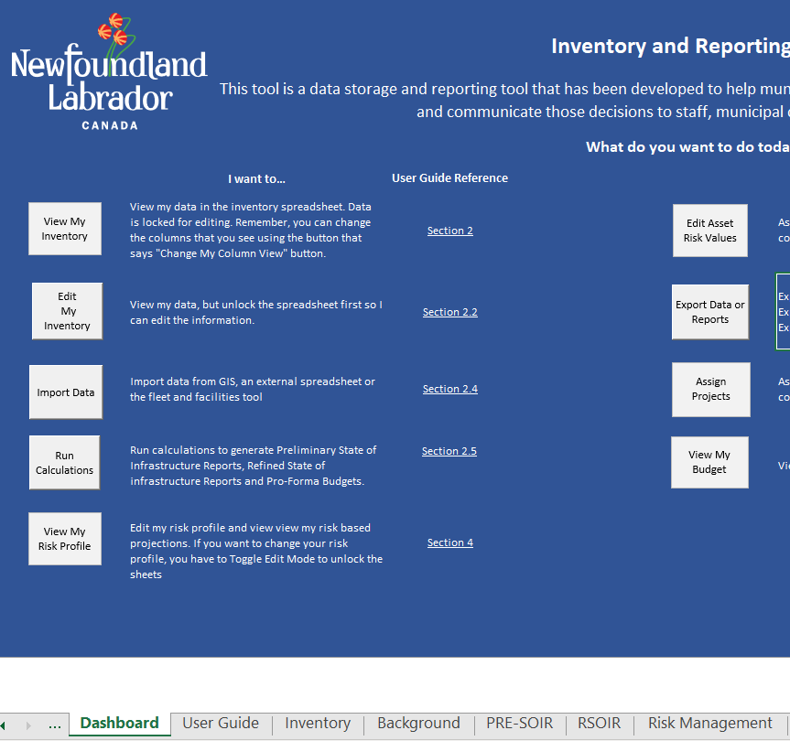
Background Sheet
Figure A-6: Background Sheet
All the data you need is now input. Click the “Run Calculations” button to update all other information in the Tool. You can then export the Preliminary State of Infrastructure and Refined State of Infrastructure Reports by clicking the “Export Data” or Reports” button to create a PDF of the reports.

