

Municipal Infrastructure Division
Department of Transportation and Infrastructure

Condition Assessment Guide

Revision | Comments | Date

Contents
STORMWATER COLLECTION i
Stormwater Gravity Main (GRVPST) 1
Conduit (CNDT) 1
Stormwater Catch Basin Lead (CBLD) 1
Stormwater Service Connection (SWSRVC) 1
Stormwater Manhole (MHST) 1
Stormwater Dry Well (DW)* 1
Stormwater Forcemain (SWFRCM) 4
Stormwater Ditch (SWDCH) 4
Stormwater Lift Station (LIFT) 4
Stormwater Catch Basin (CB) 6
Stormwater Gutter (RRGT) 6
Stormwater Inlet/Outlet (IO) 7
Stormwater Culvert (CLVT) 8
Stormwater Pond (PND) 10
Stormwater Treatment Device (TRMTD) 11
Stormwater Underground Storage (UGS) 11
WASTEWATER COLLECTION ii
Wastewater Gravity Main (GRVPSA) 1
Wastewater Gravity Main Combined (GRVPCO) 1
Wastewater Service Connection (WWCN) 1
Wastewater Effluent Discharge Pipe (WWEFDP) 1
Wastewater Pump Station (PMPS) 1
Wastewater Force Main (WWFRCM) 2
Wastewater Combined Manhole (MHCO) 2
Wastewater Manhole (MHSA) 2
Wastewater Drop Manhole (WWMD) 2
Wastewater Flush Manhole (WWMF) 2
Wastewater Combined Catch Basin (CBCO) 2
Wastewater Collection (WWC) 3
Wastewater Treatment (WWT) 3
Wastewater Septic Field (SEPT) 3
Wastewater Septic Tank (WWST) 3
Wastewater Conventional Pump (WWCPMP) 4
Wastewater Submersible Pump (WWSPMP) 4
Wastewater SBR Tank (WWSBRT) 4
Filter Feed Tank (WWFFT) 5
Wastewater Lagoon (WWLAG) 5
Wastewater Screen Chamber (WWSCRC) 6
Wastewater Bar Screen Chamber (WWBSC) 6
Wastewater Flow Meter (WWFLME) 6
Wastewater Building (WWTFBLD) 7
Wastewater Office Furniture and Supplies (WWOFS) 7
Wastewater Computer (WWCOMP) 7
Wastewater Generator (WWTFGEN) 8
Wastewater Intake Structure and Valves (WWISV) 8
Wastewater Lab Equipment (WWLAB) 8
Wastewater Presedimentation Tank (WWPTNK) 9
Wastewater Streaming Current Monitor (WWSCM) 9
Wastewater Telemetry (WWTLEM) 9
Wastewater Air Compressor (WWTFAC) 10
Wastewater Gasoline Driven Trash Pump (WWGDTP) 10
Wastewater DAF Tank or Saturation Vessel (WWDAFT) 10
Wastewater DAF Skimmer (WWDAFS) 11
Wastewater Electric Motor (WWELECM) 11
Wastewater Oxidization Ditch (WWOXDI) 12
Wastewater Paddle Aerators (WWPADAE) 12
Wastewater Clarifier (WWCLAR) 13
Wastewater Sludge Drying Bed (WWSDB) 13
Wastewater Blower (WWBLWR) 14
Wastewater Air Release Valve (ARSA) 14
Wastewater Chlorine Contact Chamber (WWCLCC) 15
Wastewater Check Valve (CVSA) 15
Wastewater Bypass Valve (WWBPV) 15
Wastewater Effluent Valve Chamber (WWEVC) 15
Wastewater Valve Chamber (WWVC) 15
Wastewater Chemical Feed System (WWCCSYS) 16
Wastewater Chemical Feed System (WWCCSYS) 16
Wastewater Cleanout (WWCO) 16
Wastewater SCADA (WWSCADA) 17
Wastewater UV Disinfection System (WWUV) 17
Wastewater Effluent Tank (WWEFT) 18
Wastewater Equalization Tank (WWEQT) 18
Wastewater Outfall/Overflow Chamber (WWOC) 18
WATER SUPPLY iii
Water Supply Storage Tank (WSST) 1
Water Booster Station (BST) 1
Water Curb Stop (CS) 2
Water Corporation Stop (CRS) 2
Water Transmission Main (TRNS) 2
Water Distribution Main (DIMN) 2
Water Service Connection (WTCN) 2
Water Meter (METER) 2
Fire Hydrant (HY) 3
Water Source (WS) 4
Water Air Pressure Relief Valve (APV) 4
Water Clean Out 4
Water Pressure Reducing Valve (PRV) 6
Water Gate Valve (GV) 6
Water Blow Off Valve (BOV) 6
Water Supply Butterfly Valve (WSBFV) 6
Water Supply Ball Valve (WSBV) 6
Water Supply Hydrant Valve (WSHYV) 6
Water Supply General Valve (WSVLV) 6
Conventional Pump (WSCPMP) 7
Water Submersible Pump (WSSPMP) 7
Water Mixed Media Filter (WSMMF) 8
Water Chemical Feed System (WSCCSYS) 8
Water Vacuum Chlorinator (WSVACCL) 9
Water Flow Meter (WSFLME) 9
Office Furniture and Supplies (WSOFS) 9
Office Furniture and Supplies (WSOFS) 10
Computer (WSCOMP) 10
Lab Equipment (WSLAB) 10
Generator (WSTFGEN) 11
Intake Structure and Valves (WSISV) 11
Clarifier (WSCLAR) 12
Presedimentation Tank (WSPTNK) 13
Streaming Current Monitor (WSSCM) 13
Chlorine Leak Detector (WSCLLD) 13
Telemetry (WSTLEM) 14
Air Compressor (WSTFAC) 14
Gasoline Driven Trash Pump (WSGDTP) 14
DAF Tank or Saturation Vessel (WSDAFT) 15
DAF Skimmer (WSDAFS) 16
Electric Motor* (WSELECM) 16
Water Membrane Filter System* (WSMFS) 17
UV Light* (WSUV) 18
Water Lagoon (WSLAG) 19
TRANSPORTATION iv
Road (RR) 1
Curbed Road (RRCB) 2
Street Light (TFSL) 4
Ornamental Street Light Standard (TFSLOR) 4
Utility Pole (UTPO)* 4
Traffic Signal on Stop Sign (TSIG) 4
Traffic Light (TFTL) 4
Sign Post (TFSP) 5
Sidewalk (RRSW) 6
Trail (RRTR) 6
Pathway (RRPW) 6
Pier (Bridge Support) (STPR) 8
Guide Rail (STGR) 9
Side Bar (SB) 9
Fence Line (FL) 9
Boardwalk (RRBW) 9

HOW TO USE THE GUIDE

This Guide is separated into four (4) sections based on asset class.
- Stormwater Collection
- Wastewater Collection
- Water Supply
- Transportation
This guide is intended to be a low barrier to entry for small to medium size municipalities to perform non-intrusive visual or subjective condition assessment of their infrastructure for high level planning. These are not engineering assessments and do not recommend repairs.
All assessment criteria is intended to identify the probability that an asset will required a capital project to repair/replace it. Maintenance and operations activities are not included in this guide.
Each inspection table is split into two sections: visual & subjective scoring. These should be applied to an asset at once, if a visual assessment is available it will override the subjective score. Many tables can be applied to the same asset due to their similaty, such as valves.
If a table has multiple criteria for the visual assessment, the overall condition should be the worst score of all the criteria.
DISCLAIMERS

This Guide is based on Province of Nova Scotia Asset Management Templates licensed under a Creative Commons ShareAlike 4.0 International Public License (“IPL 4.0”). Terms of this license can be found by visiting https://creativecommons.org/licenses/by-sa/4.0. Modifications to the Guide include formatting changes and revisions to the road assessment section.
In accordance with the requirements of CDDL 1.0 and IPL 4.0 the following disclaimer and limitation of liability statement is included on behalf of previous Contributors:
DISCLAIMER OF WARRANTY
COVERED SOFTWARE IS PROVIDED UNDER THIS LICENSE ON AN AS IS BASIS, WITHOUT WARRANTY OF ANY KIND, EITHER EXPRESSED OR IMPLIED, INCLUDING, WITHOUT LIMITATION, WARRANTIES THAT THE COVERED SOFTWARE IS FREE OF DEFECTS, MERCHANTABLE, FIT FOR A PARTICULAR PURPOSE OR NON-INFRINGING. THE ENTIRE RISK AS TO THE QUALITY AND PERFORMANCE OF THE COVERED SOFTWARE IS WITH YOU. SHOULD ANY COVERED SOFTWARE PROVE DEFECTIVE IN ANY RESPECT, YOU (NOT THE INITIAL DEVELOPER OR ANY OTHER CONTRIBUTOR) ASSUME THE COST OF ANY NECESSARY SERVICING, REPAIR OR CORRECTION. THIS DISCLAIMER OF WARRANTY CONSTITUTES AN ESSENTIAL PART OF THIS LICENSE. NO USE OF ANY COVERED SOFTWARE IS AUTHORIZED HEREUNDER EXCEPT UNDER THIS DISCLAIMER.
LIMITATION OF LIABILITY
UNDER NO CIRCUMSTANCES AND UNDER NO LEGAL THEORY, WHETHER TORT (INCLUDING NEGLIGENCE), CONTRACT, OR OTHERWISE, SHALL YOU, THE INITIAL DEVELOPER, ANY OTHER CONTRIBUTOR, OR ANY DISTRIBUTOR OF COVERED SOFTWARE, OR ANY SUPPLIER OF ANY OF SUCH PARTIES, BE LIABLE TO ANY PERSON FOR ANY INDIRECT, SPECIAL, INCIDENTAL, OR CONSEQUENTIAL DAMAGES OF ANY CHARACTER INCLUDING, WITHOUT LIMITATION, DAMAGES FOR LOST PROFITS, LOSS OF GOODWILL, WORK STOPPAGE, COMPUTER FAILURE OR MALFUNCTION, OR ANY AND ALL OTHER COMMERCIAL DAMAGES OR LOSSES, EVEN IF SUCH PARTY SHALL HAVE BEEN INFORMED OF THE POSSIBILITY OF SUCH DAMAGES. THIS LIMITATION OF LIABILITY SHALL NOT APPLY TO LIABILITY FOR DEATH OR PERSONAL INJURY RESULTING FROM SUCH PARTYS NEGLIGENCE TO THE EXTENT APPLICABLE LAW PROHIBITS SUCH LIMITATION. SOME JURISDICTIONS DO NOT ALLOW THE EXCLUSION OR LIMITATION OF INCIDENTAL OR CONSEQUENTIAL DAMAGES, SO THIS EXCLUSION AND LIMITATION MAY NOT APPLY TO YOU.

PART I
STORMWATER COLLECTION

Asset Class: | Stormwater Collection (SWC)
Asset Sub-Type: | Pipes (PI)
Feature Code(s): | Stormwater Gravity Main (GRVPST)  Conduit (CNDT)  Stormwater Catch Basin Lead (CBLD)  Stormwater Service Connection (SWSRVC)
Condition Rating: | 1 | 2 | 3 | 4 | 5
Cracking and Joint Displacement (if no CCTV available, not applicable; leave blank) | None | Minor, no infiltration evident | Minor, some seepage evident. | significant cracking and/or joint displacement. Significant infiltration | excessive cracking and/or joint displacement. Excessive infiltration. Pipe collapse imminent
Visible blockage by sediment (flush pipe) | None | <10% of diameter | 10% to 25% of diameter | 25% to 50% of diameter | Over 50% of diameter
Subjective Rating (do not include with visual assessment)
Age | < 25% Useful Life | ≥ 25% & < 50% | ≥ 50% & < 75% | ≥ 75% & < 100% | ≥ 100% UsefulLife

Asset Class: | Stormwater Collection (SWC)
Asset Sub-Type: | Manholes (MH)  Other (OT)*
Feature Code(s): | Stormwater Manhole (MHST)  Stormwater Dry Well (DW)*
Condition Rating: | 1 | 2 | 3 | 4 | 5
Appearance | Excellent condition. No signs of concrete/brick damage, cover and frame look great. No leaking evident. | Good condition. No visual concrete/brick damage, minor signs of wear on cover and frame. No leaking evident. | Fair condition. Minor concrete/brick damage no gaps or exposed rebar, minor cracking on frame and cover. Evidence of leaking along walls or pipe penetrations. | Poor condition. Significant concrete/brick damage with cracks greater than 6mm. Cracks greater than 6mm or missing pieces from frame and cover. Significant leaks along walls or pipe penetrations. | Very poor - critical condition. Excessive concrete/brick damage, exposed rebar, frame and cover missing or not safe for use. Soil penetrating walls or pipe penetrations.
Subjective Rating (do not include with visual assessment)
Age | < 25% Useful Life | ≥ 25% & < 50% | ≥ 50% & < 75% | ≥ 75% & < 100% | ≥ 100% UsefulLife

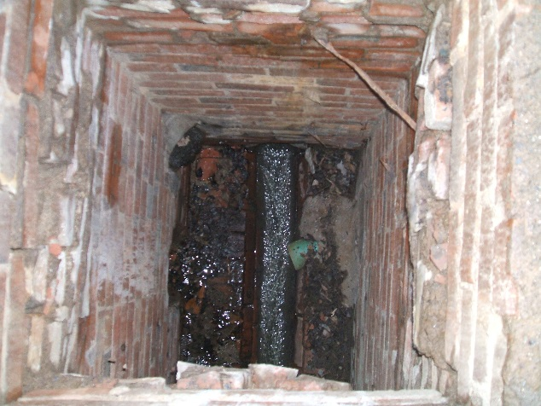 | - Brick manhole, cracks in mortar, significant damage, still safe for use (4)
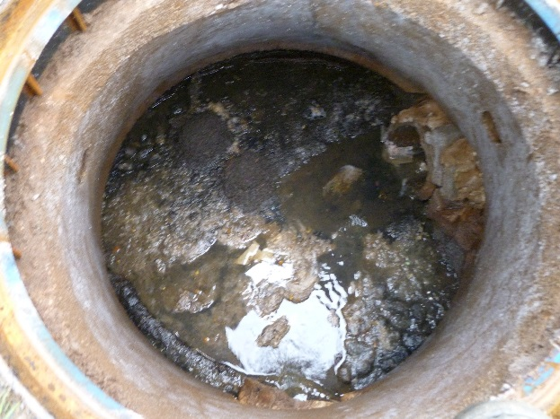 | - Exposed rebar, leakage and staining from joints (5)
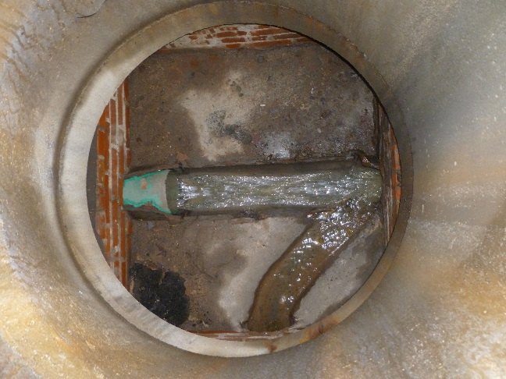 | - Manhole appearance, no signs of damage or cracking condition, signs of leakage (3)
 | - Pipe blockage, none (1)

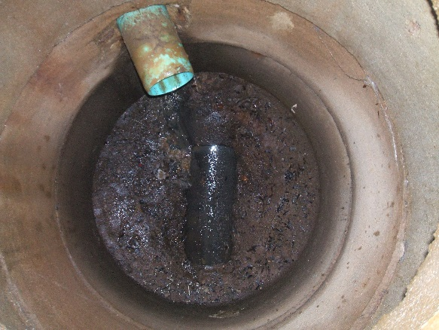 | - Manhole appearance, excellent condition, no sign of concrete leakage (1)
 | - Pipe blockage, 25% to 50% blocked (4)
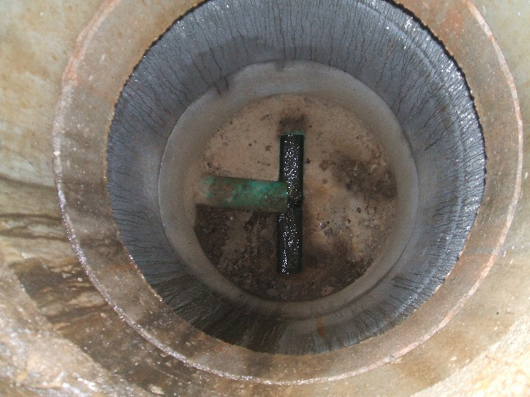 | - Manhole appearance, evidence of concrete leakage, no severe concrete damage (3)
 | - Pipe blockage, 25% to 50% blocked (4)
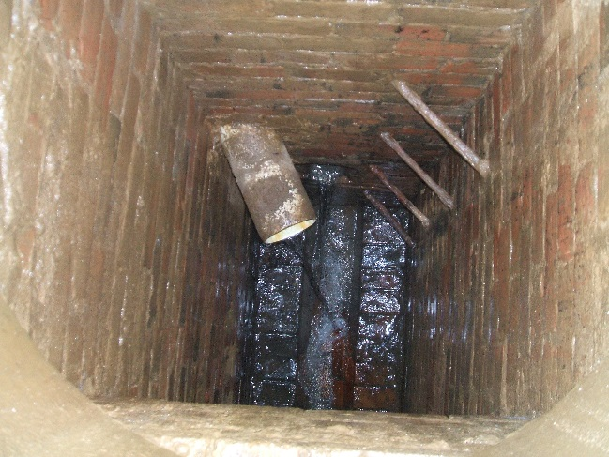 | - Manhole appearance, excellent condition, no sign of leakage or damage (1)
 | - Pipe blockage, none (1)

Asset Class: | Stormwater Collection (SWC)
Asset Sub-Type: | Pipes (PI)
Feature Code(s): | Stormwater Forcemain (SWFRCM)
Condition Rating: | 1 | 2 | 3 | 4 | 5
Number of Leaks per Year | No Leaks | < 1 leak per Year | 1 leak per Year | 2 leaks per Year | > 2 leaks per Year
Subjective Rating (do not include with visual assessment)
Age | < 25% Useful Life | ≥ 25% & < 50% | ≥ 50% & < 75% | ≥ 75% & < 100% | ≥ 100% UsefulLife

Asset Class: | Stormwater Collection (SWC)
Asset Sub-Type: | Other (PI)
Feature Code(s): | Stormwater Ditch (SWDCH)
Condition Rating: | 1 | 2 | 3 | 4 | 5
Capacity | No capacity issues with sufficient freeboard during design storm | No capacity issues with minimal to no freeboard during design storm | No capacity issues during significant rainfall events. Overtops during design storms. | Overtops during significant rainfall events | Overtops during minor rainfall events
Condition | No damage to banks or riprap | Bare patches in ditch banks, no missing riprap, minimal vegetation growth | Minor sloughing in locations above typical operating water level, missing riprap at inlet, outlet or invert, in few locations, trees and shrubs starting to grow | Numerous areas of sloughing on banks, erosion evident around riprap locations, significant tree or shrub growth | Numerous areas with sloughing on banks, tree or shrub roots may penetrate berm core.
Subjective Rating (do not include with visual assessment)
Age | < 25% Useful Life | ≥ 25% & < 50% | ≥ 50% & < 75% | ≥ 75% & < 100% | ≥ 100% UsefulLife

Asset Class: | Stormwater Collection (SWC)
Asset Sub-Type: | Pumping Station (PS)
Feature Code(s): | Stormwater Lift Station (LIFT)
Condition Rating: | 1 | 2 | 3 | 4 | 5
Interior Wet Well Condition | Excellent condition. No signs of concrete damage, paint on piping and valves looks great. No leaking evident. | Good condition. No visual concrete damage, minor rusting on piping and valves. No leaking evident. | Fair condition. Minor concrete damage, some rusting of piping and valves. Minor leaking visible when pumps running | Poor condition. Significant concrete damage, significant rusting of piping and valves. Still operable. Significant leaking visible when pumps running | Very poor - critical condition. Excessive concrete damage, exposed rebar, major rusting of piping and valves inoperable. Excessive leaking visible when pumps running
Exterior Condition | Excellent condition. No signs of concrete damage, hatch, control panel enclosure and vent piping looks great | Good condition. No visual signs of concrete damage, hatch, control panel enclosure and vent piping look good. | Fair condition. Minor concrete damage, hatch, control panel enclosure and vent piping still serviceable. | Poor condition. Significant concrete damage, hatch & control panel enclosure have broken or missing parts but is still operable. vent piping significantly deteriorated. | Very poor condition. Excessive concrete damage, hatch & control panel enclosure not lockable and hinges broken, vent piping excessively deteriorated
Mechanical Fault Outages | 0 per Year | 1 per Year | 3 per Year | 3-5 per Year | >5 per Year
Past Maintenance | 2 + per year | 1 per year | 1 per 2 years | 1 per 5 years | 0 per year
Subjective Rating (do not include with visual assessment)
Age | < 25% Useful Life | ≥ 25% & < 50% | ≥ 50% & < 75% | ≥ 75% & < 100% | ≥ 100% UsefulLife

Asset Class: | Stormwater Collection (SWC)
Asset Sub-Type: | Catch Basins (CB)
Feature Code(s): | Stormwater Catch Basin (CB)
Condition Rating: | 1 | 2 | 3 | 4 | 5
Appearance | Excellent condition. No signs of concrete/brick damage, cover and frame look great. No leaking evident. | Good condition. No visual concrete/brick damage, minor signs of wear on cover and frame. No leaking evident. | Fair condition. Minor concrete/brick damage no gaps or exposed rebar, minor cracking on frame and cover. Evidence of leaking along walls or pipe penetrations. | Poor condition. Significant concrete/brick damage with cracks greater than 6mm. Cracks greater than 6mm or missing pieces from frame and cover. Significant leaks along walls or pipe penetrations. | Very poor - critical condition. Excessive concrete/brick damage, exposed rebar, frame and cover missing or not safe for use. Soil penetrating walls or pipe penetrations.
Sump (flush sump) | <25% accumulation in sump |  | 50-75% accumulation in sump |  | No sump present, or >75% accumulation in sump
Subjective Rating (do not include with visual assessment)
Age | < 25% Useful Life | ≥ 25% & < 50% | ≥ 50% & < 75% | ≥ 75% & < 100% | ≥ 100% UsefulLife
*See Stormwater Manhole visuals for appearance scoring.
Asset Class: | Stormwater Collection (SWC)
Asset Sub-Type: | Other (OT)
Feature Code(s): | Stormwater Gutter (RRGT)
Condition Rating: | 1 | 2 | 3 | 4 | 5
Surface Condition (concrete) | Like new. No signs of surface wear, spalling, cracking, heave or settlement. All control & expansion joints are in good shape and edges are intact | Good Condition. Occasional cracks <10mm, slight signs of surface wear, slight spalling or scaling. Some isolated patches in good condition. Occasional settlement <25mm vertical. | Moderate spalling and scaling, frequent patches in good condition. Moderate longitudinal cracks extending across control joints of about 30% to 50% of length. Faulting (i.e. vertical surface drop) <25mm vertical in about 10% to 25% of slabs. | Up to 50% of slabs have severe chipping or spalling. Moderate cracks (10 to 20mm) extending continuously across a few slabs, slabs faulting 25mm or more. Large number of patch work in fair condition. | All the previous mentioned defects are in severe condition, poor drainage and extensive patching that is in poor condition.
Subjective Rating (do not include with visual assessment)
Age | < 25% Useful Life | ≥ 25% & < 50% | ≥ 50% & < 75% | ≥ 75% & < 100% | ≥ 100% UsefulLife

Asset Class: | Stormwater Collection (SWC)
Asset Sub-Type: | Other (OT)
Feature Code(s): | Stormwater Inlet/Outlet (IO)
Condition Rating: | 1 | 2 | 3 | 4 | 5
Corrosion / Denting / Spalling | Excellent condition. No signs of damage, | Good condition. No visual damage aside from minor deformation or chipped concrete with no rebar exposed. | Fair condition. Any of: Visible damage, dents, corrosion or spalling to 10% of pipe. | Poor condition. Any of: Visible damage, dents, corrosion or spalling to 50% of pipe. | Very poor - critical condition. Any of: Damage, dents, corrosion through pipe wall or spalling with exposed rebar,
Riprap Protection / Headwall | Handrails and trash racks in place. Rock protection in place. No damage to headwall. | Minor signs of wear on handrails and trash racks. Some sloughing in riprap protection. Surficial cracking, spalling on headwall | Minor damage to handrails and trash racks. Small visible gaps in riprap protection. Cracks greater than 6mm wide or spalling greater than 6mm deep in headwall. | Significant damage to handrails and trash racks, sloughing of riprap protection with visible bank erosion. Cracks greater than 12mm wide or spalling greater than 12mm deep in headwall. | Handrails not solid or broken, trash racks missing or blocked. Riprap protection not present. Cracks greater than 25mm wide or spalling that exposes rebar in headwall.
Sedimentation/ Vegetation Buildup | None | <10% of diameter | 10% to 25% of diameter | 25% to 50% of diameter | Over 50% of diameter
Subjective Rating (do not include with visual assessment)
Age | < 25% Useful Life | ≥ 25% & < 50% | ≥ 50% & < 75% | ≥ 75% & < 100% | ≥ 100% UsefulLife

Asset Class: | Stormwater Collection (SWC)
Asset Sub-Type: | Pipes (PI)
Feature Code(s): | Stormwater Culvert (CLVT)
Condition Rating: | 1 | 2 | 3 | 4 | 5
Roadway | No deterioration | Dip in asphalt above culvert | Single transverse crack above culvert | Alligator cracking and dip in asphalt above culvert | Pothole or sinkhole above culvert
General Appearance | Excellent condition. No signs of damage, No leaking evident | Good condition. No visible damage, minor signs of wear/age. | Fair condition. Minor concrete spalling / CMP corrosion / HDPE/PVC cracking. | Poor condition. significant concrete spalling / CMP corrosion / HDPE/PVC cracking. | Very Poor condition. Excessive concrete spalling / CMP corrosion / HDPE/PVC cracking.
Inlet/outlet condition | Excellent Condition. No damage, riprap intact | Good condition. No visual damage, Some sloughing in riprap protection | Fair condition. Any of: Visible damage to approximately 10% of pipe, small visible gaps in rock protection. | Poor condition. Any of: Visible damage or corrosion to 50% of pipe, sloughing of riprap protection with visible bank erosion. | Very poor - critical condition. Any of: Damage or corrosion on the majority of the pipe, erosion protection not present with evidence of erosion.
Subjective Rating (do not include with visual assessment)
Age | < 25% Useful Life | ≥ 25% & < 50% | ≥ 50% & < 75% | ≥ 75% & < 100% | ≥ 100% UsefulLife

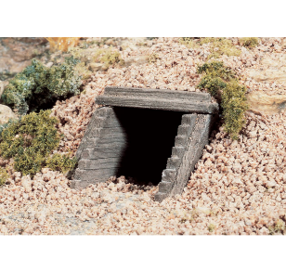 | - General Appearance, Excellent condition. No signs of damage, No leaking evident (1)  - Inlet/Outlet, Good condition (1)  - Overall condition (1)

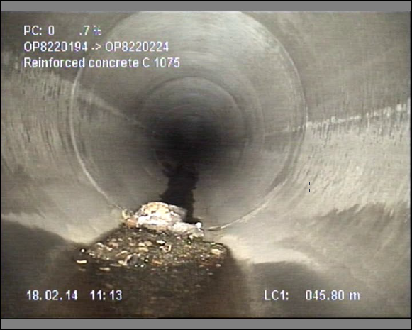 | - Culvert appearance, Good condition, Minor signs of deterioration (2)  - Overall condition (2)
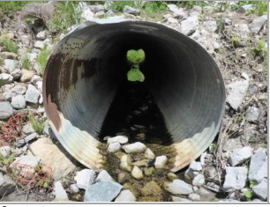 | - Culvert appearance, Fair condition,CMP corrosion (3)  - Inlet/Outlet, Inlet is slightly caved in, small visible gaps in rock protection. (2)  - Overall condition (3)
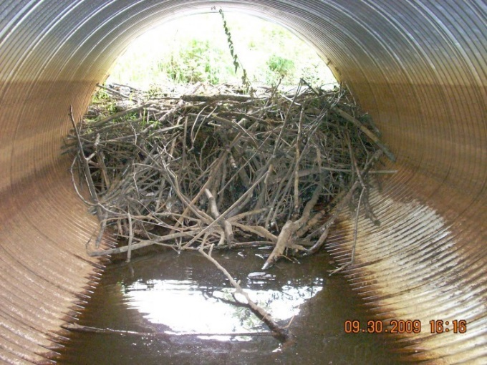 | - Culvert appearance, poor condition, CMP corrosion (4)  - Maintenance required to clean blockage.  - Overall condition (4)

Asset Class: | Stormwater Collection (SWC)
Asset Sub-Type: | Other (OT)
Feature Code(s): | Stormwater Pond (PND) Note: Consider maintenance activities to improve condition
Condition Rating: | 1 | 2 | 3 | 4 | 5
Vegetation / Clearing | Clear access to pond. No overgrown paths or equipment | Vegetation beginning to encroach on access to the pond site | Moderate vegetation growth. Access to site starting to become restricted | Significant vegetation growth which impedes access to the pond site | Access to pond site not possible.
Erosion/Bank Sloughing | No sloughing. | Sloughing on 10% of the bank. | Sloughing on 10 - 25% of bank | Sloughing up to 50% of bank. | Sloughing on over 50% of the bank
Garbage Accumulation | None |  | Minor debris in pond, no blockage of inlet or outlet |  | Significant debris causing blockage of inlet and outlet.
Sediment Accumulation (wet pond) | > 80% remaining volume capacity | 75% to 80% of remaining volume capacity | 50% to 75% of remaining volume capacity | 25% to 50% remaining volume capacity | <25% remaining volume capacity
Water Level Issues | None |  | Standing water in pockets in bottom of pond, Outlet partially blocked. |  | Permanent pool in bottom of pond, sediment blockage at outlet, anecdotal reports of overtopping.
Damaged Fencing or Concrete | No observed damage to perimeter fencing or concrete | Minor damage to fencing or concrete. Structure remains in good working order. | Moderate damage to fencing or concrete. Structure performance is degraded but functional. | Considerable damage to fencing or concrete. Structural performance compromised. Fencing can be moved by hand. | Areas of fending missing or collapsed. Posts broken or detached from foundation.
Beaver Activity | None |  |  |  | Beaver dam impeding pond flow
Subjective Rating (do not include with visual assessment)
Age | < 25% Useful Life | ≥ 25% & < 50% | ≥ 50% & < 75% | ≥ 75% & < 100% | ≥ 100% UsefulLife

Asset Class: | Stormwater Collection (SWC)
Asset Sub-Type: | Other (OT)
Feature Code(s): | Stormwater Treatment Device (TRMTD)
Condition Rating: | 1 | 2 | 3 | 4 | 5
Appearance | Excellent condition. No signs of concrete/brick damage, cover and frame look great. No leaking evident. | Good condition. No visual concrete/brick damage, minor signs of wear on cover and frame. No leaking evident. | Fair condition. Minor concrete/brick damage no gaps or exposed rebar, minor cracking on frame and cover. Evidence of leaking along walls or pipe penetrations. | Poor condition. Significant concrete/brick damage with cracks greater than 6mm. Cracks greater than 6mm or missing pieces from frame and cover. Significant leaks along walls or pipe penetrations. | Very poor - critical condition. Excessive concrete/brick damage, exposed rebar, frame and cover missing or not safe for use. Soil penetrating walls or pipe penetrations.
Subjective Rating (do not include with visual assessment)
Age | < 25% Useful Life | ≥ 25% & < 50% | ≥ 50% & < 75% | ≥ 75% & < 100% | ≥ 100% UsefulLife

Asset Class: | Stormwater Collection (SWC)
Asset Sub-Type: | Other (OT)
Feature Code(s): | Stormwater Underground Storage (UGS)
Condition Rating: | 1 | 2 | 3 | 4 | 5
Appearance | Excellent condition. No signs of concrete/brick damage, cover and frame look great. No leaking evident. | Good condition. No visual concrete/brick damage, minor signs of wear on cover and frame. No leaking evident. | Fair condition. Minor concrete/brick damage no gaps or exposed rebar, minor cracking on frame and cover. Evidence of leaking along walls or pipe penetrations. | Poor condition. Significant concrete/brick damage with cracks greater than 6mm. Cracks greater than 6mm or missing pieces from frame and cover. Significant leaks along walls or pipe penetrations. | Very poor - critical condition. Excessive concrete/brick damage, exposed rebar, frame and cover missing or not safe for use. Soil penetrating walls or pipe penetrations.
Subjective Rating (do not include with visual assessment)
Age | < 25% Useful Life | ≥ 25% & < 50% | ≥ 50% & < 75% | ≥ 75% & < 100% | ≥ 100% UsefulLife

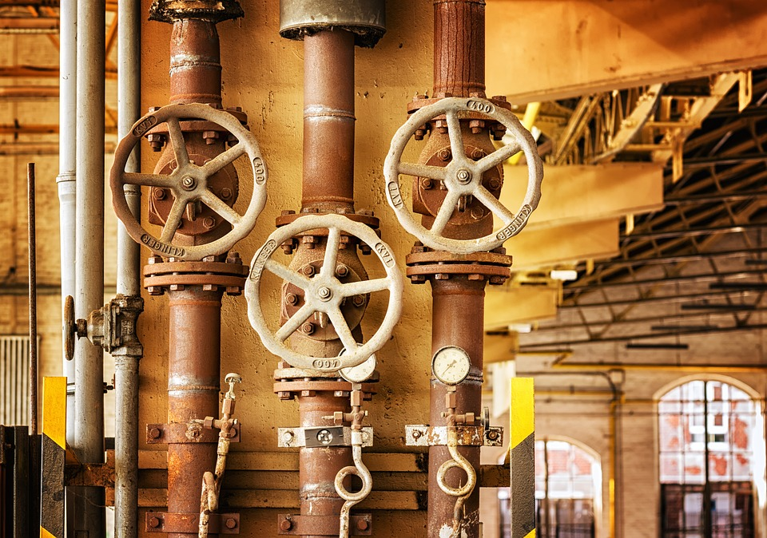

PART II

WASTEWATER COLLECTION
Asset Class: | Wastewater Collection (WWC)
Asset Sub-Type: | Pipes (PI)
Feature Code(s): | Wastewater Gravity Main (GRVPSA)  Wastewater Gravity Main Combined (GRVPCO)  Wastewater Service Connection (WWCN)  Wastewater Effluent Discharge Pipe (WWEFDP)
Condition Rating: | 1 | 2 | 3 | 4 | 5
Cracking and Joint Displacement (if no CCTV available, not applicable; leave blank) | None | Minor, no infiltration evident | Minor, some seepage evident. | significant cracking and/or joint displacement. Significant infiltration | excessive cracking and/or joint displacement. Excessive infiltration. Pipe collapse imminent
Subjective Rating (do not include with visual assessment)
Age | < 25% Useful Life | ≥ 25% & < 50% | ≥ 50% & < 75% | ≥ 75% & < 100% | ≥ 100% UsefulLife
*See Stormwater Pipe visuals for all scoring
Asset Class: | Wastewater Collection (WWC)
Asset Sub-Type: | Pumping Station (PS)
Feature Code(s): | Wastewater Pump Station (PMPS)
Condition Rating: | 1 | 2 | 3 | 4 | 5
Interior Wet Well Condition | Excellent condition. No signs of concrete damage, paint on piping and valves looks great. No leaking evident. | Good condition. No visual concrete damage, minor rusting on piping and valves. No leaking evident. | Fair condition. Minor concrete damage, some rusting of piping and valves. Minor leaking visible when pumps running | Poor condition. Significant concrete damage, significant rusting of piping and valves. Still operable. Significant leaking visible when pumps running | Very poor - critical condition. Excessive concrete damage, exposed rebar, major rusting of piping and valves inoperable. Excessive leaking visible when pumps running
Exterior Condition | Excellent condition. No signs of concrete damage, hatch, control panel enclosure and vent piping look great | Good condition. No visual signs of concrete damage, hatch, control panel enclosure and vent piping look good. | Fair condition. Minor concrete damage, hatch, control panel enclosure and vent piping still serviceable. | Poor condition. Significant concrete damage, hatch & control panel enclosure have broken or missing parts but is still operable. vent piping significantly deteriorated. | Very poor condition. Excessive concrete damage, hatch & control panel enclosure not lockable and hinges broken, vent piping excessively deteriorated
Unplanned Outages | 0 per Year | 1 per Year | 2 per Year | 3-5 per Year | >5 per Year
Subjective Rating (do not include with visual assessment)
Age | < 25% Useful Life | ≥ 25% & < 50% | ≥ 50% & < 75% | ≥ 75% & < 100% | ≥ 100% UsefulLife

Asset Class: | Wastewater Collection (WWC)
Asset Sub-Type: | Pipes (PI)
Feature Code(s): | Wastewater Force Main (WWFRCM)
Condition Rating: | 1 | 2 | 3 | 4 | 5
Number of Leaks per Year | 0 Leaks per Year | 1 leak per Year | 2 leaks per Year | 3-5 leaks per Year | > 5 leaks per Year
Subjective Rating (do not include with visual assessment)
Age | < 25% Useful Life | ≥ 25% & < 50% | ≥ 50% & < 75% | ≥ 75% & < 100% | ≥ 100% UsefulLife

Asset Class: | Wastewater Collection (WWC)
Asset Sub-Type: | Manholes (MH)
Feature Code(s): | Wastewater Combined Manhole (MHCO)  Wastewater Manhole (MHSA)  Wastewater Drop Manhole (WWMD)  Wastewater Flush Manhole (WWMF)
Condition Rating: | 1 | 2 | 3 | 4 | 5
Appearance | Excellent condition. No signs of concrete/brick damage, cover and frame look great. No leaking evident. | Good condition. No visual concrete/brick damage, minor signs of wear on cover and frame. No leaking evident. | Fair condition. Minor concrete/brick damage no gaps or exposed rebar, minor cracking on frame and cover. Evidence of leaking along walls or pipe penetrations. | Poor condition. Significant concrete/brick damage with cracks greater than 6mm. Cracks greater than 6mm or missing pieces from frame and cover. Significant leaks along walls or pipe penetrations. | Very poor - critical condition. Excessive concrete/brick damage, exposed rebar, frame and cover missing or not safe for use. Soil penetrating walls or pipe penetrations.
Subjective Rating (do not include with visual assessment)
Age | < 25% Useful Life | ≥ 25% & < 50% | ≥ 50% & < 75% | ≥ 75% & < 100% | ≥ 100% UsefulLife
*See Stormwater Pipe visuals for all scoring
Asset Class: | Wastewater Collection (WWC)
Asset Sub-Type: | Other (OT)
Feature Code(s): | Wastewater Combined Catch Basin (CBCO)
Condition Rating: | 1 | 2 | 3 | 4 | 5
Appearance | Excellent condition. No signs of concrete/brick damage, cover and frame look great. No leaking evident. | Good condition. No visual concrete/brick damage, minor signs of wear on cover and frame. No leaking evident. | Fair condition. Minor concrete/brick damage no gaps or exposed rebar, minor cracking on frame and cover. Evidence of leaking along walls or pipe penetrations. | Poor condition. Significant concrete/brick damage with cracks greater than 6mm. Cracks greater than 6mm or missing pieces from frame and cover. Significant leaks along walls or pipe penetrations. | Very poor - critical condition. Excessive concrete/brick damage, exposed rebar, frame and cover missing or not safe for use. Soil penetrating walls or pipe penetrations.
Subjective Rating (do not include with visual assessment)
Age | < 25% Useful Life | ≥ 25% & < 50% | ≥ 50% & < 75% | ≥ 75% & < 100% | ≥ 100% UsefulLife

Asset Class: | Wastewater Collection (WWC)
Asset Sub-Type: | Wastewater Treatment (WWT)
Feature Code(s): | Wastewater Septic Field (SEPT)
Condition Rating: | 1 | 2 | 3 | 4 | 5
Dispersal Bed | Looks excellent. No extra plant growth over or around bed, no foul odours detected |  | Looks fair. Some minor extra plant growth over or around bed, minor foul odours detected. No visual breakouts detected |  | Excessive plant growth over or around bed, significant foul odours detected. visual breakouts evident
Number of Leaks per Year | No Leaks | < 1 leak per Year | 1 leak per Year | 2 leaks per Year | > 2 leaks per Year
Subjective Rating (do not include with visual assessment)
Age | < 25% Useful Life | ≥ 25% & < 50% | ≥ 50% & < 75% | ≥ 75% & < 100% | ≥ 100% UsefulLife

Asset Class: | Wastewater Collection (WWC)
Asset Sub-Type: | Wastewater Treatment (WWT)
Feature Code(s): | Wastewater Septic Tank (WWST)
Condition Rating: | 1 | 2 | 3 | 4 | 5
Last Pump-Out | 1 year |  | 3 Yrs |  | 5 Yrs
Septic Tank | Tank, baffles and access ports in excellent condition. | Good condition. No visual signs of damage to tank and baffles, access covers in good condition | Fair condition. Minor tank damage visible, lose or partially blocked baffles, access covers remain serviceable | Poor condition. Significant tank damage, access covers have broken or missing parts but are still operable. Missing or significantly plugged baffles | Very poor condition. Excessive tank damage, access covers not lockable and/or broken, complete blockages of baffles evident.
Subjective Rating (do not include with visual assessment)
Age | < 25% Useful Life | ≥ 25% & < 50% | ≥ 50% & < 75% | ≥ 75% & < 100% | ≥ 100% UsefulLife

Asset Class: | Wastewater Collection (WWC)
Asset Sub-Type: | Pumping Station (PS)
Feature Code(s): | Wastewater Conventional Pump (WWCPMP)
Condition Rating: | 1 | 2 | 3 | 4 | 5
Motor Hours Run | <10,000 hours | ≥ 10,000 and < 50,000 hours | ≥ 50,000 and < 100,000 hours | ≥ 100,000 and < 200,000 hours | ≥ 200,000 hours
Vibration | No unusual vibration detectable | Minor vibration detected | Moderate vibration | Considerable vibration | Major vibration
Temperature | No unusual temperature detected | Minimal heat from casing using hand | Heat detected by hand | Heat detected by hand is uncomfortable to the touch | Heat too high to assess by hand
Leaking seals | No visible sign of leaking seals | Minor leaking seals | Moderate leaking seals | Considerable leaking seals | Major leaking seals
Unplanned Outages Avg # per Year | 0 per Year | 1-2 per Year | 3-5 per Year | 6-10 per Year | More than 10 per Year
Subjective Rating (do not include with visual assessment)
Age | < 25% Useful Life | ≥ 25% & < 50% | ≥ 50% & < 75% | ≥ 75% & < 100% | ≥ 100% UsefulLife

Asset Class: | Wastewater Collection (WWC)
Asset Sub-Type: | Pumping Station (PS)
Feature Code(s): | Wastewater Submersible Pump (WWSPMP)
Condition Rating: | 1 | 2 | 3 | 4 | 5
Motor Hours Run | < 10,000 hours | ≥ 10,000 and < 50,000 hours | ≥ 50,000 and < 100,000 hours | ≥ 100,000 and < 200,000 hours | ≥ 200,000 hours
Vibration | No unusual vibration detectable | Minor vibration detected | Moderate vibration | Considerable vibration | Major vibration
Unplanned Outages Avg # per Year | 0 per Year | 1-2 per Year | 3-5 per Year | 6-10 per Year | More than 10 per Year
Subjective Rating (do not include with visual assessment)
Age | < 25% Useful Life | ≥ 25% & < 50% | ≥ 50% & < 75% | ≥ 75% & < 100% | ≥ 100% UsefulLife

Asset Class: | Wastewater Collection (WWC)
Asset Sub-Type: | Wastewater Treatment (WWT)
Feature Code(s): | Wastewater SBR Tank (WWSBRT)
Condition Rating: | 1 | 2 | 3 | 4 | 5
Visible Condition of Tank | Excellent Condition, do distress evident |  | Cracking <3mm, cracking less than 10% of surface |  | Cracking >3mm or cracking on greater than 10% of surface
Inlet and Outlet Piping | No leakage detected |  |  |  | Visible leakage
Subjective Rating (do not include with visual assessment)
Age | < 25% Useful Life | ≥ 25% & < 50% | ≥ 50% & < 75% | ≥ 75% & < 100% | ≥ 100% UsefulLife

Asset Class: | Wastewater Collection (WWC)
Asset Sub-Type: | Wastewater Treatment (WWT)
Feature Code(s): | Filter Feed Tank (WWFFT)
Condition Rating: | 1 | 2 | 3 | 4 | 5
Yrs of Service | < 1 year | ≥ 1 and < 5 yrs | ≥ 5 and < 10 yrs | ≥ 10 and < 15 yrs | ≥ 15 yrs
Feed line leakage | No detectable leakage | Minor detectable leakage | Moderate detectable leakage | Considerable detectable leakage | Heavy detectable leakage
Feed Pump Noise | No unusual noises detected | Slight whine/rattle detected | Moderate whine/rattle detected, easily heard over pump noise | Loud whine/rattle | Disturbingly loud vibrations during operation
Unplanned Outages Avg # per Year | 0 per Year | 1 per Year | 2 per Year | 3 per Year | More than 3 per Year
Subjective Rating (do not include with visual assessment)
Age | < 25% Useful Life | ≥ 25% & < 50% | ≥ 50% & < 75% | ≥ 75% & < 100% | ≥ 100% UsefulLife

Asset Class: | Wastewater Collection (WWC)
Asset Sub-Type: | Wastewater Treatment (WWT)
Feature Code(s): | Wastewater Lagoon (WWLAG)
Condition Rating: | 1 | 2 | 3 | 4 | 5
Liner | No recorded leaks |  | 1 leak detected per year |  | >1 leak detected per year
Sludge Accumulation  (maintenance activity) | > 80% remaining volume capacity | 75% to 80% of remaining volume capacity | 50% to 75% of remaining volume capacity | 25% to 50% remaining volume capacity | <25% remaining volume capacity
Water Level Issues | None |  | Overflow events 1 per year |  | Overflow events >1 per year
Damaged Fencing or Concrete | No observed damage to perimeter fencing or concrete | Minor damage to fencing or concrete. Structure remains in good working order. | Moderate damage to fencing or concrete. Structure performance is degraded but functional. | Considerable damage to fencing or concrete. Structural performance compromised. Fencing can be moved by hand. | Areas of fending missing or collapsed. Posts broken or detached from foundation.
Subjective Rating (do not include with visual assessment)
Age | < 25% Useful Life | ≥ 25% & < 50% | ≥ 50% & < 75% | ≥ 75% & < 100% | ≥ 100% UsefulLife

Asset Class: | Wastewater Collection (WWC)
Asset Sub-Type: | Wastewater Treatment (WWT)
Feature Code(s): | Wastewater Screen Chamber (WWSCRC)
Condition Rating: | 1 | 2 | 3 | 4 | 5
Screen | Intact |  | Minor breakage, still functioning |  | Significant breakage, screening not working
Visible Condition of Tank | Excellent Condition, do distress evident |  | Cracking <3mm, cracking less than 10% of surface |  | Cracking >3mm or cracking on greater than 10% of surface
Unplanned Outages Avg # per Year | 0 per Year | 1 per Year | 2 per Year | 3 per Year | More than 3 per Year
Subjective Rating (do not include with visual assessment)
Age | < 25% Useful Life | ≥ 25% & < 50% | ≥ 50% & < 75% | ≥ 75% & < 100% | ≥ 100% UsefulLife

Asset Class: | Wastewater Collection (WWC)
Asset Sub-Type: | Wastewater Treatment (WWT)
Feature Code(s): | Wastewater Bar Screen Chamber (WWBSC)
Condition Rating: | 1 | 2 | 3 | 4 | 5
Avg # per Year | 0/year | 1/year | 2/year | 3/year | More than 3/year
Screen | Intact |  | Minor breakage, still functioning |  | Significant breakage, screening not working
Visible Condition of Tank | Excellent Condition, do distress evident |  | Cracking <3mm, cracking less than 10% of surface |  | Cracking >3mm or cracking on greater than 10% of surface
Yrs of Service | < 1 year | ≥ 1 and < 5 yrs | ≥ 5 and < 10 yrs | ≥ 10 and < 15 yrs | ≥ 15 yrs
Subjective Rating (do not include with visual assessment)
Age | < 25% Useful Life | ≥ 25% & < 50% | ≥ 50% & < 75% | ≥ 75% & < 100% | ≥ 100% UsefulLife

Asset Class: | Wastewater Collection (WWC)
Asset Sub-Type: | Other (OT)
Feature Code(s): | Wastewater Flow Meter (WWFLME)
Condition Rating: | 1 | 2 | 3 | 4 | 5
Yrs of Service | < 1 year | ≥ 1 and < 5 yrs | ≥ 5 and < 10 yrs | ≥ 10 and < 15 yrs | ≥ 15 yrs
Yrs since last calibration | < 1 year | 1< 2 yrs | 2< 3 yrs | 3< 4 yrs | > 4 yrs
Unplanned Outages Avg # per Year | 0 per Year | 1 per Year | 2 per Year | 3 per Year | More than 3 per Year
Subjective Rating (do not include with visual assessment)
Age | < 25% Useful Life | ≥ 25% & < 50% | ≥ 50% & < 75% | ≥ 75% & < 100% | ≥ 100% UsefulLife

Asset Class: | Wastewater Collection (WWC)
Asset Sub-Type: | Other (OT)
Feature Code(s): | Wastewater Building (WWTFBLD)
Condition Rating: | 1 | 2 | 3 | 4 | 5
Exterior Building Condition | Great condition. No delamination's (Siding, Roof, Foundation, Doors and Windows in pristine condition). | Good condition. No visual delamination (Siding, Roof, Foundation, Doors and Windows showing minimal wear). | Fair condition. Minor delamination's (Siding, Roof, Foundation, Doors and Windows need adjustment). | Poor condition. Some visual delamination's (Siding, Roof, Foundation, Doors and Windows not working). | Very Poor -Critical condition. Excessive delamination's (Siding, Roof leaking, Foundation, Doors and Windows broken). Unsafe.
Interior Building Condition | Great condition. No delamination's (Walls, Ceiling and Floors in pristine condition). | Good condition. No visual delamination (Walls, Ceiling and Floors showing minimal wear). | Fair condition. Minor delamination's (Repainting needed, light bulbs need replaced and windows or doors need adjustment). | Poor condition. Some visual delamination's (Windows or doors inoperable, paint peeling and electrical components not working). | Very Poor -Critical condition. Excessive delamination's (Windows broken and doors unlockable). Unsafe.
Subjective Rating (do not include with visual assessment)
Age | < 25% Useful Life | ≥ 25% & < 50% | ≥ 50% & < 75% | ≥ 75% & < 100% | ≥ 100% UsefulLife

Asset Class: | Wastewater Collection (WWC)
Asset Sub-Type: | Other (OT)
Feature Code(s): | Wastewater Office Furniture and Supplies (WWOFS)
Condition Rating: | 1 | 2 | 3 | 4 | 5
Maintenance performed | According to manufacturer’s recommendations | 75% of the time | 50 % of the time | 25% of the time. | Never
Subjective Rating (do not include with visual assessment)
Age | < 25% Useful Life | ≥ 25% & < 50% | ≥ 50% & < 75% | ≥ 75% & < 100% | ≥ 100% UsefulLife

Asset Class: | Wastewater Collection (WWC)
Asset Sub-Type: | Wastewater Treatment (WWT)
Feature Code(s): | Wastewater Computer (WWCOMP)
Condition Rating: | 1 | 2 | 3 | 4 | 5
Maintenance performed | According to manufacturer’s recommendations | 75% of the time | 50 % of the time | 25% of the time. | Never
Subjective Rating (do not include with visual assessment)
Age | < 25% Useful Life | ≥ 25% & < 50% | ≥ 50% & < 75% | ≥ 75% & < 100% | ≥ 100% UsefulLife

Asset Class: | Wastewater Collection (WWC)
Asset Sub-Type: | Other (OT)
Feature Code(s): | Wastewater Generator (WWTFGEN)
Condition Rating: | 1 | 2 | 3 | 4 | 5
Past Maintenance | 12 + per year | 8 - 11 per year | 4 - 7 per year | 1 -3 per year | 0 per year
Unplanned Outages Avg # per Year | 0 per Year | 1 - 2 per year | 3 - 5 per year | 6 - 10 per year | > 10 per year
Maintenance performed | According to manufacturer’s recommendations | 75% of the time | 50 % of the time | 25% of the time. | Never
Subjective Rating (do not include with visual assessment)
Age | < 25% Useful Life | ≥ 25% & < 50% | ≥ 50% & < 75% | ≥ 75% & < 100% | ≥ 100% UsefulLife

Asset Class: | Wastewater Collection (WWC)
Asset Sub-Type: | Other (OT)
Feature Code(s): | Wastewater Intake Structure and Valves (WWISV)
Condition Rating: | 1 | 2 | 3 | 4 | 5
Screen and Piping Condition | Screen is intact and piping in good shape |  | Screen showing signs of deterioration. |  | Screen severely damaged/ deteriorated/ missing
Isolation Valve - Was valve operable last time used | Yes |  | Unknown |  | No
Past Maintenance | 2 + per year | 1 per year | 1 per 2 years | 1 per 5 years | 0 per year
Unplanned Outages Avg # per Year | 0 per Year | 1-2 per Year | 3-5 per Year | 6-10 per Year | More than 10 per Year
Subjective Rating (do not include with visual assessment)
Age | < 25% Useful Life | ≥ 25% & < 50% | ≥ 50% & < 75% | ≥ 75% & < 100% | ≥ 100% UsefulLife

Asset Class: | Wastewater Collection (WWC)
Asset Sub-Type: | Wastewater Treatment (WWT)
Feature Code(s): | Wastewater Lab Equipment (WWLAB)
Condition Rating: | 1 | 2 | 3 | 4 | 5
Maintenance required | According to manufacturer’s recommendations | 75% of the time | 50 % of the time | 25% of the time. | Never
Subjective Rating (do not include with visual assessment)
Age | < 25% Useful Life | ≥ 25% & < 50% | ≥ 50% & < 75% | ≥ 75% & < 100% | ≥ 100% UsefulLife

Asset Class: | Wastewater Collection (WWC)
Asset Sub-Type: | Wastewater Treatment (WWT)
Feature Code(s): | Wastewater Presedimentation Tank (WWPTNK)
Condition Rating: | 1 | 2 | 3 | 4 | 5
Exterior Coating | No chipping or visible thin spots in exterior coating | Minor chipping or thin areas | Moderate chipping and thin area | Considerable chipping and thin areas | Major areas of chipped or thin exterior coating
Panel Sealant/Caulking | No leaks have been detected/ caulking has no peeling or lifting from paneling, no fading/ no visible rust | Minor leaks detected/ caulking has minor peeling or lifting from paneling, minor fading/ no visible rust | Moderate leak caulking has moderate peeling or lifting from paneling, moderate fading/ Some visible rust | considerable leaking/ caulking has considerable peeling or lifting from paneling, considerable fading/ considerable visible rust | Major leaking/ caulking has significant peeling or lifting from paneling, extreme fading, major rust (complete sealant failure)
Concrete Ringwall | No cracks or visible structural damage to exposed concrete | Minor cracking or visible damage | Moderate cracking or visible damage | Considerable cracking and visible damage | Major cracking and visible damage to concrete
Subjective Rating (do not include with visual assessment)
Age | < 25% Useful Life | ≥ 25% & < 50% | ≥ 50% & < 75% | ≥ 75% & < 100% | ≥ 100% UsefulLife

Asset Class: | Wastewater Collection (WWC)
Asset Sub-Type: | Other (OT)
Feature Code(s): | Wastewater Streaming Current Monitor (WWSCM)
Condition Rating: | 1 | 2 | 3 | 4 | 5
Maintenance required | According to manufacturer’s recommendations | 75% of the time | 50 % of the time | 25% of the time. | Never
Subjective Rating (do not include with visual assessment)
Age | < 25% Useful Life | ≥ 25% & < 50% | ≥ 50% & < 75% | ≥ 75% & < 100% | ≥ 100% UsefulLife

Asset Class: | Wastewater Collection (WWC)
Asset Sub-Type: | Other (OT)
Feature Code(s): | Wastewater Telemetry (WWTLEM)
Condition Rating: | 1 | 2 | 3 | 4 | 5
Parts available | Yes |  |  |  | No
Subjective Rating (do not include with visual assessment)
Age | < 25% Useful Life | ≥ 25% & < 50% | ≥ 50% & < 75% | ≥ 75% & < 100% | ≥ 100% UsefulLife

Asset Class: | Wastewater Collection (WWC)
Asset Sub-Type: | Other (OT)
Feature Code(s): | Wastewater Air Compressor (WWTFAC)
Condition Rating: | 1 | 2 | 3 | 4 | 5
Amount of preventative maintenance | According to manufacturer’s recommendations | 75% of the time | 50 % of the time | 25% of the time | Never
Subjective Rating (do not include with visual assessment)
Age | < 25% Useful Life | ≥ 25% & < 50% | ≥ 50% & < 75% | ≥ 75% & < 100% | ≥ 100% UsefulLife

Asset Class: | Wastewater Collection (WWC)
Asset Sub-Type: | Other (OT)
Feature Code(s): | Wastewater Gasoline Driven Trash Pump (WWGDTP)
Condition Rating: | 1 | 2 | 3 | 4 | 5
Yrs in Service | 1-2 yrs | ≥ 2 and < 4 yrs | ≥ 4 and < 6 yrs | ≥ 6 and < 8 yrs | ≥ 8 yrs
Leaking seals | No visible sign of leaking seals | Minor leaking seals | Moderate leaking seals | Considerable leaking seals | Major leaking seals
Engine Startup | Starts quickly/runs smoothly |  | Moderately hard to start engine/runs a little rough |  | Hard to start/engine quits while in use
Subjective Rating (do not include with visual assessment)
Age | < 25% Useful Life | ≥ 25% & < 50% | ≥ 50% & < 75% | ≥ 75% & < 100% | ≥ 100% UsefulLife

Asset Class: | Wastewater Collection (WWC)
Asset Sub-Type: | Wastewater Collection (WWT)
Feature Code(s): | Wastewater DAF Tank or Saturation Vessel (WWDAFT)
Condition Rating: | 1 | 2 | 3 | 4 | 5
Corrosion | None Evident, paint shows no discoloration or chipping | Paint chipped, peeling or missing and rust showing on >10% of tank or piping | Paint chipped, peeling or missing and rust showing on >25% of tank or piping |  | Paint chipped, peeling or missing and rust showing on >50% of tank or piping
Leaks | No leaks evident |  | Potential intermittent leakage from any seal or connection. Pooling is not evident. Public works reports intermittent leakage. |  | Leakage from any seal or connection ongoing. Leakage causing pooling.
Amount of preventative maintenance | According to manufacturer’s recommendations | 75% of the time | 50 % of the time | 25% of the time | Never
Subjective Rating (do not include with visual assessment)
Age | < 25% Useful Life | ≥ 25% & < 50% | ≥ 50% & < 75% | ≥ 75% & < 100% | ≥ 100% UsefulLife

Asset Class: | Wastewater Collection (WWC)
Asset Sub-Type: | Wastewater Collection (WWT)
Feature Code(s): | Wastewater DAF Skimmer (WWDAFS)
Condition Rating: | 1 | 2 | 3 | 4 | 5
Paddles | Paddles are all intact and not corroded | A single paddle is corroded or damaged by chipping | Greater than 1 paddle is corroded or damaged by chipping | Paddles are corroded or damaged, no greater than one is missing | Greater than 1 paddle is missing
Drive Chain and sprockets | Drive chain runs consistently and smoothly. No sign of wear on chain | Drive chain runs consistently and smoothly. Visual signs of wear on chain are rounded or inconsistent edges, surface defects on several links) | Drive chain skips less than once per cycle, no missing teeth on sprocket. Visual signs of wear on chain are rounded or inconsistent edges, surface defects on greater than 50% of links) | Drive chain skips less than once per cycle, one or more teeth missing from sprocket. Visual signs of wear on chain are rounded or inconsistent edges, surface defects on greater than 75% of links) | Drive chain skips on sprockets greater than once per cycle, one or more teeth missing from sprocket. Visual signs of wear on chain are rounded or inconsistent edges, surface defects on all links)
Amount of preventative maintenance | According to manufacturer’s recommendations | 75% of the time | 50 % of the time | 25% of the time | Never
Subjective Rating (do not include with visual assessment)
Age | < 25% Useful Life | ≥ 25% & < 50% | ≥ 50% & < 75% | ≥ 75% & < 100% | ≥ 100% UsefulLife

Asset Class: | Wastewater Collection (WWC)
Asset Sub-Type: | Other (OT)
Feature Code(s): | Wastewater Electric Motor (WWELECM)
Condition Rating: | 1 | 2 | 3 | 4 | 5
Vibration | No unusual vibration detectable | Minor vibration detected | Moderate vibration | Considerable vibration | Major vibration
Temperature | No unusual temperature detected | Minimal heat from casing using hand | Heat detected by hand | Heat detected by hand is uncomfortable to the touch | Heat too high to assess by hand
Unplanned Outages Avg # per Year | 0 per Year | 1-2 per Year | 3-5 per Year | 6-10 per Year | More than 10 per Year
Subjective Rating (do not include with visual assessment)
Age | < 25% Useful Life | ≥ 25% & < 50% | ≥ 50% & < 75% | ≥ 75% & < 100% | ≥ 100% UsefulLife

Asset Class: | Wastewater Collection (WWC)
Asset Sub-Type: | Other (OT)
Feature Code(s): | Wastewater Oxidization Ditch (WWOXDI)
Condition Rating: | 1 | 2 | 3 | 4 | 5
Stairs, Handrails, Walkways | No observed damage or rust. Height meets current code. | Minor damage and/or rust to 10% of surface. Structure remains in good working order. | Moderate damage and/or rust to 25% of surface. Structure performance is degraded but functional. | Considerable damage and/or rust to 25-50% of surface. Structural performance compromised. Can be easily moved by hand. | Areas of stairs, handrails or walkways missing or collapsed, and/or rust to >50% of surface. Posts broken or detached from foundation. Height not to current code.
Subjective Rating (do not include with visual assessment)
Age | < 25% Useful Life | ≥ 25% & < 50% | ≥ 50% & < 75% | ≥ 75% & < 100% | ≥ 100% UsefulLife

Asset Class: | Wastewater Collection (WWC)
Asset Sub-Type: | Wastewater Treatment (WWT)
Feature Code(s): | Wastewater Paddle Aerators (WWPADAE)
Condition Rating: | 1 | 2 | 3 | 4 | 5
Paddles | Paddles are all intact and not corroded | A single paddle is corroded or damaged by chipping | Greater than 1 paddle is corroded or damaged by chipping | Paddles are corroded or damaged, no greater than one is missing | Greater than 1 paddle is missing
Subjective Rating (do not include with visual assessment)
Age | < 25% Useful Life | ≥ 25% & < 50% | ≥ 50% & < 75% | ≥ 75% & < 100% | ≥ 100% UsefulLife

Asset Class: | Wastewater Collection (WWC)
Asset Sub-Type: | Wastewater Treatment (WWT)
Feature Code(s): | Wastewater Clarifier (WWCLAR)
Condition Rating: | 1 | 2 | 3 | 4 | 5
Baffle and Weir | Baffle and weir are level, showing consistent flow at all points. |  | Baffle and weir are slightly off level, or minor algae growth or trash in effluent weir, causing minor inconsistencies in flow. |  | Baffle and weir are significantly off level, or major algae growth or trash in effluent weir, causing flow short circuiting.
Skimmer Paddles | Paddles are all intact and not corroded |  | paddle is corroded or damaged by chipping |  | Paddle is non-functional
Stairs, Handrails, Walkways | No observed damage or rust. Height meets current code. | Minor damage and/or rust to 10% of surface. Structure remains in good working order. | Moderate damage and/or rust to 25% of surface. Structure performance is degraded but functional. | Considerable damage and/or rust to 25-50% of surface. Structural performance compromised. Can be easily moved by hand. | Areas of stairs, handrails or walkways missing or collapsed, and/or rust to >50% of surface. Posts broken or detached from foundation. Height not to current code.
Subjective Rating (do not include with visual assessment)
Age | < 25% Useful Life | ≥ 25% & < 50% | ≥ 50% & < 75% | ≥ 75% & < 100% | ≥ 100% UsefulLife

Asset Class: | Wastewater Collection (WWC)
Asset Sub-Type: | Wastewater Treatment (WWT)
Feature Code(s): | Wastewater Sludge Drying Bed (WWSDB)
Condition Rating: | 1 | 2 | 3 | 4 | 5
Condition | Excellent condition. No signs of concrete sidewall damage, paint on piping and valves looks great. No leaking evident. | Good condition. No visual concrete sidewall damage, minor rusting on piping and valves. No leaking evident. | Fair condition. Minor concrete sidewall damage, some rusting of piping and valves. Reports of minor leaking visible when loading sludge to beds | Poor condition. Significant concrete sidewall damage, significant rusting of piping and valves. Still operable. Reports of significant leaking visible when loading sludge to beds | Very poor - critical condition. Excessive concrete sidewall damage, exposed rebar, major rusting of piping and valves inoperable. Reports of excessive leaking visible when loading sludge to beds
Past Maintenance | 2 + per year | 1 per year | 1 per 2 years | 1 per 5 years | 0 per year
Subjective Rating (do not include with visual assessment)
Age | < 25% Useful Life | ≥ 25% & < 50% | ≥ 50% & < 75% | ≥ 75% & < 100% | ≥ 100% UsefulLife

Asset Class: | Wastewater Collection (WWC)
Asset Sub-Type: | Wastewater Treatment (WWT)
Feature Code(s): | Wastewater Blower (WWBLWR)
Condition Rating: | 1 | 2 | 3 | 4 | 5
Vibration | No unusual vibration detectable | Minor vibration detected | Moderate vibration | Considerable vibration | Major vibration
Temperature | No unusual temperature detected | Minimal heat from casing using hand | Heat detected by hand | Heat detected by hand is uncomfortable to the touch | Heat too high to assess by hand
Unplanned Outages Avg # per Year | 0 per Year | 1-2 per Year | 3-5 per Year | 6-10 per Year | More than 10 per Year
Subjective Rating (do not include with visual assessment)
Age | < 25% Useful Life | ≥ 25% & < 50% | ≥ 50% & < 75% | ≥ 75% & < 100% | ≥ 100% UsefulLife

Asset Class: | Wastewater Collection (WWC)
Asset Sub-Type: | Valves (VL)
Feature Code(s): | Wastewater Air Release Valve (ARSA)
Condition Rating: | 1 | 2 | 3 | 4 | 5
High Downstream Pressure | Normal operating Pressure | Minor increase in downstream pressure <2 psi | Moderate increase in downstream pressure 2 to 5 psi | Considerable increase in downstream pressure 5 to 10 psi | Major increase in downstream pressure >10 psi, pipes breaking, customer complaints
Vault | Vault and access hatch in new condition | Minor cracks and pinholes in concrete, rust on access hatch | Moderate damage to concrete and rust on access hatch | Considerable damage to concrete and rust on access hatch | Cracks in concrete, visible signs of water infiltration into the vault, and/or missing or damaged beyond repair access hatch
Past Maintenance | 2 + per year | 1 per year | 1 per 2 years | 1 per 5 years | 0 per year
Subjective Rating (do not include with visual assessment)
Age | < 25% Useful Life | ≥ 25% & < 50% | ≥ 50% & < 75% | ≥ 75% & < 100% | ≥ 100% UsefulLife

Asset Class: | Wastewater Collection (WWC)
Asset Sub-Type: | Wastewater Treatment (WWT)
Feature Code(s): | Wastewater Chlorine Contact Chamber (WWCLCC)
Condition Rating: | 1 | 2 | 3 | 4 | 5
Appearance | Excellent condition. No signs of concrete/brick damage, cover and frame look great. No leaking evident. | Good condition. No visual concrete/brick damage, minor signs of wear on cover and frame. No leaking evident. | Fair condition. Minor concrete/brick damage no gaps or exposed rebar, minor cracking on frame and cover. Evidence of leaking along walls or pipe penetrations. | Poor condition. Significant concrete/brick damage with cracks greater than 6mm. Cracks greater than 6mm or missing pieces from frame and cover. Significant leaks along walls or pipe penetrations. | Very poor - critical condition. Excessive concrete/brick damage, exposed rebar, frame and cover missing or not safe for use. Soil penetrating walls or pipe penetrations.
Subjective Rating (do not include with visual assessment)
Age | < 25% Useful Life | ≥ 25% & < 50% | ≥ 50% & < 75% | ≥ 75% & < 100% | ≥ 100% UsefulLife

Asset Class: | Wastewater Collection (WWC)
Asset Sub-Type: | Valves (VL)
Feature Code(s): | Wastewater Check Valve (CVSA)  Wastewater Bypass Valve (WWBPV)
Condition Rating: | 1 | 2 | 3 | 4 | 5
Valve Box | Box and cover in good condition | Minor deficiencies with condition of box and/or cover | Moderate deficiencies with condition of box and/or cover | Considerable deficiencies with condition of box and/or cover | Cracks in valve box and/or missing or damaged beyond repair cover
Past Maintenance | 2 + per year | 1 per year | 1 per 2 years | 1 per 5 years | 0 per year
Subjective Rating (do not include with visual assessment)
Age | < 25% Useful Life | ≥ 25% & < 50% | ≥ 50% & < 75% | ≥ 75% & < 100% | ≥ 100% UsefulLife

Asset Class: | Wastewater Collection (WWC)
Asset Sub-Type: | Valves (VL)
Feature Code(s): | Wastewater Effluent Valve Chamber (WWEVC)  Wastewater Valve Chamber (WWVC)
Condition Rating: | 1 | 2 | 3 | 4 | 5
Vault | Vault and access hatch in new condition | Minor cracks and pinholes in concrete, rust on access hatch | Moderate damage to concrete and rust on access hatch | Considerable damage to concrete and rust on access hatch | Cracks in concrete, visible signs of water infiltration into the vault, and/or missing or damaged beyond repair access hatch
Past Maintenance | 2 + per year | 1 per year | 1 per 2 years | 1 per 5 years | 0 per year
Subjective Rating (do not include with visual assessment)
Age | < 25% Useful Life | ≥ 25% & < 50% | ≥ 50% & < 75% | ≥ 75% & < 100% | ≥ 100% UsefulLife

Asset Class: | Wastewater Collection (WWC)
Asset Sub-Type: | Wastewater Treatment (WWT)
Feature Code(s): | Wastewater Chemical Feed System (WWCCSYS)
Condition Rating: | 1 | 2 | 3 | 4 | 5
Feed line leakage | No detectable leakage | Minor detectable leakage | Moderate detectable leakage | Considerable detectable leakage | Heavy detectable leakage
Feed Pump Noise | No unusual noises detected | Slight whine/rattle detected | Moderate whine/rattle detected, easily heard over pump noise | Loud whine/rattle | Disturbingly loud vibrations during operation
Unplanned Outages Avg # per Year | 0 per Year | 1 per Year | 2 per Year | 3 per Year | More than 3 per Year
Subjective Rating (do not include with visual assessment)
Age | < 25% Useful Life | ≥ 25% & < 50% | ≥ 50% & < 75% | ≥ 75% & < 100% | ≥ 100% UsefulLife

Asset Class: | Wastewater Collection (WWC)
Asset Sub-Type: | Wastewater Treatment (WWT)
Feature Code(s): | Wastewater Chemical Feed System (WWCCSYS)
Condition Rating: | 1 | 2 | 3 | 4 | 5
Feed line leakage | No detectable leakage | Minor detectable leakage | Moderate detectable leakage | Considerable detectable leakage | Heavy detectable leakage
Feed Pump Noise | No unusual noises detected | Slight whine/rattle detected | Moderate whine/rattle detected, easily heard over pump noise | Loud whine/rattle | Disturbingly loud vibrations during operation
Unplanned Outages Avg # per Year | 0 per Year | 1 per Year | 2 per Year | 3 per Year | More than 3 per Year
Subjective Rating (do not include with visual assessment)
Age | < 25% Useful Life | ≥ 25% & < 50% | ≥ 50% & < 75% | ≥ 75% & < 100% | ≥ 100% UsefulLife

Asset Class: | Wastewater Collection (WWC)
Asset Sub-Type: | Other (OT)
Feature Code(s): | Wastewater Cleanout (WWCO)
Condition Rating: | 1 | 2 | 3 | 4 | 5
Cap | cap and cover in good condition. Easily accessible. | Minor deficiencies with condition of cap and/or cover. Easily accessible. | Moderate deficiencies with condition of cap and/or cover. Accessible. | Considerable deficiencies with condition of cap and/or cover.  Difficult to access. | Cracks in ca and/or missing or damaged beyond repair cover. Not accessible.
Subjective Rating (do not include with visual assessment)
Age | < 25% Useful Life | ≥ 25% & < 50% | ≥ 50% & < 75% | ≥ 75% & < 100% | ≥ 100% UsefulLife

Asset Class: | Wastewater Collection (WWC)
Asset Sub-Type: | Wastewater Treatment (WWT)
Feature Code(s): | Wastewater SCADA (WWSCADA)
Condition Rating: | 1 | 2 | 3 | 4 | 5
Amount of preventative maintenance | According to manufacturer’s recommendations | 75% of the time | 50 % of the time | 25% of the time | Never
Subjective Rating (do not include with visual assessment)
Age | < 25% Useful Life | ≥ 25% & < 50% | ≥ 50% & < 75% | ≥ 75% & < 100% | ≥ 100% UsefulLife

Asset Class: | Wastewater Collection (WWC)
Asset Sub-Type: | Wastewater Treatment (WWT)
Feature Code(s): | Wastewater UV Disinfection System (WWUV)
Condition Rating: | 1 | 2 | 3 | 4 | 5
Concrete Tank | No cracks or visible structural damage to exposed concrete | Minor cracking or visible damage, hairline cracks only | Moderate cracking or visible damage, cracks less than 3mm | Considerable cracking and visible damage, cracks greater than 3mm, no visible rebar | Major cracking and visible damage to concrete, exposed rebar
Steel Enclosure Corrosion | None Evident, exterior shows no discoloration or chipping | Exterior coating chipped, peeling or missing and rust showing on >10% of enclosure. Pitting evident on stainless enclosures on >10% of surface | Exterior coating chipped, peeling or missing and rust showing on >25% of enclosure. Pitting evident on stainless enclosures on >25% of surface |  | Exterior coating chipped, peeling or missing and rust showing on >50% of enclosure. Pitting evident on stainless enclosures on >50% of surface
Leaks | No leaks evident |  | Potential intermittent leakage from any seal or connection. Pooling is not evident. Public works reports intermittent leakage. |  | Leakage from any seal or connection ongoing. Leakage causing pooling.
Subjective Rating (do not include with visual assessment)
Age | < 25% Useful Life | ≥ 25% & < 50% | ≥ 50% & < 75% | ≥ 75% & < 100% | ≥ 100% UsefulLife

Asset Class: | Wastewater Collection (WWC)
Asset Sub-Type: | Other (OT)
Feature Code(s): | Wastewater Effluent Tank (WWEFT)  Wastewater Equalization Tank (WWEQT)  Wastewater Outfall/Overflow Chamber (WWOC)
Condition Rating: | 1 | 2 | 3 | 4 | 5
Concrete Tank | No cracks or visible structural damage to exposed concrete | Minor cracking or visible damage, hairline cracks only | Moderate cracking or visible damage, cracks less than 3mm | Considerable cracking and visible damage, cracks greater than 3mm, no visible rebar | Major cracking and visible damage to concrete, exposed rebar
Steel Enclosure Corrosion | None Evident, exterior shows no discoloration or chipping | Exterior coating chipped, peeling or missing and rust showing on >10% of enclosure. Pitting evident on stainless enclosures on >10% of surface | Exterior coating chipped, peeling or missing and rust showing on >25% of enclosure. Pitting evident on stainless enclosures on >25% of surface |  | Exterior coating chipped, peeling or missing and rust showing on >50% of enclosure. Pitting evident on stainless enclosures on >50% of surface
Leaks | No leaks evident |  | Potential intermittent leakage from any seal or connection. Pooling is not evident. Public works reports intermittent leakage. |  | Leakage from any seal or connection ongoing. Leakage causing pooling.
Subjective Rating (do not include with visual assessment)
Age | < 25% Useful Life | ≥ 25% & < 50% | ≥ 50% & < 75% | ≥ 75% & < 100% | ≥ 100% UsefulLife

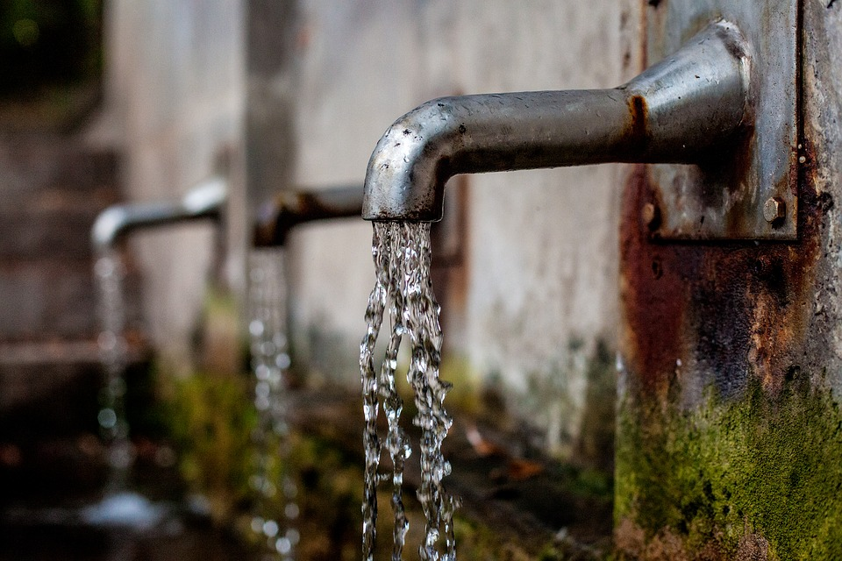

PART III

WATER SUPPLY

Asset Class: | Water Supply (PWS)
Asset Sub-Type: | Other (OT)
Feature Code(s): | Water Supply Storage Tank (WSST)
Condition Rating: | 1 | 2 | 3 | 4 | 5
Fencing and Gate | The site is secure | Security devices have minor damage, but no unauthorized personnel can enter | Moderate damage allowing unauthorized personnel to enter. | Considerable damage to security devices | No security, site is exposed to threat
Exterior Coating | No chipping or visible thin spots in exterior coating | Minor chipping or thin areas | Moderate chipping and thin area | Considerable chipping and thin areas | Major areas of chipped or thin exterior coating
Leaks | No leaks have been detected. | Minor leaks detected | Moderate Leak | Considerable Leak | Major Leak
Subjective Rating (do not include with visual assessment)
Age | < 25% Useful Life | ≥ 25% & < 50% | ≥ 50% & < 75% | ≥ 75% & < 100% | ≥ 100% UsefulLife

Asset Class: | Water Supply (PWS)
Asset Sub-Type: | Pumping Station (PS)
Feature Code(s): | Water Booster Station (BST)
Condition Rating: | 1 | 2 | 3 | 4 | 5
Exterior Vault/ Building Condition | Great condition/no delamination's (siding, roof, foundation, doors and windows in pristine condition) | Good condition/ no visual delamination (siding, roof, foundation, doors and windows showing minimal wear) | Fair condition/ minor delamination's (siding, roof, foundation, doors and windows need adjustment) | Poor condition/ some visual delamination's (siding, roof, foundation, doors and windows not working) | Very poor -critical condition/excessive delamination's (siding, roof leaking, foundation, doors and windows broken)/ unsafe
Interior Vault/ Building Condition | Great condition/ no delamination's (walls, ceiling and floors in pristine condition) | Good condition/ no visual delamination (walls, ceiling and floors showing minimal wear) | Fair condition/ minor delamination's (repainting needed, light bulbs need replaced and windows or doors need adjustment) | Poor condition/ some visual delamination's (windows or doors inoperable, paint peeling and electrical components not working) | Very poor -critical condition/excessive delamination's (windows broken and doors unlockable)/ unsafe
Subjective Rating (do not include with visual assessment)
Age | < 25% Useful Life | ≥ 25% & < 50% | ≥ 50% & < 75% | ≥ 75% & < 100% | ≥ 100% UsefulLife

Asset Class: | Water Supply (PWS)
Asset Sub-Type: | Valves (VL)
Feature Code(s): | Water Curb Stop (CS)  Water Corporation Stop (CRS)
Condition Rating: | 1 | 2 | 3 | 4 | 5
Number of Leaks per Year | No Leaks | < 1 leak per Year | 1 leak per Year | 2 leaks per Year | > 2 leaks per Year
Past Maintenance | 2 + per year | 1 per year | 1 per 2 years | 1 per 5 years | 0 per year
Subjective Rating (do not include with visual assessment)
Age | < 25% Useful Life | ≥ 25% & < 50% | ≥ 50% & < 75% | ≥ 75% & < 100% | ≥ 100% UsefulLife

Asset Class: | Water Supply (PWS)
Asset Sub-Type: | Pipes (PI)
Feature Code(s): | Water Transmission Main (TRNS)  Water Distribution Main (DIMN)  Water Service Connection (WTCN)
Condition Rating: | 1 | 2 | 3 | 4 | 5
Number of Leaks per Year | No Leaks | < 1 leak per Year | 1 leak per Year | 2 leaks per Year | > 2 leaks per Year
Subjective Rating (do not include with visual assessment)
Age | < 25% Useful Life | ≥ 25% & < 50% | ≥ 50% & < 75% | ≥ 75% & < 100% | ≥ 100% UsefulLife

Asset Class: | Water Supply (PWS)
Asset Sub-Type: | Other (OT)
Feature Code(s): | Water Meter (METER)
Condition Rating: | 1 | 2 | 3 | 4 | 5
Accuracy | No slowdown detected | Slight decrease in average demand | Noticeable decrease in average demand | Considerable decrease in average demand | Meter register does not move between monthly readings
Leaks | No visible water in meter pit or in meter | Slight condensation on glass | Moderate water in meter pit and/or water behind glass | Considerable water in meter pit and/or water behind glass | Major water in meter pit and/or water behind glass, visibly leaking from meter setter
Subjective Rating (do not include with visual assessment)
Age | < 25% Useful Life | ≥ 25% & < 50% | ≥ 50% & < 75% | ≥ 75% & < 100% | ≥ 100% UsefulLife

Asset Class: | Water Supply (PWS)
Asset Sub-Type: | Hydrant (HY)
Feature Code(s): | Fire Hydrant (HY)
Condition Rating: | 1 | 2 | 3 | 4 | 5
Paint Condition  (maintenance issue) | Great condition | Good Condition | Moderate condition, chip in paint | Paint chipped, dulled, thin in areas | Poor condition, chipped or faded paint.
Missing or defective items such as caps, misaligned nozzles, rounded operating nuts | None | Rounded operating nut | Missing cap and/or rounded operating nut | Defective items, missing items, rounded nuts | Missing parts, misaligned nozzles, rounded operating nuts, considerable deficiency
Subjective Rating (do not include with visual assessment)
Age | < 25% Useful Life | ≥ 25% & < 50% | ≥ 50% & < 75% | ≥ 75% & < 100% | ≥ 100% UsefulLife

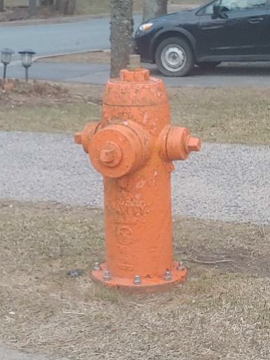 | - Paint Condition (4)  - Missing or defective items such as caps, misaligned nozzles, rounded operating nuts (2)  - Overall condition (4)
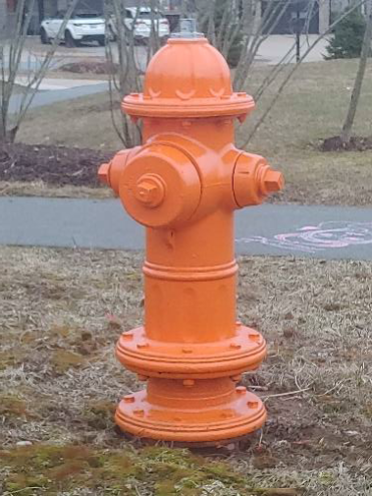 | - Paint condition (1)  - Missing or defective items such as caps, misaligned nozzles, rounded operating nuts (1)  - Overall condition (1)

Asset Class: | Water Supply (PWS)
Asset Sub-Type: | Other (OT)
Feature Code(s): | Water Source (WS)
Condition Rating: | 1 | 2 | 3 | 4 | 5
Security | The site is secure | Security devices have minor damage, but no unauthorized personnel can enter | Moderate damage allowing unauthorized personnel to enter | Considerable damage to security devices | No security, site is exposed to threat
Reliability/  Unplanned Outages | 0 per Year | 1-2 per Year | 3-5 per Year | 6-10 per Year | >10 per Year
Subjective Rating (do not include with visual assessment)
Age | < 25% Useful Life | ≥ 25% & < 50% | ≥ 50% & < 75% | ≥ 75% & < 100% | ≥ 100% UsefulLife

Asset Class: | Water Supply (PWS)
Asset Sub-Type: | Valves (VL)
Feature Code(s): | Water Air Pressure Relief Valve (APV)
Condition Rating: | 1 | 2 | 3 | 4 | 5
High Downstream Pressure | Normal operating Pressure | Minor increase in downstream pressure <2 psi | Moderate increase in downstream pressure 2 to 5 psi | Considerable increase in downstream pressure 5 to 10 psi | Major increase in downstream pressure >10 psi, pipes breaking, customer complaints
Vault | Vault and access hatch in new condition | Minor cracks and pinholes in concrete, rust on access hatch | Moderate damage to concrete and rust on access hatch | Considerable damage to concrete and rust on access hatch | Cracks in concrete, visible signs of water infiltration into the vault, and/or missing or damaged beyond repair access hatch
Past Maintenance | 2 + per year | 1 per year | 1 per 2 years | 1 per 5 years | 0 per year
Subjective Rating (do not include with visual assessment)
Age | < 25% Useful Life | ≥ 25% & < 50% | ≥ 50% & < 75% | ≥ 75% & < 100% | ≥ 100% UsefulLife

Asset Class: | Water Supply (PWS)
Asset Sub-Type: | Valves (VL)
Feature Code(s): | Water Cleanout (WSCO)
Condition Rating: | 1 | 2 | 3 | 4 | 5
Cap | cap and cover in good condition. Easily accessible. | Minor deficiencies with condition of cap and/or cover. Easily accessible. | Moderate deficiencies with condition of cap and/or cover. Accessible. | Considerable deficiencies with condition of cap and/or cover.  Difficult to access. | Cracks in ca and/or missing or damaged beyond repair cover. Not accessible.
Past Maintenance | 2 + per year | 1 per year | 1 per 2 years | 1 per 5 years | 0 per year
Subjective Rating (do not include with visual assessment)
Age | < 25% Useful Life | ≥ 25% & < 50% | ≥ 50% & < 75% | ≥ 75% & < 100% | ≥ 100% UsefulLife

Asset Class: | Water Supply (PWS)
Asset Sub-Type: | Valves (VL)
Feature Code(s): | Water Gate Valve (GV)  Water Blow Off Valve (BOV)  Water Supply Butterfly Valve (WSBFV)  Water Supply Ball Valve (WSBV)  Water Supply Hydrant Valve (WSHYV)  Water Supply General Valve (WSVLV)
Condition Rating: | 1 | 2 | 3 | 4 | 5
Valve Box | Box and cover in good condition | Minor deficiencies with condition of box and/or cover | Moderate deficiencies with condition of box and/or cover | Considerable deficiencies with condition of box and/or cover | Cracks in valve box and/or missing or damaged beyond repair cover
Past Maintenance | 2 + per year | 1 per year | 1 per 2 years | 1 per 5 years | 0 per year
Subjective Rating (do not include with visual assessment)
Age | < 25% Useful Life | ≥ 25% & < 50% | ≥ 50% & < 75% | ≥ 75% & < 100% | ≥ 100% UsefulLife

Asset Class: | Water Supply (PWS)
Asset Sub-Type: | Valves (VL)
Feature Code(s): | Water Pressure Reducing Valve (PRV)
Condition Rating: | 1 | 2 | 3 | 4 | 5
High Downstream Pressure | Normal operating Pressure | Minor increase in downstream pressure | Moderate increase in downstream pressure | Considerable increase in downstream pressure | Major increase in downstream pressure, pipe breaking, customer complaints
Vault | Vault and access hatch in new condition | Minor cracks and pinholes in concrete, rust on access hatch | Moderate damage to concrete and rust on access hatch | Considerable damage to concrete and rust on access hatch | Cracks in concrete, visible signs of water infiltration into the vault, and/or missing or damaged beyond repair access hatch
Past Maintenance | 2 + per year | 1 per year | 1 per 2 years | 1 per 5 years | 0 per year
Subjective Rating (do not include with visual assessment)
Age | < 25% Useful Life | ≥ 25% & < 50% | ≥ 50% & < 75% | ≥ 75% & < 100% | ≥ 100% UsefulLife

Asset Class: | Water Supply (PWS)
Asset Sub-Type: | Water Treatment (WT)
Feature Code(s): | Conventional Pump (WSCPMP)
Condition Rating: | 1 | 2 | 3 | 4 | 5
Vibration | No unusual vibration detectable | Minor vibration detected | Moderate vibration | Considerable vibration | Major vibration
Temperature | No unusual temperature detected | Minimal heat from casing using hand | Heat detected by hand | Heat detected by hand is uncomfortable to the touch | Heat too high to assess by hand
Noise | No unusual noises detected | Slight whine/rattle detected | Moderate whine/rattle detected, easily heard over pump noise | Loud whine/rattle | Disturbingly loud vibrations during operation
Leaking seals | No visible sign of leaking seals | Minor leaking seals | Moderate leaking seals | Considerable leaking seals | Major leaking seals
Unplanned Outages Avg # per Year | 0 per Year | 1-2 per Year | 3-5 per Year | 6-10 per Year | More than 10 per Year
Subjective Rating (do not include with visual assessment)
Age | < 25% Useful Life | ≥ 25% & < 50% | ≥ 50% & < 75% | ≥ 75% & < 100% | ≥ 100% UsefulLife

Asset Class: | Water Supply (PWS)
Asset Sub-Type: | Pumping Station (PS)
Feature Code(s): | Water Submersible Pump (WSSPMP)
Condition Rating: | 1 | 2 | 3 | 4 | 5
Vibration | No unusual vibration detectable | Minor vibration detected | Moderate vibration | Considerable vibration | Major vibration
Noise | No unusual noises detected | Slight whine/rattle detected | Moderate whine/rattle detected, easily heard over pump noise | Loud whine/rattle | Disturbingly loud vibrations during operation
Unplanned Outages Avg # per Year | 0 per Year | 1-2 per Year | 3-5 per Year | 6-10 per Year | More than 10 per Year
Subjective Rating (do not include with visual assessment)
Age | < 25% Useful Life | ≥ 25% & < 50% | ≥ 50% & < 75% | ≥ 75% & < 100% | ≥ 100% UsefulLife

Asset Class: | Water Supply (PWS)
Asset Sub-Type: | Water Treatment (WT)
Feature Code(s): | Water Mixed Media Filter (WSMMF)
Condition Rating: | 1 | 2 | 3 | 4 | 5
Visible Condition of Media | No visible deposits or change in media color | Minor visible deposits or change in media color | Moderate deposits and visible color change | Considerable visible deposits or change in media color | Heavy deposits and visible color change
Depth/Amount of Anthracite Coal as per Manufacture | 450mm | 400mm | 350mm | 300mm | 250mm
Depth/Amount of Silica Sand as per Manufacture | 225mm | 200mm | 150mm | 125mm | 100mm
Filtered Water Turbidity | Continually meets required level |  | Occasionally doesn't meet required level |  | Frequently doesn't meet required level
Subjective Rating (do not include with visual assessment)
Age | < 25% Useful Life | ≥ 25% & < 50% | ≥ 50% & < 75% | ≥ 75% & < 100% | ≥ 100% UsefulLife

Asset Class: | Water Supply (PWS)
Asset Sub-Type: | Water Treatment (WT)
Feature Code(s): | Water Chemical Feed System (WSCCSYS)
Condition Rating: | 1 | 2 | 3 | 4 | 5
Feed line leakage | No detectable leakage | Minor detectable leakage | Moderate detectable leakage | Considerable detectable leakage | Heavy detectable leakage
Feed Pump Noise | No unusual noises detected | Slight whine/rattle detected | Moderate whine/rattle detected, easily heard over pump noise | Loud whine/rattle | Disturbingly loud vibrations during operation
Unplanned Outages Avg # per Year | 0 per Year | 1 per Year | 2 per Year | 3 per Year | More than 3 per Year
Subjective Rating (do not include with visual assessment)
Age | < 25% Useful Life | ≥ 25% & < 50% | ≥ 50% & < 75% | ≥ 75% & < 100% | ≥ 100% UsefulLife

Asset Class: | Water Supply (PWS)
Asset Sub-Type: | Water Treatment (WT)
Feature Code(s): | Water Vacuum Chlorinator (WSVACCL)
Condition Rating: | 1 | 2 | 3 | 4 | 5
Condition of Chlorinator Housing/ Body | No visible cracks or broken parts | A few cracks or worn areas but still serviceable |  | Excessive amount of cracks in housing and broken parts. Barely serviceable
Unplanned Outages Avg # per Year | 0 per Year | 1-2 per Year | 3-5 per Year | 6-10 per Year | More than 10 per Year
Subjective Rating (do not include with visual assessment)
Age | < 25% Useful Life | ≥ 25% & < 50% | ≥ 50% & < 75% | ≥ 75% & < 100% | ≥ 100% UsefulLife

Asset Class: | Water Supply (PWS)
Asset Sub-Type: | Water Treatment (WT)
Feature Code(s): | Water Flow Meter (WSFLME)
Condition Rating: | 1 | 2 | 3 | 4 | 5
Yrs since last calibration | < 1 year | ≥ 1 and < 2 yrs | ≥ 2 and < 3 yrs | ≥ 3 and < 4 yrs | ≥ 4 yrs
Unplanned Outages Avg # per Year | 0 per Year | 1 per Year | 2 per Year | 3 per Year | More than 3 per Year
Subjective Rating (do not include with visual assessment)
Age | < 25% Useful Life | ≥ 25% & < 50% | ≥ 50% & < 75% | ≥ 75% & < 100% | ≥ 100% UsefulLife

Asset Class: |  | Water Supply
Asset Sub-Type: |  | Other (OT)
Feature Code(s): |  | Office Furniture and Supplies (WSOFS)
Condition Rating: |  | 1 | 2 |  | 3 |  | 4 |  | 5
Preventative Maintenance |  | According to manufacturer’s recommendations | 75% of the time |  | 50 % of the time |  | 25% of the time. |  | Never
Subjective Rating (do not include with visual assessment)
Age | < 5 yrs |  |  | ≥ 5 and < 7 yrs |  | ≥ 7 and < 9 yrs |  | ≥ 9 and < 11 yrs |  | ≥ 11 yrs

Asset Class: | Water Supply (PWS)
Asset Sub-Type: | Water Treatment (WT)
Feature Code(s): | Office Furniture and Supplies (WSOFS)
Condition Rating: | 1 | 2 | 3 | 4 | 5
Preventative Maintenance | According to manufacturer’s recommendations | 75% of the time | 50 % of the time | 25% of the time. | Never
Subjective Rating (do not include with visual assessment)
Age | < 25% Useful Life | ≥ 25% & < 50% | ≥ 50% & < 75% | ≥ 75% & < 100% | ≥ 100% UsefulLife

Asset Class: | Water Supply (PWS)
Asset Sub-Type: | Water Treatment (WT)
Feature Code(s): | Computer (WSCOMP)
Condition Rating: | 1 | 2 | 3 | 4 | 5
Preventative Maintenance | According to manufacturer’s recommendations | 75% of the time | 50 % of the time | 25% of the time. | Never
Subjective Rating (do not include with visual assessment)
Age | < 25% Useful Life | ≥ 25% & < 50% | ≥ 50% & < 75% | ≥ 75% & < 100% | ≥ 100% UsefulLife

Asset Class: | Water Supply (PWS)
Asset Sub-Type: | Water Treatment (WT)
Feature Code(s): | Lab Equipment (WSLAB)
Condition Rating: | 1 | 2 | 3 | 4 | 5
Preventative Maintenance | According to manufacturer’s recommendations | 75% of the time | 50 % of the time | 25% of the time. | Never
Subjective Rating (do not include with visual assessment)
Age | < 25% Useful Life | ≥ 25% & < 50% | ≥ 50% & < 75% | ≥ 75% & < 100% | ≥ 100% UsefulLife

Asset Class: | Water Supply (PWS)
Asset Sub-Type: | Other (OT)
Feature Code(s): | Generator (WSTFGEN)
Condition Rating: | 1 | 2 | 3 | 4 | 5
Past Maintenance | 2 + per year | 1 per year | 1 per 2 years | 1 per 5 years | 0 per year
Unplanned Outages Avg # per Year | 0 per Year | 1 - 2 per year | 3 - 5 per year | 6 - 10 per year | > 10 per year
Preventative Maintenance | According to manufacturer’s recommendations | 75% of the time | 50 % of the time | 25% of the time. | Never
Subjective Rating (do not include with visual assessment)
Age | < 25% Useful Life | ≥ 25% & < 50% | ≥ 50% & < 75% | ≥ 75% & < 100% | ≥ 100% UsefulLife

Asset Class: | Water Supply (PWS)
Asset Sub-Type: | Water Treatment (WT)
Feature Code(s): | Intake Structure and Valves (WSISV)
Condition Rating: | 1 | 2 | 3 | 4 | 5
Screen and Piping Condition | Screen is intact and piping in good shape |  | Screen showing signs of deterioration. |  | Screen severely damaged/deteriorated/missing
Isolation Valve - Was valve operable last time used | Yes |  | Unknown |  | No
Past Maintenance | 2 + per year | 1 per year | 1 per 2 years | 1 per 5 years | 0 per year
Unplanned Outages Avg # per Year | 0 per Year | 1-2 per Year | 3-5 per Year | 6-10 per Year | More than 10 per Year
Subjective Rating (do not include with visual assessment)
Age | < 25% Useful Life | ≥ 25% & < 50% | ≥ 50% & < 75% | ≥ 75% & < 100% | ≥ 100% UsefulLife

Asset Class: | Water Supply (PWS)
Asset Sub-Type: | Water Treatment (WT)
Feature Code(s): | Clarifier (WSCLAR)
Condition Rating: | 1 | 2 | 3 | 4 | 5
Baffle and Weir | Baffle and weir are level, showing consistent flow at all points. |  | Baffle and weir are slightly off level, or minor algae growth or trash in effluent weir, causing minor inconsistencies in flow. |  | Baffle and weir are significantly off level, or major algae growth or trash in effluent weir, causing flow short circuiting.
Skimmer Paddles | Paddles are all intact and not corroded |  | paddle is corroded or damaged by chipping |  | Paddle is non-functional
Stairs, Handrails, Walkways | No observed damage or rust. Height meets current code. | Minor damage and/or rust to 10% of surface. Structure remains in good working order. | Moderate damage and/or rust to 25% of surface. Structure performance is degraded but functional. | Considerable damage and/or rust to 25-50% of surface. Structural performance compromised. Can be easily moved by hand. | Areas of stairs, handrails or walkways missing or collapsed, and/or rust to >50% of surface. Posts broken or detached from foundation. Height not to current code.
Subjective Rating (do not include with visual assessment)
Age | < 25% Useful Life | ≥ 25% & < 50% | ≥ 50% & < 75% | ≥ 75% & < 100% | ≥ 100% UsefulLife

Asset Class: | Water Supply (PWS)
Asset Sub-Type: | Water Treatment (WT)
Feature Code(s): | Presedimentation Tank (WSPTNK)
Condition Rating: | 1 | 2 | 3 | 4 | 5
Exterior Coating | No chipping or visible thin spots in exterior coating | Minor chipping or thin areas | Moderate chipping and thin area | Considerable chipping and thin areas | Major areas of chipped or thin exterior coating
Panel Sealant/Caulking | No leaks have been detected/ caulking has no peeling or lifting from paneling, no fading/ no visible rust | Minor leaks detected/ caulking has minor peeling or lifting from paneling, minor fading/ no visible rust | Moderate leak caulking has moderate peeling or lifting from paneling, moderate fading/ Some visible rust | considerable leaking/ caulking has considerable peeling or lifting from paneling, considerable fading/ considerable visible rust | Major leaking/ caulking has significant peeling or lifting from paneling, extreme fading, major rust (complete sealant failure)
Concrete Ringwall | No cracks or visible structural damage to exposed concrete | Minor cracking or visible damage | Moderate cracking or visible damage | Considerable cracking and visible damage | Major cracking and visible damage to concrete
Subjective Rating (do not include with visual assessment)
Age | < 25% Useful Life | ≥ 25% & < 50% | ≥ 50% & < 75% | ≥ 75% & < 100% | ≥ 100% UsefulLife

Asset Class: | Water Supply (PWS)
Asset Sub-Type: | Other (OT)
Feature Code(s): | Streaming Current Monitor (WSSCM)
Condition Rating: | 1 | 2 | 3 | 4 | 5
Preventative Maintenance | According to manufacturer’s recommendations | 75% of the time | 50 % of the time | 25% of the time. | Never
Subjective Rating (do not include with visual assessment)
Age | < 25% Useful Life | ≥ 25% & < 50% | ≥ 50% & < 75% | ≥ 75% & < 100% | ≥ 100% UsefulLife

Asset Class: | Water Supply (PWS)
Asset Sub-Type: | Water Treatment (WT)
Feature Code(s): | Chlorine Leak Detector (WSCLLD)
Condition Rating: | 1 | 2 | 3 | 4 | 5
Replacement Timeframe | Sensor is < 1 year old |  | Sensor is 1 year old |  | Sensor is over 2 yrs old
Subjective Rating (do not include with visual assessment)
Age | < 25% Useful Life | ≥ 25% & < 50% | ≥ 50% & < 75% | ≥ 75% & < 100% | ≥ 100% UsefulLife

Asset Class: | Water Supply (PWS)
Asset Sub-Type: | Other (OT)
Feature Code(s): | Telemetry (WSTLEM)
Condition Rating: | 1 | 2 | 3 | 4 | 5
Availability of Parts | Yes |  |  |  | No
Subjective Rating (do not include with visual assessment)
Age | < 25% Useful Life | ≥ 25% & < 50% | ≥ 50% & < 75% | ≥ 75% & < 100% | ≥ 100% UsefulLife

Asset Class: | Water Supply (PWS)
Asset Sub-Type: | Other (OT)
Feature Code(s): | Air Compressor (WSTFAC)
Condition Rating: | 1 | 2 | 3 | 4 | 5
Preventative Maintenance | According to manufacturer’s recommendations | 75% of the time | 50 % of the time | 25% of the time | Never
Subjective Rating (do not include with visual assessment)
Age | < 25% Useful Life | ≥ 25% & < 50% | ≥ 50% & < 75% | ≥ 75% & < 100% | ≥ 100% UsefulLife

Asset Class: | Water Supply (PWS)
Asset Sub-Type: | Water Treatment (WT)
Feature Code(s): | Gasoline Driven Trash Pump (WSGDTP)
Condition Rating: | 1 | 2 | 3 | 4 | 5
Leaking seals | No visible sign of leaking seals | Minor leaking seals | Moderate leaking seals | Considerable leaking seals | Major leaking seals
Engine Startup | Starts quickly/runs smoothly |  | Moderately hard to start engine/runs a little rough |  | Hard to start/engine quits while in use
Subjective Rating (do not include with visual assessment)
Age | < 25% Useful Life | ≥ 25% & < 50% | ≥ 50% & < 75% | ≥ 75% & < 100% | ≥ 100% UsefulLife

Asset Class: | Water Supply (PWS)
Asset Sub-Type: | Water Treatment (WT)
Feature Code(s): | DAF Tank or Saturation Vessel (WSDAFT)
Condition Rating: | 1 | 2 | 3 | 4 | 5
Corrosion | None Evident, paint shows no discoloration or chipping | Paint chipped, peeling or missing and rust showing on >10% of tank or piping | Paint chipped, peeling or missing and rust showing on >25% of tank or piping |  | Paint chipped, peeling or missing and rust showing on >50% of tank or piping
Leaks | No leaks evident |  | Potential intermittent leakage from any seal or connection. Pooling is not evident. Public works reports intermittent leakage. |  | Leakage from any seal or connection ongoing. Leakage causing pooling.
Preventative Maintenance | According to manufacturer’s recommendations | 75% of the time | 50 % of the time | 25% of the time | Never
Subjective Rating (do not include with visual assessment)
Age | < 25% Useful Life | ≥ 25% & < 50% | ≥ 50% & < 75% | ≥ 75% & < 100% | ≥ 100% UsefulLife

Asset Class: | Water Supply (PWS)
Asset Sub-Type: | Water Treatment (WT)
Feature Code(s): | DAF Skimmer (WSDAFS)
Condition Rating: | 1 | 2 | 3 | 4 | 5
Paddles | Paddles are all intact and not corroded | A single paddle is corroded or damaged by chipping | Greater than 1 paddle is corroded or damaged by chipping | Paddles are corroded or damaged, no greater than one is missing | Greater than 1 paddle is missing
Drive Chain and sprockets | Drive chain runs consistently and smoothly. No sign of wear on chain | Drive chain runs consistently and smoothly. Visual signs of wear on chain are rounded or inconsistent edges, surface defects on several links) | Drive chain skips less than once per cycle, no missing teeth on sprocket. Visual signs of wear on chain are rounded or inconsistent edges, surface defects on greater than 50% of links) | Drive chain skips less than once per cycle, one or more teeth missing from sprocket. Visual signs of wear on chain are rounded or inconsistent edges, surface defects on greater than 75% of links) | Drive chain skips on sprockets greater than once per cycle, one or more teeth missing from sprocket. Visual signs of wear on chain are rounded or inconsistent edges, surface defects on all links)
Corrosion | According to manufacturer’s recommendations | 75% of the time | 50 % of the time | 25% of the time | Never
Subjective Rating (do not include with visual assessment)
Age | < 25% Useful Life | ≥ 25% & < 50% | ≥ 50% & < 75% | ≥ 75% & < 100% | ≥ 100% UsefulLife

Asset Class: | Water Supply (PWS)
Asset Sub-Type: | Water Treatment (WT)
Feature Code(s): | Electric Motor* (WSELECM)
Condition Rating: | 1 | 2 | 3 | 4 | 5
Motor Hours Run | < 10,000 hours | ≥ 10,000 and < 50,000 hours | ≥ 50,000 and < 100,000 hours | ≥ 100,000 and < 200,000 hours | ≥ 200,000 hours
Vibration | No unusual vibration detectable | Minor vibration detected | Moderate vibration | Considerable vibration | Major vibration
Temperature | No unusual temperature detected | Minimal heat from casing using hand | Heat detected by hand | Heat detected by hand is uncomfortable to the touch | Heat too high to assess by hand
Unplanned Outages Avg # per Year | 0 per Year | 1-2 per Year | 3-5 per Year | 6-10 per Year | More than 10 per Year
Subjective Rating (do not include with visual assessment)
Age | < 25% Useful Life | ≥ 25% & < 50% | ≥ 50% & < 75% | ≥ 75% & < 100% | ≥ 100% UsefulLife
*Pumps excluded

Asset Class: | Water Supply (PWS)
Asset Sub-Type: | Water Treatment (WT)
Feature Code(s): | Water Membrane Filter System* (WSMFS)
Condition Rating: | 1 | 2 | 3 | 4 | 5
Piping, valves and fittings | Excellent condition. Paint on piping, valves and fittings looks great. No leaking evident. | Good condition. Minor rusting on piping, valves and fittings. No leaking evident. | Fair condition. Minor rusting of piping, valves and fittings. Minor leaking visible when pumps running | Poor condition. Significant rusting of piping, valves and fittings. Still operable. Significant leaking visible when pumps running | Very poor - Major rusting of piping, valves and fittings inoperable. Excessive leaking visible when pumps running
Support Structure | Excellent condition. Coating intact, no signs of rust. | Good condition. Some flaking or degradation of coating. Minor rust spots. | Fair condition. Exposed steel over 10% of structure. Rust evident in exposed areas and weld locations. | Poor condition. Exposed steel over 25% of structure. Rust and pitting evident in exposed areas and weld locations. | Very poor condition. Exposed steel over 25% of structure. Cracks, split welds or rusted through evident anywhere on structure.
Unplanned Outages Avg # per Year | 0 per Year | 1 per Year | 2 per Year | 3-5 per Year | >5 per Year
Subjective Rating (do not include with visual assessment)
Age | < 25% Useful Life | ≥ 25% & < 50% | ≥ 50% & < 75% | ≥ 75% & < 100% | ≥ 100% UsefulLife
*Individual filters are consumable items

Asset Class: | Water Supply (PWS)
Asset Sub-Type: | Water Treatment (WT)
Feature Code(s): | UV Light* (WSUV)
Condition Rating: | 1 | 2 | 3 | 4 | 5
Concrete Tank | No cracks or visible structural damage to exposed concrete | Minor cracking or visible damage, hairline cracks only | Moderate cracking or visible damage, cracks less than 3mm | Considerable cracking and visible damage, cracks greater than 3mm, no visible rebar | Major cracking and visible damage to concrete, exposed rebar
Steel Enclosure Corrosion | None Evident, exterior shows no discoloration or chipping | Exterior coating chipped, peeling or missing and rust showing on >10% of enclosure. Pitting evident on stainless enclosures on >10% of surface | Exterior coating chipped, peeling or missing and rust showing on >25% of enclosure. Pitting evident on stainless enclosures on >25% of surface |  | Exterior coating chipped, peeling or missing and rust showing on >50% of enclosure. Pitting evident on stainless enclosures on >50% of surface
Leaks | No leaks evident |  | Potential intermittent leakage from any seal or connection. Pooling is not evident. Public works reports intermittent leakage. |  | Leakage from any seal or connection ongoing. Leakage causing pooling.
Subjective Rating (do not include with visual assessment)
Age | < 25% Useful Life | ≥ 25% & < 50% | ≥ 50% & < 75% | ≥ 75% & < 100% | ≥ 100% UsefulLife
* Bulb Replacement is Considered a Consumable Item

Asset Class: | Water Supply
Asset Sub-Type: | Water Treatment (WT)
Feature Code(s): | Water Lagoon (WSLAG)
Condition Rating: | 1 | 2 |  | 3 |  | 4 |  | 5
Liner | No recorded leaks |  |  | 1 leak detected per year |  |  |  | >1 leak detected per year
Sludge Accumulation | > 80% remaining volume capacity | 75% to 80% of remaining volume capacity |  | 50% to 75% of remaining volume capacity |  | 25% to 50% remaining volume capacity |  | <25% remaining volume capacity
Water Level Issues | None |  |  | Overflow events 1 per year |  |  |  | Overflow events >1 per year
Damaged Fencing or Concrete | No observed damage to perimeter fencing or concrete | Minor damage to fencing or concrete. Structure remains in good working order. |  | Moderate damage to fencing or concrete. Structure performance is degraded but functional. |  | Considerable damage to fencing or concrete. Structural performance compromised. Fencing can be moved by hand. |  | Areas of fending missing or collapsed. Posts broken or detached from foundation.
Subjective Rating (do not include with visual assessment)
Age | <5 Yrs |  | ≥ 5 and < 10 Yrs |  | ≥ 10 and < 20 Yrs |  | ≥ 20 and < 30 Yrs |  | ≥ 30 Yrs

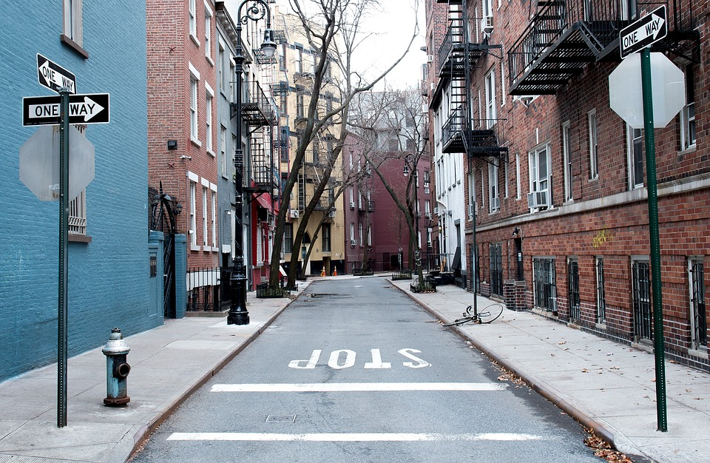

PART IV

TRANSPORTATION
Asset Class: | Transportation (TRN)
Asset Sub-Type: | Road (RD)
Feature Code(s): | Road (RR)
Condition Rating: | 1 | 2 | 3 | 4 | 5
Potholes | None | minor potholes (<25mm in depth) | occasional small potholes (25-50mm in depth) | moderate (50 -100mm in depth) over 10-25% of the area | severe (over 100mm in depth) over at least 25% of the area
Rutting | None | Slight rutting (< 25 mm) in some areas during wet weather | Moderate rutting (25-50 mm deep), during wet weather | Severe rutting (> 75 mm) in 10 to 25 % of roadway during wet weather. | Severe rutting (> 75 mm) on more than 25 % of roadway during wet weather
Surface Gravel Condition | Good gravel thickness and excellent drainage. | Adequate gravel thickness, good pavement crown, and good drainage.  Moderate loose aggregate and slight washboarding. | Gravel layer is adequate, but additional aggregate is necessary in isolated areas. Some loose aggregate (50 mm deep). Moderate washboarding (25- 50 deep) over 10 to 25% of the area. | Some areas (up to 25 %) with little or no aggregate. Moderate to severe washboarding (> 75 mm) over up to 25 % of area. Severe loose aggregate (> 100 mm) | Many areas (>25 %) with little or no aggregate. Moderate to severe washboarding (> 75 mm) over more than 25 % of area. Severe loose aggregate (> 100 mm)
Subjective Rating (do not include with visual assessment)
Age | < 25% Useful Life | ≥ 25% & < 50% | ≥ 50% & < 75% | ≥ 75% & < 100% | ≥ 100% UsefulLife
*Paver is a recommend alternative to the above assessment to covert the Paver PCI to the Tool kit 1-5 use the table below

PAVER Surface Rating Conversion
Condition Rating: | 1 | 2 | 3 | 4 | 5
PAVER PCI Rating | 19 to 31.8 | 31.8 to 44.6 | 44.6 to 57.4 | 57.4 to 70.2 | 70.2 to 83

Asset Class: | Transportation (TRN)
Asset Sub-Type: | Road (RD)
Feature Code(s): | Curbed Road (RRCB)
Condition Rating: | 1 | 2 | 3 | 4 | 5
Potholes | None | minor potholes (<25mm in depth) | occasional small potholes (25-50mm in depth) | moderate (50 -100mm in depth) over 10-25% of the area | severe (over 100mm in depth) over at least 25% of the area
Rutting | None | Slight rutting (< 25 mm) in some areas during wet weather | Moderate rutting (25-50 mm deep), during wet weather | Severe rutting (> 75 mm) in 10 to 25 % of roadway during wet weather. | Severe rutting (> 75 mm) on more than 25 % of roadway during wet weather
Surface Gravel Condition | Good gravel thickness and excellent drainage. | Adequate gravel thickness, good pavement crown, and good drainage.  Moderate loose aggregate and slight washboarding. | Gravel layer is adequate, but additional aggregate is necessary in isolated areas. Some loose aggregate (50 mm deep). Moderate washboarding (25- 50 deep) over 10 to 25% of the area. | Some areas (up to 25 %) with little or no aggregate. Moderate to severe washboarding (> 75 mm) over up to 25 % of area. Severe loose aggregate (> 100 mm) | Many areas (>25 %) with little or no aggregate. Moderate to severe washboarding (> 75 mm) over more than 25 % of area. Severe loose aggregate (> 100 mm)
Curb | Like new. No signs of surface wear, spalling, cracking, heave or settlement. All control & expansion joints are in good shape and edges are intact | Good Condition. Occasional cracks <10mm, slight signs of surface wear, slight spalling or scaling. Some isolated patches in good condition. Occasional settlement <25mm vertical. | Moderate spalling and scaling, frequent patches in good condition. Moderate longitudinal cracks extending across control joints of about 30% to 50% of length. Faulting (i.e. vertical surface drop) <25mm vertical in about 10% to 25% of slabs. | Up to 50% of slabs have severe chipping or spalling. Moderate cracks (10 to 20mm) extending continuously across a few slabs, slabs faulting 25mm or more. Large number of patch work in fair condition. | All the previous mentioned defects are in severe condition, poor drainage and extensive patching that is in poor condition.
Subjective Rating (do not include with visual assessment)
Age | < 25% Useful Life | ≥ 25% & < 50% | ≥ 50% & < 75% | ≥ 75% & < 100% | ≥ 100% UsefulLife

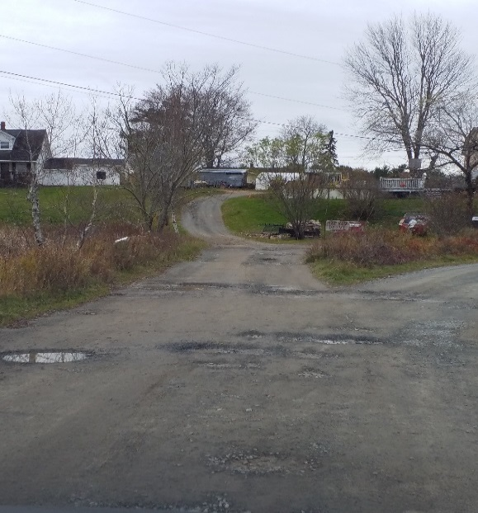 | 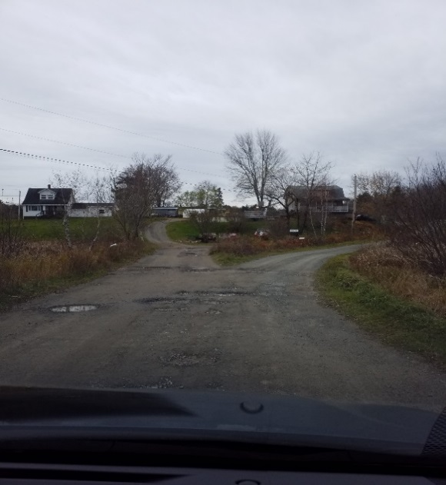 | - Gravel Surface Condition: (4) Many areas (>25 %) with little or no aggregate. Moderate to severe washboarding (> 75 mm) over more than 25 % of area. Severe loose aggregate (> 100 mm)
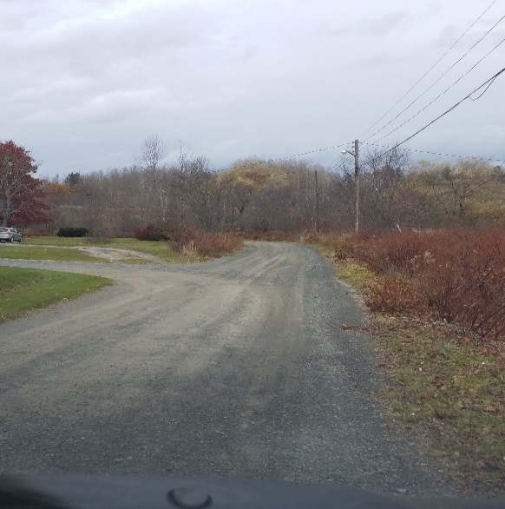 | 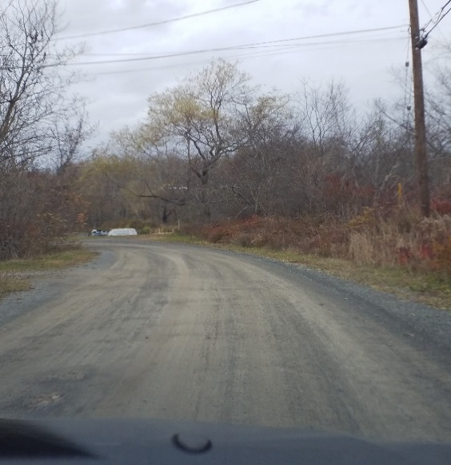 | - Gravel Surface Condition: (3) Gravel layer is adequate, but additional aggregate is necessary in isolated areas. Some loose aggregate (50 mm deep). Moderate washboarding (25- 50 deep) over 10 to 25% of the area.
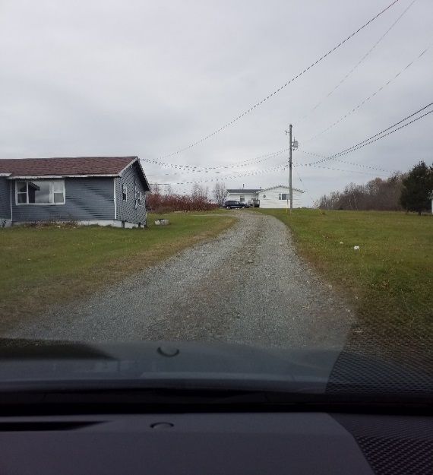 | 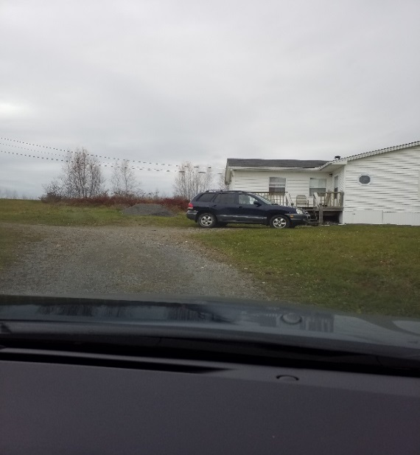 | - Gravel Surface Condition: (2) Adequate gravel thickness, good pavement crown, and good drainage.  Moderate loose aggregate and slight washboarding

Asset Class: | Transportation (TRN)
Asset Sub-Type: | Lights (LI)  Other (OT)*
Feature Code(s): | Street Light (TFSL)  Ornamental Street Light Standard (TFSLOR)  Utility Pole (UTPO)*
Condition Rating: | 1 | 2 | 3 | 4 | 5
Pole Condition | Excellent, coating / finishing defect free |  | Fair, coating / finishing shows some visual defects but no pitting or cracking |  | Poor, pitting or cracking is evident
Electrical Condition | Excellent, to current municipal standard, no operational issues. |  | Fair, obsolete or non-standard parts, no operational issues. |  | Operational issues such as outages, inconsistent function
Subjective Rating (do not include with visual assessment)
Age | < 25% Useful Life | ≥ 25% & < 50% | ≥ 50% & < 75% | ≥ 75% & < 100% | ≥ 100% UsefulLife

Asset Class: | Transportation (TRN)
Asset Sub-Type: | Signs and Signals (SS)
Feature Code(s): | Traffic Signal on Stop Sign (TSIG)  Traffic Light (TFTL)
Condition Rating: | 1 | 2 | 3 | 4 | 5
Post and arm condition | New |  | Signs of wear/age (minor rusting, pitting, wood cracking) but remains sturdy and plumb |  | Poor condition. Significant rusting, pitting or cracking, bending, needs replaced
Visibility | Excellent. No obstructions, signal oriented towards traffic. |  | Partially obstructed by signs, trees, shrubs, etc. or oriented slightly away from traffic however signal's effectiveness not significantly reduced. |  | Obstructed by signs, trees, shrubs, etc. or oriented in such a manner where effectiveness of signal is significantly or totally reduced
Bulbs burnt out | No |  |  |  | Yes
Subjective Rating (do not include with visual assessment)
Age | < 25% Useful Life | ≥ 25% & < 50% | ≥ 50% & < 75% | ≥ 75% & < 100% | ≥ 100% UsefulLife

Asset Class: | Transportation (TRN)
Asset Sub-Type: | Signs and Signals (SS)
Feature Code(s): | Sign Post (TFSP)
Condition Rating: | 1 | 2 | 3 | 4 | 5
Priority | Guide and miscellaneous signs (street name, wayfinding, hospital, etc.) |  | Warning signs (stop ahead, obstruction ahead, curve ahead, change in speed ahead, deer crossing, etc.) |  | Regulatory Signs (stop, yield, crosswalk, speed limit, parking/ no parking
Sign condition | New |  | noticeable fading and/or color change, no damage |  | Damaged severely or badly faded and color almost gone
Post Condition | New |  | Signs of wear/age (minor rusting, pitting, wood cracking) but remains sturdy and plumb |  | Poor condition. Significant rusting, pitting or cracking, bending, needs replaced
Visibility | Excellent. No obstructions, sign oriented towards traffic. |  | Partially obstructed by other signs, trees, shrubs, etc. or oriented slightly away from traffic however sign's effectiveness not significantly reduced. |  | obstructed by other signs, trees, shrubs, etc. or oriented in such a manner where effectiveness of sign is significantly or totally reduced
Subjective Rating (do not include with visual assessment)
Age | < 25% Useful Life | ≥ 25% & < 50% | ≥ 50% & < 75% | ≥ 75% & < 100% | ≥ 100% UsefulLife

Asset Class: | Transportation (TRN)
Asset Sub-Type: | Sidewalk and Trails (ST)
Feature Code(s): | Sidewalk (RRSW)  Trail (RRTR)  Pathway (RRPW)
Condition Rating: | 1 | 2 | 3 | 4 | 5
Surface Condition (concrete) | Like new. No signs of surface wear, spalling, cracking, heave or settlement. All control & expansion joints are in good shape and edges are intact | Good Condition. Occasional cracks <10mm, slight signs of surface wear, slight spalling or scaling. Some isolated patches in good condition. Occasional settlement of some slabs <25mm vertical. | Moderate spalling and scaling, frequent patches in good condition. Moderate longitudinal cracks extending across control joints of about 30%-50% of length of sidewalk. Faulting (i.e. vertical surface drop) <25mm vertical in about 10%-25% of slabs. | Up to 50% of slabs have severe chipping or spalling. Moderate cracks (10 to 20mm) extending continuously across a few slabs. Moderate settlement and trip hazard - slabs faulting 25mm or more. Large number of patch work in fair condition. | All the previous mentioned defects are in severe condition, posing a safety hazard to users, poor drainage and extensive patching that is in poor condition.
Surface Condition (asphalt) | Like new. No signs of surface wear or raveling, cracking, heave or settlement. Asphalt surface age <1 yr. | Good Condition. Minor cracks <10mm, slight signs of surface wear or raveling. Isolated patches in good condition. Slight surface rippling (sag or hog) at occasion isolated spots. | Moderate surface wear and raveling. Frequent patching in good condition. Moderate longitudinal cracks from 10 to 20mm. Minor block cracks visible in a few lengths. Occasional sagging & shallow potholes. | Top surface worn out, severe raveling. Continuous longitudinal cracks >20mm open, closely spaced block cracking. Significant heave or sagging with frequent potholes >25mm in depth. Severely eroded or broken edges. | All the previous mentioned defects are in severe condition, posing a safety hazard to users, poor drainage and extensive patching that is in poor condition.
Surface Condition (gravel) | Like new. No signs of surface wear. Good compaction and drainage. | Good Condition. Minor erosion or scour. Minor rutting, occasional shallow (<25mm) pothole | up to 50% of gravel layer washed way or embedded in subgrade, moderate ruts, moderately spaced potholes (>2-3m spacing, 25-50mm depth) & drop off edges in ~50% of sidewalk/trail | Top gravel layer mostly eroded with closely spaced potholes (<1m spacing, >50mm depth) in more than 50% of surface area, Shoulder edges eroded with deep burrows/cuts. | All the previous mentioned defects are in severe condition, posing a safety hazard to users, poor drainage.
Subjective Rating (do not include with visual assessment)
Age | < 25% Useful Life | ≥ 25% & < 50% | ≥ 50% & < 75% | ≥ 75% & < 100% | ≥ 100% UsefulLife

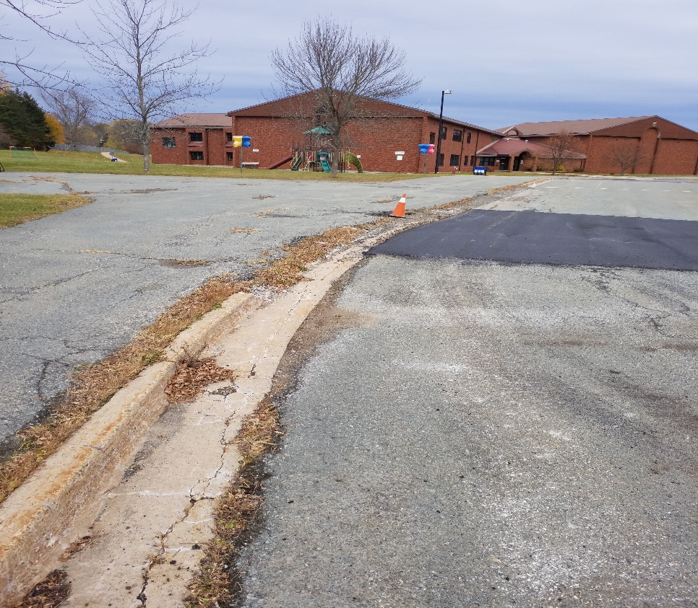 | - Surface Material: Asphalt  - Surface Condition: (3) Moderate surface wear and raveling. Frequent patching in good condition. Moderate longitudinal cracks from 10 to 20mm. Minor block cracks visible in a few lengths. Occasional sagging & shallow potholes.
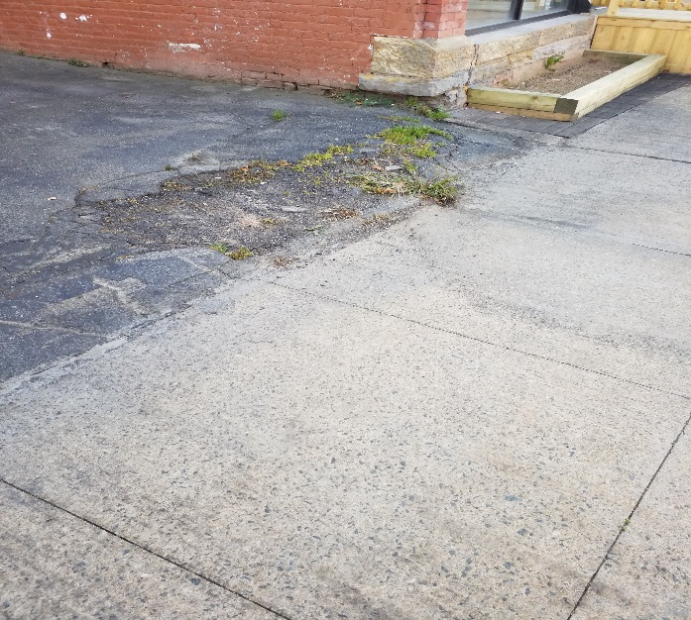 | - Surface Material: Concrete  - Surface Condition: (3) Moderate spalling and scaling, frequent patches in good condition. Moderate longitudinal cracks extending across control joints of about 30% to 50% of length of sidewalk. Faulting (i.e. vertical surface drop) <25mm vertical in about 10% to 25% of slabs. potholes
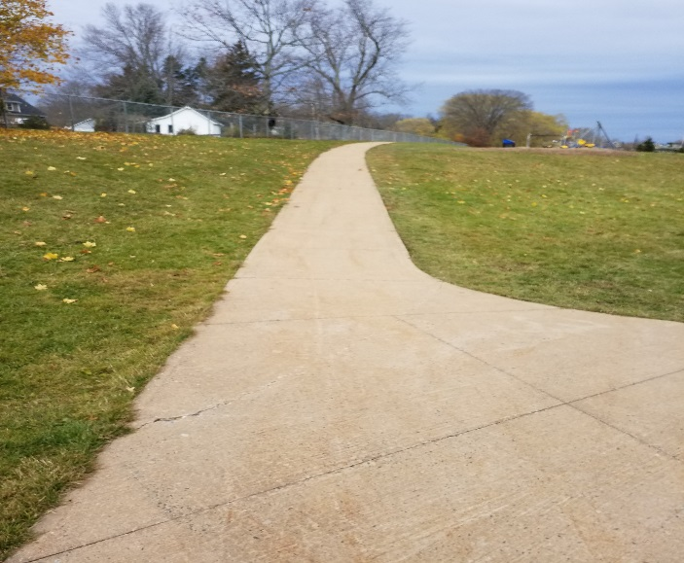 | - Surface Material: Concrete  - Surface Condition: (2) Good Condition. Occasional cracks <10mm, slight signs of surface wear, slight spalling or scaling. Some isolated patches in good condition. Occasional settlement of some slabs <25mm vertical.

Asset Class: | Transportation (TRN)
Asset Sub-Type: | Bridges (BR)
Feature Code(s): | Pier (Bridge Support) (STPR)
Condition Rating: | 1 | 2 | 3 | 4 | 5
Abutments | Excellent, no concrete spalling, wood rot or steel corrosion |  | Fair, concrete spalling, wood rot or steel corrosion over <10% of surface |  | Conduct engineering assessment. Concrete spalling, wood rot or steel corrosion over >10% of surface
Foundations
Girders
Beams
Decking | No cracking or spalling | Cracks <3mm wide over less than 10% of the surface | Cracks <3mm wide over 50% or greater of the surface | Cracks >3mm wide over 25% of surface, <5 potholes | Cracks >3mm wide over >25% of surface, >5 potholes
Sidewalks | Excellent, no cracking, misalignment or missing concrete. |  | Fair, minor cracking over <25% of surface, limited missing concrete, misalignment does not impede walking or wheelchairs |  | Poor, cracking over >25% of surface, missing concrete impedes travel, misalignment poses tripping hazards or impedes wheelchairs
Barriers | Excellent, barriers intact, no concrete spalling or corrosion |  | Fair, barriers intact, limited concrete spalling and corrosion |  | Poor, missing barrier, extensive concrete spalling, significant corrosion
Bearings | Bearings and joints are to be assessed by a qualified professional engineer
Joints
Subjective Rating (do not include with visual assessment)
Age | < 25% Useful Life | ≥ 25% & < 50% | ≥ 50% & < 75% | ≥ 75% & < 100% | ≥ 100% UsefulLife
NOTE: This assessment is not intended as an engineering structural assessment. Structural condition assessments of bridges shall be conducted by a qualified professional engineer in accordance with all applicable laws and regulations.

Asset Class: | Transportation (TRN)
Asset Sub-Type: | Barriers and Fences (BF)
Feature Code(s): | Guide Rail (STGR)  Side Bar (SB)  Fence Line (FL)
Condition Rating: | 1 | 2 | 3 | 4 | 5
Height | Meets current code |  |  |  | Does not meet current code
Damage | None | Post alignment good, rail connections missing or not tight | Poor post alignment, railing connections missing or not tight | Majority of posts out of alignment, rail connections insufficient for impact | Poor rail alignment, posts missing, rail missing
Rust | None | 10% of surface | 25% of surface | 25-50% of surface | >50% of surface
Subjective Rating (do not include with visual assessment)
Age | < 25% Useful Life | ≥ 25% & < 50% | ≥ 50% & < 75% | ≥ 75% & < 100% | ≥ 100% UsefulLife

Asset Class: | Transportation (TRN)
Asset Sub-Type: | Roads (RD)
Feature Code(s): | Boardwalk (RRBW)
Condition Rating: | 1 | 2 | 3 | 4 | 5
Abutments | Excellent, no concrete spalling, wood rot or steel corrosion |  | Fair, concrete spalling, wood rot or steel corrosion over <10% of surface |  | Conduct engineering assessment. Concrete spalling, wood rot or steel corrosion over >10% of surface
Foundations
Girders
Beams/Joists
Decking | Excellent, even walking surface, no wood rot. |  | Fair, minor misalignment, minimal wood rot. |  | Unsafe misalignment posing tripping hazard. Wood rot > 10% of surface
Safety & Accessibility | Warning plates present at grade changes and un-protected edges. |  |  |  | No Warning plates present.
Subjective Rating (do not include with visual assessment)
Age | < 25% Useful Life | ≥ 25% & < 50% | ≥ 50% & < 75% | ≥ 75% & < 100% | ≥ 100% UsefulLife

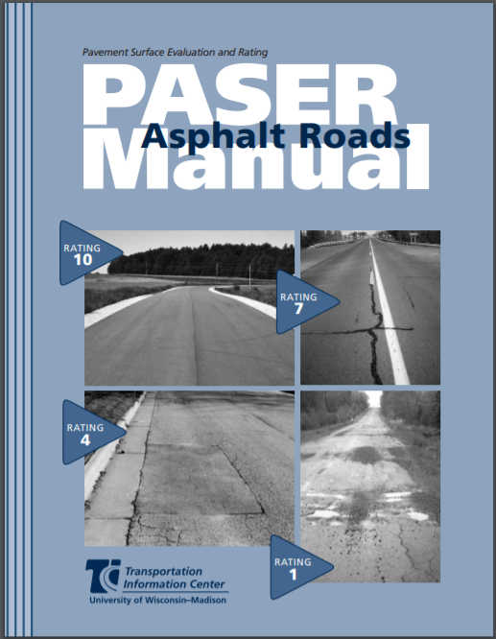
Figure 1: PASER Road Assessment Manual
http://www.apa-mi.org/docs/Asphalt-PASERManual.pdf
PASER Surface Rating Conversion
Condition Rating: | 1 | 2 | 3 | 4 | 5
PASER Surface Rating | 10-8 | 7-6 | 5-4 | 3 | 2-1

