To access the toolkit spreadsheets please follow the directions below.
First download the Asset Management Toolkit.zip file from the webpage by clicking on the file.
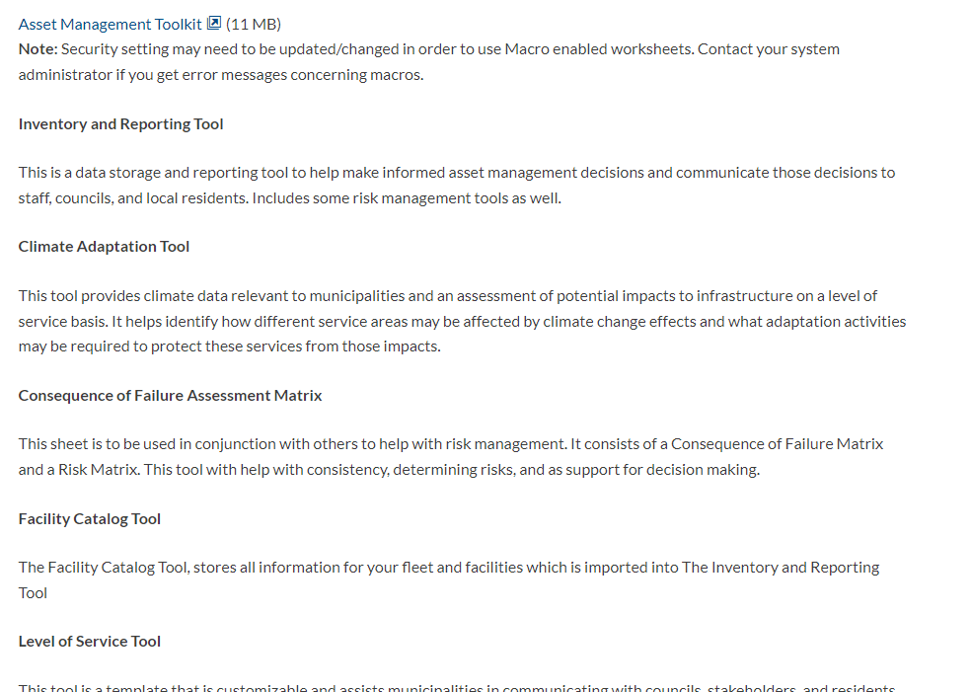
Navigate to where the file has downloaded. Typically the file will automatically download to the “Downloads” folder on the computer. If it can’t be found there, go back to google chrome and look near the bottom of the screen. Next to the file name will be an arrow that. Click that and select, “Show in Folder”
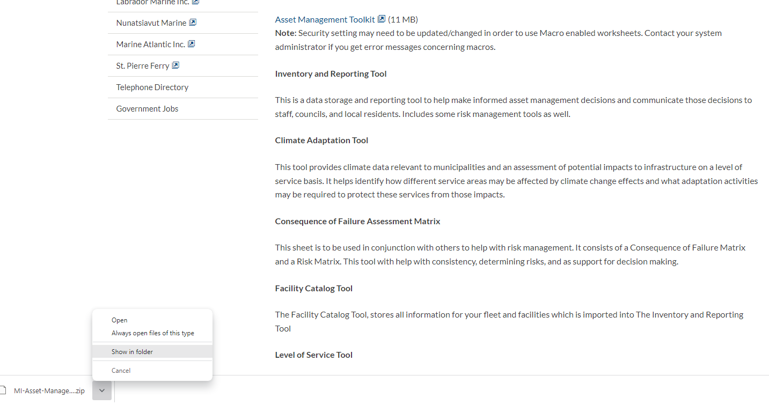
You can now copy and paste the folder to the location where you want the toolkit files to be saved.
Right click the folder and select “Extract All” then select “Extract”. This will unzip the file and give you access to the toolkit spreadsheets in a folder in the same location as the .zip file.
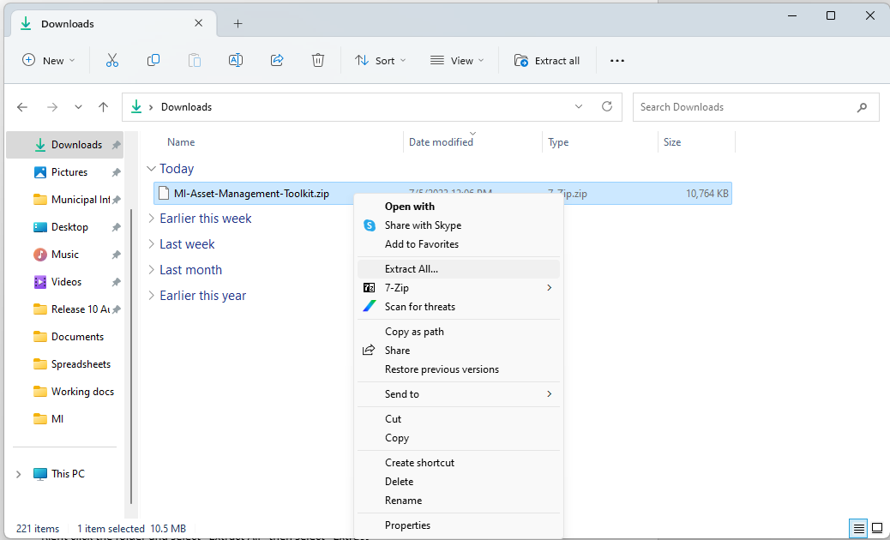

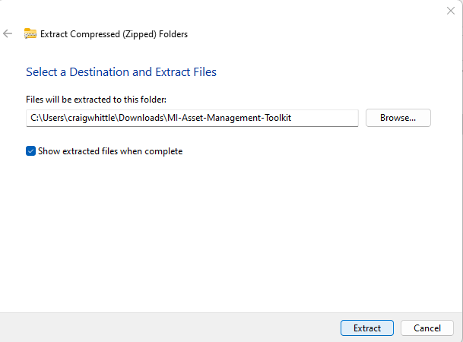
You can now use the excel toolkit files.

