Site Specific Safety Plan (SSSP)

PROJECT: Insert Project Name

PROJECT #: Insert TI Project Number

PRIME CONSULTANT: Insert Prime Consultant Name

CONSULTANT REPRESENTATIVE (RESIDENT INSPECTOR or EMPLOYEE):
Insert Name

AND/OR

CONSULTANT CORPORATE SAFETY OFFICER (IF APPLICABLE):
Insert Name, If Applicable

Disclaimer: The information presented is intended for general use and may not apply to every circumstance. It is not a definitive guide to government regulations and does not relieve persons using this publication from their responsibilities under applicable legislation. The Department of Transportation and Infrastructure does not guarantee the accuracy of, nor assume liability for, the information presented here and shall not be liable for any loss or damage arising out of the use of these materials or the application of the concepts set out therein. Individuals and companies are advised to seek further counseling and advice pertaining to their specific set of circumstances.

TABLE OF CONTENTS

- INTRODUCTION
  - PURPOSE
  - SCOPE OF WORK
  - ABBREVIATIONS AND DEFINITIONS

- HEALTH AND SAFETY POLICY

- COMPREHENSIVE WORKPLAN

- ORGANIZATION STRUCTURE

- RECOGNITION, EVALUATION AND CONTROL OF HAZARDS

  - HAZARD RECOGNITION
  - HAZARD EVALUATION
  - HAZARD CONTROLS
    - ENGINEERING CONTROLS
    - ADMINISTRATIVE CONTROLS
    - PERSONAL PROTECTIVE EQUIPMENT

- PERSONAL PROTECTIVE EQUIPMENT PROGRAM

- EMERGENCY REPONSE PROCEDURE

- HAZARD COMMUNICATION PROGRAM

- INTERNAL RESPONSIBILITY SYSTEM

- HEALTH AND SAFETY TRAINING PROGRAM

- GENERAL SAFETY RULES

- APPENDICES

INTRODUCTION

PURPOSE
This document shall constitute (enter prime consultant or consultant name here) Site Specific Safety Plan, in accordance with the terms of reference as received from request for pricing for Project # (enter TI project #) , project description (enter project description here). This Site Specific Safety Plan is to be read and applied in conjunction with the existing (enter prime consultant or consultant name here if applicable or delete sentence) Health and Safety Program.

SCOPE OF WORK
(Enter prime consultant or consultant name here) has been contracted to (enter description of what you have been engaged to perform on this work site for the principal contractor)

ABBREVIATIONS AND DEFINITIONS
Contract Project No.(ENTER PROJECT #)
Contractor (ENTER PRIME CONSULTANT or CONSULTANT NAME HERE)
CORTM Certificate of Recognition
CSA Canadian Standard Association
FLHA Field Level Hazard Assessment
HSE Health, Safety and Environment
TI Department of Transportation and Infrastructure
NLCSA Newfoundland and Labrador Construction Safety Association
OHS Occupational Health and Safety
Owner (ENTER PRINCIPAL CONTRACTOR NAME HERE)
PPE Personal Protective Equipment
SDS Safety Data Sheets
SSSP Site Specific Safety Plan
SWP Safe Work Practice/Procedure
Sub-Contractor The party awarded work by Contractor
WorkplaceNL Workplace Health, Safety and Compensation Commission

HEALTH AND SAFETY POLICY
Insert YOUR COMPANIES HEALTH AND SAFETY POLICY STATEMENT.

COMPREHESIVE WORKPLAN
Insert a detailed description of the work plan, which breaks the project down into steps or tasks. Consultants shall be as detailed as they wish for this entry or divide duties into tasks or milestones as they complete the work plan.

ORGANIZATION STRUCTURE
The purpose of this is to identify the chain of command and identify the overall responsibilities of consultant’s employees at this work site:

PRIME CONSULTANT or CONSULTANT REPRESENTATIVE:
Insert Name, PH #: (709) XXX-XXXX
CELL #: (709) XXX-XXXX
AND/OR

PRIME CONSULTANT or CONSULTANT CORPORATE SAFETY OFFICER (IF APPLICABLE):
Insert Name, PH #: (709) XXX-XXXX
CELL #: (709) XXX-XXXX

SUB-CONSULTANT SAFETY REPRESENTATIVE (IF APPLICABLE add if more than one):
Insert Name, PH #: (709) XXX-XXXX
CELL #: (709) XXX-XXXX

Insert an ORGANIZATION STRUCTURE for chain of command reporting your company. Please include contact information.

Sub-Contractors (applicable or not applicable, delete if not applicable)
Sub-contractors are required to demonstrate that they meet Contractor's OHS requirements. Once approved, the applicable Sub-Contractor's employees shall participate in the orientation process and follow Contractor and Owner policies and procedures for any work carried out associated with the Work. Sub-Contractors must adhere to all site safety regulations, as per provincial and federal legislation, and must ensure compliance to all safety policies and procedures.

Sub-Contractors shall ensure that all hazards are identified, evaluated and controlled by:

- Completion of site hazard assessments and reassessment of hazards over time.
- Completion of job safety analyses for all routine work site tasks and/or procedures and reassessment of hazards as changes occur.

In addition, all incidents shall be reported and investigated by Contractor and Owner, as applicable, in conjunction with the Sub-Contractor and findings reports back to the principal contractor.

RECOGNITION, EVALUATION AND CONTROL OF HAZARDS

Hazard Recognition
Contractor must conduct a pre-job hazard assessment for the scope of work, identifying critical tasks and required controls. The pre-job hazard assessment is to be reviewed with Contractor personnel and Sub-Contractor personnel during the orientation process. Contractor will revise the hazard assessment when a new work process is introduced, when a work process changes, and before the construction of significant additions or alterations to the project site.
Refer to the appendices for Contractor Pre-Job Hazard Assessment.

Contractor will ensure the completion (as required ) of daily FLHAs to assist supervisors and workers to safely accomplish their day-to-day activities and responsibilities through the application of hazard identification and control where the work is conducted. The FLHAs will enhance communication between workers and supervisors resulting in increased awareness.

Should any unforeseen or peculiar safety-related factor, hazard, or condition become evident during performance of work, Contractor shall follow procedures in place for the refusal of unsafe work, in accordance with the OHS Act and Regulations. Where such a situation occurs, Owner must be notified verbally and in writing.

Hazard Evaluation
The primary objective of the hazard evaluation is to observe and correct unsafe acts and unsafe conditions which, if left unattended, may cause accidents resulting in injuries or losses. Hazard evaluation is also an effective tool to allow management to visualize their commitment to the safe operation of all activities associated with the project.

Supervisors are responsible for performing and documenting hazard evaluations within his/her area of responsibility.

The following ranking system will be used to rank hazards:

- Determine the hazards associated with the job.

- Rank the exposure:
1 = unlikely: a person is exposed to the hazard 1x per job or project
2 = occasionally: a person is exposed to the hazard 2 x per job or project
3 = often: a person is exposed to the hazard more than 3x to 5x per job or project
4 = frequently: a person is exposed to the hazard 5 or more times per job or project
5 = continuous: a person is exposed to the hazard continually

- What is the probability of occurrence:
1 = unlikely to occur
2 = some chance
3 = could occur
4 = good chance
5 = will occur if not addressed

- What are the consequences:
1 = insignificant: a person receives a very minor injury, no damage to property.
2 = first aid or minor property damage: a person administers first aid to self.
3 = injury results in lost time, seeking medical air or significant property damage
4 = injury results in permanent disability, serious health effects or property damage.
5 = Injury results in a fatality, or there is major property damage.

- Add the exposure, probability of occurrence and consequences to obtain the risk rating:

Serious (11-15) The hazard must be addressed immediately prior to the commencement of the job. Controls, including a safe operating procedure, must be in place prior to commencing the job.

Moderate (6-10) The hazard requires attention. Controls, including a safe operating procedure, should be put in place prior to commencing the job, but could be implemented once the job commences. Employees must be aware of the hazard.

Low (3-5) The hazard requires monitoring. Controls, in including a safe operating procedure, are recommended.

Hazard Controls
While it is anticipated that engineering controls and administrative controls will be used as a first line of defense in eliminating or reducing the risk of exposure to workplace hazards, it will still be necessary for site personnel to wear appropriate PPE. This section will identify the engineering controls, administrative controls and PPE used on the project. Personnel are reminded that based on site hazard evaluations; revisions may, and will, be made to the level of controls implemented.

Engineering Controls
Well-designed work areas and the use of engineering controls can be used to control hazards. The following controls will be considered while carrying out Contractor specific work tasks:
  - Machine guarding
  - Traffic control
  - Delineation and barriers
  - Substitution, isolation or enclosure of hazard

Administrative Controls
In addition to engineering controls, the following administrative controls will be implemented:

  - Posted site signage
  - Use of safe work practices and procedures
  - Training and education
  - Completion of site inspections
  - Completion of investigations
  - Completion of toolbox talks and OHS committee meetings

Personal Protective Equipment
All personnel on the project site must wear PPE appropriate to the hazards present. The purpose of personal protective clothing and equipment is to shield or isolate individuals from the hazards that may be encountered while working on the project. PPE for site-specific hazards will be selected, used and maintained in accordance with manufacturer’s specifications.

At a minimum, all personnel must wear the following PPE at ALL times:
- CSA approved safety boots meeting the CSA Z195 Standard
- CSA approved hard hat meeting the CSA Z94.1 Standard
- CSA approved safety glasses meeting the CSA Z94.3 Standard
- High visibility apparel as outlined in the OH&S Regulations

At specified times, personnel may be required to have additional PPE, including:

- CSA approved safety goggles
- Approved respiratory protection
- CSA approved hearing protection, where noise exceeds standards outlined in the OHS Regulations

Respiratory protective equipment may be used depending on the anticipated exposure hazard and its concentration in air. The selection, use and care or respiratory equipment will conform to Standard CSA Z94.4-11.

When necessary, each worker will complete a pre-screening questionnaire, be assigned an approved respirator appropriate for the hazard conditions and undergo a fit-test prior to use. Since facial hair compromises the fit of the face piece, all workers required to wear a respirator must be clean-shaven. Under the direction of the supervisor, and in accordance with a SWP, each worker will be responsible for the cleaning and maintenance of all assigned PPE.

Hearing protection may be used depending on the anticipated exposure to noise hazards. The performance, selection, care, and use of hearing protection devices will conform to Standard CSA Z94.2-02.

The OHS Regulations requires approved fall protection when there is a hazard of falling from a work area that is:

- 3 metres or more above the nearest safe surface or water;
- above a surface or thing that could cause injury to the worker if the worker were to fall on the surface or thing; or
- above an open tank, pit or vat containing hazardous material.

Fall protection can include guardrails, safety nets, temporary flooring, a fall arrest system, or another means that provides a level of safety equal to or greater than a fall arrest system. Where a fall arrest system is the chosen method, it must be assembled from various components to comply with CSA standards. A fall arrest system will at a minimum consist of a full body harness, lanyard and an anchor point. The anchor shall be capable of withstanding a force of 22.2 kN.

A worker shall not use fall protection equipment unless they complete a 2-day training program on fall protection approved by WorkplaceNL. The contractor shall ensure the fall arrest system is inspected by a qualified person before each work shift undertaken by the worker, and competently inspected as per manufacturer instructions.

Where a fall arrest system is used, Contractor will have a written fall protection plan. The plan must specify the procedure to assemble, maintain, inspect, use, and, and disassemble the fall arrest system. The plan will adhere to Owner's rescue procedure for falls at height. The fall protection plan will be submitted to Owner at least 24 hours prior to the planned use of the fall arrest system.

EMERGENCY REPONSE PROCEDURE
Contractor (Prime Consultant) will adhere to Principal Contractors emergency response plan including (if one exists – please discuss with the principal contractor):

- ensuring personnel are trained in accordance with the OHS First Aid Regulations, and the OHS Regulations;
- posting the names of certified first aid personnel in the site trailer; ensuring emergency response equipment is available for use, in accordance with the OHS First Aid Regulations; and
- ensuring that specific employees are assigned to and trained in the use of firefighting equipment.

A cellular telephone will be onsite at all times for Emergencies and Emergency numbers (see Appendix E) will be posted in a known area. For remote areas that have no cellular service, satellite phones is an acceptable means for emergency contact means.

Insert Emergency Rescue plan as required. Simply indicating you will call 911 or the local fire department is not considered a sound Emergency Response Procedure. Local Fire Departments need to be aware of all activities they may be asked to participate in Emergency Responses so they can inform the employer whether they have the appropriate training for the rescue being asked for. You may include written agreements with Local Fire Departments for expected emergency response procedures anticipated especially related to confined space rescue as not all fire departments are trained in confined space.

Please note Occupation Health and Safety Regulations section 38 state:
Emergency plan risk assessment
38. (1) An employer shall conduct a risk assessment in a workplace in which a need to rescue or evacuate workers may arise.
(2) Where the risk assessment required by subsection (1) shows a need for evacuation or rescue, appropriate written procedures shall be developed and implemented and a worker assigned to coordinate their implementation.
(3) Written rescue and evacuation procedures are required for but not limited to
(a) work at high angles;
(b) work in confined spaces or where there is a risk of entrapment;
(c) work with hazardous substances;
(d) underground work;
(e) work in close proximity to power lines;
(f) work on or over water; and
(g) workplaces where there are persons who require physical assistance to be moved.
(4) Where a workplace is a low risk workplace in the opinion of an employer, the employer shall post information about escape routes and conduct emergency drills he or she considers appropriate.

HAZARD COMMUNICATION PROGRAM
The “right to know”, along with the “right to participate” and the “right to refuse”, are referred to as the three fundamental rights provided for in the Occupational Health and Safety Act and regulations. The “right to know” means that everyone in a workplace has a right to receive information needed to identify and control the hazards to which they may be exposed. Workers must know about the hazards they are likely to encounter on the job in order to protect themselves. The Consultant Representative or Consultant Corporate Safety Officer has a duty to obtain accurate and sufficient information about those hazards and communicate it effectively to the workers in their area. Workers employed by the consultant have a duty to report hazards to the Consultant Representative or Consultant Corporate Safety Officer and ask questions about any aspect of the job which they are not sure of.

By completing Hazard Assessments and conducting Safety Meetings (Tool Box Meetings) potential hazards will be communicated to workers and give them a chance to identify any hazards or concerns to the Consultant Representative or Consultant Corporate Safety Officer.

All visitors are required to check-in with the Contractor (Consultant Representative or Consultant Corporate Safety Officer). Admission to the site is at the discretion of the Contractor (Consultant Representative or Consultant Corporate Safety Officer) and is conditional upon each visitor abiding by the health and safety rules for the Site Specific Safety Plan.

INTERNAL RESPONSIBILITY SYSTEM
The goal of the internal responsibility system is to have all employees working
together to identify and control situations (hazards) that could cause harm. Its
ultimate objective is to ensure everyone integrates health and safety into their work. It is the foundation of the Occupational Health and Safety Act. ‘Internal’ in the responsibility system refers to both internal to each workplace as well as internal to each individual employee at that workplace. There are many advantages to recognizing and adopting the internal responsibility system:

- It places responsibility for controlling hazards on those in the workplace, making everyone a contributor to workplace health and safety;
- It applies everyone’s knowledge to improve health and safety;
- It is better suited to developing solutions for each workplace than traditional
- “command and control” systems;
- It encourages management and workers to take joint action to identify and
- control hazards through co-management of health and safety; and
- It promotes cooperation and motivates everyone to protect their health and safety and that of their fellow workers.

The internal responsibility system emphasizes cooperation because all employees should have the same objective - to improve health and safety. Although everyone at a workplace has shared responsibility for health and safety, the individual responsibilities are complementary, not identical. The individual duties of a manager are different from the individual duties of a supervisor, which in turn are different from the individual worker fulfilling his or her duties; but taken together, a safe and healthy workplace can be achieved. Everyone in the workplace is accountable for occupational health and safety.

HEALTH AND SAFETY TRAINING PROGRAM
All personnel, including Sub-Contractors, shall receive a Contractor orientation, as well as a site specific safety orientation. The Contractor orientation will be delivered in accordance with the Contractor OHS Program, including but not limited to a review of:

- the importance of safety on the project site;
- disciplinary procedures/policy;
- Contractor safety policies and procedures;
- employee’s responsibilities to wear appropriate work clothing and PPE;
- specific job hazards and safety precautions;
- introduction to the OHS Committee members and their functions;
- employee’s three (3) rights;
- a review of project hazards and the reporting process;
- safe work practices and procedures related to their job position;
- emergency response plan;
- safety training (i.e. WHMIS 2015, OHS committee, First Aid, etc.);
- return to work policy and procedures;
- generic health and safety rules;
- introduction to staff; and
- location of OHS bulletin board and other OHS information.

Contractor (Prime Consultant or Consultant) is responsible for determining the training requirements for its employees and Sub-Contractors. Any identified training shall be completed before they are permitted to work on site. Contractor to review training requirements and to obtain training for specified employees in the following areas prior to start of work. ( Suggested training, please edit to suit the project safety training requirements - The training shall include, but not be limited to)

- WHMIS 2015;
- power line hazards;
- excavation and trenching;
- traffic control;
- fall protection;
- confined space entry;
- First Aid; and
- WorkplaceNL OHS committee training ( if applicable depending on the number of employees on the work site).
- Contractor to Add courses as needed.

Documentation of all orientations and other training certification shall be maintained at the worksite Contractor office trailer (or other work location).

Authorized visitors shall not access the work site until they have been:
- notified of the names of persons responsible for implementing, monitoring and enforcing the Plan;
- briefed on safety and health hazards present on the site;
- instructed in the proper use and limitations of personal protective equipment;
- briefed as the emergency response protocol including notification and evacuation process;
- informed of practices and procedures to minimize risks from hazards and applicable to activities performed by visitors; and
- accompanied while on site, and provided with the appropriate PPE.

See below for Contractor Training Matrix and Certificates.

It will be the responsibility of the Contractor (prime consultant or consultant) to:

IDENTIFY ALL TRAINING REQUIREMENTS FOR THEIR WORKERS AND TO HAVE TRAINING COMPLETED PRIOR TO THE EXECUTION OF THE WORK TASK. PLEASE ATTACH COPIES OF CURRENT TRAINING RECORD, WHICH SHOULD INCLUDE TRAINING PROVIDER, DATE, AND CERTIFICATE NUMBER.

Construction Awareness Program or Construction Worker Safety ( as offered by NLCSA) – Other training providers may have a similar course so please review independently - (or equivalent – Mandatory for all as per circular issued Nov 26, 2018)

TRAINING RECORD

EMPLOYEE’S NAME | TRAINING  (Describe type of training) | TRAINING  CERTIFICATE  (Attached Y or N)  (Applicable or not applicable) | EXPIRY DATE
Please provide | Construction Awareness Program or Construction Worker Safety (NLCSA) – Other training providers may have a similar course so please review independently - (or equivalent – Mandatory for all as per circular issued Nov 26, 2018) | Please provide | Please provide
Add rows as required

OR

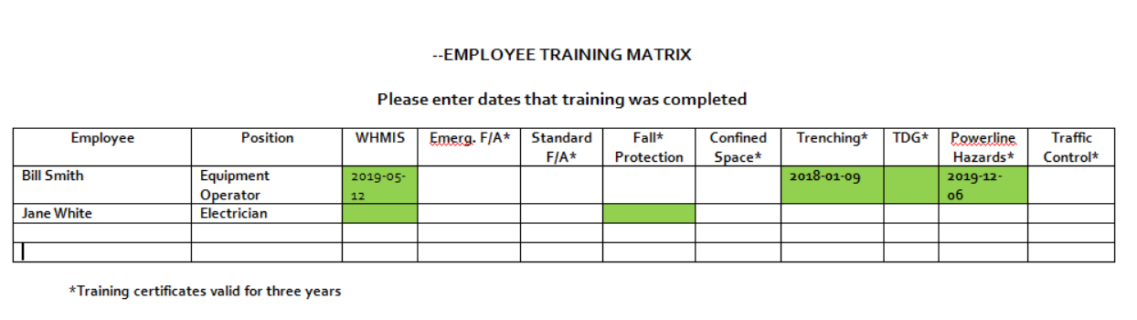

GENERAL SAFETY RULES

The following are the Safety Rules for the project site and must be strictly adhered to.
- All accidents, incidents, and injuries as well as unsafe acts and conditions observed by an employee are to be reported promptly to their immediate supervisor, and not later than the end of the working day. Employees are also required to report any concerns about poor workstation / task design and any early signs or symptoms of soft tissue injuries they may experience.

- First aid treatment is to be obtained promptly for any injury, and must be recorded in the First Aid Logbook.

- Employees shall comply with the current Occupational Health and Safety Act and Regulations.

- All work must be carried out according to appropriate safe work practices and safe work procedures where applicable.

- Employees must wear proper Personal Protective Equipment (PPE) and shall maintain and clean personal protective equipment which is issued to them.

- Tools are to be used only for the purpose for which they were intended. Only tools which are in good repair shall be used. Tools which are designed for use with guards and safety devices shall not be used if those guards or safety devices have been removed or tampered with.

- All tools or equipment which have been damaged or become worn are to be promptly tagged and taken out of service for repair or replacement.

- Good housekeeping practices must be maintained daily in all work areas.

- Employees are prohibited from arriving at work or remaining at work when their ability to perform the job safely is impaired for any reason.

- Horseplay, fighting, harassment of any kind, and otherwise interfering with another worker is strictly prohibited.

Disciplinary Procedures for Violation of Company’s Safety Rules

Discipline Structure
The following are the minimum disciplinary procedures that will be adhered to. Penalties could be more severe for the first and second violation it is determined that the Company’s safety procedures were knowingly ignored.

First Violation Verbal Warning
Second Violation Written Warning
Third Violation Suspension or Dismissal

If an employee who has committed a safety violation goes one year without committing any further violations, the violations then standing against the employee will be deleted.

Grounds for Dismissal
- Possession or consumption of alcohol or illegal drugs.
- Arriving for work or remaining at work when ability to perform the job safety is impaired.
- Possession of firearms.
- Fighting, horseplay and practical jokes.
- Theft and vandalism
- Damaging, disabling or interfering with safety, fire-fighting or first aid equipment.

APPENDICES
{Add or edit as required}

Appendix A – Field Level Hazard Assessment
Appendix B – Hazard Assessment Form - Checklist
Appendix C – Safety Meeting Sheets (Tool Box Meetings)
Appendix D – Emergency Phone Number
Appendix E – Job Safety Analysis
Appendix F – Safe Work Procedures
Appendix G – Worker Acknowledgement Form

Contractor to utilize others forms from their Health and Safety Manual or from other service providers such as NLCSA.

http://www.nlcsa.com/resource/index.php

Appendix A

Field Level Hazard Assessment – FLHA
(Typical)

Add or edit as required
http://nlcsa.com/search/index.php?q=flha

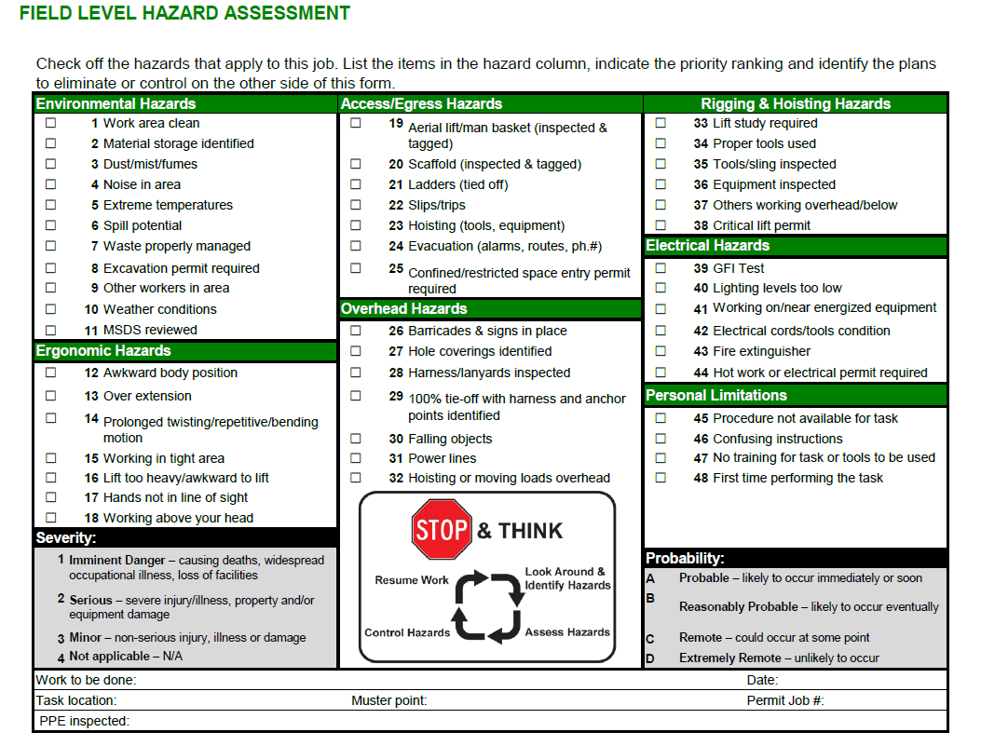
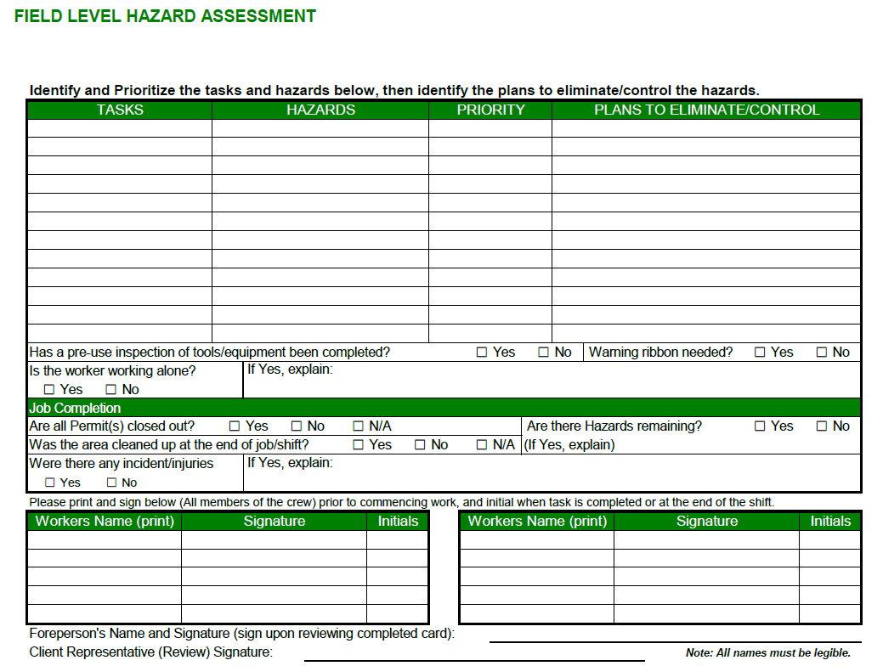

Appendix B
Hazard Assessment Form – Checklist

Hazard Assessment Form – Checklist
Add or edit as required
Company Name: | Location: Date/Time:
Assessment Team: Name Position
*RISK RATING

Serious (11-15) The hazard must be addressed immediately prior to the commencement of the job. Controls, including a safe operating procedure, must be in place prior to commencing the job.
Moderate (6-10) The hazard requires attention. Controls, including a safe operating procedure, should be put in place prior to commencing the job, but could be implemented once the job commences. Employees must be aware of the hazard.
Low (3-5) The hazard requires monitoring. Controls, in including a safe operating procedure, are recommended.
(N/A) Not Applicable – Currently the hazard does not exist

When completing this checklist please review the types of tasks you anticipate to be performed or are performing. As a consultant you should consider the following:

Pre-Design Stage - Site Meetings with clients, surveying, geotechnical investigations, building assessments, data collection, etc.
Design Stage – Periodic/routine meetings with client and others during the design.
Construction / Contract Administration Stage – Periodic/Routine meetings with the contractor, site inspections of ongoing work on an active construction site. Resident Inspection Services for daily inspections and liason with contractors site personnel and sub-trades during execution of resident inspection services.
Final Inspection/Systems Commissioning – Determine the level of inspection required for non-energized and energized systems. Team Inspections with other consultants may be required.

Orientation of co-workers not common to the project or specific site. Non-routine visits from other specialists or direct hire of contractors for small work tasks.

Emergency call outs from clients for non-routine consultant activities. Hazards still exist whether the construction site is active or not.

Check All that APPLY or ADD if new hazard is identified that is not on the list. This is not meant to be a complete list but added to give all consultants a starting point.

ITEM # | IDENTIFIED  HAZARDS  (ACTIVITIES AND CONDITIONS) | *RISK RATING  (3-15 or N/A) | SAFETY HAZARD LOCATION  AND  CONTROL  (Engineering, Administrative, PPE)
1 | Housekeeping
2 | Working at Heights
3 | Materials and Manual Handling / Back Injuries
4 | Slips / Trips / Falls
5 | Vibration Hand Tools / and Eqpt.
6 | Collapsing Trenches during Inspections
7 | Trenching and Excavation  (either during the activity or supervising the contractor)
8 | Asbestos – Naturally Occuring
9 | Asbestos – As contained within building materials
10 | Airborne fibers and materials – Dust Control
11 | Noise
12 | Hazardous Materials  ( GENERAL – OTHER such as mould, lead paint )
13 | Electrical Hazards – General whether below ground or within a building
14 | Overhead Hazards  (Powerlines/Canopy/Overhang, etc)
15 | Underground Hazards  General  (Buried Wires or infrastructure)
16 | Electrical Hazards  (Extension Chords)
17 | Mass Excavation  (Open Pit)
18 | Excavation  (Trenching)
19 | Energized Equipment  (Lockout / Tagout)
20 | Waste Disposal
21 | Lighting
22 | Ventilation
23 | Extreme Temperatures (cold/hot)
24 | Radiation Exposure
25 | Gas (Toxic or Non-Life-Supporting)
26 | Flammables (Fire/Explosion)
27 | Dangerous Pressure or Steam
28 | Chemicals / Controlled Products (WHMIS)
29 | Material Storage
30 | Restricted Access/Egress
31 | Ladders
32 | Work at Heights
33 | Scaffolds
34 | Work over Water  ( As opposed to travel on water)
35 | Major Lifts (hoisting)
36 | Vehicles  (Travel via Car, Truck)
37 | Vehicles  (travel via Snowmobile, ATV)
38 | Travel over water  (Boat)
39 | Travel Over Frozen Water  (ATV, Snowmobile, Walking)
40 | Working Alone
41 | Communications
42 | Mobile Equipment
43 | Traffic  (Pedestrian/Vehicle)
44 | Power Tools
45 | Arc Flash
46 | Confined Space Entry
47 | Forklifts
48 | Collapse  Maybe not a hazard but a risk – accident waiting to happen
49 | Add Hazards if not included above
50
51
52
53
54
56
57
58

59
60

Taken from Section 5.2 in the SSSP
The following ranking system will be used to rank hazards:

1. Determine the hazards associated with the job.

- Rank the exposure:
1 = unlikely: a person is exposed to the hazard 1x per job or project
2 = occasionally: a person is exposed to the hazard 2 x per job or project
3 = often: a person is exposed to the hazard more than 3x to 5x per job or project
4 = frequently: a person is exposed to the hazard 5 or more times per job or project
5 = continuous: a person is exposed to the hazard continually

- What is the probability of occurrence:
1 = unlikely to occur
2 = some chance
3 = could occur
4 = good chance
5 = will occur if not addressed

- What are the consequences:
1 = insignificant: a person receives a very minor injury, no damage to property.
2 = first aid or minor property damage: a person administers first aid to self.
3 = injury results in lost time, seeking medical air or significant property damage
4 = injury results in permanent disability, serious health effects or property damage.
5 = Injury results in a fatality, or there is major property damage.

- Add the exposure, probability of occurrence and consequences to obtain the risk rating:

Serious (11-15) The hazard must be addressed immediately prior to the commencement of the job. Controls, including a safe operating procedure, must be in place prior to commencing the job.

Moderate (6-10) The hazard requires attention. Controls, including a safe operating procedure, should be put in place prior to commencing the job, but could be implemented once the job commences. Employees must be aware of the hazard.

Low (3-5) The hazard requires monitoring. Controls, in including a safe operating procedure, are recommended

APPENDIX C

TOOL BOX MEETING

Add or edit as required

Presenter’s Name: ____ Date:

Safety Topic:

Employees Attending: (See Attached Worker Acknowledgement Form)

Employee Concerns:

Action Recommended: (Check when complete)

Concern | Date Complete

Supervisor’s Signature: Date:

APPENDIX D

EMERGENCY PHONE NUMBERS
Add or edit as required

EMERGENCY PHONE NUMBERS
HOSPITAL | 1-709-XXX-XXXX
FIRE DEPARTMENT | 1-709-XXX-XXXX
ROYAL CANADIAN MOUNTED POLICE | 1-709-XXX-XXXX
RCMP - TOLL FREE | 1-800-409-7267
ENVIRONMENTAL EMERGENCIES | 1-800-563-2444
INDUSTRIAL ACCIDENT REPORTING | 1-709-729-4444
POISON CONTROL CENTRE, ST. JOHN'S | 1-709-722-1110
CRIME STOPPERS | 1-800-363-8477
OHS - MAJOR INCIDENT REPORTING | 1-XXX-XXX-XXXX
CLIENT CONTACT - IN CASE OF EMERGENCY | 1-709-XXX-XXXX
ADD AS REQUIRED

APPENDIX E

JOB SAFETY ANALYSIS
Add or edit as required

The Job Safety Analysis (JSA) Process

In cases where a specific work or job tasks cannot be properly assessed for required safety measures or if the work task is new to the worker, the work task can be analyzed via the Job Safety Analysis Process. The employer is encouraged to involved more than one competent worker(s) for the evaluation as this will increase the work experience for analyzing the work steps and the hazards associated with each step.

The four basis steps are:

- Selecting the Job to be analyzed
- Breaking the task down into a sequence of steps
- Identifying potential hazards with each step
- Determining the preventative measures to overcome each of the identified hazards.

See web link:

https://www.ccohs.ca/oshanswers/hsprograms/job-haz.html

for assistance in completing the Job Safety Analysis form.

Job Safety Analysis Worksheet - Add or edit as required
Job / Work Task:
Analysis By: |  | Reviewed By: |  | Approved By:
Date: |  | Date: |  | Date:
Analysis By: |  | Reviewed By:
Date: |  | Date:
Analysis By: |  | Reviewed By:
Date: |  | Date:
Sequence of Steps |  | Potential Incidents or Hazards |  | Preventative Measures

APPENDIX F

Safe Work Procedures
Add or edit as required

Insert Company Safe Work Procedures as required.

APPENDIX – G

WORKER ACKNOWLEDGEMENT FORM

APPENDIX – G  WORKER ACKNOWLEDGEMENT FORM - Add or edit as required | Project Name/Location: | Attachments:
Presented By: |  | Date/Time:
Type of Briefing

Safety Plan/Emergency Response Plan Tool Box Meeting Job Site Orientation

Specify Other:

Worker Name (Print) | Signature* | Date |  | Time
* By signing this document, I am stating that I have read and fully understand the plan and/or information provided to me. |  |  | Worker Acknowledgement  Page of

